Project proposal Master Degree Project, 18th February,2018
Project Title: Characterization and mitigation of timing constraints of 802.15.4 protocol in Software Defined Radio.

Author
Saptarshi Hazra
Hanstavagen 49 lgh 1614, Kista, 164 53.
Email: hazra@kth.se
Phone: +4917667504267

Organization and Supervisor
The work will be done at RISE SICS, Networked Embedded Systems Group under the supervision of Dr. Simon Duquennoy (simon.duquennoy@ri.se) and Niklas Wirström (niklas.wirstrom@ri.se)

Keywords
IOT, IEEE 802.15.4, Software Defined Radio, Contiki, FPGA, GNU Radio.

Background
The Internet of Things has enabled the development of wide diversity of communication protocols, but the testing of these protocols are limited by flexibility of the radio-head. Software Defined Radio (SDR) provides flexibility in terms of design and allows for carefully analysing RF signals and experimenting with decoding and modulation techniques.

Problem statement
Software Defined Radio based communication systems are limited by the round trip delay which consists of communication delay between the SDR platform and the host computer and also processing delay in the host computer.

Problem
These delays don’t usually comply with the standard MAC definitions hence real time standard complaint performance is not possible. Understanding and mitigation of these delays is missing for recent SDR platforms like LimeSDR.

Purpose
The purpose of the project is to initially study and understand the delays in the context of 802.15.4 physical layer on LimeSDR and looks for ways to mitigate them to enable real time standard complaint implementation.

Goal(s)
The goals of the project are:
- Study of the delays associated with the SDR implementation.
- Find methods to mitigate these delays.

Tasks
- Implementation and Interoperability testing of the 802.15.4 PHY in GNU Radio and LimeSDR.
- Experimental Study and classification of the timing delays and these respective jitters.
- Understanding and analytical explanation of these delays.
- Find methods to mitigate the respective delays.

Method
I am going to use quantitative experimental validation as my project depends on objective data, and analysis of data for different approaches will help me evaluate which approaches are helping me get better results.

Milestone chart (time schedule)
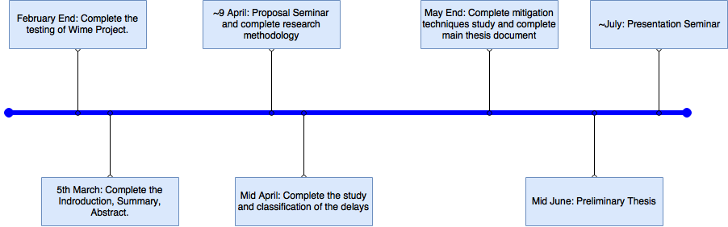

Risks, Consequences and Ethics
TBD

Summary
Software Defined Radio provides major flexibility but increases difficulty of implementation timing driven protocols. On the other hand timing driven protocols lead to better reliable performance. The project will focus on characterizing the timing delays and find ways to mitigate those in order to enable real time standard complaint communication system implementation.

