|  |  |
| --- | --- |
|  | **LDCW6123 FUNDAMENTALS OF DIGITAL COMPETENCE FOR PROGRAMMERS**  Trimester 2, 2023/2024 |

**Group Project**

## Lecturer : Professor Muhammad Arif Bin Hasan

## Group : DC2 / 2C

*Prepared by:*

|  |  |  |
| --- | --- | --- |
| **Student ID** | **Student Name** | **Phone number** |
| 241UT2408V | WONG WEN FUNG | 011-10730529 |
| 241UT240NM | SHAMAN A/L DEVA KUMAR | 011-72657905 |
| 241UT24014 | ASIM IYAD OMER MUSTAFA | 010-2151275 |

**Declaration by group leader**

I hereby declare that all group members’ names are correctly included in the above section. I hold a copy of this assignment which I can produce if the original is lost or damaged. I certify that no part of this assignment has been copied from any other student’s work or from any other source except where due acknowledgement is made in the assignment.

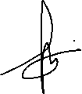

Group leader’s signature : _____________________________

Group leader’s name : ____WONG WEN FUNG____________

Group leader’s student ID : _____241UT2408V ____________

Date : _____27 JUNE.2024________________

Group leader’s tel. no. : 011-10730529

## Declaration by student

I hereby declare that aforementioned name is correctly included in the above section. I hold a copy of this assignment which I can produce if the original is lost or damaged. I certify that no part of this assignment has been copied from any other student’s work or from any other source except where due acknowledgement is made in the assignment.

For the purpose of completing this assignment, I have performed the following tasks (please list):

- Wix Website design of our company

- Project arrangement

- Conclusion



Student signature :

Student name : WONG WEN FUNG

Student ID : 241UT2408V

Date : 27 JUNE 2024

Group member’s tel. no. : 011-10730529

## Declaration by student

I hereby declare that aforementioned name is correctly included in the above section. I hold a copy of this assignment which I can produce if the original is lost or damaged. I certify that no part of this assignment has been copied from any other student’s work or from any other source except where due acknowledgement is made in the assignment.

For the purpose of completing this assignment, I have performed the following tasks (please list):

-

-

-

Student signature :

Student name :

Student ID :

Date :

Group member’s email :

Group member’s tel. no. : ________________________________

## Declaration by student

I hereby declare that aforementioned name is correctly included in the above section. I hold a copy of this assignment which I can produce if the original is lost or damaged. I certify that no part of this assignment has been copied from any other student’s work or from any other source except where due acknowledgement is made in the assignment.

For the purpose of completing this assignment, I have performed the following tasks (please list):

-

-

-

Student signature :

Student name :

Student ID :

Date :

Group member’s email :

Group member’s tel. no. : ________________________________

**Website & Mobile apps prototype evaluation**

|  |  |  |  |  |  |
| --- | --- | --- | --- | --- | --- |
| **Criteria** | Excellent (5) | Good (4) | Satisfactory (3) | Needs Improvement (2) | Inadequate (1) |
| 1. **User Interface & Design (15 marks)** | | | | | |
| * Visual Appeal |  |  |  |  |  |
| * Navigation and Layout |  |  |  |  |  |
| * Consistency in Design Elements |  |  |  |  |  |
| 1. **Functionality & Interactivity (15 marks)** | | | | | |
| * Responsive Design |  |  |  |  |  |
| * Feature Integration |  |  |  |  |  |
| * Cross-browser Compatibility |  |  |  |  |  |
| 1. **Content Quality (15 marks)** | | | | | |
| * Relevance and Accuracy of Information |  |  |  |  |  |
| * Readability and Clarity |  |  |  |  |  |
| * Multimedia Integration |  |  |  |  |  |
| 1. **Accessibility & Inclusivity (15 marks)** | | | | | |
| * Compliance with Accessibility Standards |  |  |  |  |  |
| * Inclusive Design |  |  |  |  |  |
| * Overall Website & prototype performance |  |  |  |  |  |
| **Total (60 marks)** | | | | | |

**Designing and Developing Website and Mobile Apps Prototypes in Collaboration with Git & GitHub**

WONG WEN FUNG, SHAMAN A/L DEVA KUMAR, and ASIM IYAD OMER MUSTAFA

Faculty of Information Science & Technology (FIST), Multimedia University Melaka

LCBW6192: Fundamental of Digital Competence of Programmers

Professor Muhammad Arif Bin Hasan

27 JUNE 2024

**Content**

1. Website URL Link …………………………………………………8
2. Mobile Apps URL Link ……………………………………………
3. Mobile Apps User Manual …………………………………………

**E-commerce Website**

**FINIX**

**Second-Hand Anime figure and Fan-Art selling platform**

[Home | Finixanime (wenfung118.wixsite.com)](https://wenfung118.wixsite.com/finixanime) 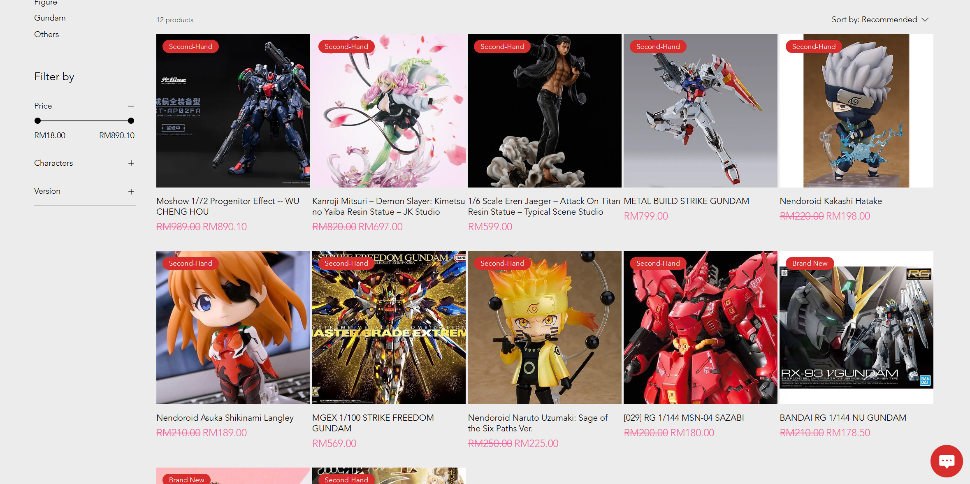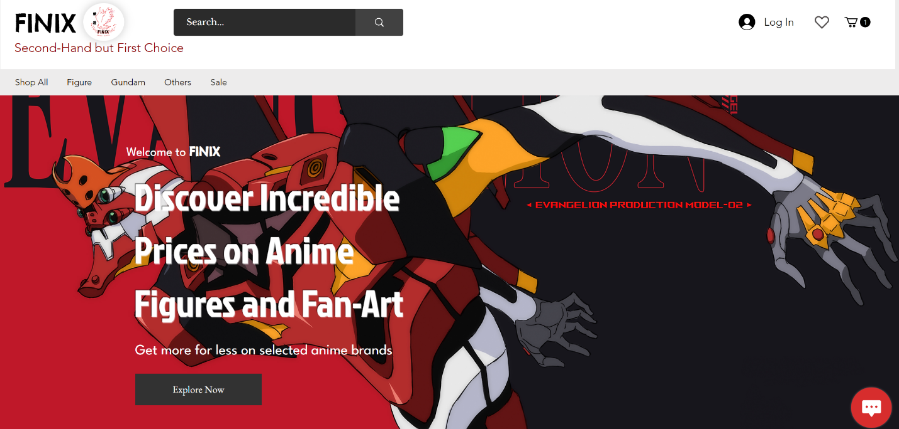

Figure 1.0: Wix e-commerce website

**Site Map**

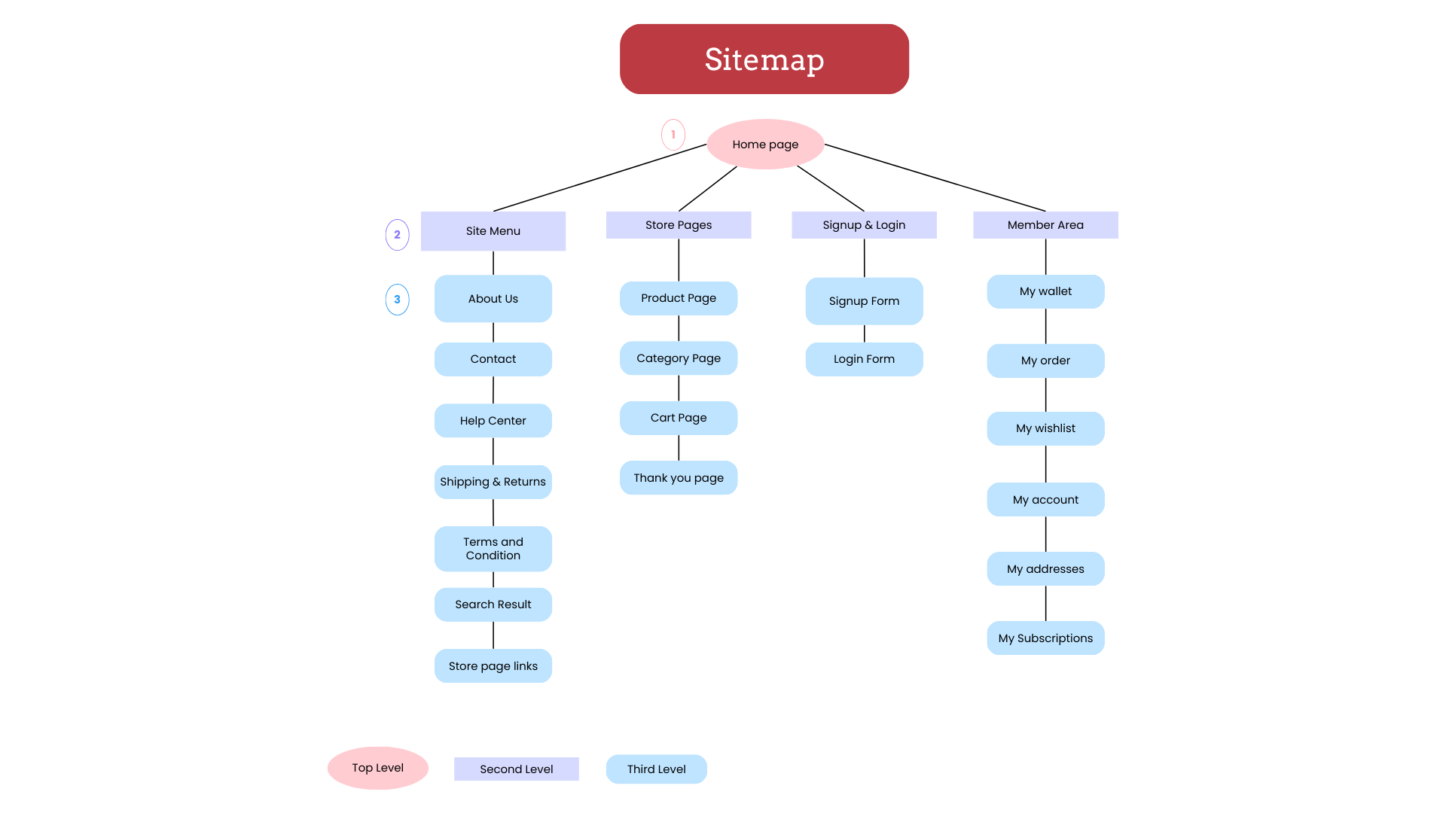

Figure 1.1: Website sitemap

**Mobile App**

**Mobile Apps User Manual**

**Video Presentation**

**GitHub Log activities**

**Conclusion**

This project is a new challenge of us and our team, because none of us has use GitHub and its function before. But thankfully we manage to overcome the challenge together. Wix.com is surely a handy tool for all of us, the easy and simple UI makes design a website so easily and efficiently. For me, I love the part of we can actually choose a template to start with, so that we wouldn’t have to start from zero. This function surely gives a lot convenient, thus it not only shortens the time that we need to implement the section of our website, it also kind of providing ideas to us that how we going to set our function and also the design element.

Then, Figma is another handy tool for student to design their application on mobile phone. Simple and easy use function really helps a lot, because we do not need to study all of the basic coding language in order to start our design.

After this, GitHub log sure takes us some time to figure it out what we going to do. But after some basic introduction and the help of lecturer, we mange to finish our work at the time.