**Module:1(SDLC)**

1. **What is software? What is software engineering?**

**Ans:-** A set of instruction given to the computer to solve a problem is called **software.**

**Software engineering** is a detailed study of engineering to the design,development and maintenance of software.

1. **Explain types of software.**

**Ans:-** Two types of software:-

1. **System software**
2. **Application software**
3. **System software:-** A set of program to control and manage the operations of a computer hardware.

* Manage resources
* Helps application software to run
* Saving data on disk
* Makes computer usable
* Printing document
* **Types**:-

1. **Operating system**:- Software that controls the operation of a computer and directs the processing of programs(by assigning storage space in memory and controlling input and output functions).

* Requirement of each computer
* Other software run through it

**Examples**:-

* Windows
* MAC OS
* Linux
* Unix
* Ubuntu

1. **Utility program:-** A program that performs a specific task related to the management of computer functions,resources,or files.

* Improve the performance
* Protect the computer
* Optimize resources

**Examples:-**

* Disk Tools
* Antivirus
* Compression tools
* Backup Software

1. **Device Drivers:-** A device driver is a computer program that operates or controls a particular type of device that is attached to a computer.
2. **Application Software:-** Application software is used to perform various task on the computers.

* So many application software
* Use according to need
* Also known as application package
* **Types:-**

1. **Customized Software:-** A type of application software that is designed for a particular business or organization.

* Exact requirements
* Developed by a team or individual
* Very Costly

1. **Package Software:-** A type of application software that is developed for the scale to the general public.

* Off the shelf software
* Developed by expert programmers
* Loaded with features

**Examples:-**

* MS Word
* MS Excel
* Adobe photo shop

1. **What is SDLC? Explain each phase of SDLC.**

**Ans:-** SDLC stands for software development life cycle, SDLC is a

Process used by the software industry to design, develop and test high quality soft wares.

* **Phases of SDLC:-**

1. Gathering Requirements & Analysis
2. Design
3. Coding or Development
4. Testing
5. Deployment
6. Maintenance
7. **Gathering Requirements & Analysis:-** This phase involves gathering information about the software requirement from stakeholder, such as customers, end-users, and business analysts.
8. **Design:-** In this phase, the software design is created, which includes the overall architecture of the software, data structures, and interfaces.

It has two steps:-

* **High-level design(HLD):-** It gives the architecture of software products.
* **Low-level design(LLD):-** It describes how each and every feature in the product should work and every component.

1. **Coding or Development:-** The design is then implemented in code, usually in several iterations, and this phase is also called as Development.

Things you need to know about this phase:

* This is the longest phase in SDLC model.
* This phase consist of Front end+Middleware+Back-end.
* **In Front-end:** Development of coding is done even SEO setting are done.
* **In Middleware:** They connect both the front end back end.
* **In the back-end:** A database is created.

1. **Testing:-** The software is thoroughly tested to ensure that it meets the requirements and works correctly.
2. **Deployment:-** After successful testing, The software is deployed to a production environment and made available to end-users.
3. **Maintenance:-** This phase includes on going support, bug fixes, and updates to the software.
4. **What is DFD? Create a DFD diagram on Flipkart.**

**Ans:-** A data flow diagram(DFD) is a graphical or visual representation using a standardized set of symbols and notation to describe a business’s operations through data movement.

* **DFD diagram on Flipkart:-**

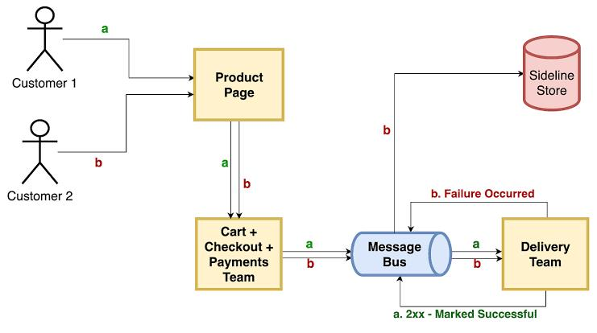

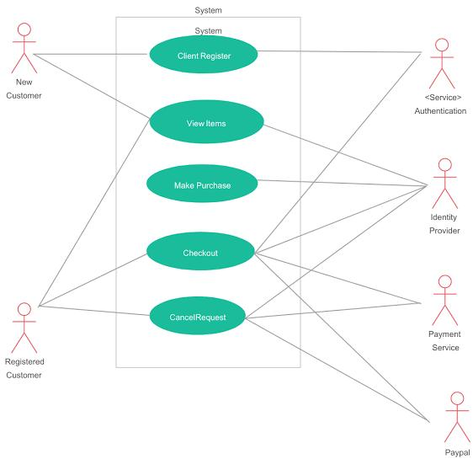

1. **What is Flow chart? Create a flowchart to make addition of two numbers.**

**Ans:-** Flowchart is a symbolic or diagrammatic representation of an algorithm. It uses several geometrical figures to represent the operations, and arrows to show the direction of flow.

* **Flowchart to make addition of two numbers:-**

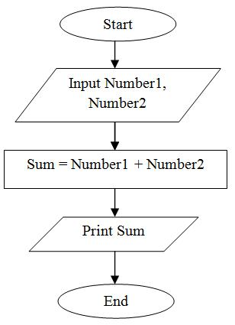

1. **What is Use case Diagram? Create a use-case on bill payment on paytm.**

**Ans:-** Use case diagrams describe the high-level functions and scope of a system. These diagram also identify the interactions between the system and its actors.

* **Use case diagram on bill payment on paytm:-**

