# Omega Quick Start

## What Does Omega Do?

Omega is a non-profit management application to help non-profits manage their operations. Omega helps you focus on your non-profit mission by making it easy to keep track of all the details needed to manage a modern non-profit organization. As a side benefit, Omega produces reports that help explain the organization’s impact to donors, volunteers and community members. Omega is available 24 hours a day 7 days a week on the Internet.

## What Omega Does **NOT** Do

Many non-profits make their first IT investments in financial and/or fund raising software. OMEGA does not attempt to replace your existing software but does provide mechanisms for sharing the data that you have already stored in your existing software.

## BASIC Features or Modules

Omega is an online application which means you access the application via your favorite web browser. There is no need to install any software. Each organization has their own web site which is accessed by typing in: **http://<myorganiztion>.myomegaportal.org**

The first page (or HOME) page of your application will display your logo and information about your organization. At the top of the page will be a MENU similar to the menu below:

figure1.jpg

The menu items indicate the major work areas within Omega. You access this functionality by clicking the mouse on the name of the module you wish to use. Currently the modules are:

**Volunteering –** this module helps you manage your volunteer staff. You can create opportunities for volunteers and allow volunteers to sign up for the opportunities, which you can approve or reject. This module helps you make the best use of your volunteers, keeps them informed of new changes to participate and even tracks how much effort your volunteers are putting in.

**Services –** this module is used to manage the various services offered by a non-profit organization. Members of the organization can create new services (classes, ceremonies, events) and share them with others on the web. Interested parties can choose to take advantage of a “service” and the system will keep track of their request, reserve any resources necessary to provide the service and produce reports that help staff understand the status of a particular service and its associated resources.

**Calendar –** all events and services that have a date associated with them are also placed in the calendar. Omega users can look at all (non-private) events and services to get an overview of what is going on in the organization. The calendar system provides personalized views for groups and individuals.

**Contacts –** the heart of any organization is people and the contact module allows you to manage people, create groups of people, and communicate with these groups. These groups can be your donors, your volunteers and your staff. Omega also has an import/export capability that allows you to use existing contact lists and even take advantage of Omega’s management features to maintain your contact lists.

**MyOmega –** in order to keep your volunteers, staff and donors excited about their contributions to the organization, Omega provides a personal hub, which helps users track their volunteer assignments, upcoming events of interest, etc. MyOmega also allows them to share their work with friends on various social networks such as Facebook and Twitter.

## Accounts and Roles

Before using Omega it’s important to understand how the program presents information based on the “role” of the person logged into the Omega program. Roles are simply a set of permissions that are associated with a group of volunteers or staff in your organization. For example, if your organization has a group of “volunteer managers,” Omega may have a role called “volunteer manager” assigned to all members of the volunteer management group. Only members with the role of volunteer manager can create assignments, edit assignments and approve applicants. In another organization these privileges may be assigned to a role called “office staff.”

The person that administers Omega for your organization will create various roles appropriate for the group and then assign them to users. This prevents users from accidently performing actions that they are not trained to perform. If you have been asked to do a task in Omega and the necessary menu items do not appear you will have to contact your system administrator and ask to have them added to your login account.

Omega users who are not registered are assigned the role of “anonymous user.” In general these anonymous users will have very few privileges and will only be able to view publicly available information.

## Volunteering Module

The volunteering management makes it easier to fully utilize your volunteer staff. In the volunteer module, you create new volunteer opportunities, advertise them to potential volunteers and then manage the application process. The main menu for the volunteering module is shown below:

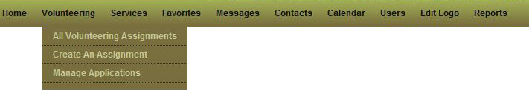

The menu shows all the current functionality available in the module. You may not see all the “Create” or ”Manage” entries unless the manager of your organization’s Omega site has given your Omega account the ability to create volunteer assignments.

### Assignment Listing

All users have access to the “All Volunteering Assignments” menu item. Selecting this with your mouse brings up the assignment listing. If the assignment was created as a “public” volunteer assignment then it can be seen by both registered and unregistered omega users. Each entry in the list will look similar to the following example:

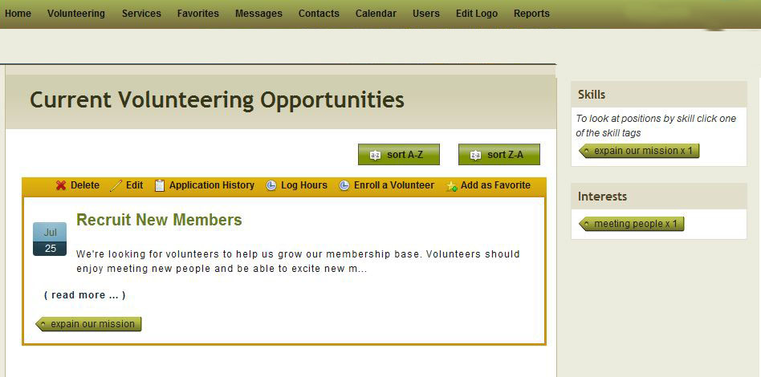

Each volunteer assignment is shown in a box (yellow in this example) with a description and other information about the volunteer opportunity. On the top line of each box the Omega application lists the actions you can take regarding this volunteer opportunity. All users will see the “Enroll, Log Hours, Enroll and Favorite” commands. You simply click on the action you wish to take and the system will prompt you through the next steps. Only Omega users who have been given a role that allows them to create volunteer opportunities will see the “Edit, Delete and History” actions.

If your organization has many volunteer opportunities, Omega has a number of tools to help potential volunteers find opportunities suited to them. At the top of the listing are different options for sorting the list. To the right are buttons that allow Omega users to sort the volunteer opportunity list by skills and interests. When each volunteer position is created the person creating the opportunity can add skills and interest keywords (called “tags”), which suggest the type of volunteers who might be appropriate for a given position.

### Creating an Assignment

If you wish to create a new volunteer assignment, you select the “Create an Assignment” menu item. Omega will present you with a form to fill out. You type in the information that will be used to create a new volunteer assignment. Fields that are required are marked with a “🟏” and Omega will not let you create a new assignment unless all these fields contain valid information. Most fields on the page have a simple feature: if you place your mouse over the field and leave it there for a second or so the system will put up a small box which describes the information that the field expects.

### Managing Volunteer Applications

Once a volunteer assignment is published, members and non-members may apply for the position (by pushing the “Apply” action as described above). If you are responsible for responding to these offers to volunteer then you will select the “Managing Volunteer Applications” menu item. You will see something like the following display:

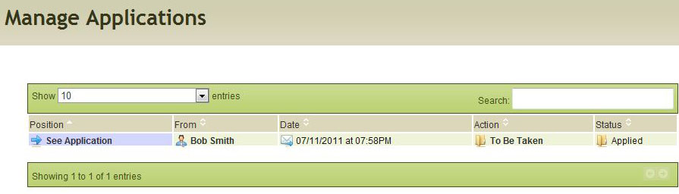

In this case Mr. Bob Smith has applied for our volunteer position. To process his application you simply click on the “To Be Taken” label. This will bring up another screen where you find out more information about Mr. Smith and accept or reject his application. The system will send Mr. Smith a message indicating whether or not he has been accepted. You will be returned to this page and the Action/Status labels will change to indicate that you have processed Mr. Smith, as well as whether he was accepted, rejected, etc.