**版本1：將每個單字排一列印出**

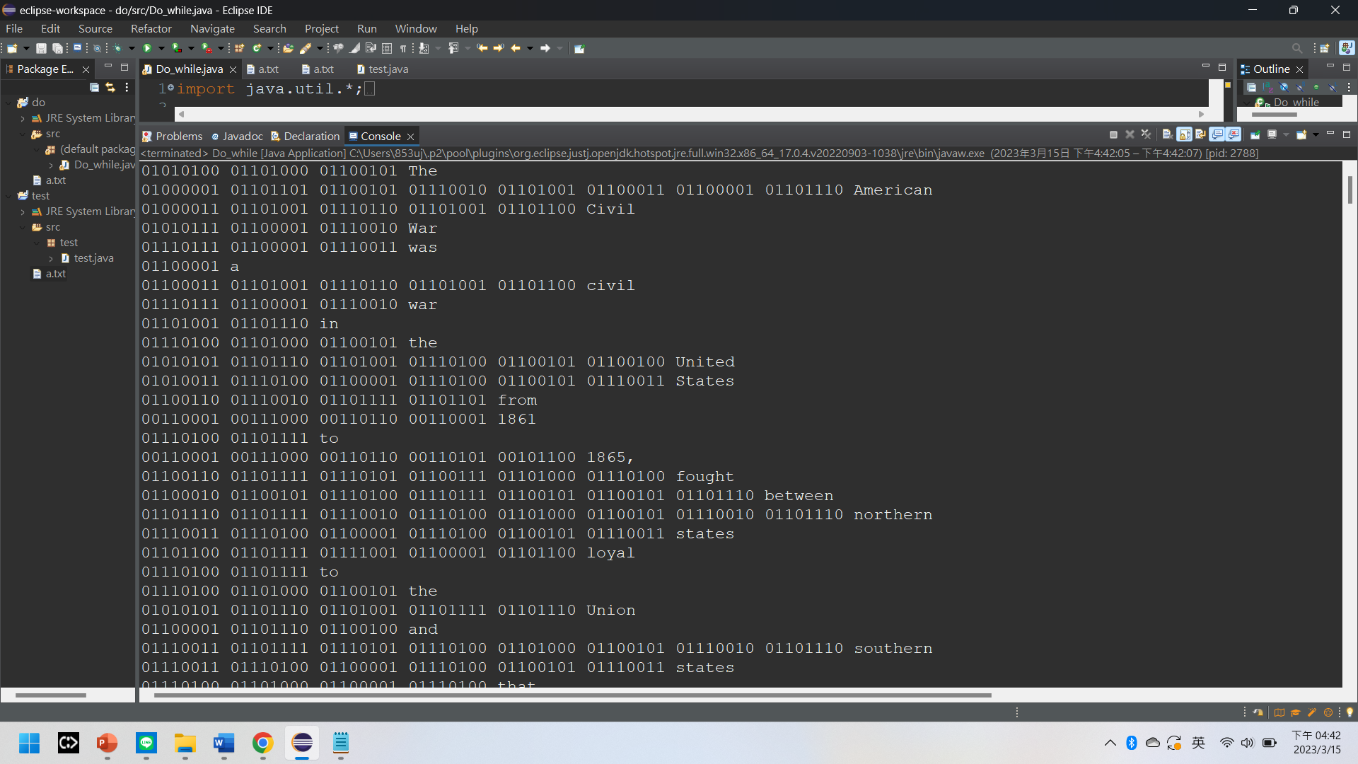

import java.util.*;

import java.io.*;

public class Do_while {

public static void main(String[] args) {

File file = new File("a.txt");

Scanner sc;

try {

sc = new Scanner(file);

String line;

while (sc.hasNext()) {

// Check if there is more input to be read

line = sc.next();

int[] arr = new int[8];

for (int i = 0; i < line.length(); i++) {

// convert character to ASCII code and OctToBinary

arr= OctToBinary((int)line.charAt(i));

for(int j:arr) {

System.out.print(j);

}

System.out.print(" ");

}

System.out.println(line);

}

sc.close();

} catch (FileNotFoundException e) {

System.out.print("Stop");

}

}

public static int[] OctToBinary(int input) {

int num = 0;

int[] arr = new int[8];

int[] arrRev = new int[8];

for(int i = 0; i<8 ; i++) {

arr[i] = 0;

}

int j = 0;

while(input!=0) {

if(input % 2 == 0) {

input = input/2;

j++;

}

else {

arr[j] = 1;

input = input/2;

j++;

}

}

int p=8;

for(int i=0;i<8;i++) {

arrRev[p-1]=arr[i];

p = p-1;

}

return arrRev;

}

}

**版本2：將所有二進位數合起來變一串代碼 (空格為00100000)**

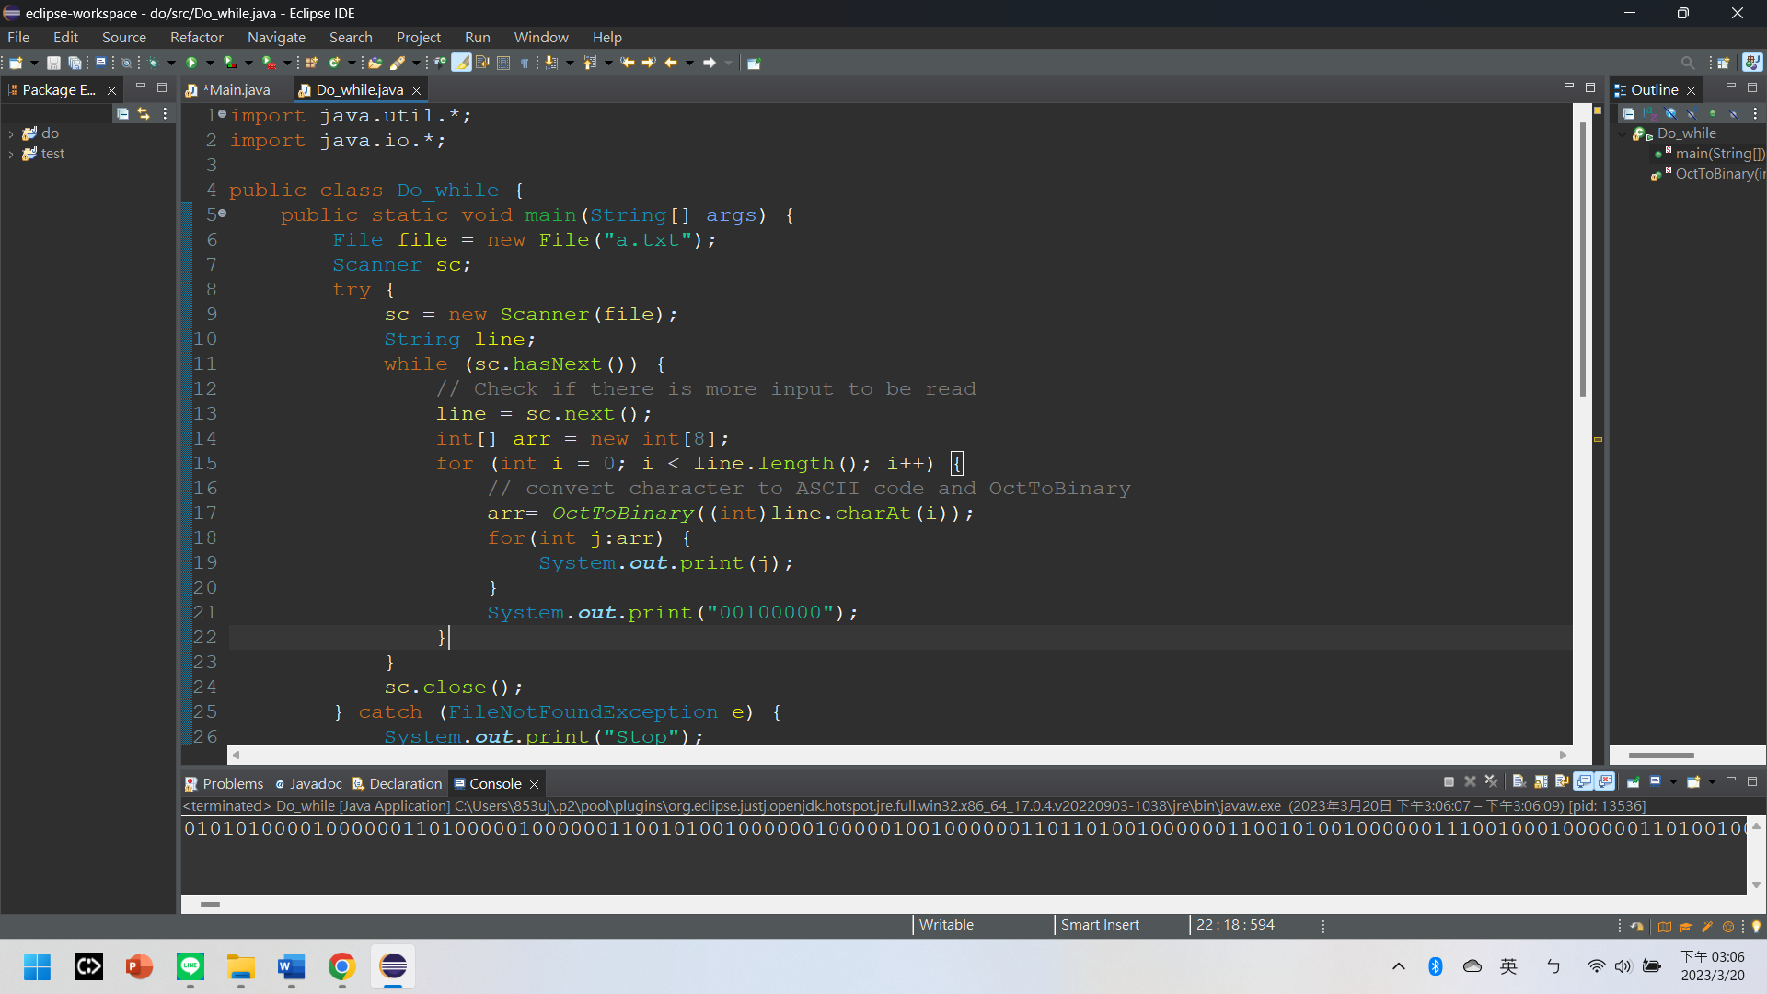

import java.util.*;

import java.io.*;

public class Do_while {

public static void main(String[] args) {

File file = new File("a.txt");

Scanner sc;

try {

sc = new Scanner(file);

String line;

while (sc.hasNext()) {

// Check if there is more input to be read

line = sc.next();

int[] arr = new int[8];

for (int i = 0; i < line.length(); i++) {

// convert character to ASCII code and OctToBinary

arr= OctToBinary((int)line.charAt(i));

for(int j:arr) {

System.out.print(j);

}

System.out.print("00100000");

}

}

sc.close();

} catch (FileNotFoundException e) {

System.out.print("Stop");

}

}

public static int[] OctToBinary(int input) {

int num = 0;

int[] arr = new int[8];

int[] arrRev = new int[8];

for(int i = 0; i<8 ; i++) {

arr[i] = 0;

}

int j = 0;

while(input!=0) {

if(input % 2 == 0) {

input = input/2;

j++;

}

else {

arr[j] = 1;

input = input/2;

j++;

}

}

int p=8;

for(int i=0;i<8;i++) {

arrRev[p-1]=arr[i];

p = p-1;

}

return arrRev;

}

}

**版本3：bmp用byte array存取，並將每個byte轉換成binary**

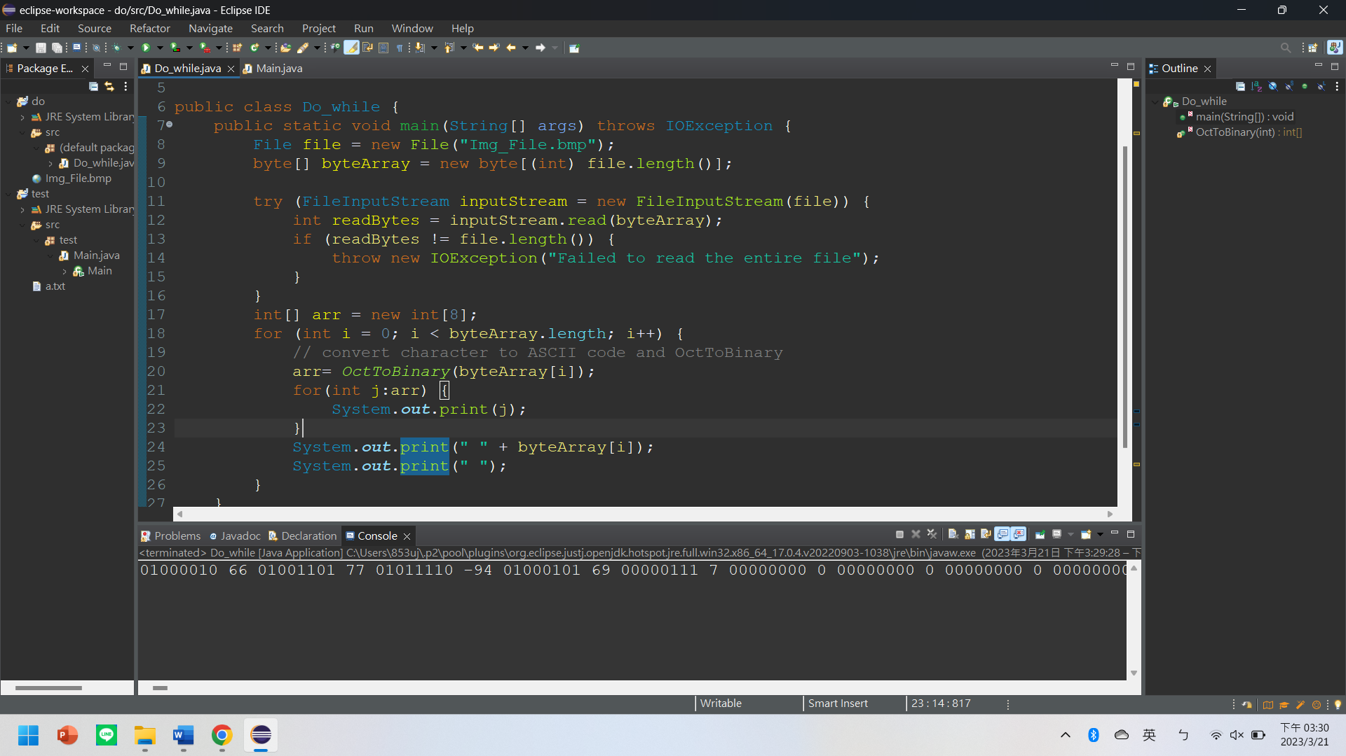

import java.io.File;

import java.io.FileInputStream;

import java.io.IOException;

import java.util.Arrays;

public class Do_while {

public static void main(String[] args) throws IOException {

File file = new File("Img_File.bmp"); //read file(import java.io.File

byte[] byteArray = new byte[(int) file.length()];

try (FileInputStream inputStream = new FileInputStream(file)) {

int readBytes = inputStream.read(byteArray);

if (readBytes != file.length()) {

throw new IOException("Failed to read the entire file");

}

}

int[] arr = new int[8];

for (int i = 0; i < byteArray.length; i++) {

// convert number to Binary

arr= OctToBinary(byteArray[i]);

for(int j:arr) {

System.out.print(j);

}

System.out.print(" " + byteArray[i]);

System.out.print(" ");

}

}

public static int[] OctToBinary(int input) {

int num = 0;

int[] arr = new int[8];

int[] arrRev = new int[8];

for(int i = 0; i<8 ; i++) {

arr[i] = 0;

}

int j = 0;

while(input!=0) {

if(input % 2 == 0) {

input = input/2;

j++;

}

else {

arr[j] = 1;

input = input/2;

j++;

}

}

int p=8;

for(int i=0;i<8;i++) {

arrRev[p-1]=arr[i];

p = p-1;

}

return arrRev;

}

}

**版本4：用二補數存負數，去掉空格及數字**

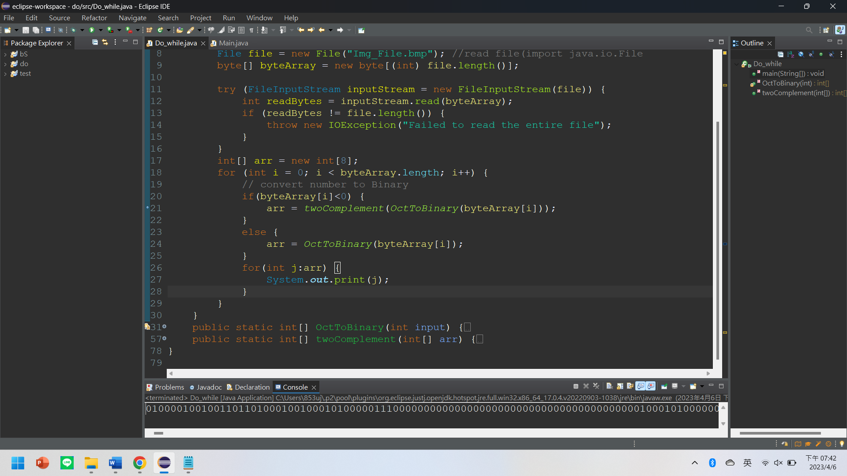

import java.io.File;

import java.io.FileInputStream;

import java.io.IOException;

import java.util.Arrays;

public class Do_while {

public static void main(String[] args) throws IOException {

File file = new File("Img_File.bmp"); //read file(import java.io.File

byte[] byteArray = new byte[(int) file.length()];

try (FileInputStream inputStream = new FileInputStream(file)) {

int readBytes = inputStream.read(byteArray);

if (readBytes != file.length()) {

throw new IOException("Failed to read the entire file");

}

}

int[] arr = new int[8];

for (int i = 0; i < byteArray.length; i++) {

// convert number to Binary

if(byteArray[i]<0) {

arr = twoComplement(OctToBinary(byteArray[i]));

}

else {

arr = OctToBinary(byteArray[i]);

}

for(int j:arr) {

System.out.print(j);

}

}

}

public static int[] OctToBinary(int input) {

int num = 0;

int[] arr = new int[8];

int[] arrRev = new int[8];

for(int i = 0; i<8 ; i++) {

arr[i] = 0;

}

int j = 0;

while(input!=0) {

if(input % 2 == 0) {

input = input/2;

j++;

}

else {

arr[j] = 1;

input = input/2;

j++;

}

}

int p=8;

for(int i=0;i<8;i++) {

arrRev[p-1]=arr[i];

p = p-1;

}

return arrRev;

}

public static int[] twoComplement(int[] arr) {

for(int i=0; i<8 ; i++) {

if(arr[i]>0) {

arr[i] = 0;

}

else {

arr[i] = 1;

}

}

int carry = 1;

for(int i=7; i>=0 ; i--) {

arr[i] = arr[i] + carry;

if(arr[i]>1) {

arr[i] = 0;

}

else {

break;

}

}

return arr;

}

}

**版本5：輸出.txt檔(bmp的binary code)並以二補數表達負數**

import java.io.File;

import java.io.FileInputStream;

import java.io.FileWriter;

import java.io.IOException;

import java.util.Arrays;

public class Do_while {

public static void main(String[] args) throws IOException {

File file = new File("Img_File.bmp"); //read file(import java.io.File)

**FileWriter writer = new FileWriter("i.txt");**

String space = " ";

String data = "";

byte[] byteArray = new byte[(int) file.length()];

try (FileInputStream inputStream = new FileInputStream(file)) {

int readBytes = inputStream.read(byteArray);

if (readBytes != file.length()) {

throw new IOException("Failed to read the entire file");

}

}

int[] arr = new int[8];

for (int i = 0; i < byteArray.length; i++) {

// convert number to Binary

if(byteArray[i]<0) {

arr = twoComplement(OctToBinary(byteArray[i]));

}

else {

arr = OctToBinary(byteArray[i]);

}

**for(int j:arr) {**

**data = j+"";**

**writer.write(data);**

**}**

**writer.write(space);**

**}**

**writer.close();**

}

public static int[] OctToBinary(int input) {

int num = 0;

int[] arr = new int[8];

int[] arrRev = new int[8];

for(int i = 0; i<8 ; i++) {

arr[i] = 0;

}

int j = 0;

while(input!=0) {

if(input % 2 == 0) {

input = input/2;

j++;

}

else {

arr[j] = 1;

input = input/2;

j++;

}

}

int p=8;

for(int i=0;i<8;i++) {

arrRev[p-1]=arr[i];

p = p-1;

}

return arrRev;

}

public static int[] twoComplement(int[] arr) {

for(int i=0; i<8 ; i++) {

if(arr[i]>0) {

arr[i] = 0;

}

else {

arr[i] = 1;

}

}

int carry = 1;

for(int i=7; i>=0 ; i--) {

arr[i] = arr[i] + carry;

if(arr[i]>1) {

arr[i] = 0;

}

else {

break;

}

}

return arr;

}

}

**版本6：輸出.txt檔(txt的ASCII decimal)**

package test;

import java.util.*;

import java.io.*;

public class Main {

public static void main(String[] args) {

File file = new File("a.txt");

Scanner sc;

String data = "";

try {

sc = new Scanner(file);

String line;

while (sc.hasNext()) {

// Check if there is more input to be read

line = sc.next();

int tmp = 0;

for (int i = 0; i < line.length(); i++) {

// convert character to ASCII code and OctToBinary

tmp = (int)line.charAt(i);

data += tmp;

data += " ";

}

}

sc.close();

} catch (FileNotFoundException e) {

System.out.print("Stop");

}

//write to c.txt

try {

FileWriter writer = new FileWriter("c.txt");

writer.write(data);

writer.close();

} catch (IOException e) {

e.printStackTrace();

}

}

public static int[] OctToBinary(int input) {

int num = 0;

int[] arr = new int[8];

int[] arrRev = new int[8];

for(int i = 0; i<8 ; i++) {

arr[i] = 0;

}

int j = 0;

while(input!=0) {

if(input % 2 == 0) {

input = input/2;

j++;

}

else {

arr[j] = 1;

input = input/2;

j++;

}

}

int p=8;

for(int i=0;i<8;i++) {

arrRev[p-1]=arr[i];

p = p-1;

}

return arrRev;

}

}