**版本1：將txt單字及空格接續印出ascii binary +4 (txt無overflow)**

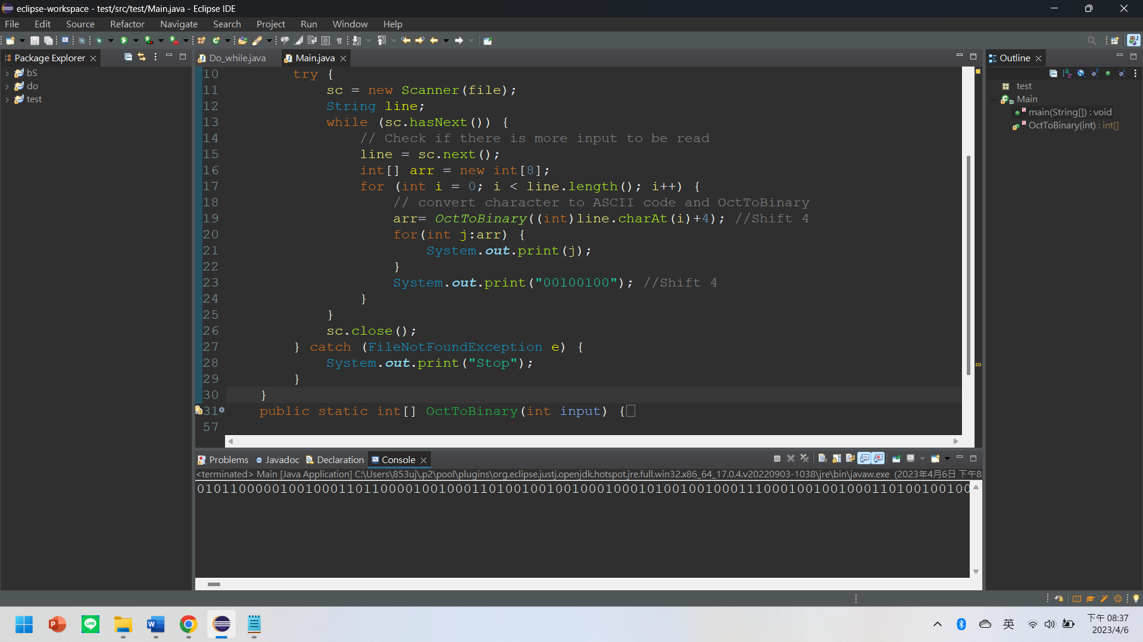

package test;

import java.util.*;

import java.io.*;

public class Main {

public static void main(String[] args) {

File file = new File("a.txt");

Scanner sc;

try {

sc = new Scanner(file);

String line;

while (sc.hasNext()) {

// Check if there is more input to be read

line = sc.next();

int[] arr = new int[8];

for (int i = 0; i < line.length(); i++) {

// convert character to ASCII code and OctToBinary

arr= OctToBinary((int)line.charAt(i)+4); **//Shift 4**

for(int j:arr) {

System.out.print(j);

}

System.out.print("00100100"); **//Shift 4**

}

}

sc.close();

} catch (FileNotFoundException e) {

System.out.print("Stop");

}

}

public static int[] OctToBinary(int input) {

int num = 0;

int[] arr = new int[8];

int[] arrRev = new int[8];

for(int i = 0; i<8 ; i++) {

arr[i] = 0;

}

int j = 0;

while(input!=0) {

if(input % 2 == 0) {

input = input/2;

j++;

}

else {

arr[j] = 1;

input = input/2;

j++;

}

}

int p=8;

for(int i=0;i<8;i++) {

arrRev[p-1]=arr[i];

p = p-1;

}

return arrRev;

}

}

**版本2：將bmp接續印出ascii binary +4 並以下列確定無overflow**

if((byteArray[i]+4)>127||(byteArray[i]+4)<-126)System.***out***.print(" "+(byteArray[i]+4)+" ");

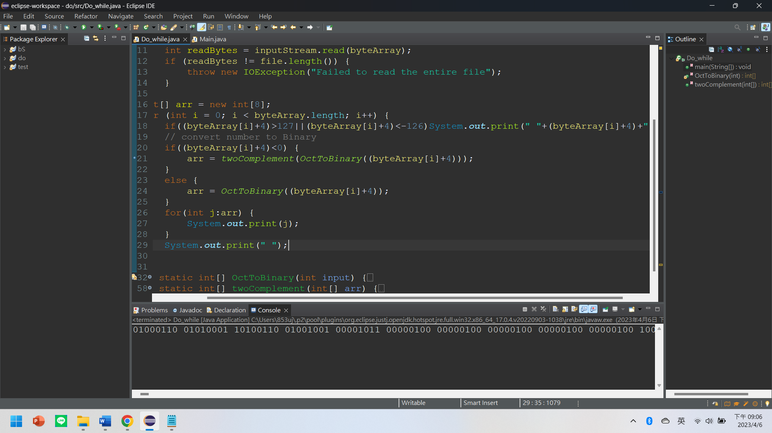

import java.io.File;

import java.io.FileInputStream;

import java.io.IOException;

public class Do_while {

public static void main(String[] args) throws IOException {

File file = new File("Img_File.bmp"); //read file(import java.io.File

byte[] byteArray = new byte[(int) file.length()];

try (FileInputStream inputStream = new FileInputStream(file)) {

int readBytes = inputStream.read(byteArray);

if (readBytes != file.length()) {

throw new IOException("Failed to read the entire file");

}

}

int[] arr = new int[8];

for (int i = 0; i < byteArray.length; i++) {

**if((byteArray[i]+4)>127||(byteArray[i]+4)<-126)System.out.print(" "+(byteArray[i]+4)+" ");**

// convert number to Binary

if((byteArray[i]+4)<0) { //shift 4

arr = twoComplement(OctToBinary((byteArray[i]+4))); //shift 4

}

else {

arr = OctToBinary((byteArray[i]+4)); //shift 4

}

for(int j:arr) {

System.out.print(j);

}

System.out.print(" ");

}

}

public static int[] OctToBinary(int input) {

int num = 0;

int[] arr = new int[8];

int[] arrRev = new int[8];

for(int i = 0; i<8 ; i++) {

arr[i] = 0;

}

int j = 0;

while(input!=0) {

if(input % 2 == 0) {

input = input/2;

j++;

}

else {

arr[j] = 1;

input = input/2;

j++;

}

}

int p=8;

for(int i=0;i<8;i++) {

arrRev[p-1]=arr[i];

p = p-1;

}

return arrRev;

}

public static int[] twoComplement(int[] arr) {

for(int i=0; i<8 ; i++) {

if(arr[i]>0) {

arr[i] = 0;

}

else {

arr[i] = 1;

}

}

int carry = 1;

for(int i=7; i>=0 ; i--) {

arr[i] = arr[i] + carry;

if(arr[i]>1) {

arr[i] = 0;

}

else {

break;

}

}

return arr;

}

}

**版本3：將bmp寫入BmpBinary.txt**

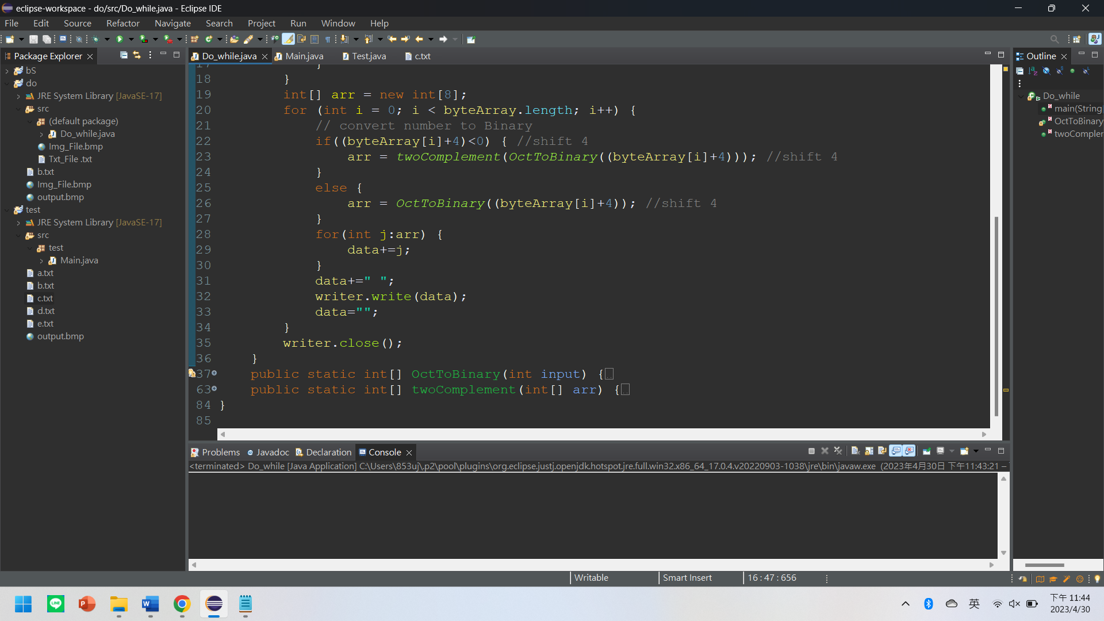

import java.io.File;

import java.io.FileInputStream;

import java.io.FileWriter;

import java.io.IOException;

public class Do_while {

public static void main(String[] args) throws IOException {

File file = new File("Img_File.bmp"); //read file(import java.io.File

FileWriter writer = new FileWriter("BmpBinary.txt");

String data ="";

byte[] byteArray = new byte[(int) file.length()];

try (FileInputStream inputStream = new FileInputStream(file)) {

int readBytes = inputStream.read(byteArray);

if (readBytes != file.length()) {

throw new IOException("Failed to read the entire file");

}

}

int[] arr = new int[8];

for (int i = 0; i < byteArray.length; i++) {

// convert number to Binary

if((byteArray[i]+4)<0) { //shift 4

arr = twoComplement(OctToBinary((byteArray[i]+4))); //shift 4

}

else {

arr = OctToBinary((byteArray[i]+4)); //shift 4

}

for(int j:arr) {

data+=j;

}

data+=" ";

writer.write(data);

data="";

}

writer.close();

}

public static int[] OctToBinary(int input) {

int num = 0;

int[] arr = new int[8];

int[] arrRev = new int[8];

for(int i = 0; i<8 ; i++) {

arr[i] = 0;

}

int j = 0;

while(input!=0) {

if(input % 2 == 0) {

input = input/2;

j++;

}

else {

arr[j] = 1;

input = input/2;

j++;

}

}

int p=8;

for(int i=0;i<8;i++) {

arrRev[p-1]=arr[i];

p = p-1;

}

return arrRev;

}

public static int[] twoComplement(int[] arr) {

for(int i=0; i<8 ; i++) {

if(arr[i]>0) {

arr[i] = 0;

}

else {

arr[i] = 1;

}

}

int carry = 1;

for(int i=7; i>=0 ; i--) {

arr[i] = arr[i] + carry;

if(arr[i]>1) {

arr[i] = 0;

}

else {

break;

}

}

return arr;

}

}

**版本4：將BmpBinary.txt轉回ASCII**

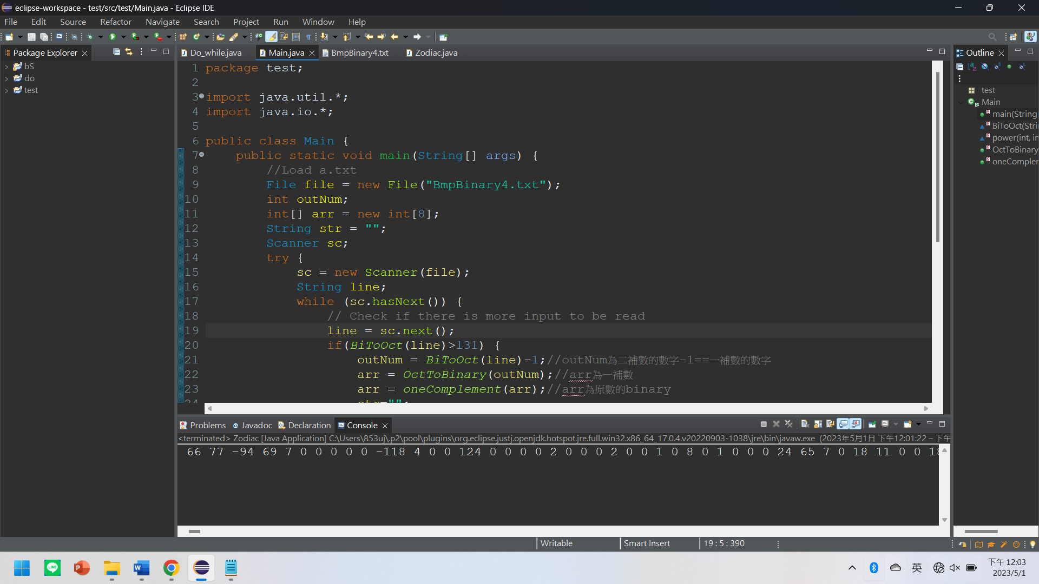

package test;

import java.util.*;

import java.io.*;

public class Main {

public static void main(String[] args) {

//Load a.txt

File file = new File("BmpBinary4.txt");

int outNum;

int[] arr = new int[8];

String str = "";

Scanner sc;

try {

sc = new Scanner(file);

String line;

while (sc.hasNext()) {

// Check if there is more input to be read

line = sc.next();

if(BiToOct(line)>131) {

outNum = BiToOct(line)-1;//outNum為二補數的數字-1==一補數的數字

arr = OctToBinary(outNum);//arr為一補數

arr = oneComplement(arr);//arr為原數的binary

str="";

for(int i=0;i<8;i++){

str = str + arr[i] + "";

}

System.out.print(-(BiToOct(str))-4);

}

else {

System.out.print(BiToOct(line)-4);

}

System.out.print(" ");

}

sc.close();

} catch (FileNotFoundException e) {

System.out.print("Stop");

}

}

static int BiToOct(String str){

int i,output = 0,str_len;

str_len = str.length();

char[] s=new char[16];

for(int j=0;j < str_len ; j++) {

s[j]=str.charAt(j);

}

for(i = 0 ; i < str_len ; i++)

{

output+= (s[i]-'0') * power(2,str_len-i-1);

}

return output;

}

static int power(int x,int y){

int i;

int result = x;

if(y==0)

return 1;

for(i=1;i<y;i++)

result*=x;

return result;

}

public static int[] OctToBinary(int input) {

int[] arr = new int[8];

int[] arrRev = new int[8];

for(int i = 0; i<8 ; i++) {

arr[i] = 0;

}

int j = 0;

while(input!=0) {

if(input % 2 == 0) {

input = input/2;

j++;

}

else {

arr[j] = 1;

input = input/2;

j++;

}

}

int p=8;

for(int i=0;i<8;i++) {

arrRev[p-1]=arr[i];

p = p-1;

}

return arrRev;

}

public static int[] oneComplement(int[] arr) {

for(int i=0; i<8 ; i++) {

if(arr[i]>0) {

arr[i] = 0;

}

else {

arr[i] = 1;

}

}

return arr;

}

}

**版本4：將Img_File.bmp每byte右移4後寫入output.bmp**

**!!! BMP檔Header共34bytes，所以右移header後的bytes就好!!!**

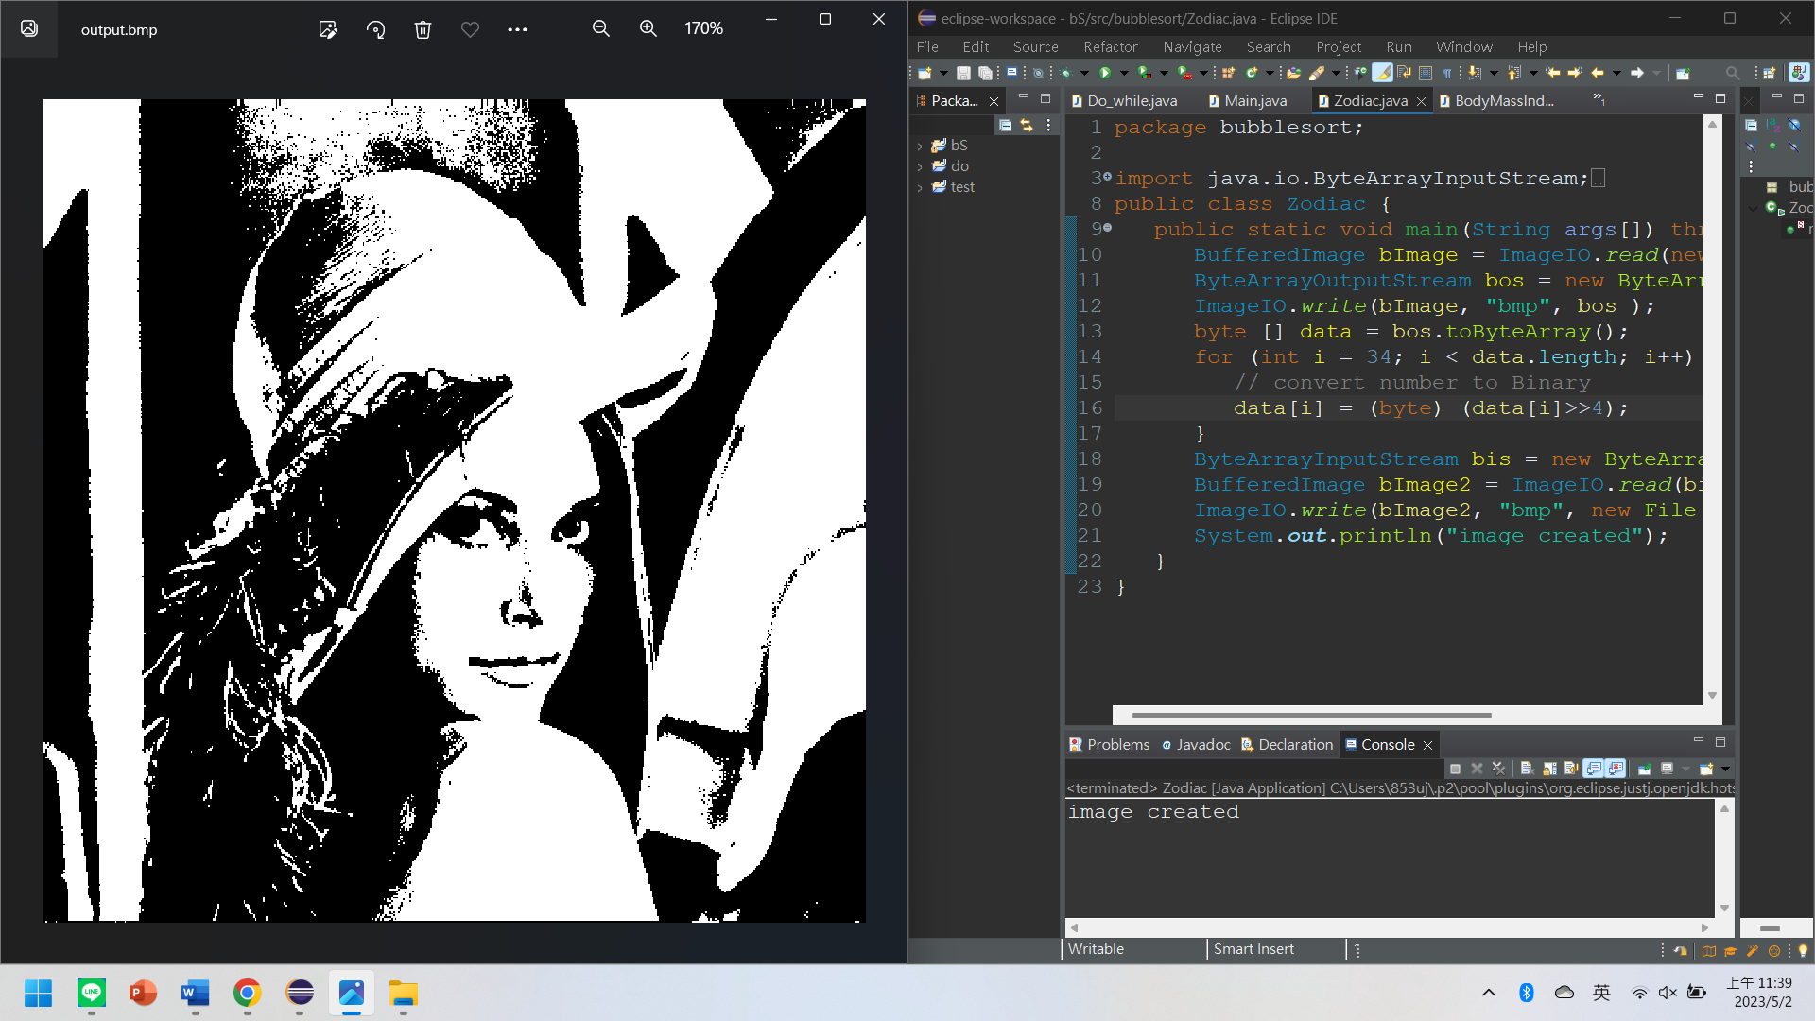

package bubblesort;

import java.io.ByteArrayInputStream;

import java.io.ByteArrayOutputStream;

import java.awt.image.BufferedImage;

import java.io.File;

import javax.imageio.ImageIO;

public class Zodiac {

public static void main(String args[]) throws Exception {

BufferedImage bImage = ImageIO.read(new File("Img_File.bmp"));

ByteArrayOutputStream bos = new ByteArrayOutputStream();

ImageIO.write(bImage, "bmp", bos );

byte [] data = bos.toByteArray();

for (int i = **34**; i < data.length; i++) {

// convert number to Binary

data[i] = (byte) (data[i]>>4);

}

ByteArrayInputStream bis = new ByteArrayInputStream(data);

BufferedImage bImage2 = ImageIO.read(bis);

ImageIO.write(bImage2, "bmp", new File("output.bmp") );

System.out.println("image created");

}

}