**版本1：將原先a.txt to binary加上binary write to b.txt再加上印出b.txt的結果**

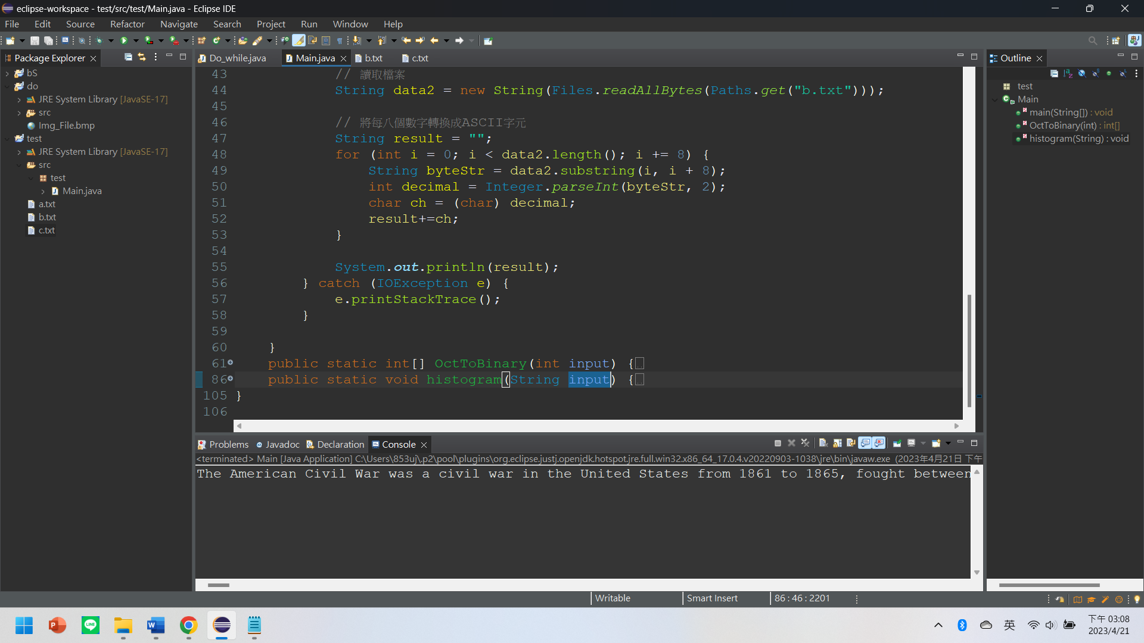

package test;

import java.util.*;

import java.io.*;

import java.nio.file.Files;

import java.nio.file.Paths;

public class Main {

public static void main(String[] args) {

//Load a.txt

File file = new File("a.txt");

String data = "";

Scanner sc;

try {

sc = new Scanner(file);

String line;

while (sc.hasNext()) {

// Check if there is more input to be read

line = sc.nextLine();

int[] arr = new int[8];

for (int i = 0; i < line.length(); i++) {

// convert character to ASCII code and OctToBinary

arr= OctToBinary((int)line.charAt(i));

for(int j:arr) {

data+=j;

}

}

}

sc.close();

} catch (FileNotFoundException e) {

System.out.print("Stop");

}

//Write to b.txt

try {

FileWriter writer = new FileWriter("b.txt");

writer.write(data);

writer.close();

} catch (IOException e) {

e.printStackTrace();

}

//b.txt binaryToOct

try {

// 讀取檔案

String data2 = new String(Files.readAllBytes(Paths.get("b.txt")));

// 將每八個數字轉換成ASCII字元

String result = "";

for (int i = 0; i < data2.length(); i += 8) {

String byteStr = data2.substring(i, i + 8);

int decimal = Integer.parseInt(byteStr, 2);

char ch = (char) decimal;

result+=ch;

}

System.out.println(result);

} catch (IOException e) {

e.printStackTrace();

}

}

public static int[] OctToBinary(int input) {

int[] arr = new int[8];

int[] arrRev = new int[8];

for(int i = 0; i<8 ; i++) {

arr[i] = 0;

}

int j = 0;

while(input!=0) {

if(input % 2 == 0) {

input = input/2;

j++;

}

else {

arr[j] = 1;

input = input/2;

j++;

}

}

int p=8;

for(int i=0;i<8;i++) {

arrRev[p-1]=arr[i];

p = p-1;

}

return arrRev;

}

public static void histogram(String input) {

System.out.print("請輸入英文字串：");

int[] freq = new int[128]; // 0-127 為ASCII code 的範圍

for (int i = 0; i < input.length(); i++) {

char ch = input.charAt(i);

freq[ch]++;

}

for (int i = 0; i < freq.length; i++) {

if (freq[i] > 0) {

System.out.print((char) (i+4) +"("+(int) i+")"+ ":\t");

for (int j = 0; j < freq[i]; j++) {

System.out.print("*");

}

System.out.println();

}

}

}

}

**版本2：Shift 4 (空格變$)**

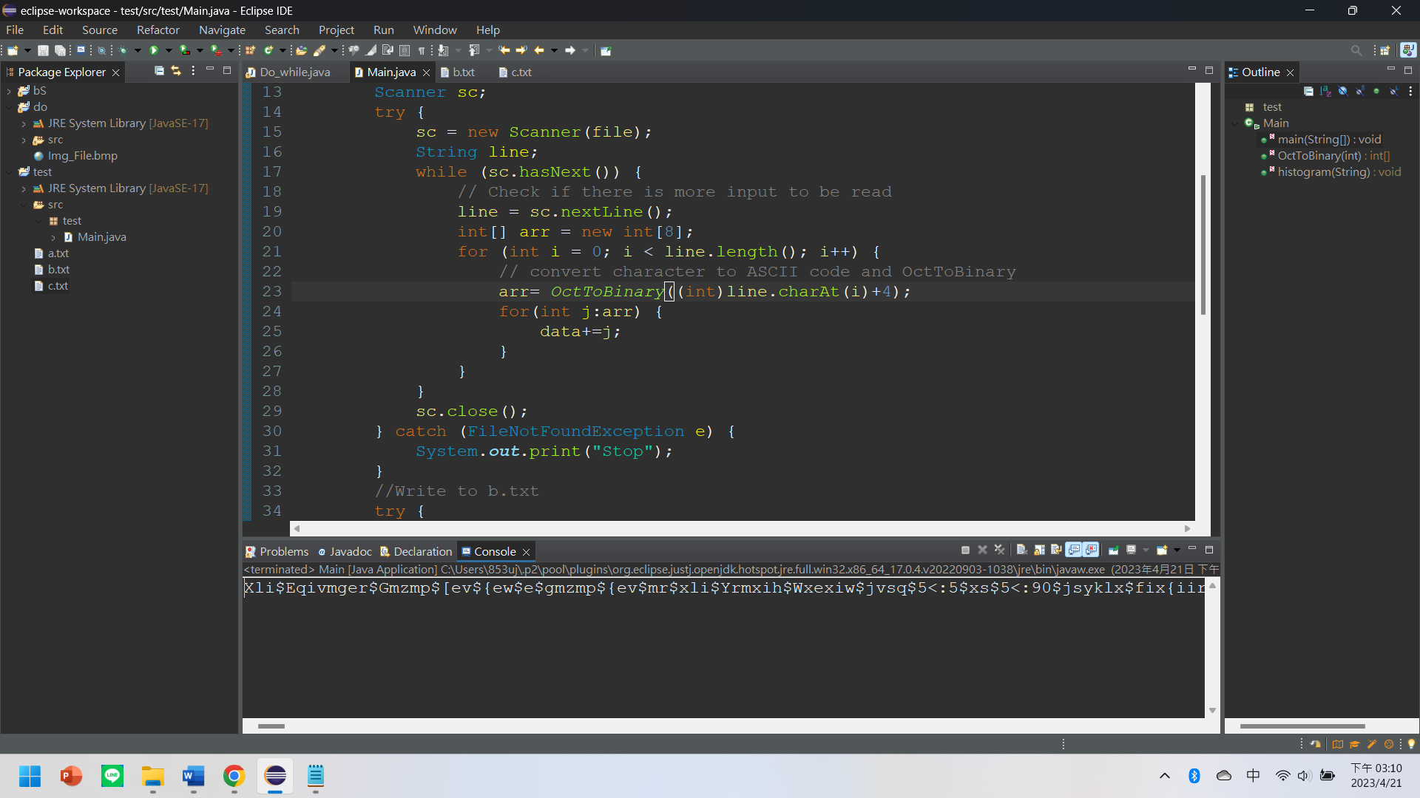

arr= *OctToBinary*((int)line.charAt(i)+4);

**版本3：Shift 4的結果放入c.txt (所以a.txt原文 b.txt二進位 c.txt加4)**

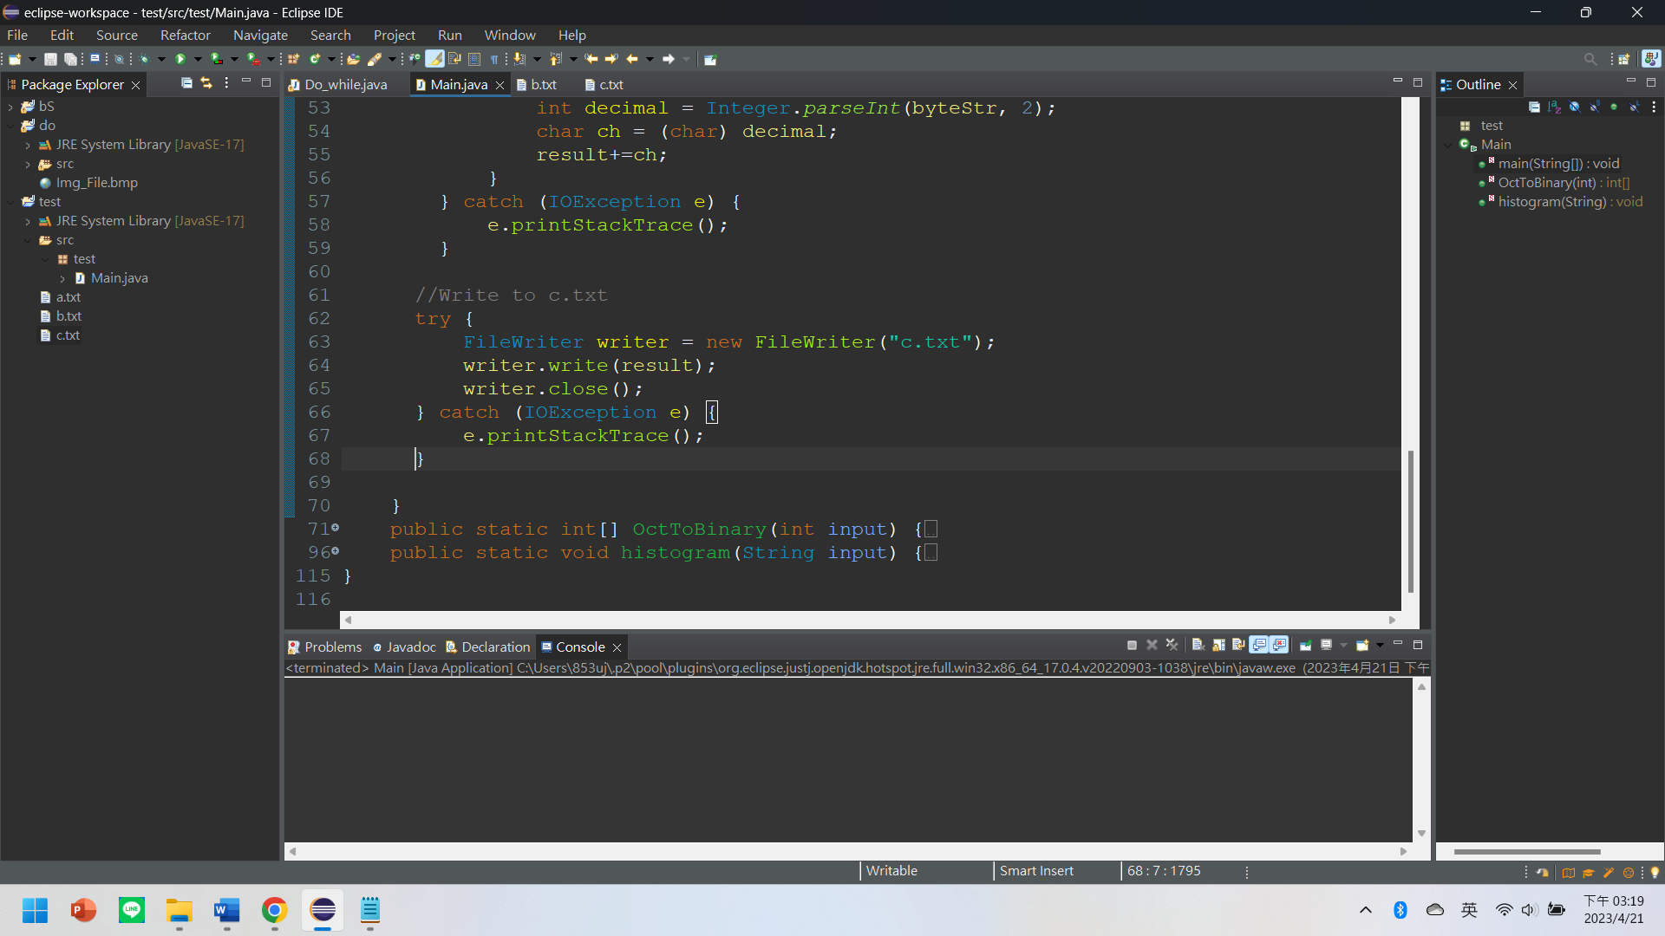

package test;

import java.util.*;

import java.io.*;

import java.nio.file.Files;

import java.nio.file.Paths;

public class Main {

public static void main(String[] args) {

//Load a.txt

File file = new File("a.txt");

String data = "";

Scanner sc;

try {

sc = new Scanner(file);

String line;

while (sc.hasNext()) {

// Check if there is more input to be read

line = sc.nextLine();

int[] arr = new int[8];

for (int i = 0; i < line.length(); i++) {

// convert character to ASCII code and OctToBinary

arr= OctToBinary((int)line.charAt(i)+4);

for(int j:arr) {

data+=j;

}

}

}

sc.close();

} catch (FileNotFoundException e) {

System.out.print("Stop");

}

//Write to b.txt

try {

FileWriter writer = new FileWriter("b.txt");

writer.write(data);

writer.close();

} catch (IOException e) {

e.printStackTrace();

}

//b.txt binaryToASCII

String result = "";

try {

// 讀取檔案

String data2 = new String(Files.readAllBytes(Paths.get("b.txt")));

// 將每八個數字轉換成ASCII字元(Use SubString)

for (int i = 0; i < data2.length(); i += 8) {

String byteStr = data2.substring(i, i + 8);

int decimal = Integer.parseInt(byteStr, 2);

char ch = (char) decimal;

result+=ch;

}

} catch (IOException e) {

e.printStackTrace();

}

//Write to c.txt

try {

FileWriter writer = new FileWriter("c.txt");

writer.write(result);

writer.close();

} catch (IOException e) {

e.printStackTrace();

}

}

public static int[] OctToBinary(int input) {

int[] arr = new int[8];

int[] arrRev = new int[8];

for(int i = 0; i<8 ; i++) {

arr[i] = 0;

}

int j = 0;

while(input!=0) {

if(input % 2 == 0) {

input = input/2;

j++;

}

else {

arr[j] = 1;

input = input/2;

j++;

}

}

int p=8;

for(int i=0;i<8;i++) {

arrRev[p-1]=arr[i];

p = p-1;

}

return arrRev;

}

public static void histogram(String input) {

System.out.print("請輸入英文字串：");

int[] freq = new int[128]; // 0-127 為ASCII code 的範圍

for (int i = 0; i < input.length(); i++) {

char ch = input.charAt(i);

freq[ch]++;

}

for (int i = 0; i < freq.length; i++) {

if (freq[i] > 0) {

System.out.print((char) (i+4) +"("+(int) i+")"+ ":\t");

for (int j = 0; j < freq[i]; j++) {

System.out.print("*");

}

System.out.println();

}

}

}

}