**分別將經過加密所得Txt及原文當成字串輸入Histogram.java得**

import java.io.File;

import java.io.FileWriter;

import java.io.IOException;

import java.util.Scanner;

public class Histogram{

public static void main(String[] args) throws IOException {

File file = new File("c.txt"); //read file(import java.io.File

FileWriter writer = new FileWriter("TxtHistogramShift.txt");

String data ="",str="";

Scanner sc;

sc = new Scanner(file);

data = sc.nextLine();

int[] freq = new int[128]; // 0-127 為ASCII code 的範圍

for (int i = 0; i < data.length(); i++) {

char ch = data.charAt(i);

freq[ch]++;

}

for (int i = 0; i < freq.length; i++) {

if (freq[i] > 0) {

str = (char) i +"("+(int) i+")"+ ":\t";

writer.write(str);

str = "";

for (int j = 0; j < freq[i]/10; j++) {

str = ".";

writer.write(str);

str = "";

}

str = "\n";

writer.write(str);

str = "";

}

}

writer.close();

}

}

**Cipher text**

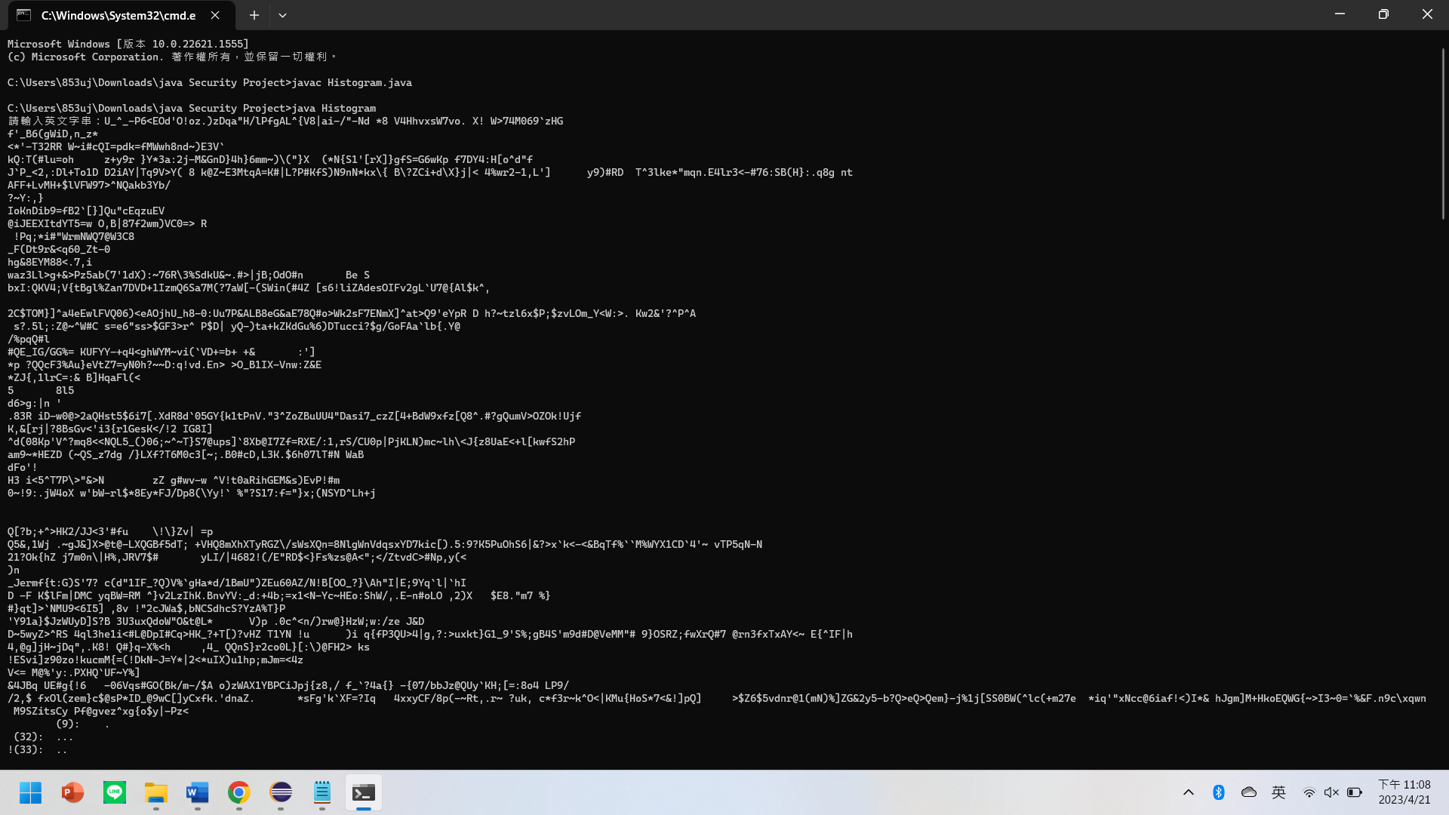

**Plain Text**

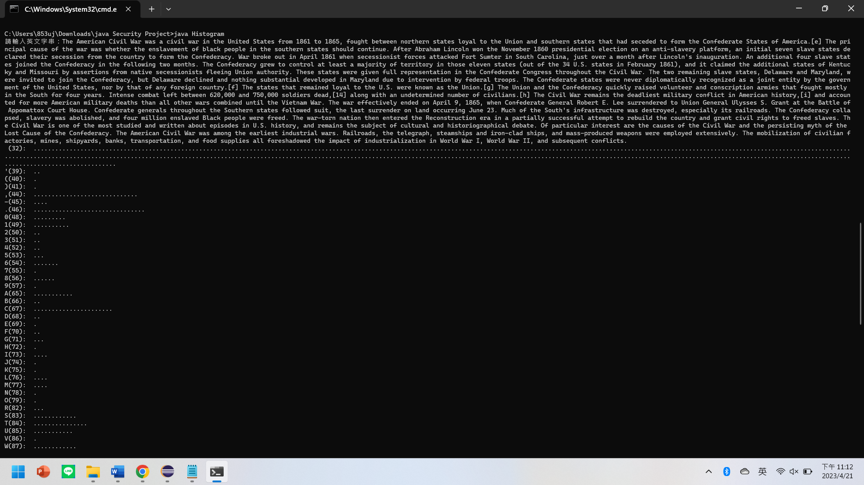

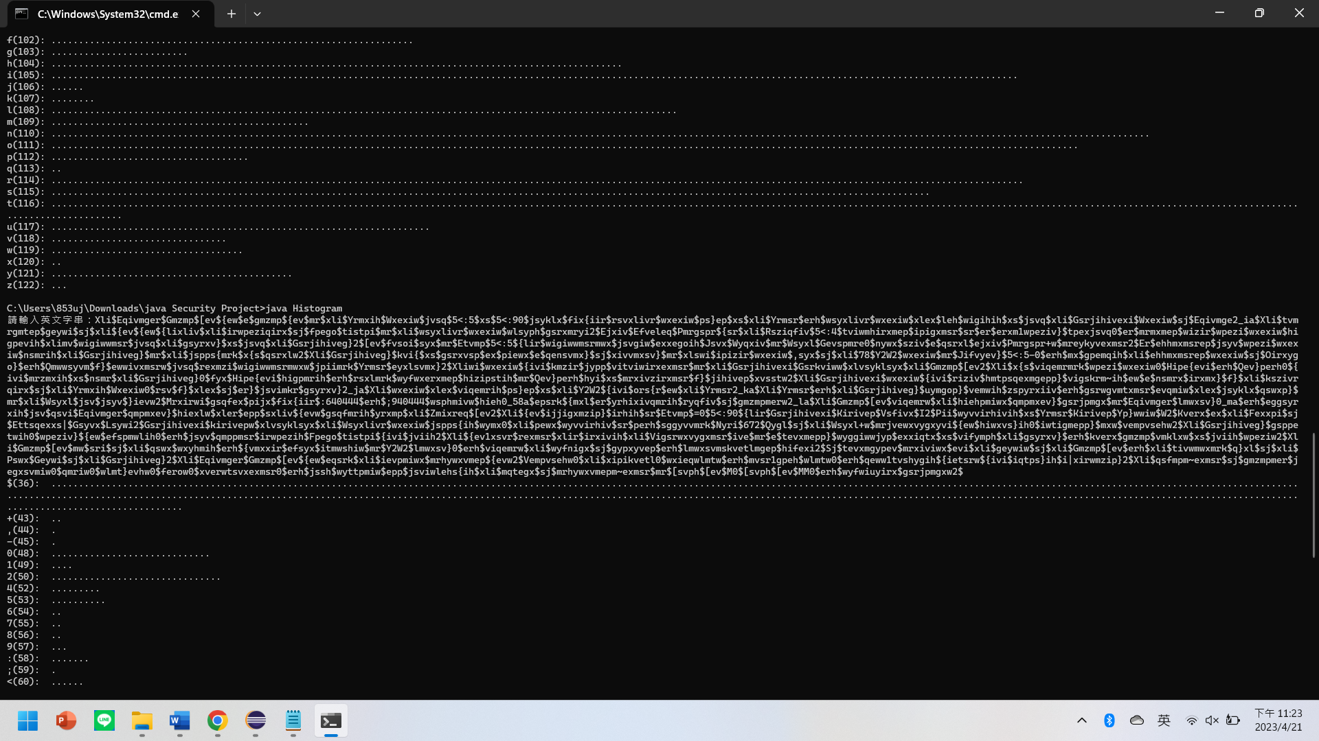

**Shift 4 text**

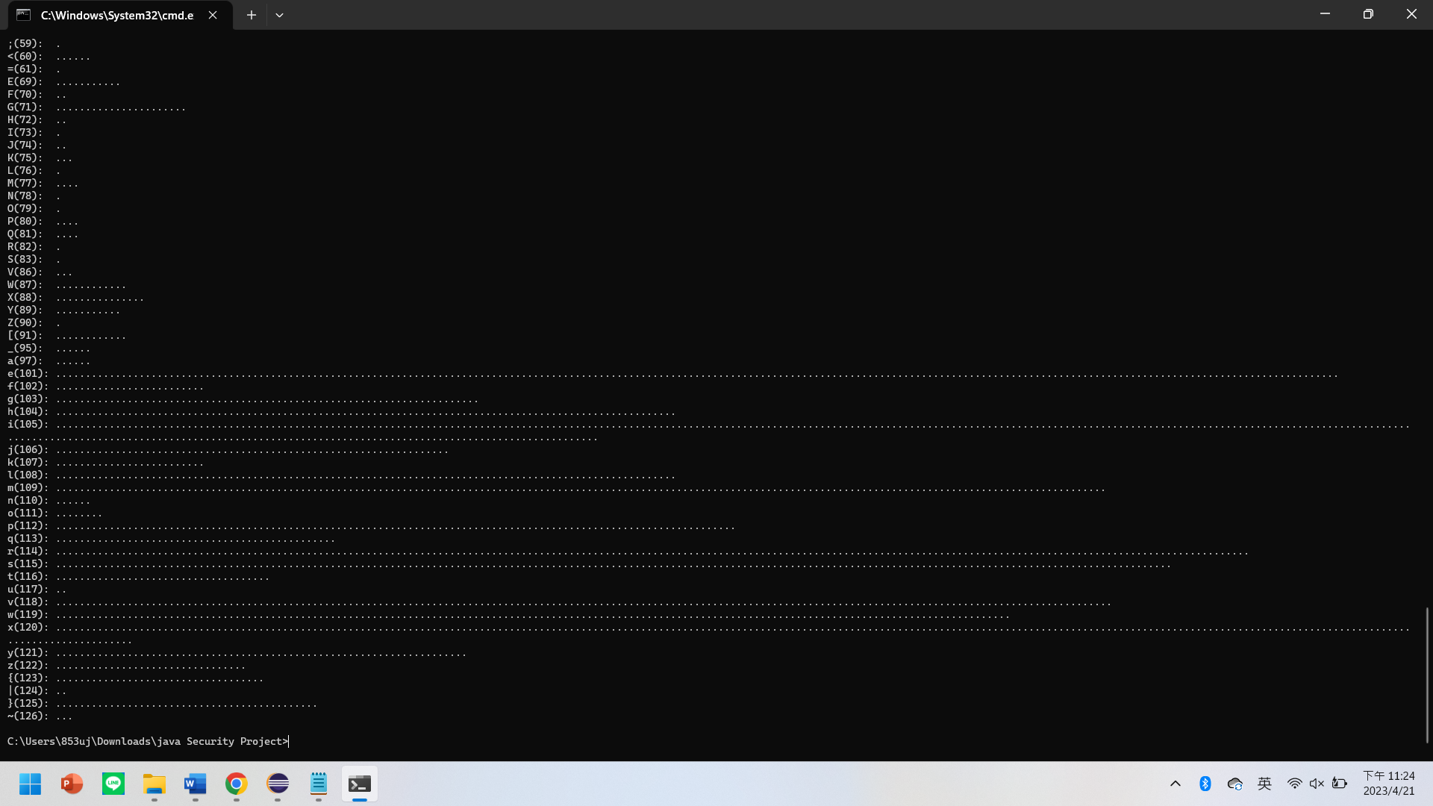

**BMP Histogram Generator.java**

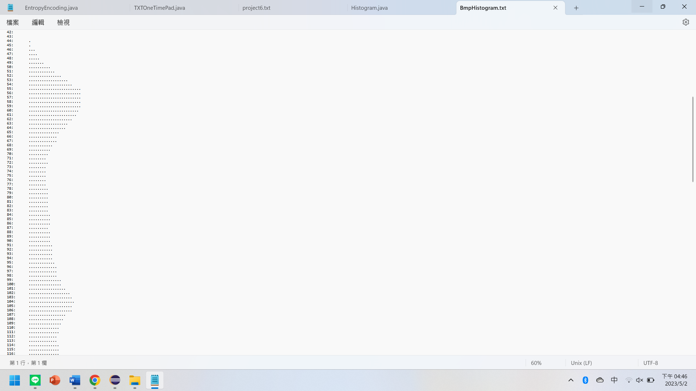

**import java.util.*;**

**import java.io.*;**

**public class Do_while{**

**public static void main(String[] args) throws FileNotFoundException, IOException {**

**File file = new File("Img_File.bmp");**

**FileWriter writer = new FileWriter("BmpHistogram.txt");**

**String data ="";**

**byte[] byteArray = new byte[(int) file.length()];**

**try (FileInputStream inputStream = new FileInputStream(file)) {**

**int readBytes = inputStream.read(byteArray);**

**if (readBytes != file.length()) {**

**throw new IOException("Failed to read the entire file");**

**}**

**}**

**int[] freq = new int[256]; // 0-127 為ASCII code 的範圍**

**for (int i = 0; i < file.length(); i++) {**

**int ch = byteArray[i];**

**if(ch<0) {**

**ch = (-ch) + 127;**

**freq[ch]++;**

**}**

**else {**

**freq[ch]++;**

**}**

**}**

**for (int i = 0; i < freq.length; i++) {**

**if (freq[i] > 0) {**

**if(i>127) {**

**data = (-(i-127)) + ":\t";**

**writer.write(data);**

**for (int j = 0; j < freq[i]/100; j++) {**

**data = ".";**

**writer.write(data);**

**}**

**data = "\n";**

**writer.write(data);**

**}**

**else {**

**data= i + ":\t";**

**writer.write(data);**

**for (int j = 0; j < freq[i]/100; j++) {**

**data = ".";**

**writer.write(data);**

**}**

**data = "\n";**

**writer.write(data);**

**}**

**}**

**}**

**writer.close();**

**}**

**}**

**BMP Shift4 Histogram Generator.java**

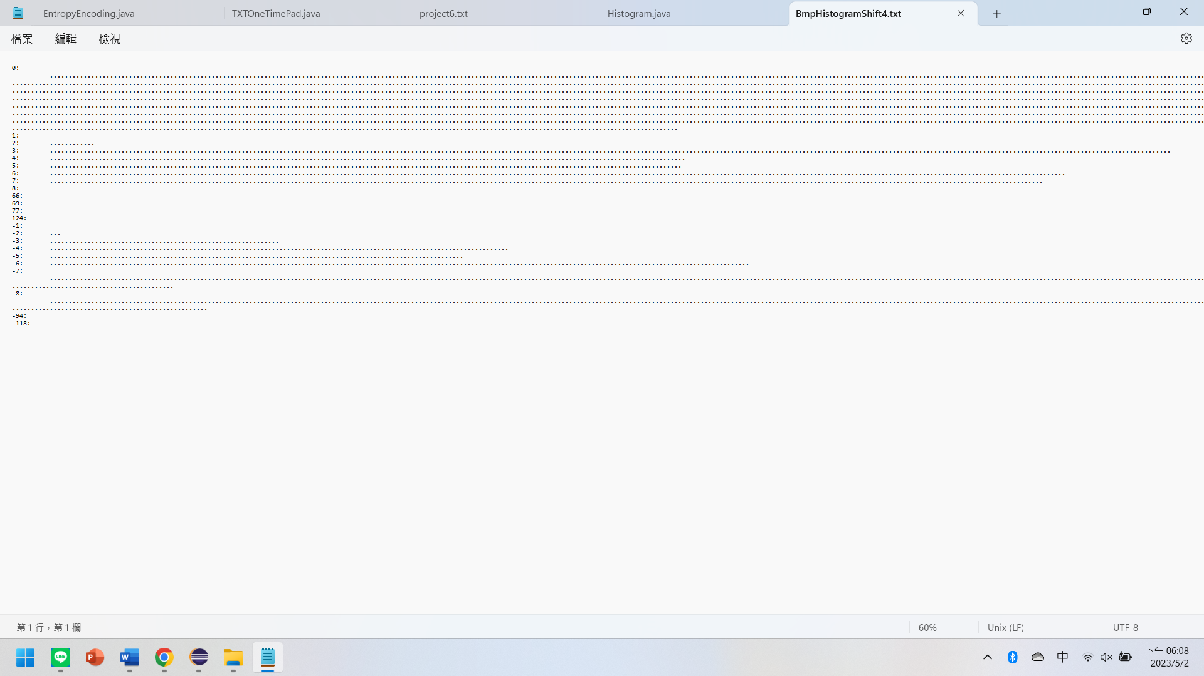

**import java.util.*;**

**import java.io.*;**

**public class Do_while{**

**public static void main(String[] args) throws FileNotFoundException, IOException {**

**File file = new File("Img_File.bmp");**

**FileWriter writer = new FileWriter("BmpHistogramShift4.txt");**

**String data ="";**

**byte[] byteArray = new byte[(int) file.length()];**

**try (FileInputStream inputStream = new FileInputStream(file)) {**

**int readBytes = inputStream.read(byteArray);**

**if (readBytes != file.length()) {**

**throw new IOException("Failed to read the entire file");**

**}**

**}**

**for (int i = 34; i < byteArray.length; i++) {**

**// convert number to Binary**

**byteArray[i] = (byte) (byteArray[i]>>4);**

**}**

**int[] freq = new int[256]; // 0-127 為ASCII code 的範圍**

**for (int i = 0; i < file.length(); i++) {**

**int ch = byteArray[i];**

**if(ch<0) {**

**ch = (-ch) + 127;**

**freq[ch]++;**

**}**

**else {**

**freq[ch]++;**

**}**

**}**

**for (int i = 0; i < freq.length; i++) {**

**if (freq[i] > 0) {**

**if(i>127) {**

**data = (-(i-127)) + ":\t";**

**writer.write(data);**

**for (int j = 0; j < freq[i]/100; j++) {**

**data = ".";**

**writer.write(data);**

**}**

**data = "\n";**

**writer.write(data);**

**}**

**else {**

**data= i + ":\t";**

**writer.write(data);**

**for (int j = 0; j < freq[i]/100; j++) {**

**data = ".";**

**writer.write(data);**

**}**

**data = "\n";**

**writer.write(data);**

**}**

**}**

**}**

**writer.close();**

**}**

**}**