
Co-hosted by:
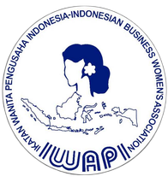
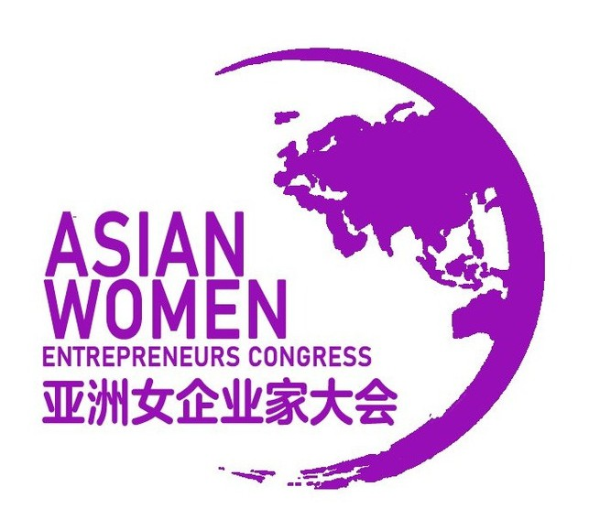

I W B I F 2 0 2 6
I W A P I | I N T E R N A T I O N A L

Women Business & Investment Forum 2026
J a k a r t a | 1 4 - 1 7 O ct o b e r 2 0 2 6
E m p o w e r i n g W o m e n E n t r e p r e n e u r s
T h r o u g h F i n a n c e , G l o b a l C o l l a b o r a t i o n , a n d D i g i t a l T r a n s f o r m a t i o n

1


DELEGATE PACKAGE A

Delegate Package & Participation Fee
2 DAYS EVENTS

USD 500 / Delegate (Twin Sharing Basis)
Additional USD 200 (Additional Suplemen for Single Room for 3 nights)

Inclusive of:
- 3 Nights Sharing Room Accommodation at 5 star hotel Jakarta
- Airport Transfers
- Local Transportation
- Conference Access & Pass to TEI - Trade Expo Indonesia
- 2 times lunch & 2 time Coffee Breaks
- 1 time Welcome Dinner at PIK2
- 1 time Welcome Dinner hosted by Governor of DKI Jakarta
- Jakarta City Tour

IWAPI Womenpreneur Summit 2026 16


DELEGATE PACKAGE B

Delegate Package & Participation Fee
2 DAYS EVENTS

USD 400 / Delegate (Twin Sharing Basis)
Additional USD 150 (Additional Suplemen for Single Room for 3 nights)

Inclusive of:
- 3 Nights Sharing Room Accommodation at 3/4 star hotel Jakarta
- Airport Transfers
- Local Transportation
- Conference Access & Pass to TEI - Trade Expo Indonesia
- 2 times lunch & 2 time Coffee Breaks
- 1 time Welcome Dinner at PIK2
- 1 time Welcome Dinner hosted by Governor of DKI Jakarta
- Jakarta City Tour

IWAPI Womenpreneur Summit 2026 17


DELEGATE PACKAGE (DETAIL)

Delegate Package & Participation Fee
IWBIF 2026 | Jakarta, Indonesia | 14–17 October 2026
14 October 2026 Arrival  - Airport transfer from Soekarno-Hatta International Airport  - Overnight Stay at Hotel, Jakarta | 17 October 2026 Jakarta  - Breakfast at Hotel  - Check out Hotel Jakarta  - Trip to Jababeka  - Airport Transfer to Soekarno - Hatta International Airport
15 October 2026 Jakarta  - Visit to TEI - TRADE EXPO INDONESIA  - Exhibition & Talk Show  - Lunch  - Dinner at Dreamville PIK 2  - Overnight Stay at Hotel, Jakarta | EVENT HIGHLIGHTS   Business Matching Sessions   Conference & Networking Forum  Governor Dinner Reception   Trade Expo Visit
16 October 2026 Jakarta  - Opening Event, Business Matching & Conference  - Buffet lunch & 2 Coffee Breaks at Hotel  - Welcome Dinner hosted by the Governor of DKI Jakarta  - Overnight Stay at Hotel, Jakarta | IMPORTANT NOTES  - Flight tickets are not included  - Passport validity minimum 6 months  - Program subject to minor adjustments  - Hotel check-in/check-out follows hotel policy

IWAPI Womenpreneur Summit 2026 18


DELEGATE PACKAGE ADDITIONAL TRIP BANDUNG

Delegate Package & Participation Fee
2 DAYS EVENTS

USD 200 / Delegate (Twin Sharing Basis)

Inclusive of:
- 2 Nights Sharing Room Accommodation at 4 star hotel Bandung
- Airport Transfers
- Local Transportation
- Meals As the Program
- Destination at Bandung
- Bandung City Tour
- Visiting Jababeka Industry

IWAPI Womenpreneur Summit 2026 4


DELEGATE PACKAGE A BANDUNG

Delegate Package & Participation Fee
IWBIF 2026 | Jakarta- Bandung, Indonesia | 17–18 October 2026
17 October 2026 Jakarta - Bandung
- Check out Hotel Jakarta
- Visit Jababeka Industry
- Transfer to Bandung via Bus
- Dinner at Atmosphere Restaurant
- Overnight Stay at Hotel, Bandung
18 October 2026 Bandung
- Breakfast at Hotel
- Lunch at Aroem / Kapulaga Restaurant
- Visit Cultural Tour Saung Angklung Mangudjo
- City tour Visiting : Gedung Sate & Gedung Merdeka
- Lunch at Braga Permai Restaurant
- Shopping Visit
- Back to Hotel
19 October 2026 Bandung - Jakarta
- Breakfast at hotel
- Check out
- Back to Jakarta
- Transfer out to Soekarno Hatta International Airport

IWAPI Womenpreneur Summit 2026 5

