**Exp1:-**

**Title of the program:-**

Write a program to extract integer character from a string. If no integer is present then print “No integer”.

**Program instruction:-**

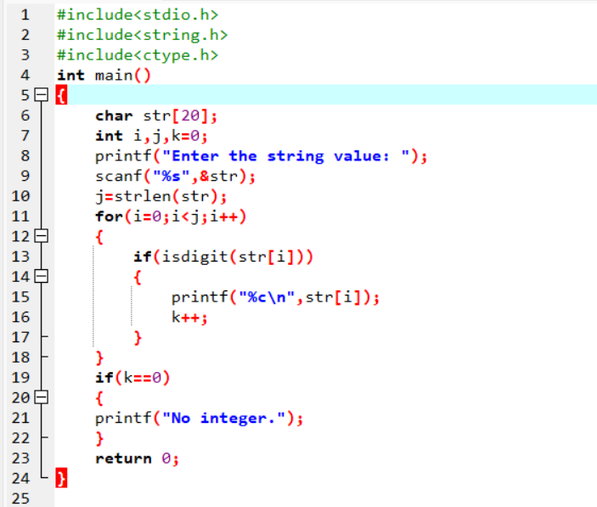

**Output:-**

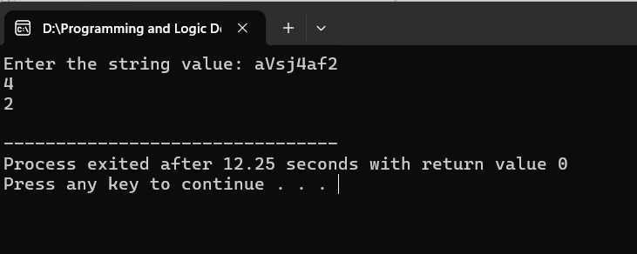

**Exp2:-**

**Title of the program:-**

Write a program to convert lower case string to upper case & vice versa.

**Program instruction:-**

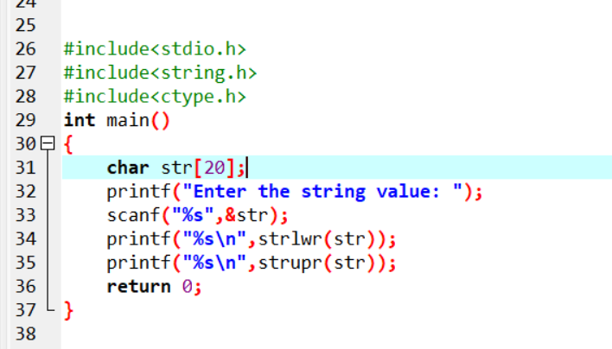

**Output:-**

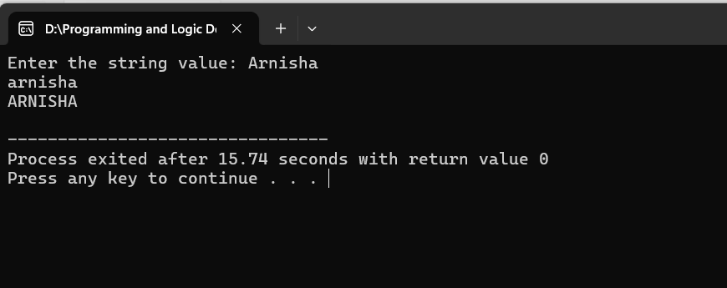

**Exp3:-**

**Title of the program:-**

Write a program to take user name & password from user and compare with pre-assigned values.

If matched print “Login successful” else print “Invalid login”.

**Program instruction:-**

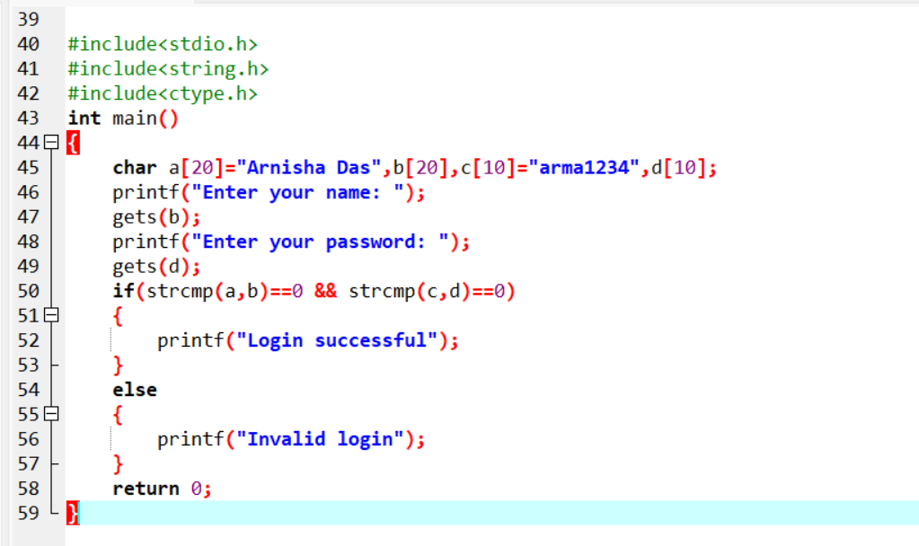

**Output:-**

