**Exp1:-**

**Title of the program:-**

Write a program to find out Armstrong numbers between 1 to 1000.

**Program instruction:-**

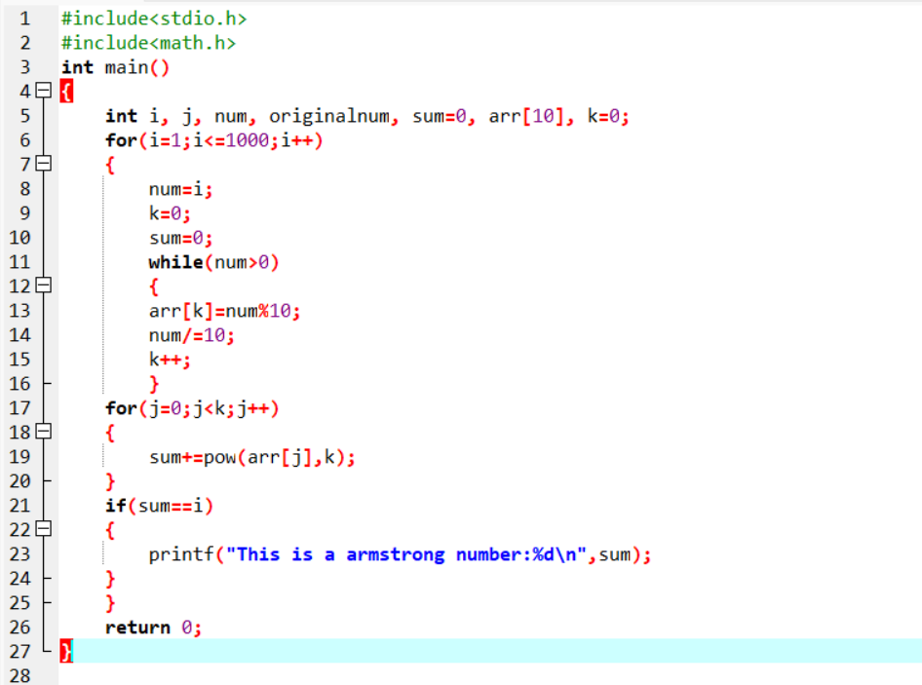

**Output:-**

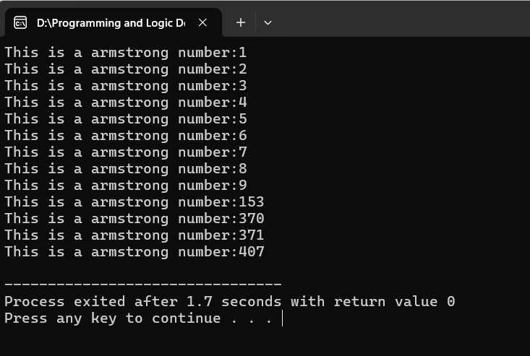

**Exp2:-**

**Title of the program:-**

Write a program to take book details(title,author,edition & acc.no) of 10 books & display the result. If search a book by its acc.no then the other details will be printed.

**Program instruction:-**

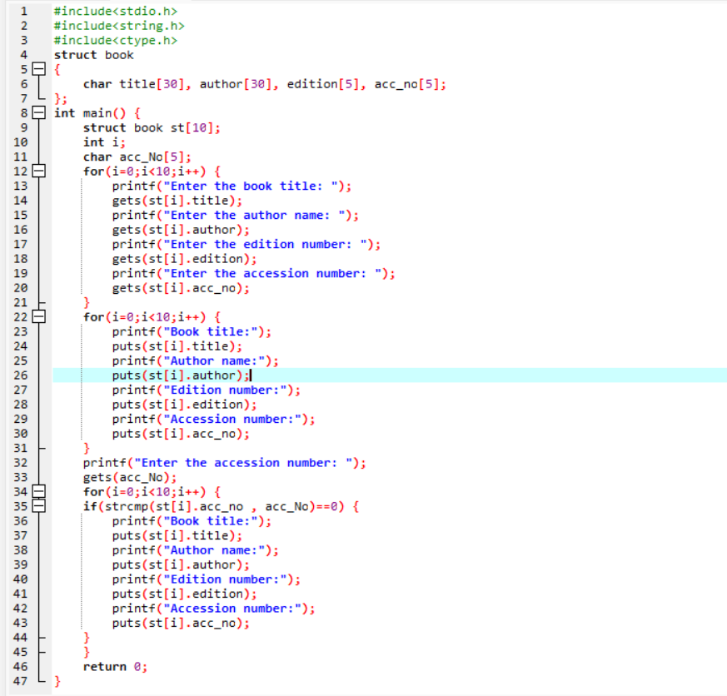

**Output:-**

