**Exp3:-**

**Title of the program:-**

Write a program to compute the GCD & LCM of two numbers. Write the Algorithm of the program.

**Algorithm:-**

**Step 1:-** Take input a, b, gcd, product, lcm

**Step 2:-** Take user input in a, b

**Step 3:-** set product = a * b

**Step 4:-** set gcd = a % b go to step – 5

**Step 5:-** set a =b go to step – 6

**Step 6:-** set b = gcd go to step – 7

**Step 7:-** if (a % b !=0) go to step – 4

else go to step – 8

**Step 8:-** set lcm = product / gcd

**Step 9:-** print gcd

print lcm

**Program instruction:-**

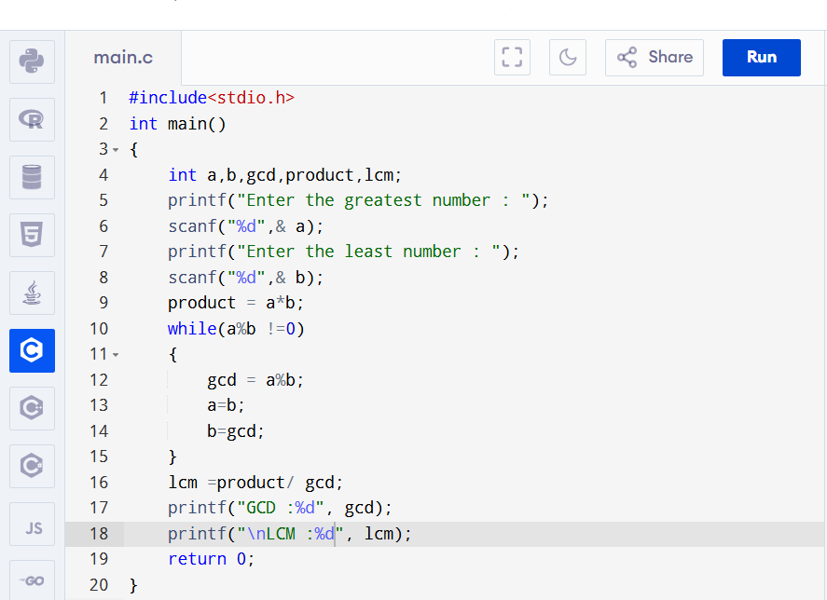

**Output:-**

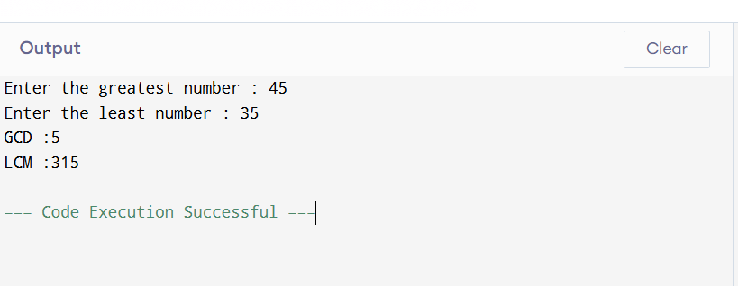

**Exp4:-**

**Title of the program:-**

Write a program to check a 4 digit number to be divisible by 9 or not without using modulus operator. Write the flowchart of the program.

**Flowchart:-**

int n,sum=0,reminder

Take the value of n

reminder=n-(n/10)*10)

n=n/10

if  
n!=0

print The number is divisible by 9

print The number is not divisible by 9

Yes

No

No

Yes

sum=sum+reminder

if  
sum-((sum/9)*9)==0

**Program instruction:-**

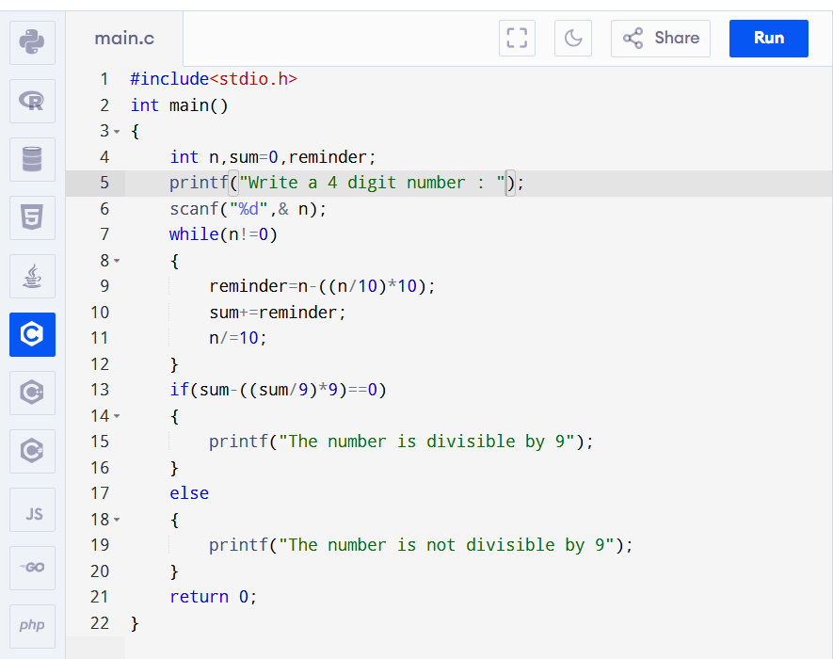

**Output:-**

