**Exp1:-**

**Title of the program:-**

Write a program to compute the factorial of a number. Write the flowchart of the program.

**Flowchart:-**

int n,i=1,product=1

Take the value of n

product=product * i

if i<5

print product

No

Yes

i=I + 1

**Program instruction:-**

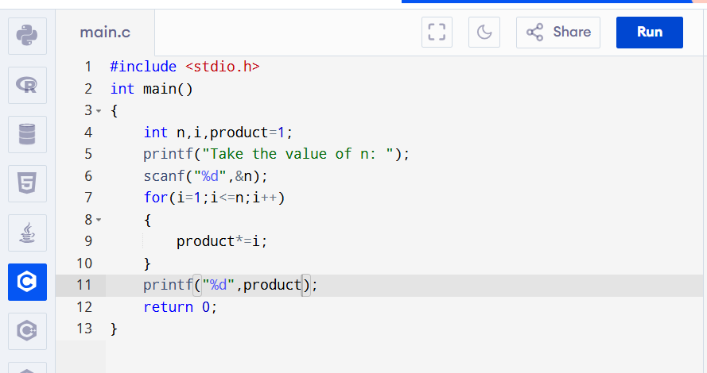

**Output:-**

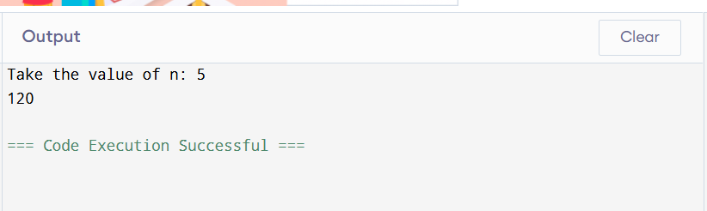

**Exp2:-**

**Title of the program:-**

Write a program to print the Fibonacci series of length 10. Write the flowchart of the program.

**Flowchart:-**

int n, a=1,b=1,sum,i=0

Take the value of n

sum=a+b

if   
i<n

a=b

No

Yes

print a

b=sum

**Program instruction:-**

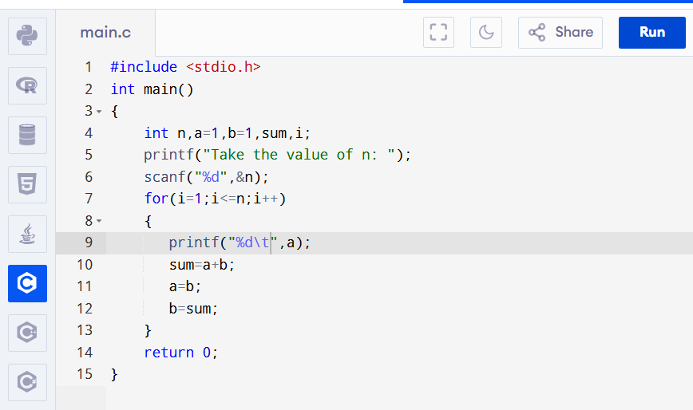

**Output:-**

