**Exp1:-**

**Title of the program:-**

Write a program to compute nCr where n= total number of element & r= number of element selected at random.

**Program instruction:-**

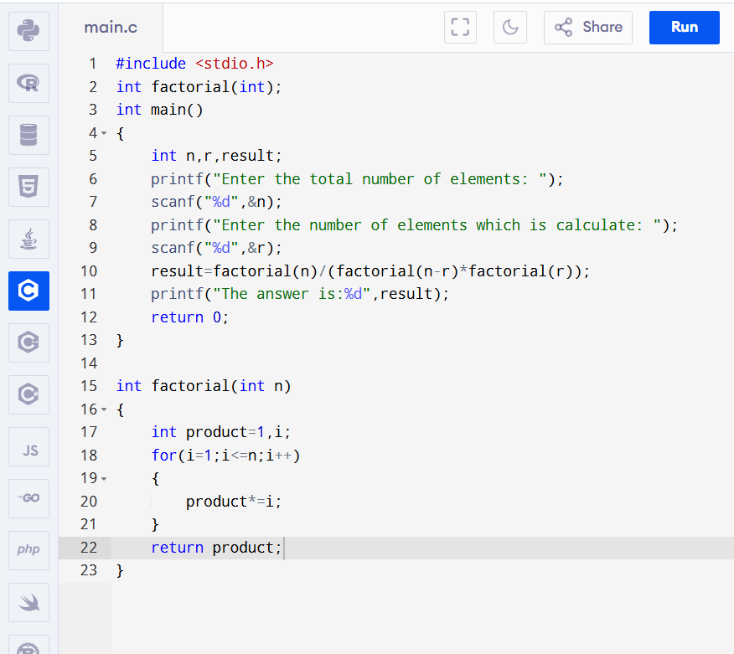

**Output:-**

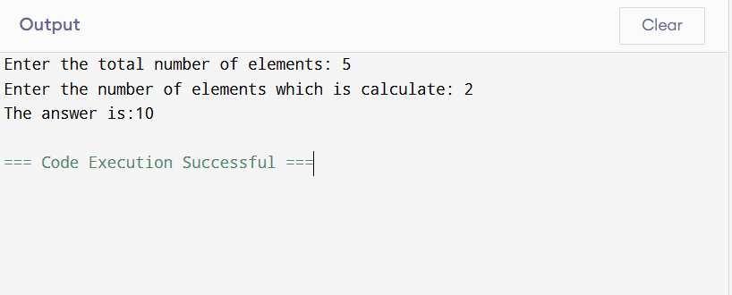

**Exp2:-**

**Title of the program:-**

Write a program to compute the diagonal elements of a 4 X 4 matrix.

**Program instruction:-**

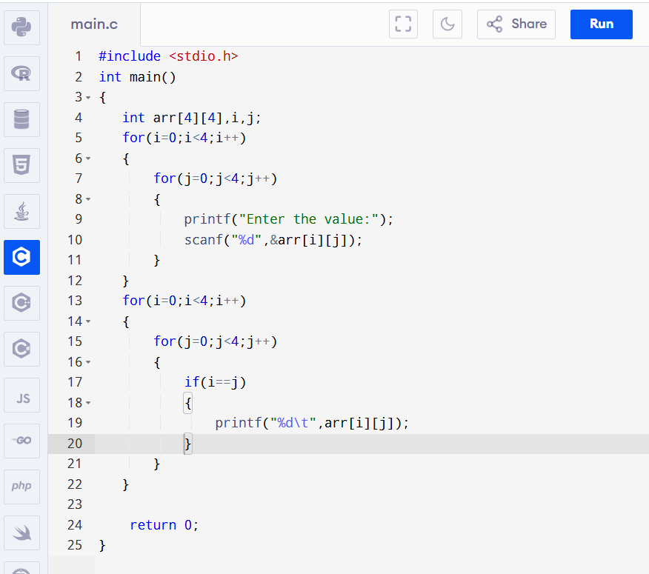

**Output:-**

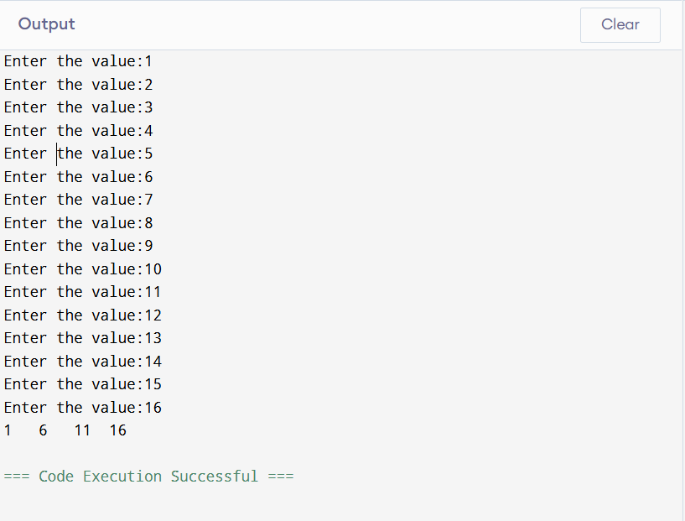

**Exp3:-**

**Title of the program:-**

Write a program to compute the square root of a number A using the formula $x_{n+1}$ = $\frac{1}{2}{(x}_{n}$ + $\frac{A}{x_{n}})$ using iteration where A= number whose square root is computed.

**Program instruction:-**

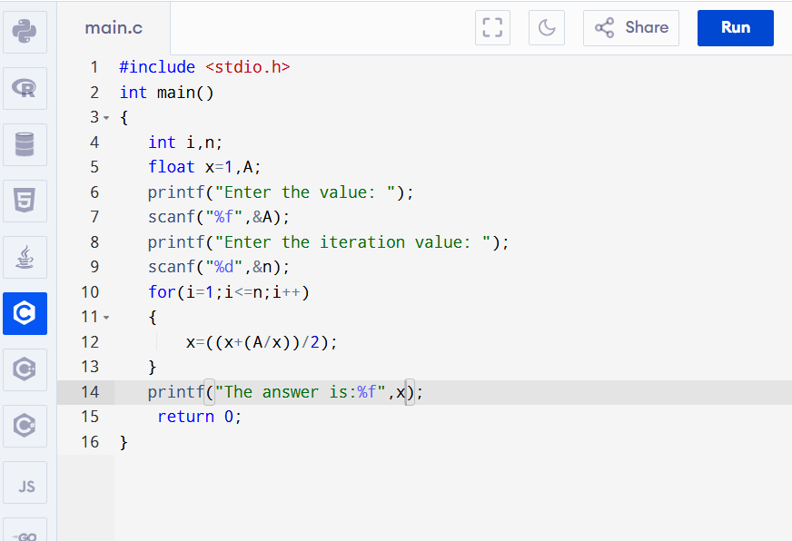

**Output:-**

