**Exp21:-**

**Title of the program:-**

Take two variables x=25 & y= “Hello” in a class with private access specifier. Write a program to update the values of the variables.

**Program instruction:-**

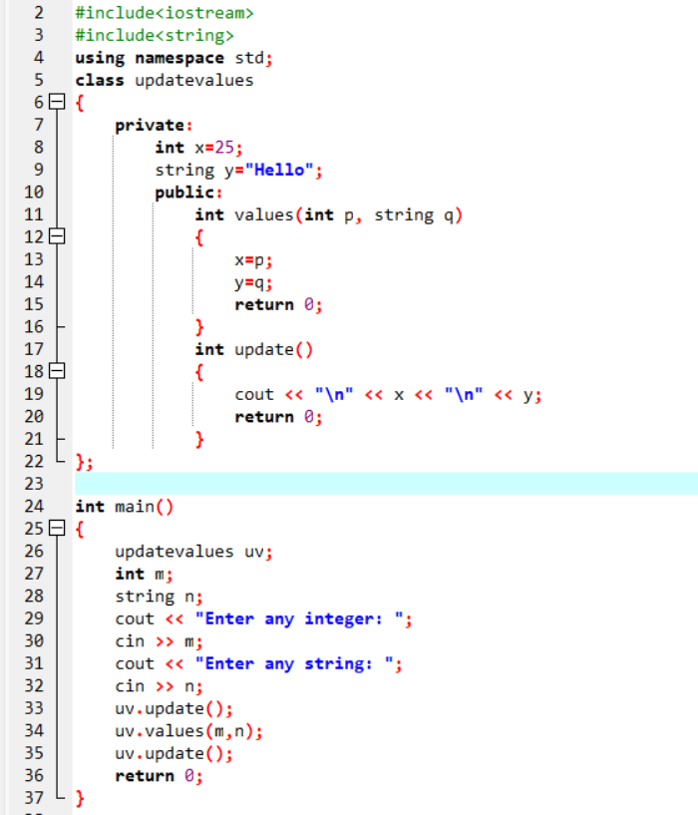

**Output:-**

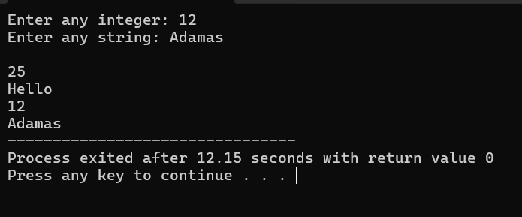

**Exp22:-**

**Title of the program:-**

You have two classes “parent” & “child”. “parent” class has a method “show” which prints “Hello world”. “child” class has a method “display” which prints “How are you?”. Write a program to inherit parent class properties to child class.

**Program instruction:-**

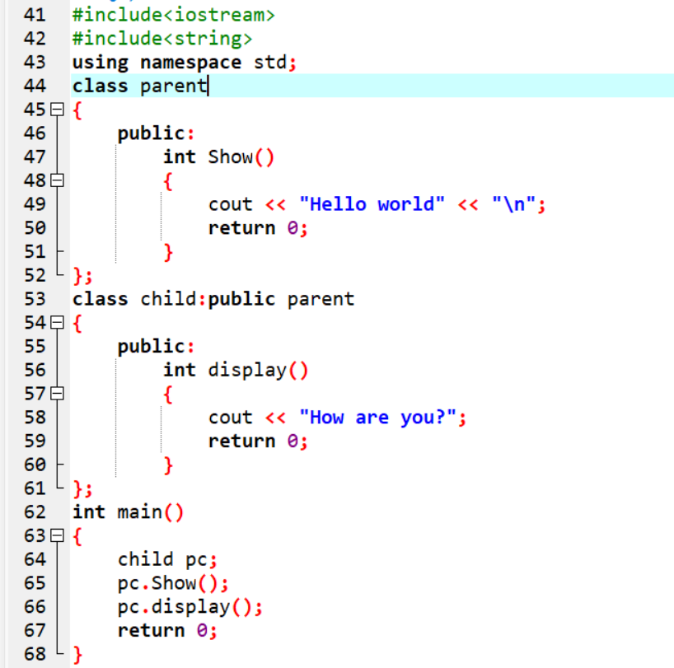

**Output:-**

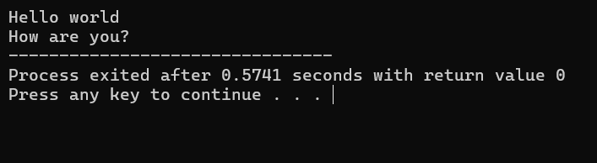

**Exp23:-**

**Title of the program:-**

5 employees have the details (employee name, id, account no. & salary). Take the user input of employees and print them.

**Program instruction:-**

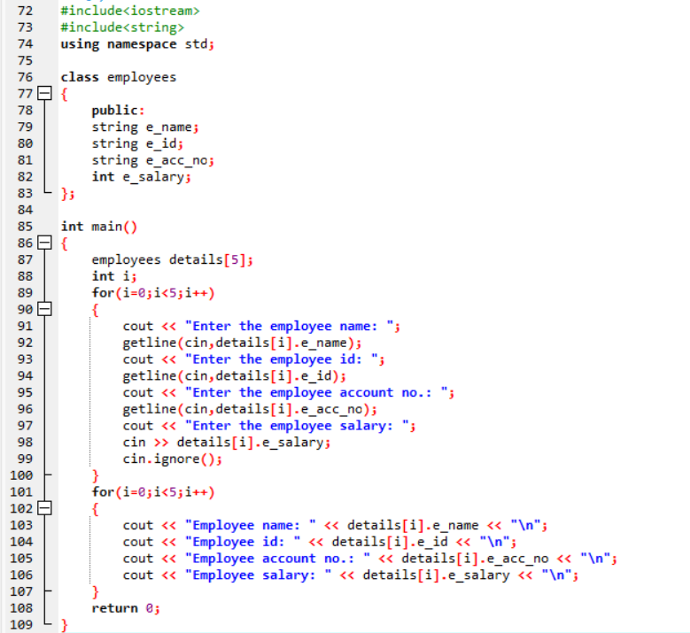

**Output:-**

