**Exp24:-**

**Title of the program:-**

Write a C++ program to check a leap year.

**Program instruction:-**

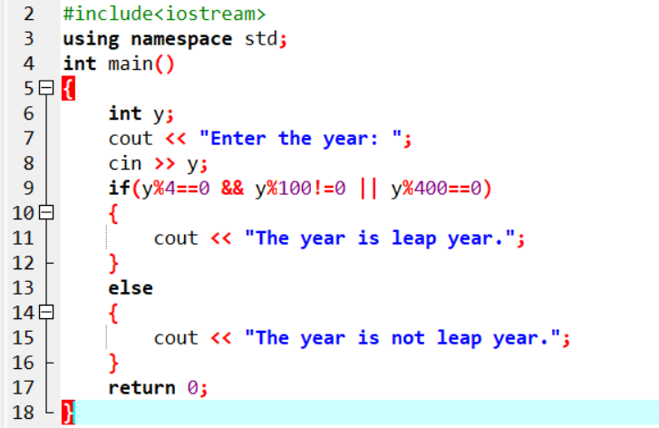

**Output:-**

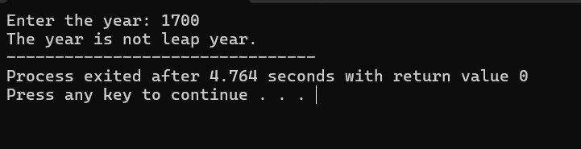

**Exp25:-**

**Title of the program:-**

Write a C++ program to reverse a number.

**Program instruction:-**

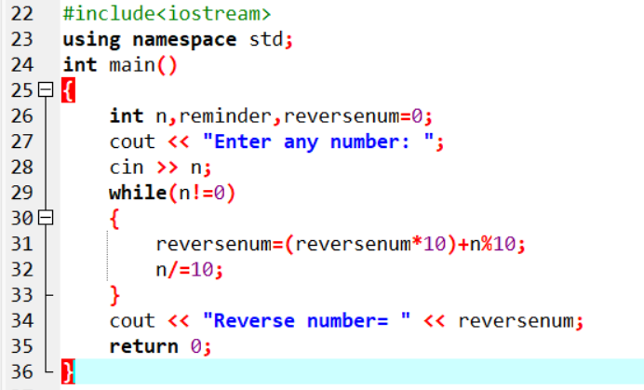

**Output:-**

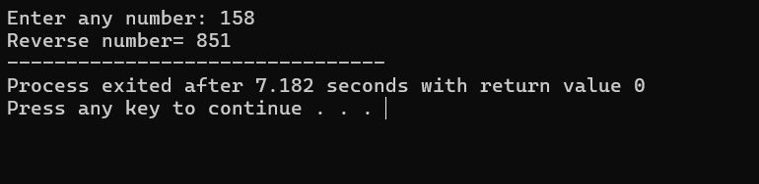

**Exp26:-**

**Title of the program:-**

Write a C++ program to find Harshad number between 1 to 1000(A number is called Harshad number if it is divisible by the sum of its digits).

**Program instruction:-**

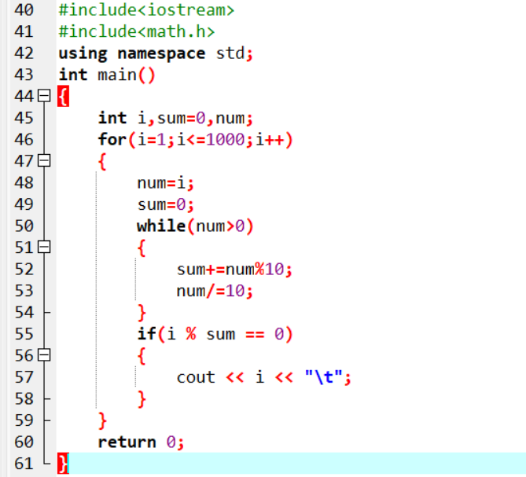

**Output:-**

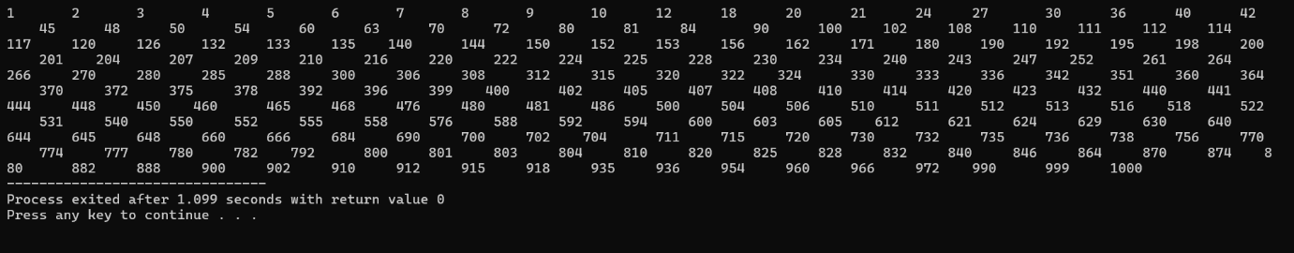

**Exp27:-**

**Title of the program:-**

Write a C++ program to convert a binary sequence to its corresponding decimal number.

**Program instruction:-**

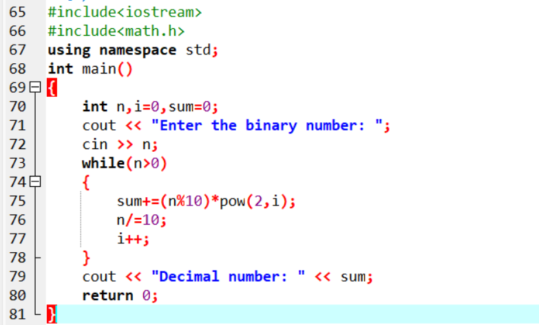

**Output:-**

