**Exp28:-**

**Title of the program:-**

Write a C and C++ program to reverse a string.

**Program instruction:-**

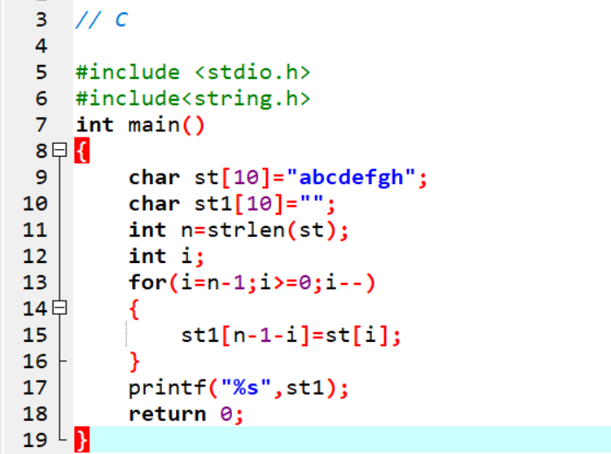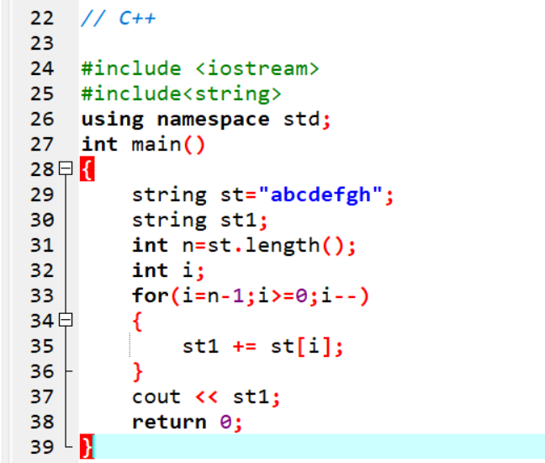

**Output:-**

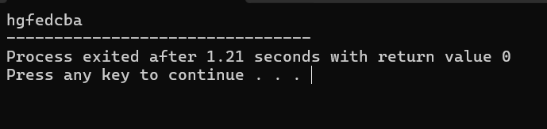

**Exp29:-**

**Title of the program:-**

Configure a list and take 10 integers. Show the elements. Take 2 more integers at the back side and 1 integer at the front side pop two elements at the back side. Show the list again.

**Program instruction:-**

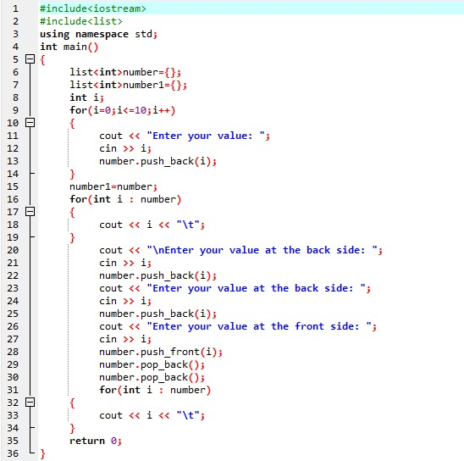

**Output:-**

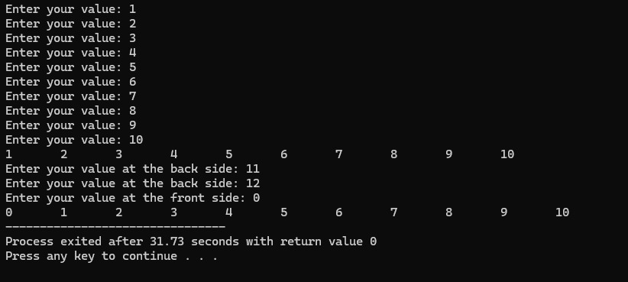

**Exp30:-**

**Title of the program:-**

Configure a stack and take 10 integers. Show the elements. Again take 2 more integers and remove 3 integers show the stack again.

**Program instruction:-**

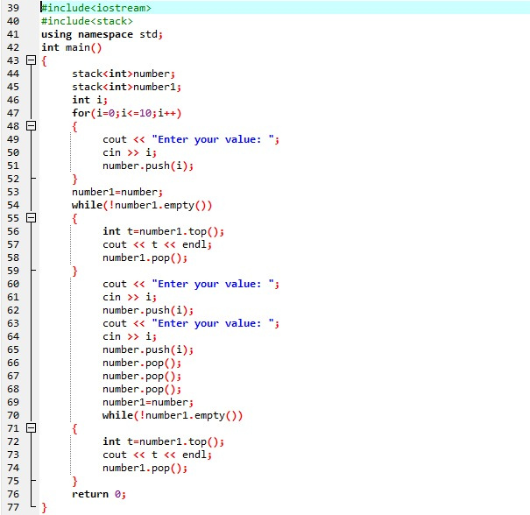

**Output:-**

