Exp21:-
Title of the program:-
Take two variables x=25 & y= “Hello” in a class with private access specifier. Write a program to update the values of the variables.
Program instruction:-
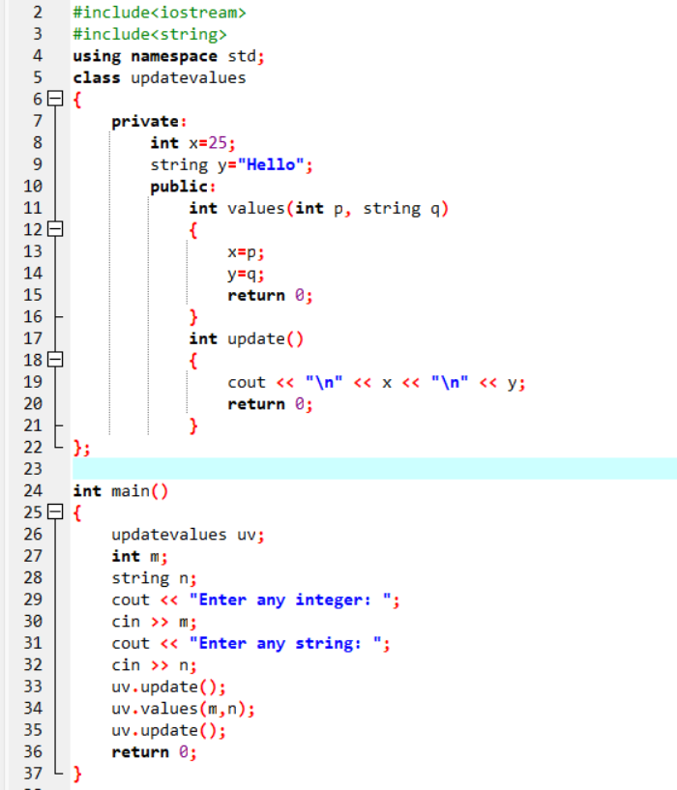
Output:-

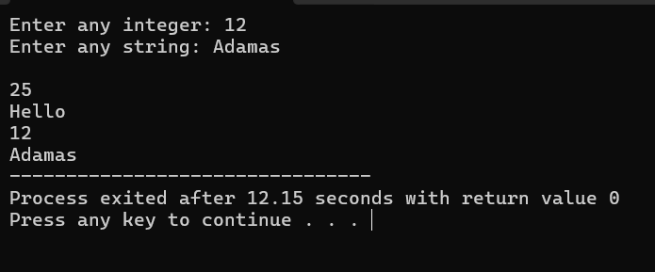
Exp22:-
Title of the program:-
You have two classes “parent” & “child”. “parent” class has a method “show” which prints “Hello world”. “child” class has a method “display” which prints “How are you?”. Write a program to inherit parent class properties to child class.
Program instruction:-

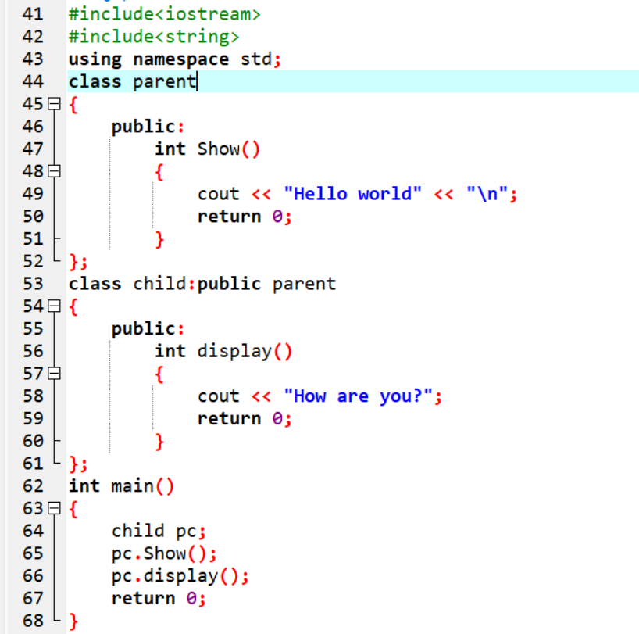

Output:-

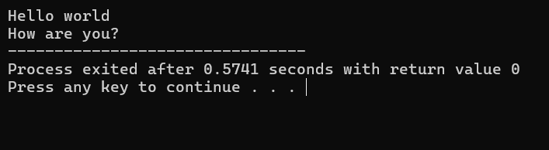

Exp23:-
Title of the program:-
5 employees have the details (employee name, id, account no. & salary). Take the user input of employees and print them.
Program instruction:-

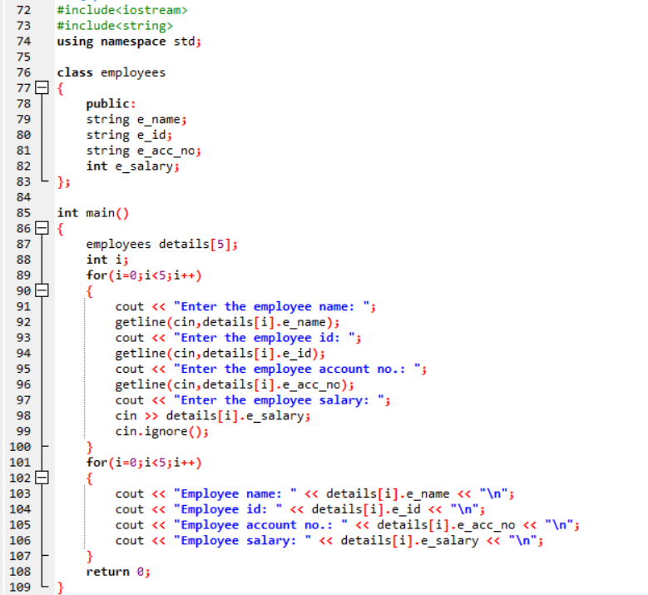

Output:-

