Exp28:-
Title of the program:-
Write a C and C++ program to reverse a string.
Program instruction:-
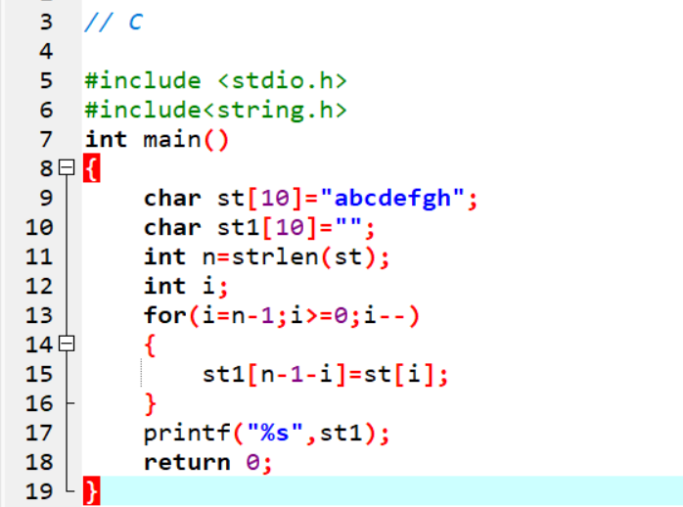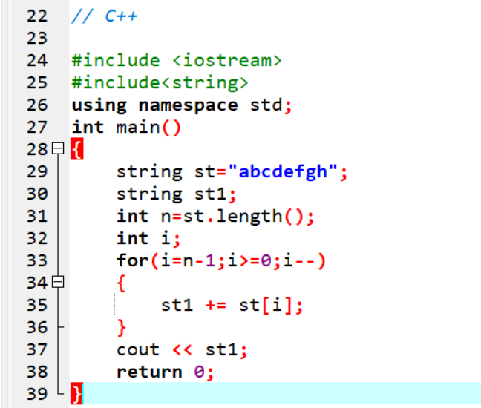
Output:-

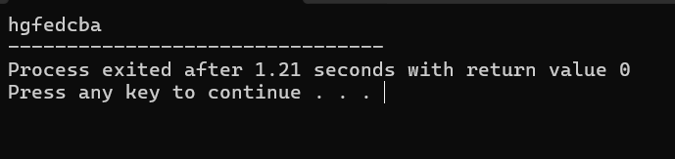

Exp29:-
Title of the program:-
Configure a list and take 10 integers. Show the elements. Take 2 more integers at the back side and 1 integer at the front side pop two elements at the back side. Show the list again.
Program instruction:-

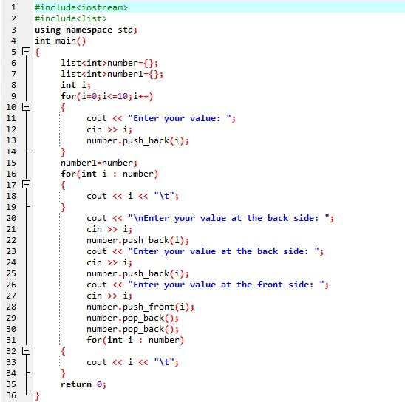

Output:-
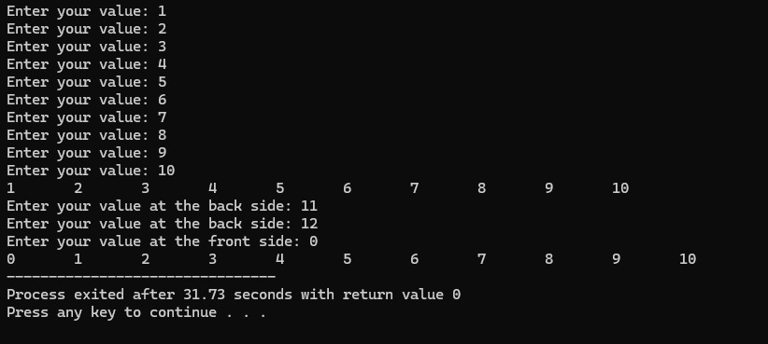

Exp30:-
Title of the program:-
Configure a stack and take 10 integers. Show the elements. Again take 2 more integers and remove 3 integers show the stack again.
Program instruction:-

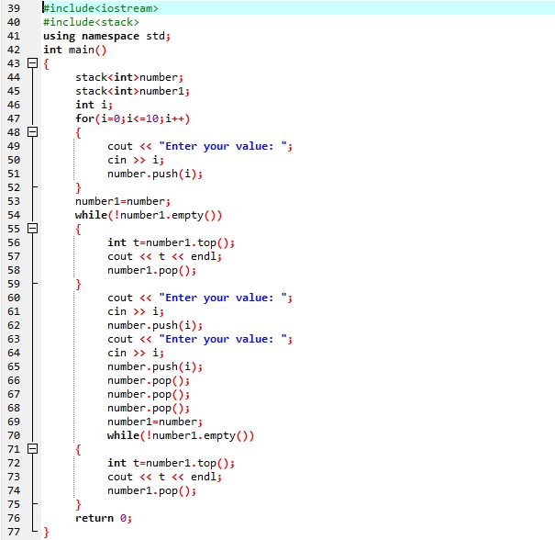
Output:-

