ILPD dataset
Univariate EDA
The ILPD dataset actually contains all total 11 columns likewise
Age
Gender
Total Bilirubine
Direct Bilirubine
Alkaline Phosphotase
Alamine Aminotransferase
Aspartate Aminotransferase
Total Proteins
Albumin
Albumin & Globulin Ratio
Selector (Result)
Now you may think that what is the dataset all about, well, the dataset is about the disease Liver Cirrhosis, and the columns provided here are the responsible factors of this disease.
So allover this dataset contains 583 entries, i.e. 583 different patient’s data is stored in the dataset.
EDA:
So here we plotted the boxplots for each and every column which are as follows
Age:
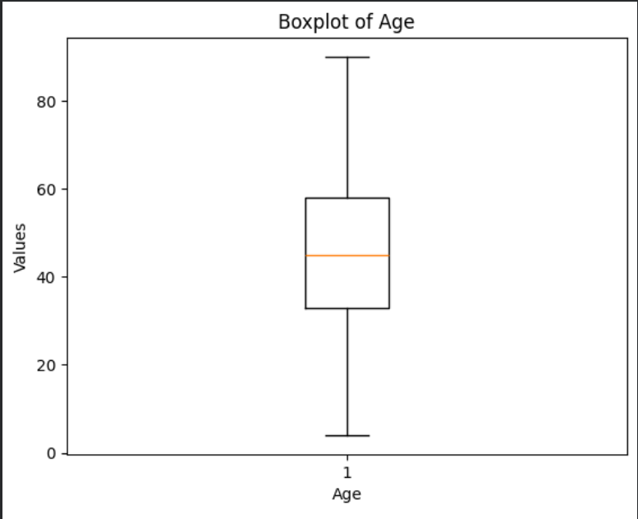
As we can see patient from every age group are included here starting from 10-11 years (single digit age is also included here) upto 90+ years, but in most entries, the ages are between 35 – 58 (IQR range/50% of the data resides from range) and also the median is almost 45 as it is the central value of age distribution. In the distribution the most frequent age for a patient is 60 (mode).
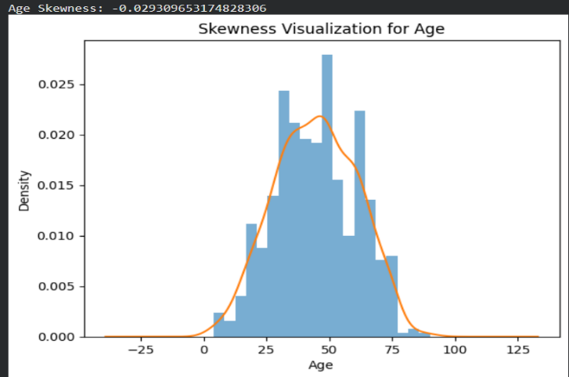
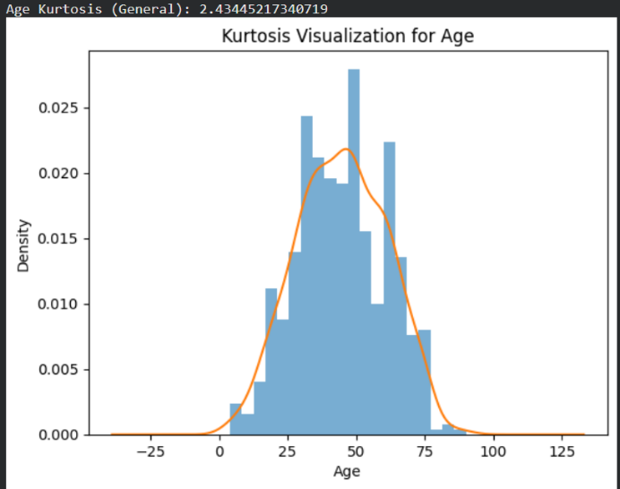

Here is the histogram plot of age along with density curve.
In case of skewness we can definitely tell it’s an almost balanced distribution (not ideally) as the median (45) and mean (44.74) are almost same, i.e. the age is almost evenly distributed throughout the distribution.
For kurtosis also, even though the middle values of ages are very high, still not enough to be outliers (as the range of this column is widespread). So practically there is not much outliers and it’s a more even distribution, but theoretically (from kurtosis calculation formula) there are some points which can be treated as outlier.

Total_Bilirubin:
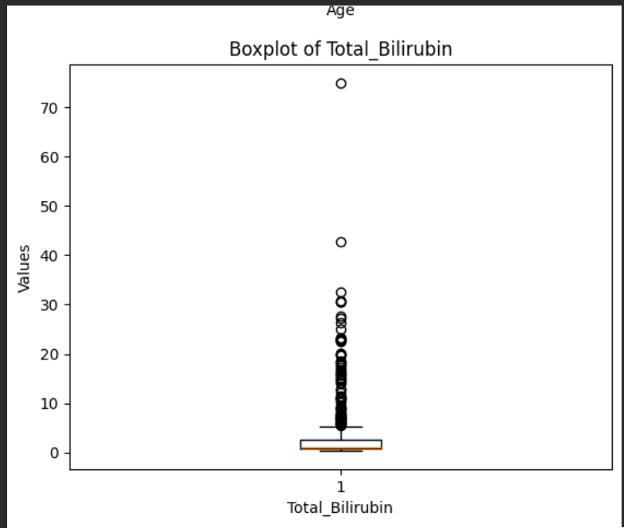
As from this boxplot, we can see that there are multiple outlier values present in the distribution. Actually as the general distribution values are very less (the box and whiskers took very less space), so that the entries with higher values treated as outliers. That’s why you can see the difference between mean (3.298) and median (1.00) because of their uneven distribution.
Here according to the boxplot the values lie between 0.5 to 6-7 (app.) from which most of the values lie between 0.8 to 2.6 (IQR range), rest of the higher values are treated as outliers.
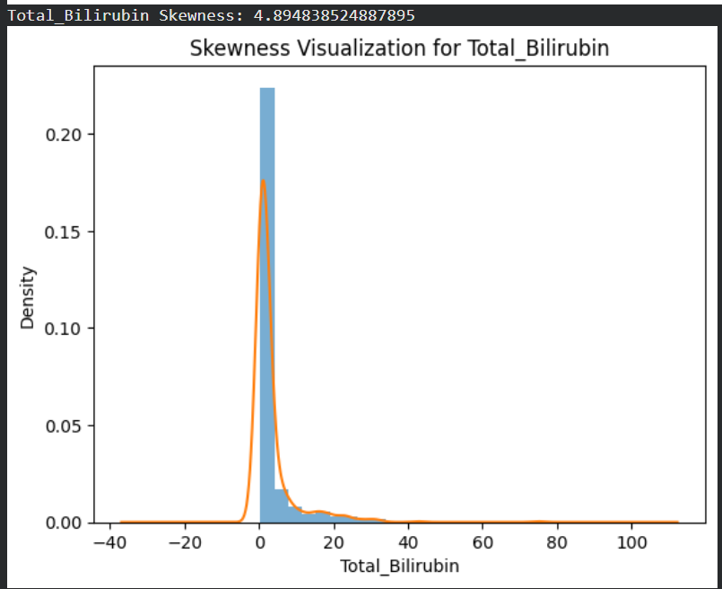
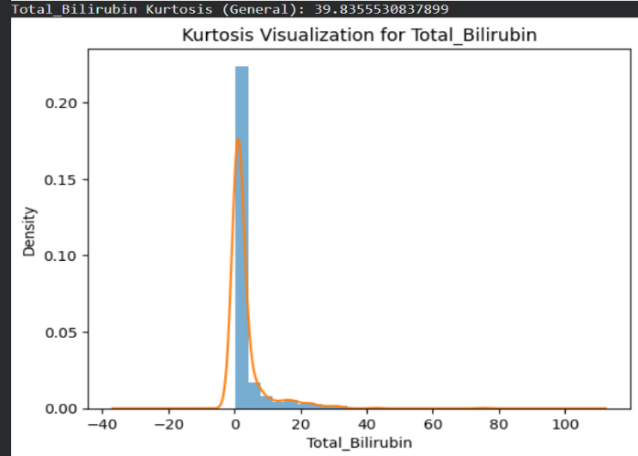

By looking at the histogram and density curve we can easily tell that the biggest histogram bar is definitely an outlier point but even the lower bars are also consists of very higher value than most of the values of the distribution.
So for kurtosis it is definitely leptokurtic (outliers are there), and they are actually the clearly visible bars of the histogram.
For skewness, as we have already discussed the difference between mean and median, and mean is also greater than median, so it contains higher values in a small amount (positive skew). So the mean is shifted towards right of the median for the higher values.

Direct_Bilirubin:
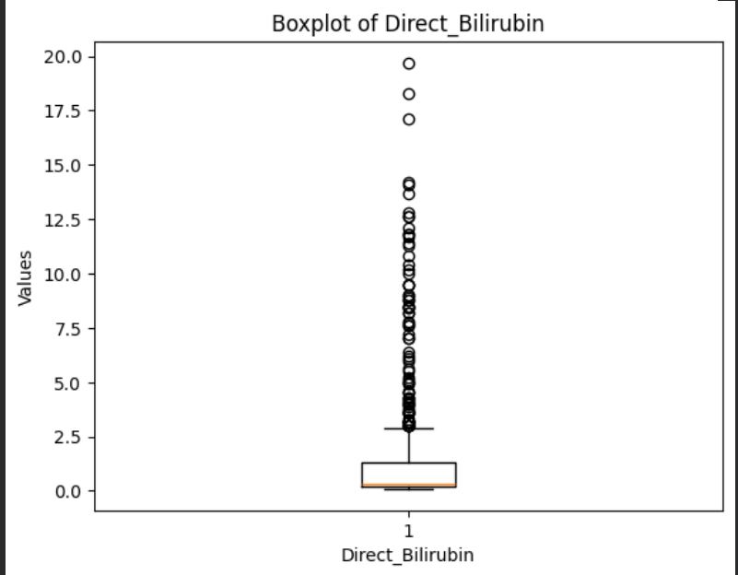
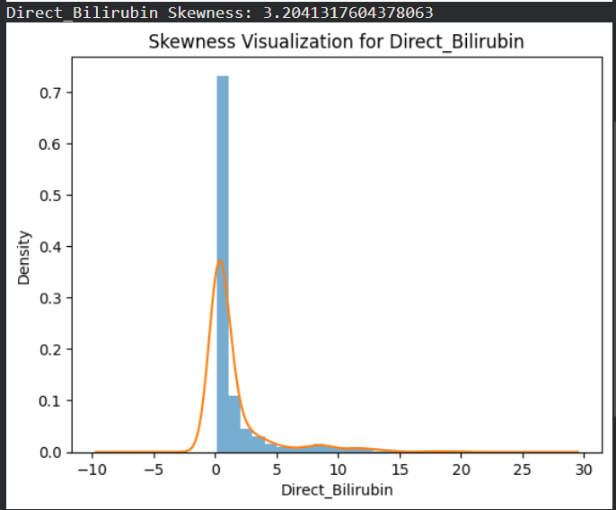
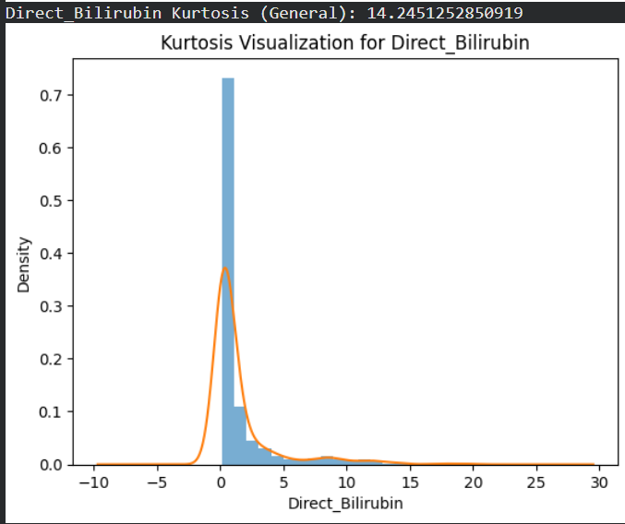
As we can see, similar to the previous boxplot, here also multiple outliers are present, and the median is almost same with the Q1 value (under which 25% of the data points lie). The Q1 value is almost 0.2 and it spread upto almost 1.3, so most of the data points lies within this range (IQR), and allover spread of the data points are from 0.1 and upto 3.0 (app.), rest of the data are pretty rare in his distribution so that it is counted as outliers.

As per the histogram and density curve of direct bilirubin, definitely we can see one clearly visible outlier bar (multiple values in that range present in the distribution) and some lower but out of the normal distribution values, which are also outliers.
As per the mean and median comparison, for kurtosis, it readily contains some outliers (mean>median and also the density of the higher values are there but it’s very less [leptokurtic]), so this column needs to be cleaned by those outliers if they are not valid values.
For skewness, as the mean is larger than the median, so the distribution is shifted towards left side (positive skew), most values are in small range but few outlier values actually stretch the distribution towards right side of the graph to form a long tail of values.

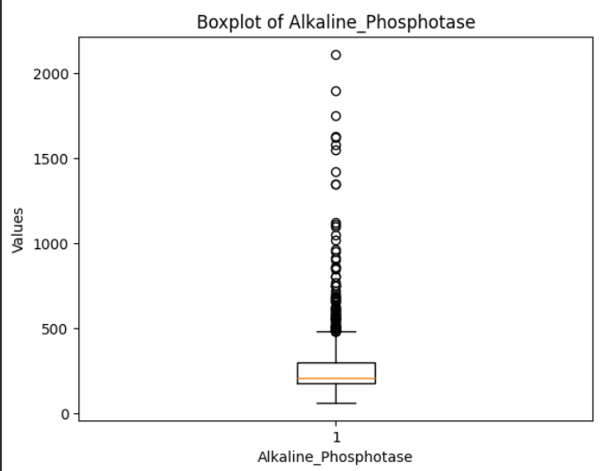
Alkaline_Phosphotase:

From the boxplot, we can readily see there are many outliers point present also here, and as the most values are present in the range of 175 to 300 (app.) (IQR). The allover spread of the main distribution is from 100 (app.) upto 450 (app.) (excluding outlier), there are outlier values present in this distribution (almost upto 2000+). Here half of the distribution has 200+ value (median).
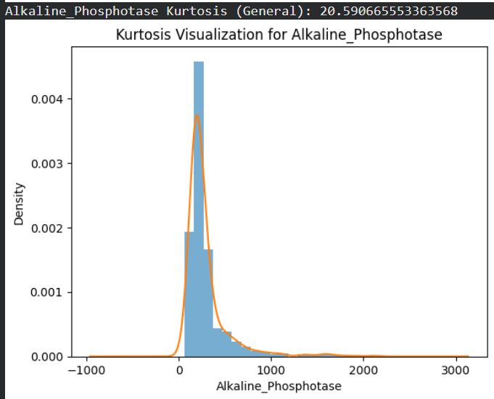
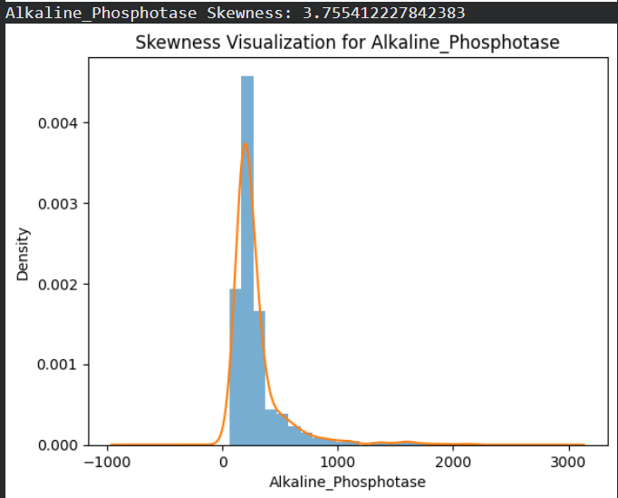

As per the histogram and density curve, we can see the most frequent values are within 500 (app.), there are more values but their frequency is very less, and very large values are rare in this distribution
As per the kurtosis, this distribution also contain outliers as the large values are very rare and they took the distribution stretched towards the right tail. Due to long right tail (many outlier points) the distribution is a leptokurtic one.
For skewness, the distribution has a long tail towards right. And even with comparison of median (208.00) and mean (290.57), we can readily tell it’s a positive skew that means most of the values are in smaller range and the outliers actually humongously large values for which the tail of distribution is shifted towards right.

Alamine_Aminotransferase:
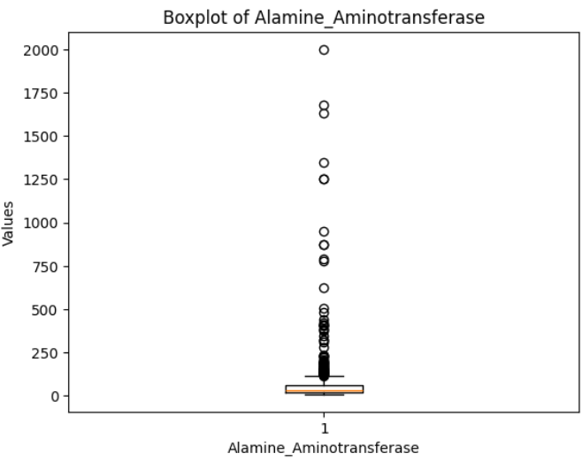
From the boxplot, we can readily see there are many outliers point present also here, and as the most values are present in the range of 23 to 61 (app.) (IQR). The allover spread of the main distribution is from 10 (app.) upto 150 (app.) (excluding outlier), there are outlier values present in this distribution (almost upto 2000+). Here half of the distribution has 35+ value (median).
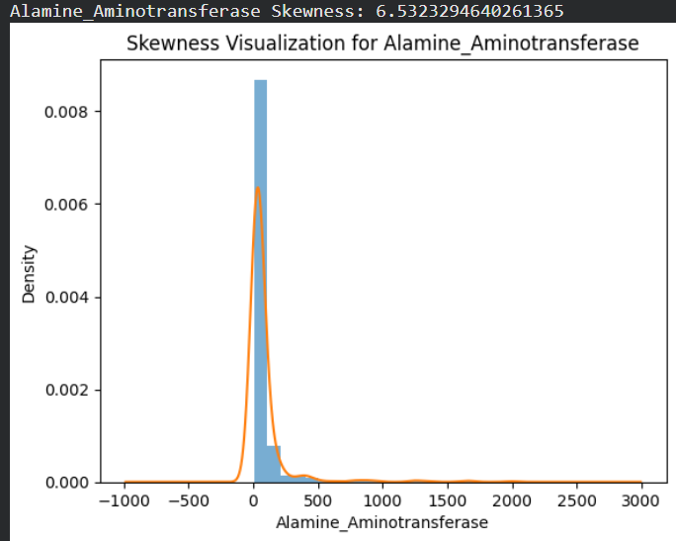
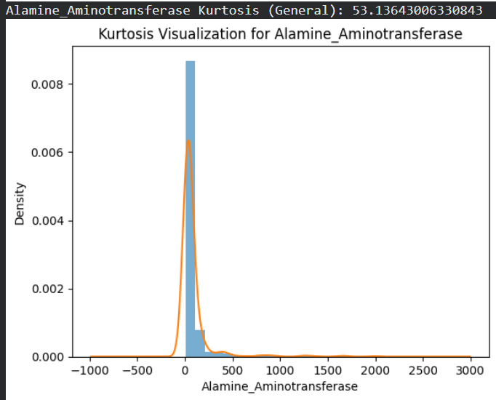

As per the kurtosis, this distribution also contain outliers as the large values are very rare and they took the distribution stretched towards the right tail and the actual distribution is concentrated in a very small region (23 - 61 app.). Due to long right tail (many outlier points) the distribution is a leptokurtic one.
For skewness, the distribution has a long tail towards right. And even with comparison of median (35.00) and mean (80.71), we can readily tell it’s a positive skew that means most of the values are in smaller range and the outliers actually humongously large values for which the tail of distribution is shifted towards right.

Aspartate_Aminotransferase:
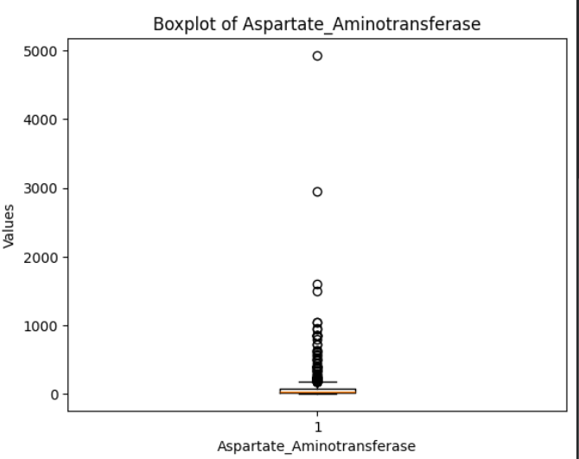
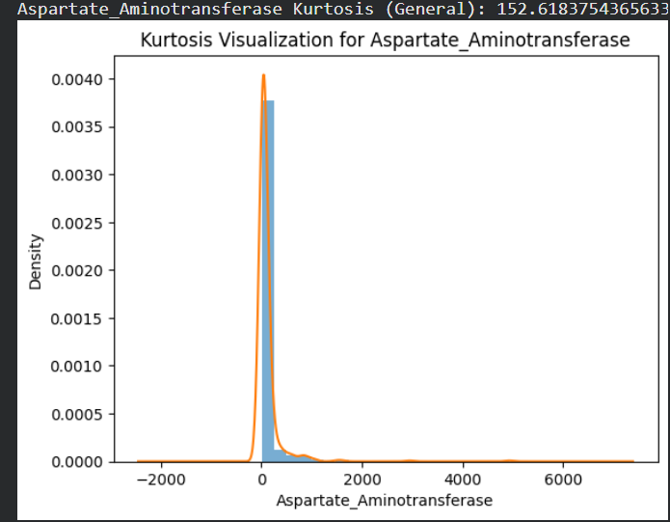
From the boxplot, we can readily see there are many outliers point present also here, and as the most values are present in the range of 25 to 87 (app.) (IQR). The allover spread of the main distribution is from 10 (app.) upto 250 (app.) (excluding outlier), there are outlier values present in this distribution (basically most of them are within 1000 or just 1000+, some of them are like with 3000 or 4000+ value). Here half of the distribution has 42+ value (median).
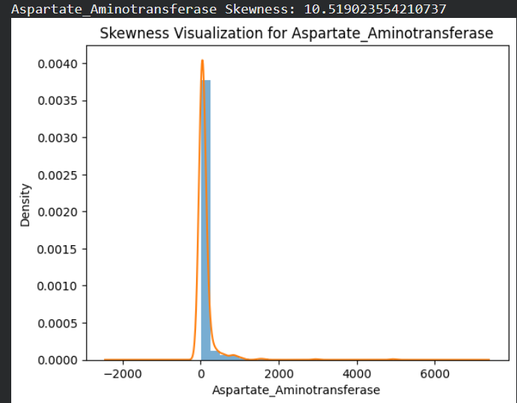

As per the kurtosis, this distribution also contain outliers as the large values are very rare and they took the distribution stretched towards the right tail and the actual distribution is concentrated in a very small region (25 - 87 app.). Due to long right tail (many outlier points) the distribution is a leptokurtic one.
For skewness, the distribution has a long tail towards right. And even with comparison of median (42.00) and mean (109.91), we can readily tell it’s a positive skew (as the outliers heavily influence the mean) that means most of the values are in smaller range and the outliers actually humongously large values for which the tail of distribution is shifted towards right.

Total_Proteins:
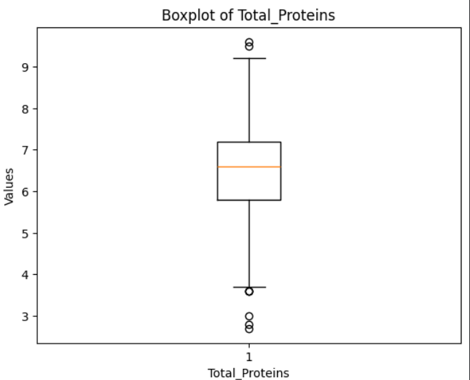
From the boxplot, we can readily see there are outliers point present also here, but not as much as the previous columns, and as the most values are present in the range of 5.8 to 7.2 (app.) (IQR). The allover spread of the main distribution is from 3.7 (app.) upto 9.1 (app.) (excluding outlier), there are outlier values present in this distribution in both then end but they are very few in number. Here half of the distribution has 6.6+ value (median).
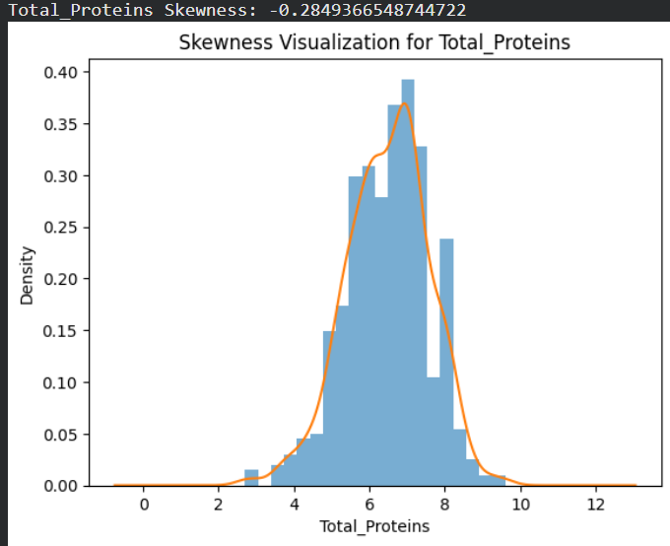
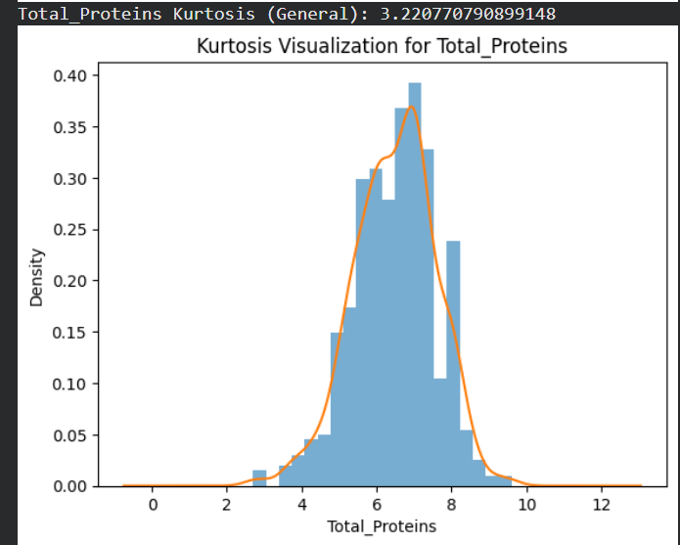

As per the kurtosis, this distribution also contain outliers but in a very small amount, that’s why the kurtosis value is almost near to 3 (mesokurtic and very little leptokurtic), i.e. the distribution is almost evenly distributed over the most distribution range (5.8 – 7.2 app.). Due to short tail (very few outlier points) the distribution can be seen as a evenly spread distribution.
For skewness, the distribution has a short tail towards both ends. And as the mean (6.48) and the median (6.6) are very close to each other, we can tell it’s almost a symmetrical distribution but with theoretical values it’s a slightly negative skewed one (as mean is slightly lower than the median) and as in both sides there are outliers so they have almost nullified each others and we can have this distribution.

Albumin:
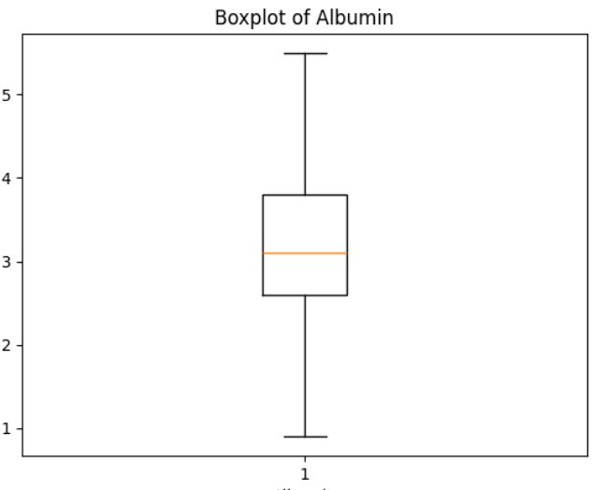
As here we can see there are no outliers detected as such by the boxplot, so we can tell there is no influence of outliers in the particular feature. The most values of the distribution is spread over the values (2.6 – 3.8 app.) the allover distribution is spread over the range 0.8 upto 5+.
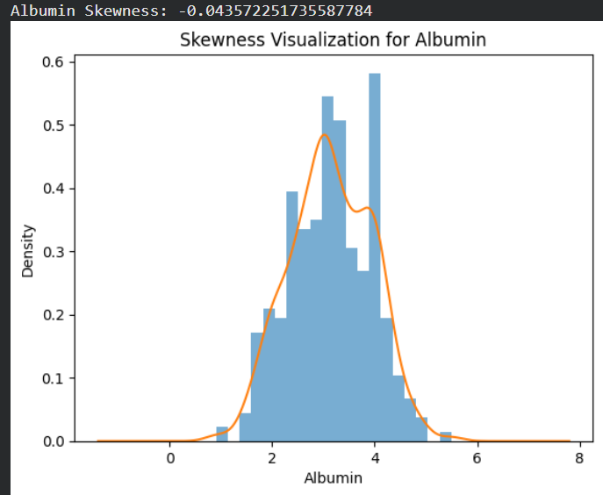
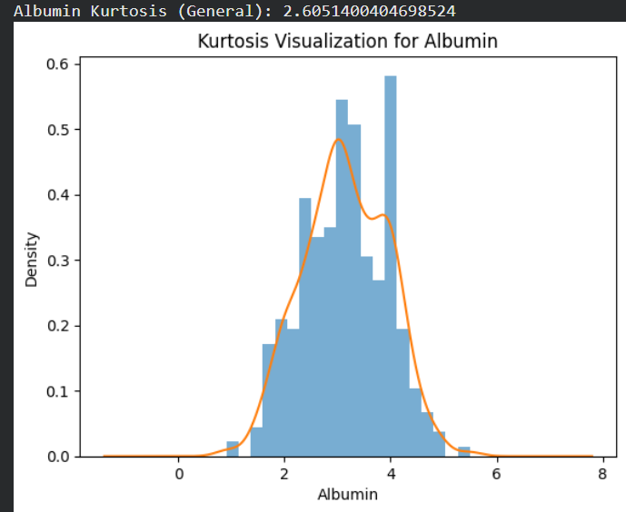

As per the kurtosis, this distribution also contain literally no outliers, that’s why the kurtosis value is almost near to 3 (mesokurtic and very little platykurtic), i.e. the distribution is almost evenly distributed over the most distribution range (2.6 – 3.8 app.). Due to short tail (no outlier points) the distribution can be seen as a evenly spread distribution.
For skewness, the distribution has a short tail towards both ends. And as the mean (3.14) and the median (3.10) are very close to each other, we can tell it’s almost a symmetrical distribution but with theoretical values it’s a slightly positive skewed one (as mean is slightly higher than the median) and as in both sides there are no outliers so we have this evemly spread distribution.

Albumin_and_Globulin_Ratio:
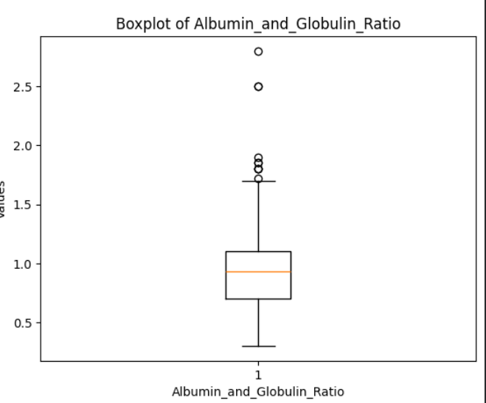
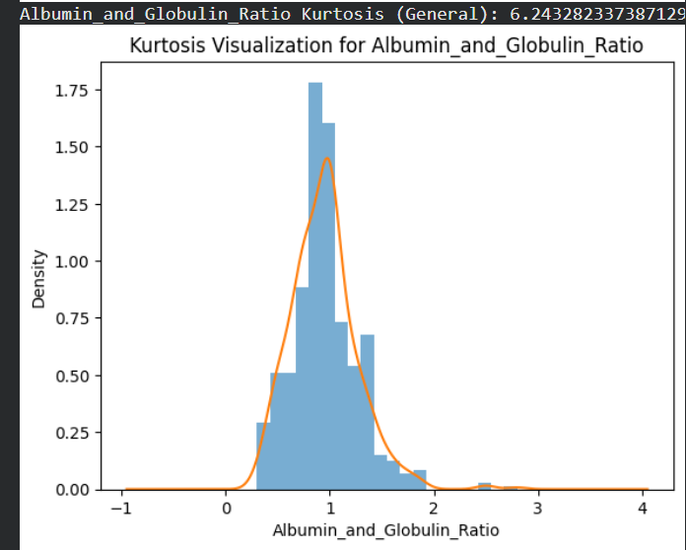
From the boxplot, we can readily see there are outliers point present also here, but not as much as the previous columns, and as the most values are present in the range of 0.7 to 1.1 (app.) (IQR). The allover spread of the main distribution is from 0.3 (app.) upto 1.7 (app.) (excluding outlier), there are outlier values present in this distribution, but they are very few in number. Here half of the distribution has 0.93+ value (median).
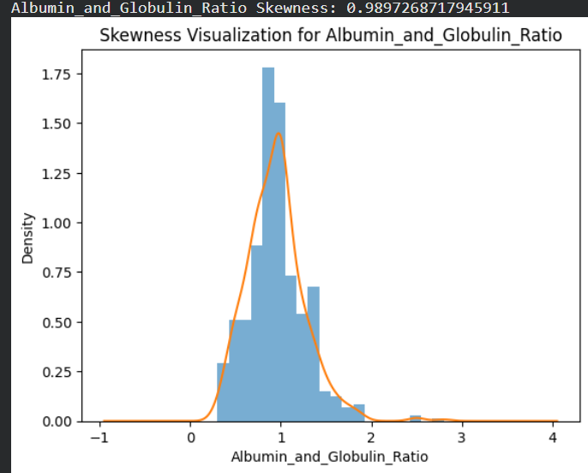

As per the kurtosis, this distribution also contain outliers but in a very small amount, but still the value is greater than 6 (leptokurtic), i.e. the distribution is not evenly distributed and the outliers do influence the distribution. Here also the value is concentrated in a small region over the distribution range 0.7 – 1.1 (app.). Due to medium sized tail (few outlier points) the distribution can be seen as a leptokurtic distribution.
For skewness, the distribution has a medium sized tail towards right. And as the mean (0.94) and the median (0.93) are very close to each other, we can tell it’s almost a symmetrical distribution but with theoretical values it’s a slightly positive skewed one (as mean is slightly lower than the median) but even with few outliers this doesn’t affect the skewness of the distribution much.
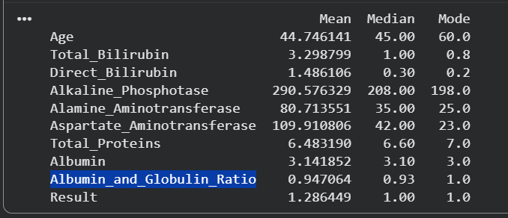

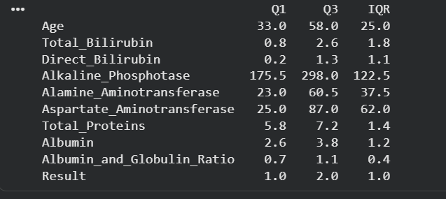

Contour Plots:
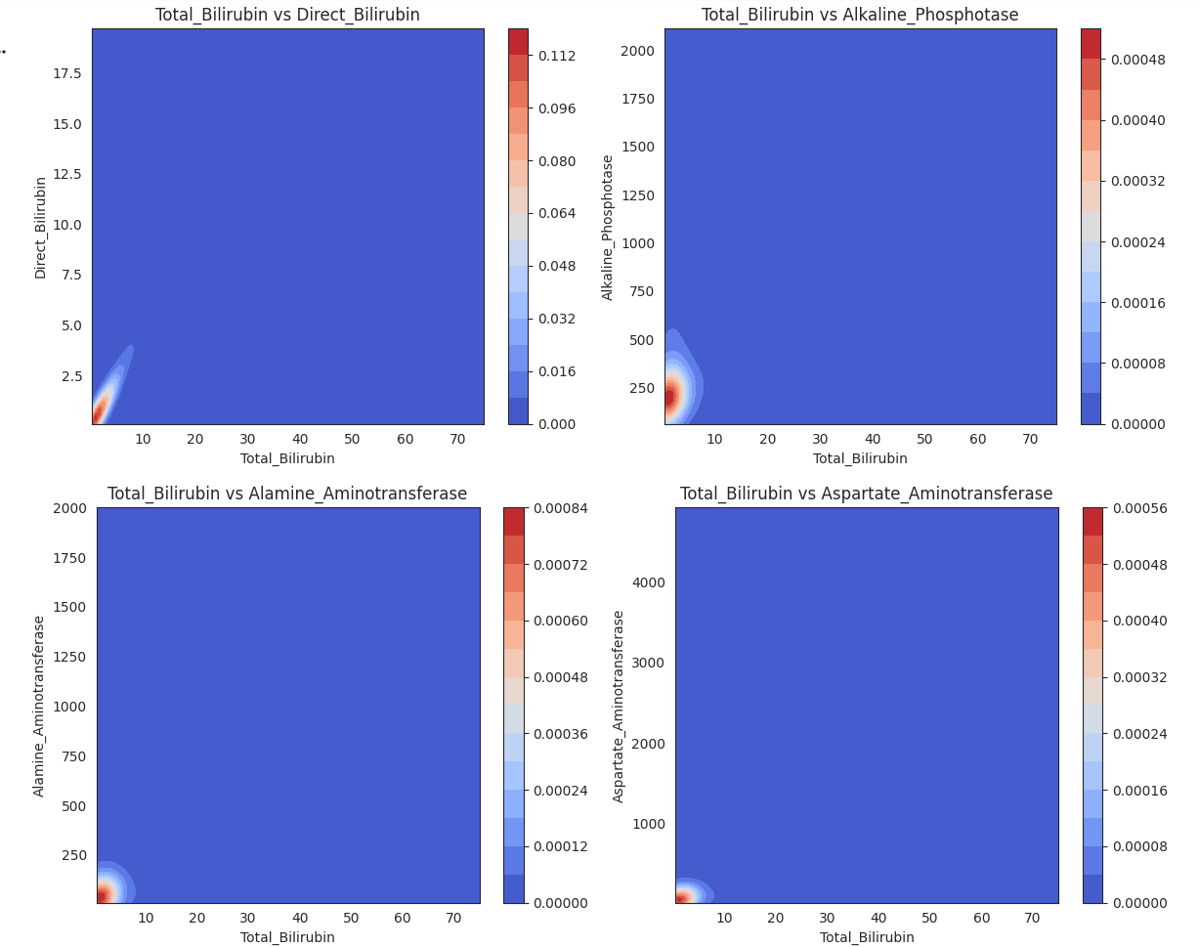

Here mostly the features depicts weak relationship between them as we can see the they have very small inter contour range between different heights.

Total bilirubin vs Direct bilirubin has a strong relationship as they are diagonally spread so changing in one variable actually affect the other one positively.
Total bilirubin vs Alkaline phosphatase has a weak dependency as increasing alkaline phosphatase level very slightly affect the bilirubin level.
Total bilirubin vs Alamine aminotransferase and Total bilirubin vs Aspertate aminotransferase has a very weak relationship between them as increasing one of the feature almost doesn’t affecting the other one or very slightly because of their roundish shape.

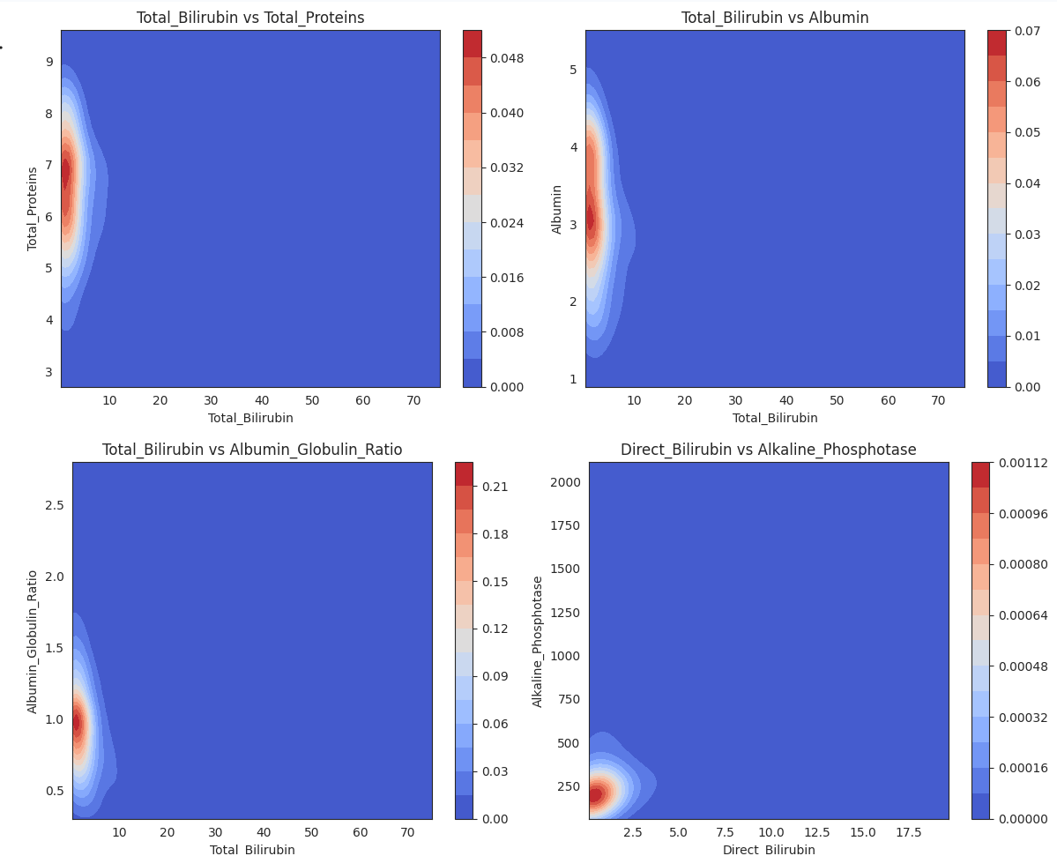

Here the nature of the first three plots are almost same.
In Total bilirubin vs Total proteins, Total bilirubin vs Albumin, Total bilirubin vs Albumin globulin ratio actually the y-axis value varies almost independently.of the x-axis value. Actually the increment of x-axis is very low on the increment of y-axis value.
Only the direct bilirubin vs alkaline phosphatase graph shows very weak relation between them, as they have the circular pattern of contours, so increment in both of them are pretty slow.

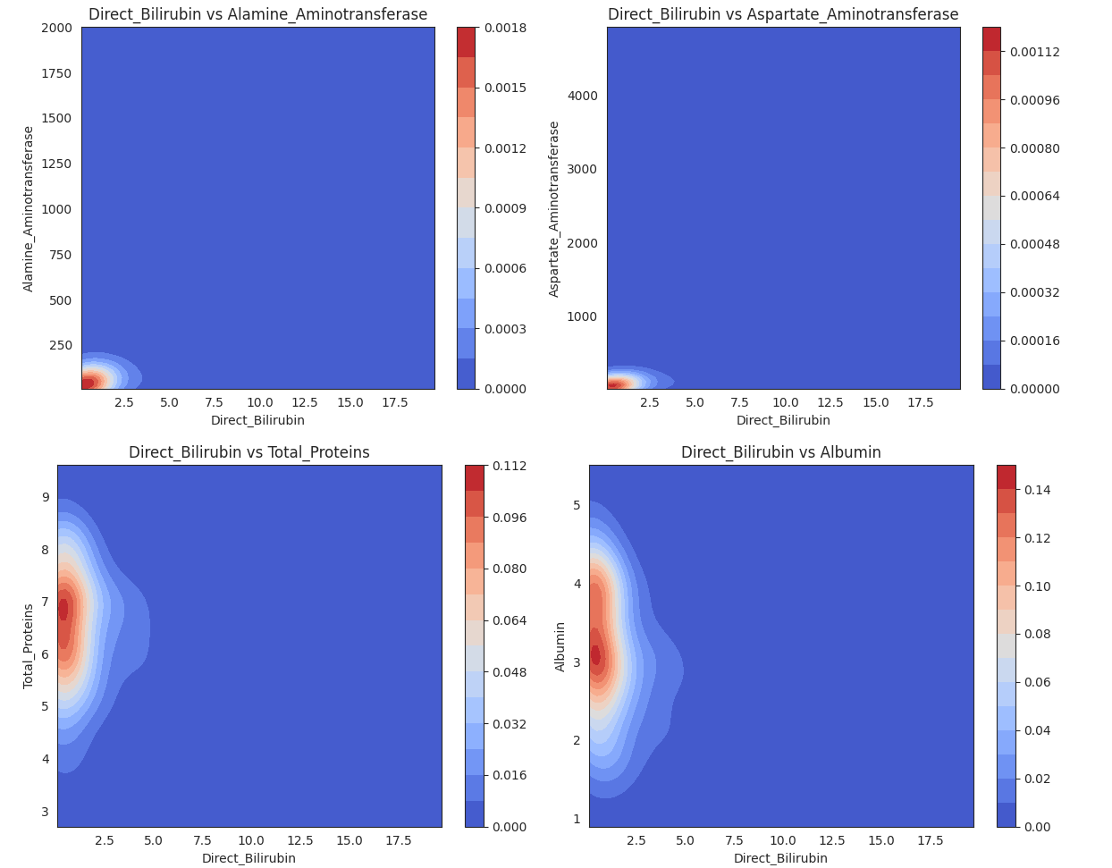
Direct Bilirubin vs Alamine Aminotransferase:
Very weak or no relationship — contours are tightly concentrated in the lower-left corner, indicating most observations have low Direct Bilirubin and low ALT, with no clear directional trend between the variables.
Direct Bilirubin vs Aspartate Aminotransferase:
Very weak or no relationship — contours cluster near the origin without diagonal stretching, suggesting AST values vary widely while Direct Bilirubin mostly remains low.
Direct Bilirubin vs Total Proteins:
Weak relationship — contours form a slightly vertical spread around normal Total Protein values, indicating Total Proteins stay relatively stable even as Direct Bilirubin changes.
Direct Bilirubin vs Albumin:
Weak negative tendency — contours extend slightly downward as Direct Bilirubin increases, suggesting Albumin may decrease slightly when Direct Bilirubin becomes higher, though the relationship is not strong.

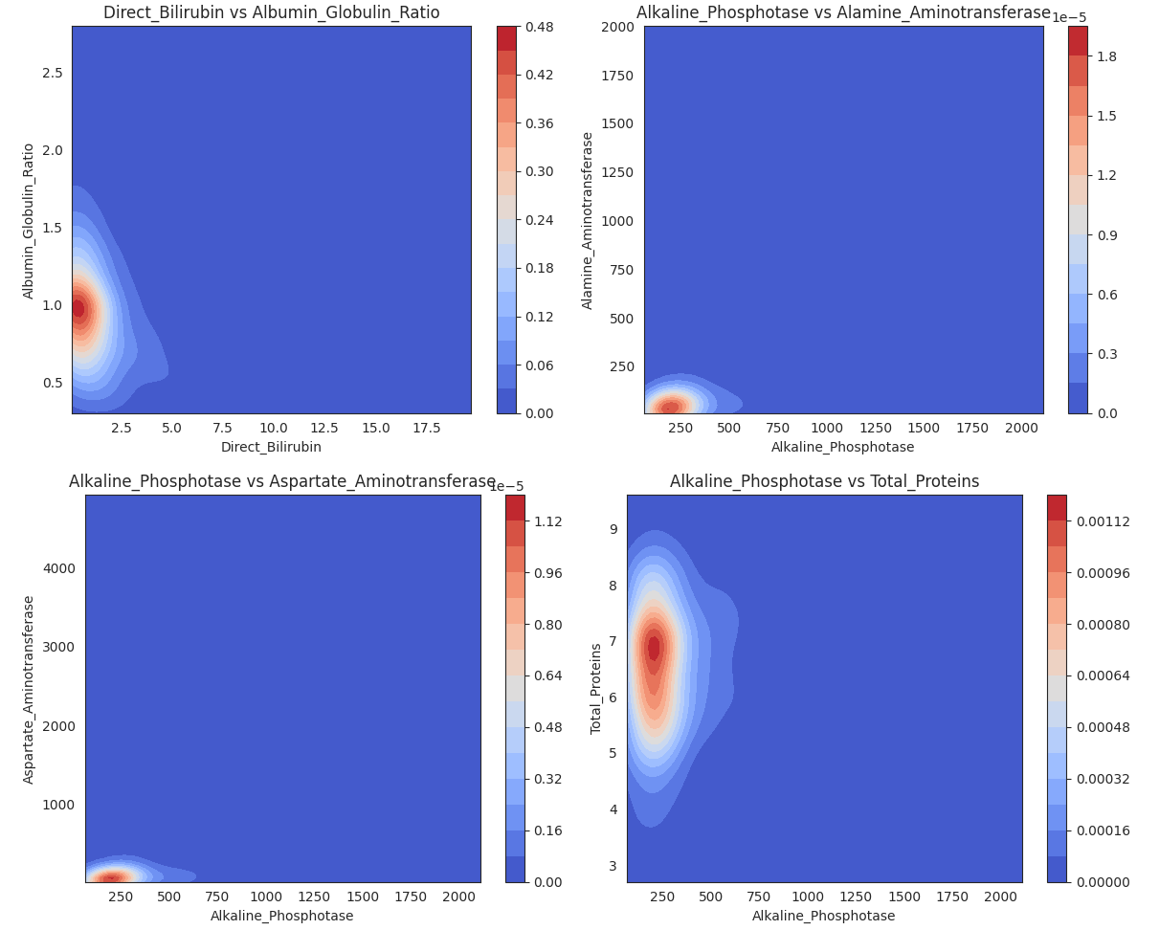

Direct Bilirubin vs Albumin-Globulin Ratio:
Weak negative relationship — contours are concentrated near low Direct Bilirubin values and show a slight downward spread, suggesting the Albumin-Globulin Ratio may decrease slightly as Direct Bilirubin increases.
Alkaline Phosphotase vs Alamine Aminotransferase:
Very weak or no relationship — contours are clustered in a small region with mostly vertical spread, indicating ALT varies independently while Alkaline Phosphotase changes.
Alkaline Phosphotase vs Aspartate Aminotransferase:
Very weak relationship — contours remain compact near lower values with little diagonal elongation, suggesting AST does not strongly increase or decrease with Alkaline Phosphotase.
Alkaline Phosphotase vs Total Proteins:
Weak relationship — contours show a vertical concentration around normal Total Protein values, meaning Total Proteins remain relatively stable even when Alkaline Phosphotase varies.

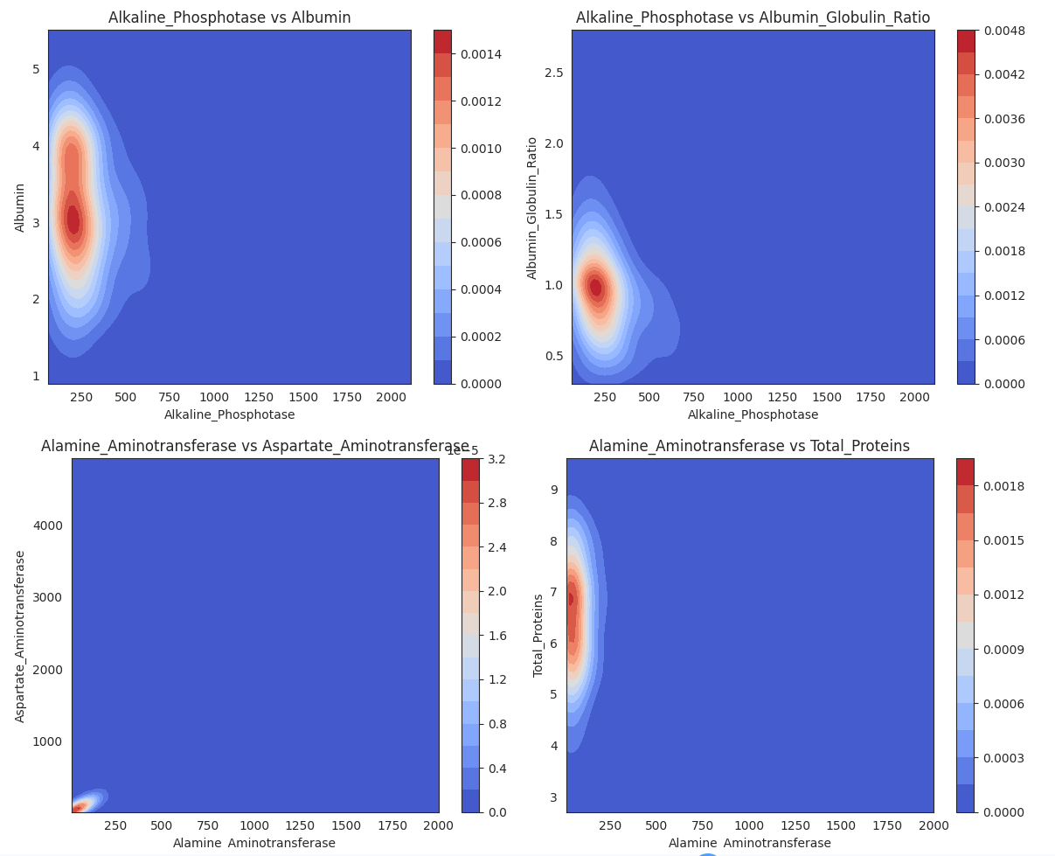

Alkaline Phosphotase vs Albumin: Weak relationship — contours are mostly vertically spread, meaning Albumin stays around similar values even when Alkaline Phosphotase changes.
Alkaline Phosphotase vs Albumin-Globulin Ratio: Weak relationship — contours form a compact vertical cluster, indicating the ratio remains nearly constant despite variation in Alkaline Phosphotase.
Alamine Aminotransferase vs Aspartate Aminotransferase: Moderate positive relationship — contours show a slight diagonal elongation, suggesting both enzymes tend to increase together.
Alamine Aminotransferase vs Total Proteins: Very weak or no relationship — contours are vertically concentrated, meaning Total Proteins remain roughly constant while ALT varies.

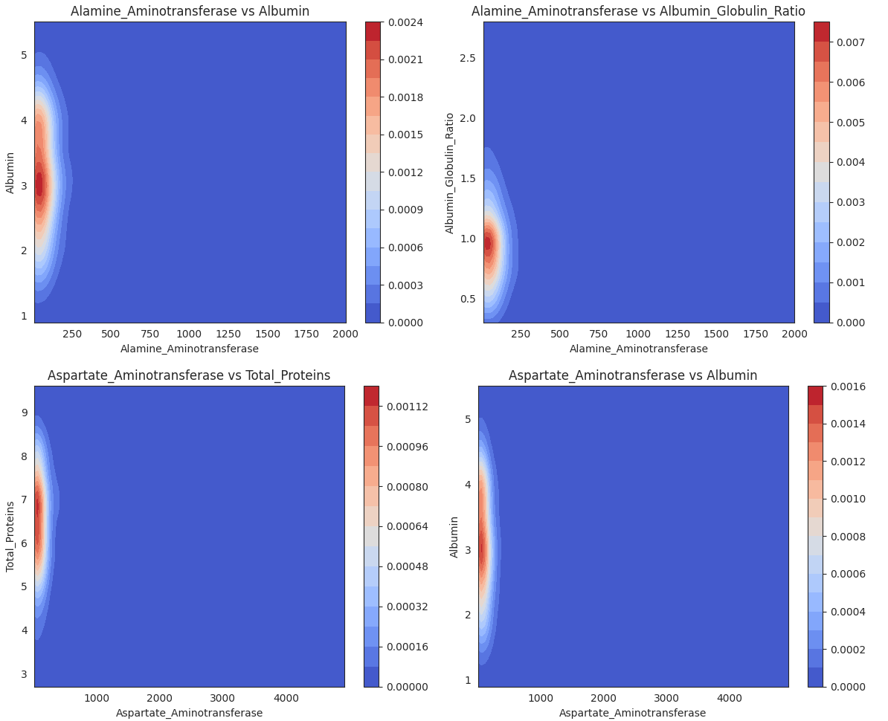

Alamine Aminotransferase vs Albumin: Weak relationship — contours are vertically concentrated, indicating Albumin stays near similar values even when ALT varies.
Alamine Aminotransferase vs Albumin-Globulin Ratio: Weak relationship — contours form a compact vertical cluster, showing the A/G ratio remains almost constant despite changes in ALT.
Aspartate Aminotransferase vs Total Proteins: Very weak or no relationship — contours are vertically spread, meaning Total Proteins remain stable while AST varies.
Aspartate Aminotransferase vs Albumin: Weak relationship — contours are vertically oriented, indicating Albumin does not systematically change with AST.

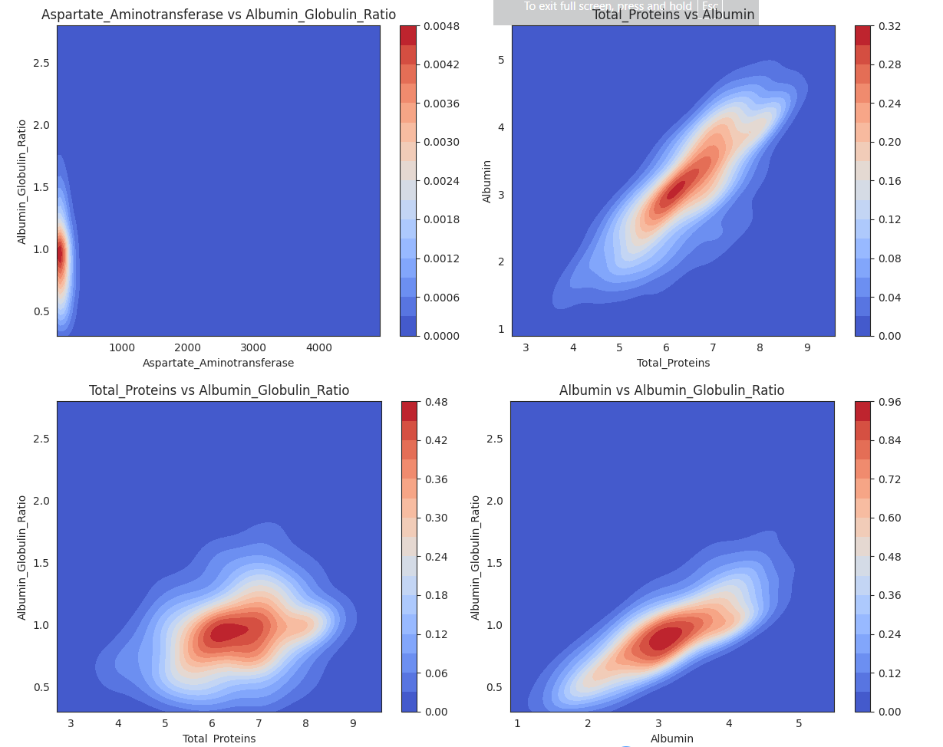

Aspartate Aminotransferase vs Albumin–Globulin Ratio: Weak relationship — contours are vertically concentrated, indicating the A/G ratio stays nearly constant even when AST varies widely.
Total Proteins vs Albumin: Strong positive relationship — contours are narrow and diagonally elongated, showing Albumin increases consistently as Total Proteins increase.
Total Proteins vs Albumin–Globulin Ratio: Moderate positive relationship — contours show a slight diagonal spread, indicating the A/G ratio tends to increase somewhat with Total Proteins.
Albumin vs Albumin–Globulin Ratio: Strong positive relationship — contours are clearly diagonally elongated, meaning the A/G ratio increases as Albumin increases.

