**Project Objective**

Determine the country of origin of asylum seekers over the years, where they are seeking asylum and if possible answer why.

**Hypothesis**

It is often hypothesized that individuals will seek to settle in areas that are politically stable, offer abundant opportunities and have favorable climatic conditions.

This study aims to determine if asylum seekers are primarily seeking asylum because of conflict or economic betterment or both. Countries such as Afghanistan, Syria, Libya which has seen conflict in recent years are expected to be origin countries of majority of asylum seekers. On the other hand countries such as Bangladesh, Pakistan, countries in South America are hypothesized to be origin of economic asylum seekers.

The second question that this study aims to answer is:

Do asylum seekers, seek asylum in neighboring countries with similar culture, language and climate or are they willing to travel far to settle down?

Older individuals may not be inclined to move far away from their place of upbringing due to social, emotional and economic ties whereas younger individuals may be more willing to undertake longer journeys to seek asylum.

**Data Source**

<http://popstats.unhcr.org/en/asylum_seekers_monthly>

**Observations**

**Figure 1**

The asylum applications peaked in 2015. Through the war in Afghanistan and Iraq, the asylum applications were not relatively high compared to 2015, 2016.

It is also interesting to note that during the great recession, the asylum applications did not rise significantly.

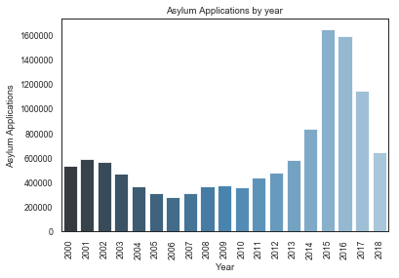

Figure

**Figure 2**

Studying the data further, it is found that asylum seekers from Syria, Afghanistan and Iraq dominate the list of countries from where people seek asylum.

However, what is interesting to find is that countries such as China and Russia figure in this list.

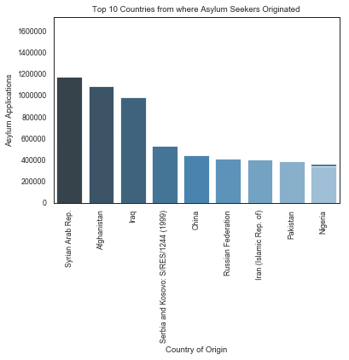

Figure

**Figure 3**

What is also interesting to note is that which countries provide the most assistance to asylum seekers. Germany and France feature among the top of the list even when they had a lesser role to play in the destabilizing role in Middle East and Africa.

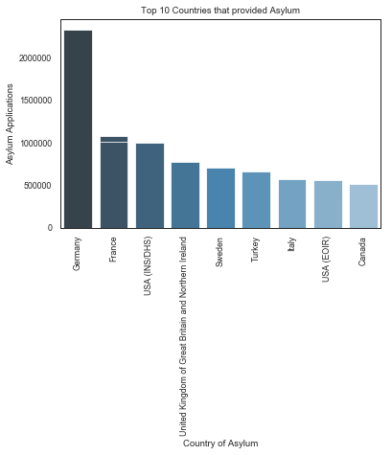

Figure

**Figure 4**

Shifting our focus to one year now (2016), we notice that people from Syria make up the majority of asylum seekers. However, countries such as Pakistan, Eritrea, El Salvador and China feature among that list as well.

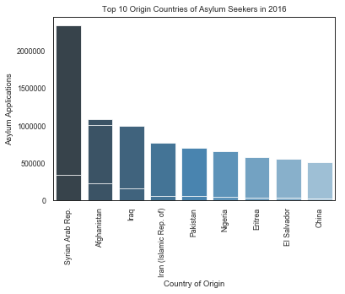

Figure

**Figure 5**

Since Syrians comprise the largest number of the asylum seekers, we focus on which countries did they apply for asylum in.

Unsurprisingly, Germany comes out on top. It is interesting to note that Greece and Austria figure next on the list. Surprisingly, Italy does not figure among the top 10 countries where Syrians want to settle in.

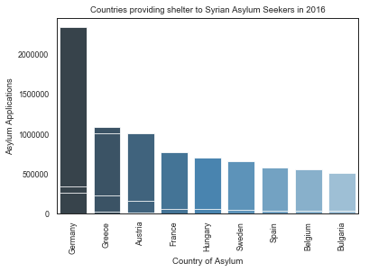

Figure

**Figure 6**

When doing a similar comparison for China, it is interesting to note that Chinese asylum seekers tend to flock to USA.

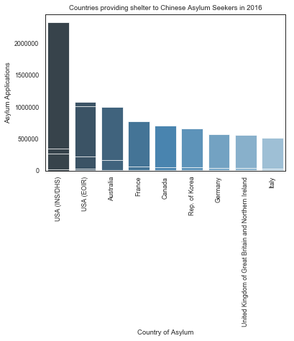

**Figure 7**

We found out before that Germany is one of the top asylum providers that Syrians are one of the biggest beneficiaries of German accommodation. We explore in the next chart which other groups have settled down in Germany in 2016.

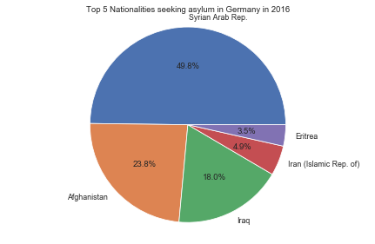

Figure

**Relevance and Future Work**

The analysis of the dataset is extremely useful to policymakers to understand how global events have a human repercussion in the domestic context. In this case the war in Afghanistan, Iraq and Syria have created thousands of displaced persons. However, it is interesting to note that after the dust has settled it the responsibility of taxpayers in other countries (eg: Germany, France etc.) to accommodate those less fortunate individuals.

The data on Chinese asylum seekers is interesting, as China being a developed country should have less people wanting to move. Yet China figures among the top 10 countries where asylum seekers originate.

There is definitely room for future work. I want to explore how macro economic events play a role in the context of asylum seekers, and if possible why certain countries appeal to individuals more (In this context why Germany has been able to attract so many asylum seekers compared to its peers while Italy which is closer does not figure among the top 10).