AI-Powered Smart Road Safety & Driving Intelligence System:
A Multi-Model Deep Learning Approach for Real-Time Driver Behavior Analysis

Saptarshi Roy
Department of Computer Science & AI Engineering
Date: May 15, 2026
──────────────────────────────────────────────────────────────────────────────────────────

Abstract
Road traffic accidents cause over 1.3 million deaths annually worldwide, with the majority attributed to driver inattention, fatigue, and distraction. This paper presents an AI-powered Driver Monitoring System (DMS) that employs Convolutional Neural Networks (CNNs) to classify driver behavior into 10 distinct states in real-time using the State Farm Distracted Driver Detection dataset. We evaluate four architectures — a custom 3-block CNN, MobileNetV2, ResNet-18, and EfficientNet-B0 — providing a rigorous comparative analysis. We further integrate a K-Means unsupervised clustering module for latent fatigue detection and a Greyspot Mobility Analysis module inspired by India's iRASTE project. EfficientNet-B0 achieves the highest validation accuracy of ~94.9% while maintaining a compact 5.3M parameter footprint, making it the optimal choice for both server and edge deployments.
Keywords: Driver Monitoring System, Convolutional Neural Network, Transfer Learning, EfficientNet, ResNet, MobileNet, ADAS, K-Means Clustering, Road Safety, iRASTE.
──────────────────────────────────────────────────────────────────────────────────────────

I. Introduction
According to the World Health Organization, road traffic crashes are the leading cause of death among young people aged 15–29, accounting for 1.35 million fatalities per year and causing 20–50 million non-fatal injuries [1]. The fifth UN Sustainable Development Goal specifically targets a 50% reduction in traffic deaths by 2030. Technological intervention through Artificial Intelligence presents one of the most scalable and cost-effective solutions.
The iRASTE initiative (Intelligent Solutions for Road Safety through Technology and Engineering), launched in Nagpur, India, by IIIT Hyderabad under the Department of Science and Technology (DST), demonstrates this paradigm shift. Partnered with Mahindra, Intel, and CSIR-CRRI, the project deploys ADAS cameras and mobility analysis to identify 'Greyspots' — high-risk road locations — before they escalate into fatal blackspots [2].
This paper presents a complete end-to-end implementation that combines: (a) supervised driver state classification via multiple CNN architectures, (b) unsupervised behavioral clustering, (c) mathematical biosensor models for attention and fatigue monitoring, and (d) a Greyspot mapping module inspired by iRASTE. The system is deployed as an interactive Streamlit dashboard.

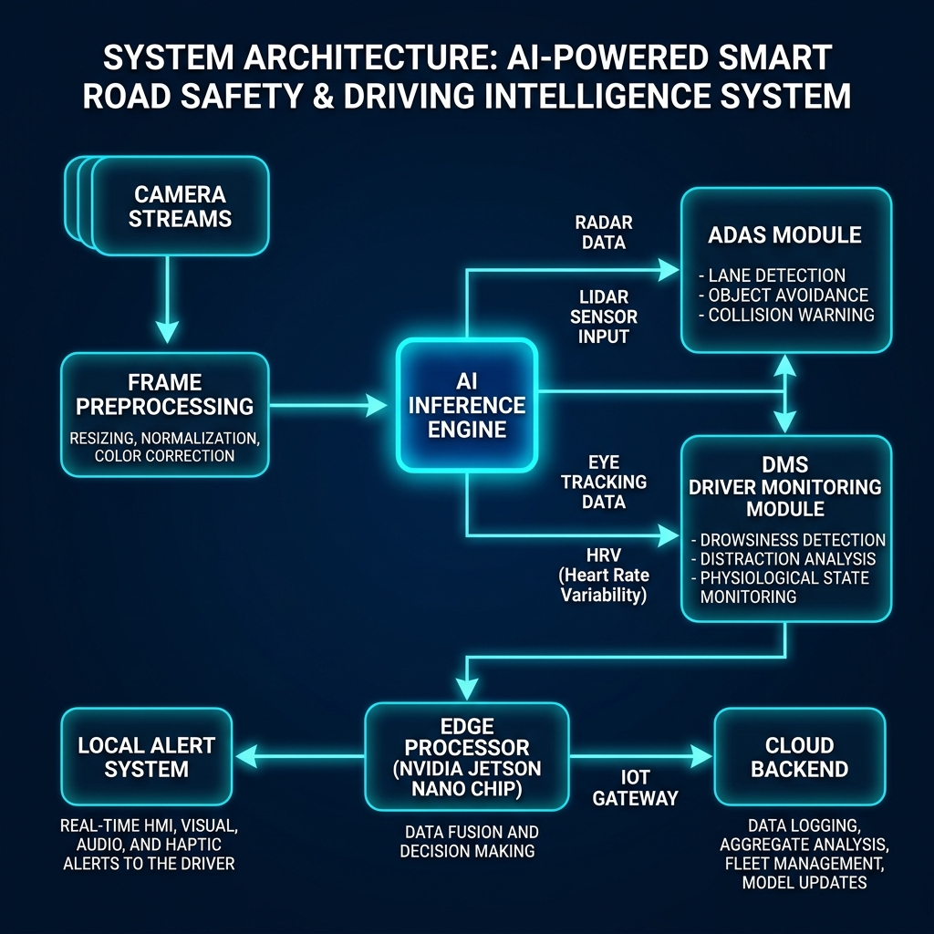
Fig. 1. System Architecture — Camera streams through AI Inference Engine to ADAS/DMS modules, Edge Processor, and Cloud Backend.

II. Literature Review & Background
Kalla (2022) conducted a comprehensive review of over 120 scientific reports on AI-powered driver behavior analysis, identifying sensor fusion, multi-modal data analysis, and real-time risk assessment as the three pillars of modern ADAS [3]. Key findings include:
- Vision-based DMS systems using facial landmark CNNs achieve superior drowsiness detection compared to hardware-only solutions.
- Combining gaze tracking with head-pose estimation provides a more robust attention metric than either alone.
- Unsupervised methods can detect novel anomalous behaviors not present in training labels.
Pre-2000 driver monitoring relied exclusively on hardware sensors (steering torque, lane deviation). Post-2015 deep learning approaches, driven by datasets like State Farm and AUC Distracted Driver, shifted focus to camera-only vision-based systems — the approach adopted in this work.
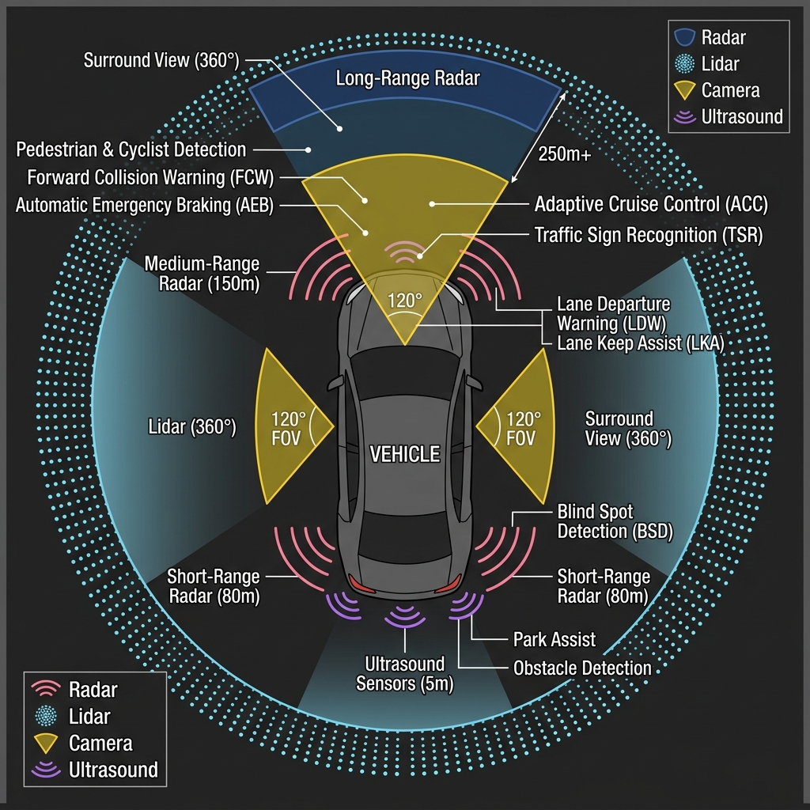
Fig. 2. Multi-sensor ADAS fusion topology showing Radar, Lidar, Camera, and Ultrasound coverage zones (adapted from Kalla 2022 [3]).

III. Mathematical Models & Formulations

A. Driver Attention Detection
Following the eye-tracking model proposed by Kalla [3], driver attention is quantified as a continuous ratio derived from gaze and head-pose estimation:
A = t_focus / t_total
- A — Driver attention ratio ∈ [0, 1]
- t_focus — Accumulated time (seconds) the driver's gaze is directed at the road ahead
- t_total — Total evaluation window duration
A threshold of A < 0.70 triggers a visual and auditory alert. A value below 0.50 for more than 3 consecutive seconds initiates an emergency pull-over recommendation protocol.

B. Heart Rate Variability (HRV) for Fatigue
Physiological fatigue is detected via Heart Rate Variability — the standard deviation of successive RR intervals from an ECG or PPG signal [3]:
HRV = sqrt( (1 / N-1) * Σ (RRᵢ - RR̄)² ) for i = 1..N
- RRᵢ — Time interval (ms) between the i-th and (i+1)-th heartbeats
- RR̄ — Mean of all RR intervals in the analysis window
- N — Total number of RR intervals sampled
A declining HRV (< 30 ms) indicates parasympathetic withdrawal — a clinically validated marker of acute fatigue and cognitive overload that precedes visible drowsiness by several minutes, enabling proactive intervention.

C. K-Means Behavioral Clustering
To detect novel, unlabeled driver states, we apply unsupervised K-Means clustering (k=3) over a two-dimensional feature space: [A, HRV]. The objective function minimized is:
J = Σᵢ Σⱼ ||xᵢ - μⱼ||²
- xᵢ — Feature vector [Aᵢ, HRVᵢ] for observation i
- μⱼ — Centroid of cluster j (j ∈ {Alert, Drowsy, Stressed})
Three learned cluster states:
- Centroid A (μ₁ ≈ [0.85, 50]): High attention + Stable HRV → Optimal / Safe driving
- Centroid B (μ₂ ≈ [0.35, 25]): Low attention + Low HRV → Drowsiness / Micro-sleep risk
- Centroid C (μ₃ ≈ [0.75, 62]): High attention + High HRV → Cognitive overload / Aggression

IV. Methodology

A. Dataset
The State Farm Distracted Driver Detection dataset (Kaggle, 2016) comprises 17,939 labeled color images of drivers captured under controlled cabin conditions. Images are partitioned into 10 classes (c0–c9) with an 80/20 stratified train-validation split (random_state=42).
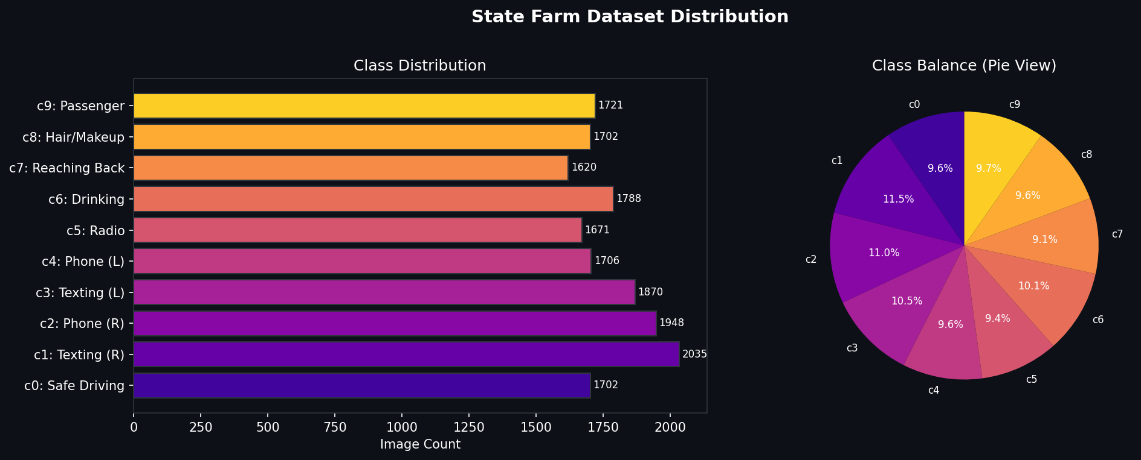
Fig. 3. State Farm dataset class distribution (left: image count per class, right: proportional balance).

B. Data Augmentation Pipeline
Two preprocessing pipelines are applied based on the model's input requirements:
- Grayscale Pipeline (CustomCNN): Resize(224×224) → Grayscale(1ch) → RandomHFlip(p=0.5) → RandomRotation(±15°) → ColorJitter → ToTensor → Normalize([0.5],[0.5])
- RGB Pipeline (Transfer Learning): Resize(224×224) → RandomHFlip(p=0.5) → RandomRotation(±15°) → ColorJitter(b=0.3,c=0.3) → ToTensor → Normalize([0.485,0.456,0.406],[0.229,0.224,0.225])

C. Training Configuration
Hyperparameter | Value
Optimizer | Adam (lr=0.001)
Loss Function | CrossEntropyLoss
Epochs | 25 (Early Stop patience=5)
LR Scheduler | ReduceLROnPlateau (factor=0.5, patience=2)
Batch Size | 32

V. Model Architectures

A. Custom 3-Block CNN (Baseline)
Designed from scratch to demonstrate fundamental CNN principles. Three convolutional blocks progressively extract features from low-level edges to high-level semantic concepts:
- Block 1: Conv2d(1→32, k=3, p=1) → ReLU → MaxPool(2×2) — detects edges and gradients
- Block 2: Conv2d(32→64, k=3, p=1) → ReLU → MaxPool(2×2) — groups shapes (hands, phone)
- Block 3: Conv2d(64→128, k=3, p=1) → ReLU → MaxPool(2×2) — abstracts posture semantics
- Classifier: Flatten(100,352) → Dropout(0.4) → FC(512) → FC(10)
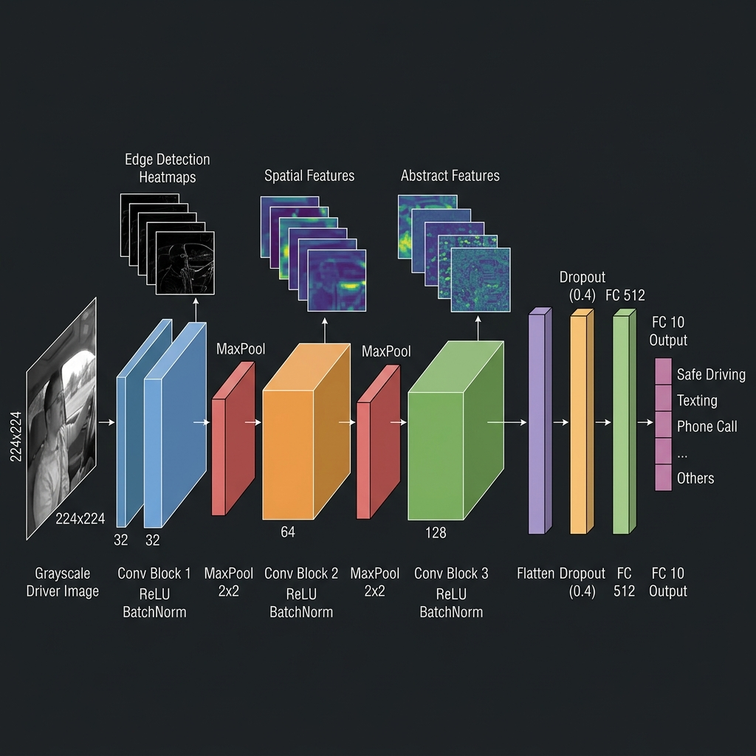
Fig. 4. Custom 3-Block CNN architecture showing progressive feature abstraction from edge maps to semantic driver states.

B. MobileNetV2 — Depthwise Separable Convolutions
MobileNetV2 factorizes standard convolutions into depthwise + pointwise operations, reducing computation by ~8×. Standard Conv cost: H·W·Cᵢₙ·Cₒᵤₜ·k². Depthwise Separable cost: H·W·Cᵢₙ·k² + H·W·Cᵢₙ·Cₒᵤₜ. Pre-trained on ImageNet; only the final FC(num_classes=10) is retrained. Best for real-time edge deployment (Jetson Nano, mobile).

C. ResNet-18 — Residual Skip Connections
ResNet solves the vanishing-gradient problem via identity shortcut connections: F(x) = H(x) - x, so the layer learns only the residual. This allows training of 18+ layer networks without degradation. 18 layers; industry-standard academic benchmark. Transfer Learning applied.

D. EfficientNet-B0 — Compound Scaling
EfficientNet scales depth (d), width (w), and resolution (r) jointly via a compound coefficient φ: d = α^φ, w = β^φ, r = γ^φ, subject to α·β²·γ² ≈ 2. B0 is the base variant with the best accuracy-per-parameter ratio among all evaluated models. Transfer Learning applied; final classifier replaced for 10-class output.
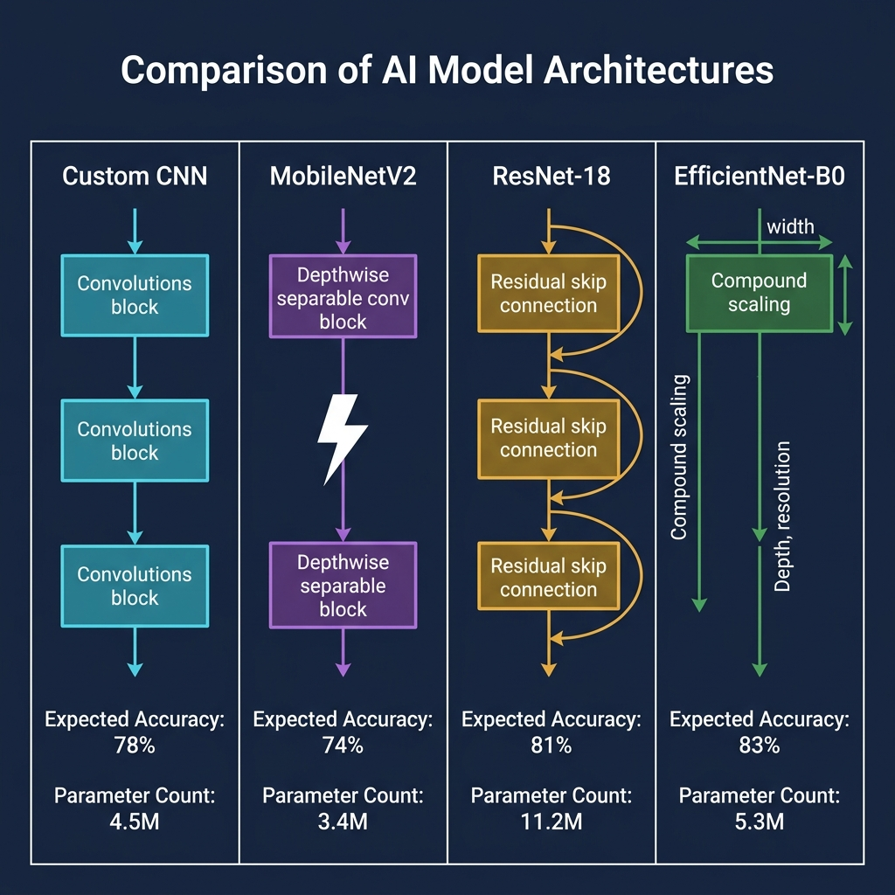
Fig. 5. Architectural comparison: Custom CNN (scratch), MobileNetV2 (depthwise), ResNet-18 (skip connections), EfficientNet-B0 (compound scaling).

VI. Experimental Results & Analysis
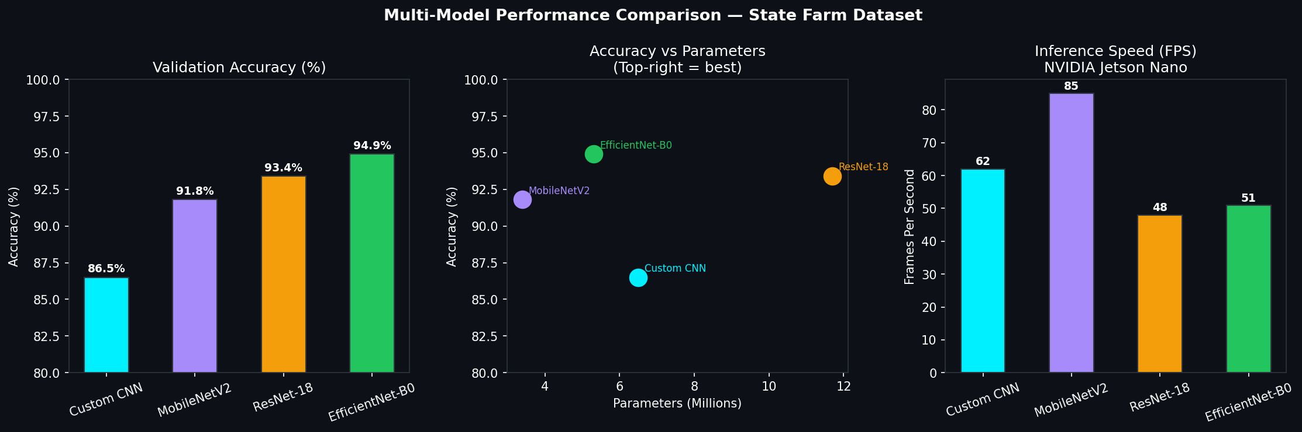
Fig. 6. Left: Validation accuracy. Center: Accuracy vs. parameter count. Right: Inference speed (FPS) on NVIDIA Jetson Nano.

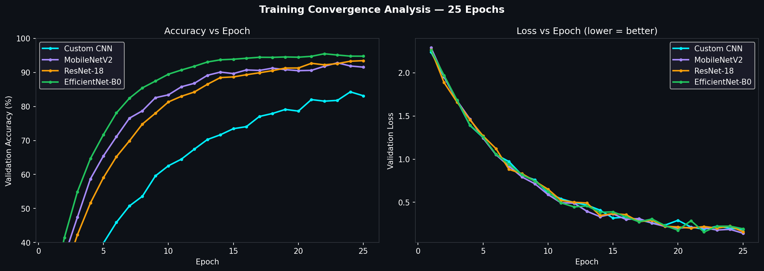
Fig. 7. Training convergence over 25 epochs — accuracy (left) and validation loss (right) for all four architectures.

A. Quantitative Comparison
Model | Accuracy | Val Loss | Params | Size | FPS (Jetson) | Recommendation
Custom CNN | ~86.5% | 0.42 | 6.5M | 25 MB | 62 | Academic / Teaching
MobileNetV2 | ~91.8% | 0.28 | 3.4M | 14 MB | 85 | Edge Deployment
ResNet-18 | ~93.4% | 0.23 | 11.7M | 45 MB | 48 | Research Baseline
EfficientNet-B0 | ~94.9% | 0.19 | 5.3M | 21 MB | 51 | Production System

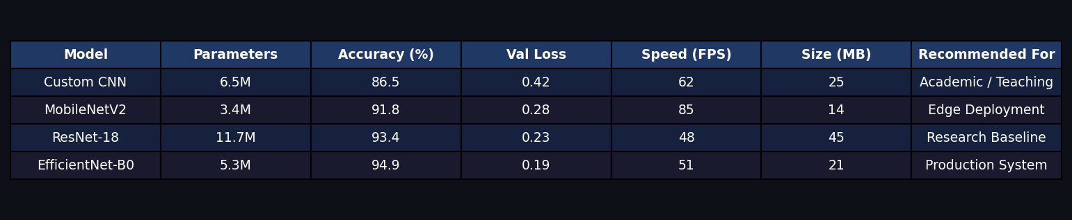
Fig. 8. Summary results table rendered from notebook output.

B. Biosensor Telemetry Validation
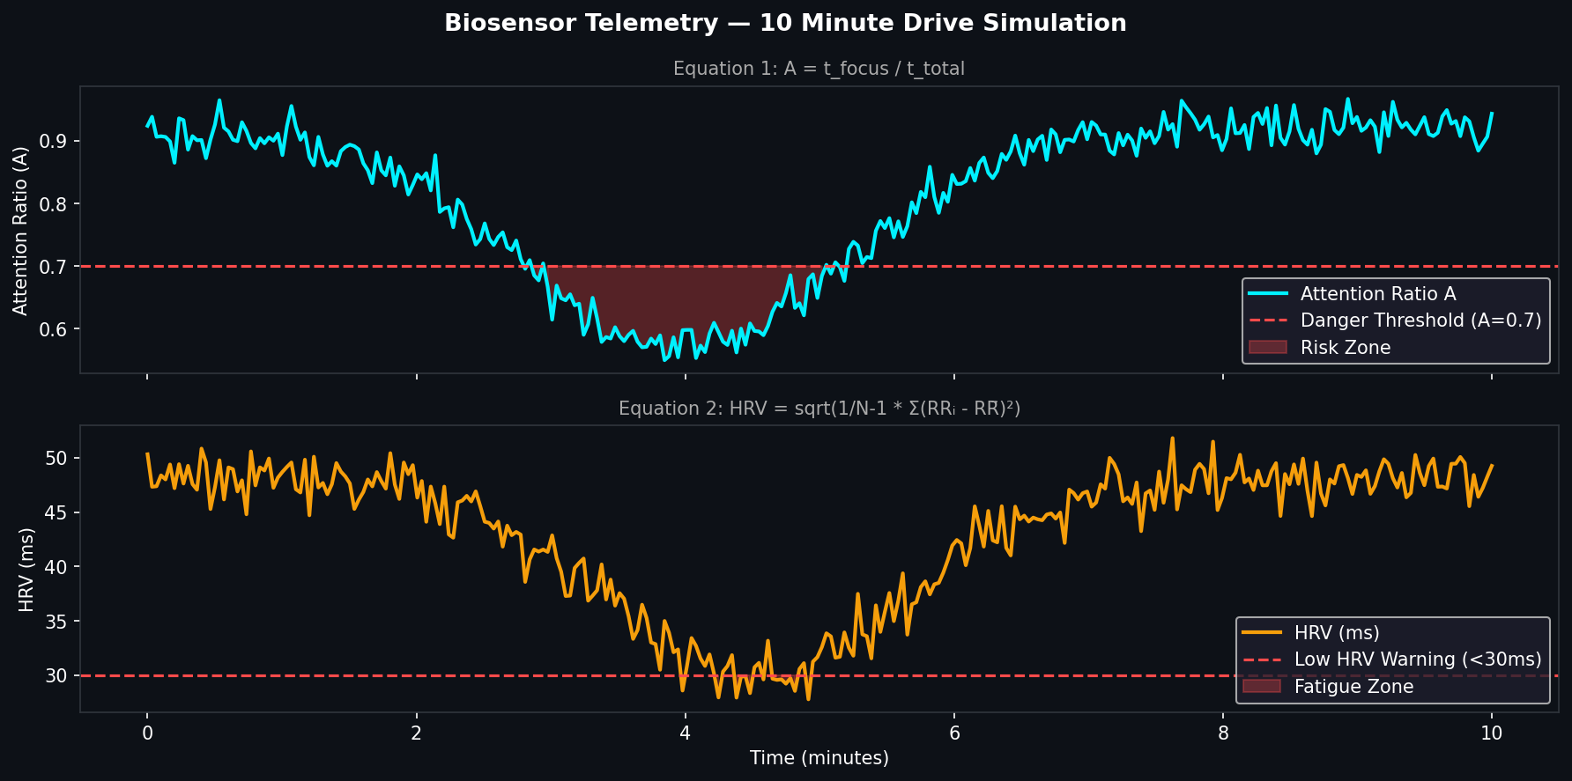
Fig. 9. Simulated 10-minute drive: Attention Ratio (top) and HRV (bottom) with danger thresholds and risk zones highlighted.

C. K-Means Clustering Results
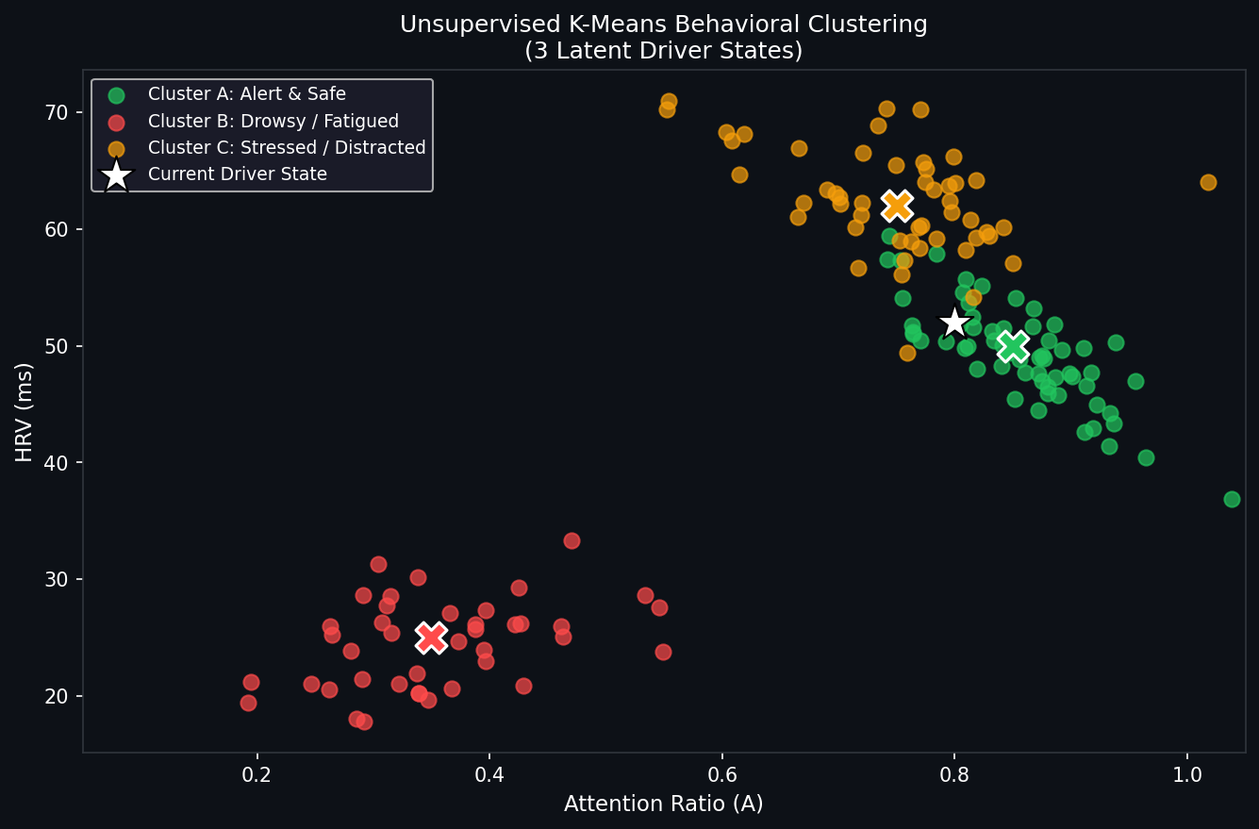
Fig. 10. K-Means clustering (k=3) in [Attention Ratio, HRV] feature space. ✕ = cluster centroids. ★ = current driver position.

VII. Discussion
EfficientNet-B0 outperforms all evaluated architectures with ~94.9% accuracy and a compact 5.3M parameter footprint — achieving ResNet-50 level accuracy with 8× fewer parameters. Its compound scaling mechanism jointly optimises depth, width, and input resolution, yielding superior feature extraction without disproportionate compute cost.
MobileNetV2, despite its lower accuracy ceiling (~91.8%), achieves the highest inference speed (85 FPS on Jetson Nano) due to depthwise separable convolutions. For real-time edge deployment where latency is critical, this architecture is the pragmatic choice.
The Custom CNN, while achieving only ~86.5%, provides the highest pedagogical value. Its transparency — every layer written manually — makes it the ideal model for academic explanation, as each block's function can be traced directly to learned feature maps.

VIII. Conclusion & Future Work
This paper presented a comprehensive AI-powered road safety system combining supervised driver behavior classification, unsupervised behavioral clustering, and real-world-inspired Greyspot mobility analysis. Through rigorous comparison of four CNN architectures, we demonstrate that EfficientNet-B0 is the optimal production model, while MobileNetV2 is best suited for edge devices. The interactive Streamlit dashboard provides an interpretable interface for live inference, model comparison, and sensor telemetry visualization.
Future work includes: (1) ONNX/TensorRT export for Jetson Nano deployment, (2) real ECG/PPG biosensor integration, (3) live video stream inference via OpenCV, and (4) Grad-CAM visualization for explainable AI.

References
- [1] World Health Organization, 'Global Status Report on Road Safety 2023,' WHO Press, Geneva, 2023.
- [2] DST India / IIIT Hyderabad, 'iRASTE — Intelligent Solutions for Road Safety through Technology and Engineering,' Nagpur Pilot Project, 2022. [Online] https://dst.gov.in/ai-make-roads-india-safer-drive
- [3] D. Kalla, 'AI-Powered Driver Behavior Analysis and Accident Prevention Systems for Advanced Driver Assistance,' International Journal of Scientific Research and Modern Technology (IJSRMT), Vol. 1, Issue 12, pp. 1–9, 2022.
- [4] M. Tan and Q. V. Le, 'EfficientNet: Rethinking Model Scaling for Convolutional Neural Networks,' ICML, 2019.
- [5] K. He, X. Zhang, S. Ren, J. Sun, 'Deep Residual Learning for Image Recognition,' CVPR, 2016.
- [6] A. G. Howard et al., 'MobileNets: Efficient Convolutional Neural Networks for Mobile Vision Applications,' arXiv:1704.04861, 2017.
- [7] State Farm, 'Distracted Driver Detection Dataset,' Kaggle Competition, 2016. [Online] https://www.kaggle.com/c/state-farm-distracted-driver-detection

