DISTRIBUTED JOB SCHEDULER
Design & Evaluation-Criteria Document
Prepared for: Codity.AI — Intern Assignment
Submitted by: Sapthagiri Rajan Rajamanickam(RA2311026010413)

1. System Architecture — 20 marks
The system is split into four independently deployable pieces: the API server (single source of truth), one or more worker processes, an embedded/relational data layer, and a dashboard client. This mirrors how a real distributed scheduler (e.g. Sidekiq, Celery, BullMQ) is structured, and lets the worker tier scale horizontally without any code change.

1.1 Component Diagram
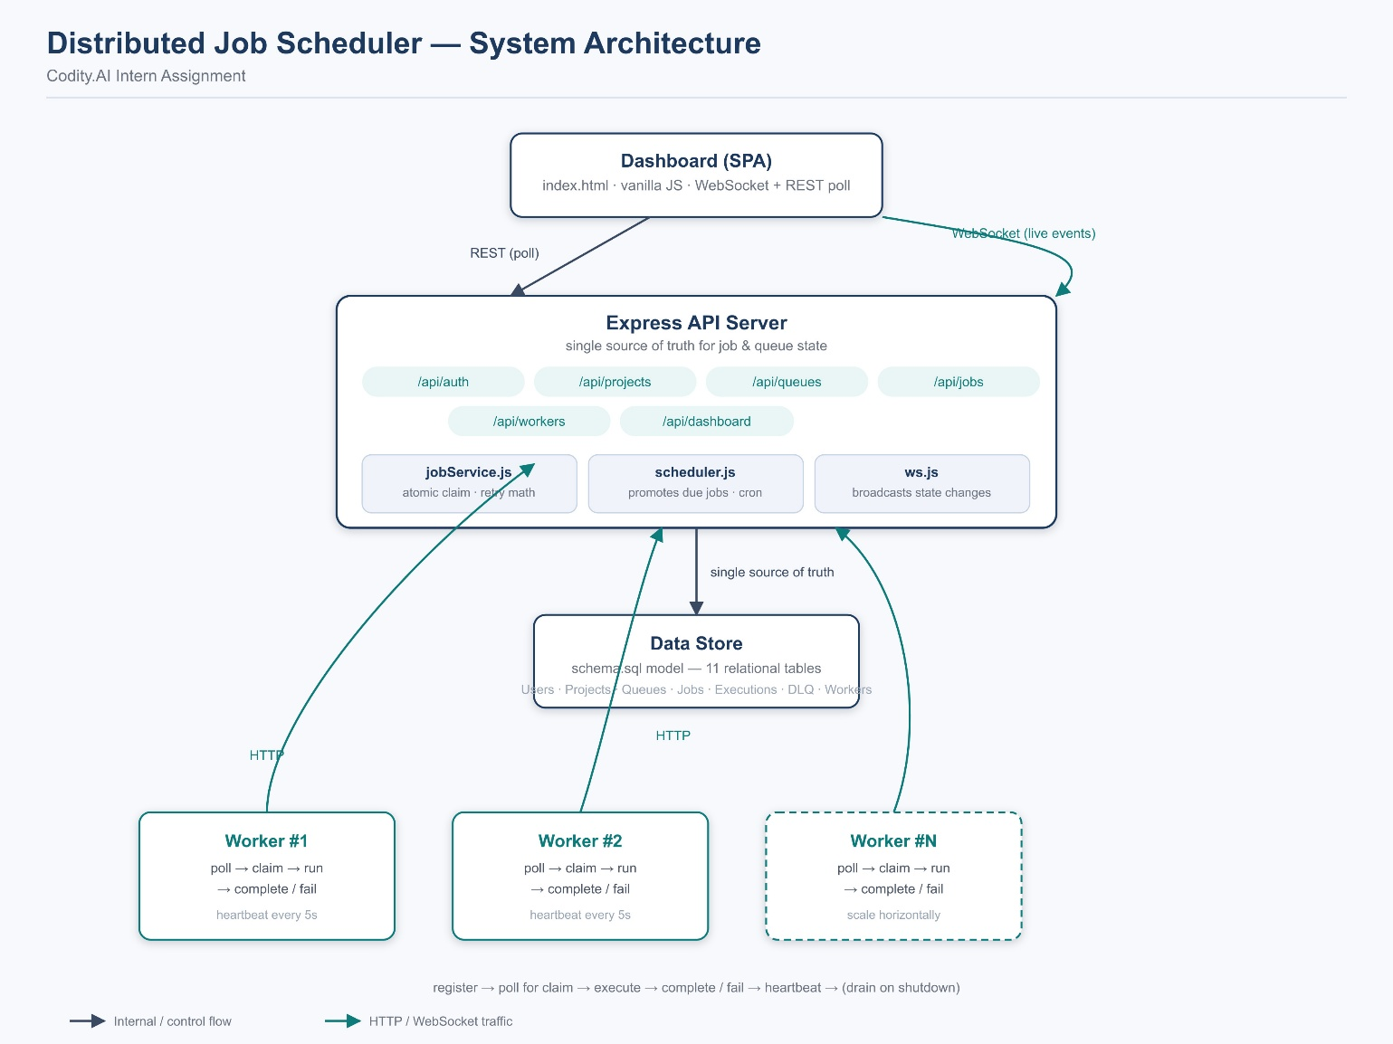

1.2 Key architectural decisions
- Workers are separate OS processes that talk to the API over HTTP (not direct DB access) — this keeps the atomic claim logic centralized in one place and lets workers run on different machines in a real deployment.
- The API server is the single source of truth for job state; the dashboard and workers are both just clients of it.
- A scheduler component runs inside the API process on a 1-second tick to promote delayed/scheduled jobs whose run_at has passed, and to expand recurring (cron) job definitions into concrete job instances.
- WebSocket broadcast (services/ws.js) decouples state changes from delivery — any number of dashboard clients can subscribe without polling load on the API.
- Swappable data layer: every module talks to store.js through a small method set (findById, insert, update, query) — replacing it with a real Postgres client is a single-file change, not a rewrite.

2. Database Design
A full relational schema (schema.sql) was designed first, independent of the runtime implementation. It defines 11 tables covering every entity the assignment specifies: Users, Organizations, Projects, Queues, Retry Policies, Jobs, Job Executions, Job Logs, Dead Letter Queue, Workers, and Worker Heartbeats.

2.1 Entity overview
- organizations → users → projects → queues → jobs: a strict ownership chain enforced with foreign keys and ON DELETE CASCADE, so deleting a project cleanly removes its queues and jobs.
- jobs → job_executions → job_logs: one job can have many execution attempts (one per retry), and each execution can have many log lines — this is what powers the full retry/audit history in the dashboard.
- dead_letter_queue keeps an independent payload_snapshot, so audit data survives even if the parent job row is later purged.
- retry_policies is a separate table (not columns on queues) so a queue's backoff strategy can be edited without touching the queue row itself, and could later support per-job overrides.

2.2 Keys, indexes, and performance
- Primary keys: UUIDs throughout, chosen so IDs can be generated by any node (API, worker, or offline batch import) without a central sequence — a prerequisite for a distributed system.
- idx_jobs_claim on (status, priority DESC, created_at ASC) — this is the exact access pattern the worker's claim query uses, so the highest-priority, oldest-eligible job is found in a single indexed scan instead of a table scan.
- Partial index idx_jobs_run_at ... WHERE status IN ('queued','scheduled') — keeps the "what's due" scheduler scan cheap as history accumulates, since completed/failed jobs (the majority over time) are excluded from the index entirely.
- UNIQUE(queue_id, idempotency_key) on jobs — lets API producers safely retry a job-creation call (e.g. after a network timeout) without ever creating a duplicate job.
- UNIQUE(project_id, name) on queues — prevents accidental duplicate queues inside one project.

2.3 Normalization & trade-offs
The schema is normalized to 3NF: no repeating groups, and derived/aggregatable data (like queue stats) is computed on read from job rows rather than stored redundantly, avoiding update anomalies. The one deliberate denormalization is dead_letter_queue.payload_snapshot, which duplicates jobs.payload — justified because DLQ entries must remain inspectable even after the parent job is purged for retention/cleanup.

3. Backend Engineering

3.1 Modular layering
- routes/ — thin HTTP handlers only: parse input, call a service, shape the response.
- services/ — all business logic (jobService, scheduler, ws) lives here, independent of Express, so it is unit-testable without spinning up a server.
- middleware/ — cross-cutting concerns (JWT auth, RBAC) applied declaratively per route.
- db/ — the only module allowed to touch persistent state, isolating the eventual swap to a real relational database.

3.2 Validation & error handling
- Every job-type-specific requirement is validated before a row is created (e.g. delayed/scheduled jobs must include run_at; recurring jobs must include a cron_expression).
- Errors carry an explicit HTTP status (err.status) set at the point of failure and surfaced by a single centralized error-handling middleware, so every endpoint returns a consistent { error: string } shape.

3.3 Configurability
- Per-queue configuration: priority, concurrency_limit, is_paused, rate_limit_per_min, and an attached retry policy (strategy, base_delay_ms, max_retries, max_delay_ms) — all editable at runtime via PATCH without restarting anything.
- Structured, timestamped request logging on every API call (method, path, status, duration) for operational visibility.

3.4 API surface (representative endpoints)
- POST /api/auth/register, /api/auth/login
- POST /api/projects, GET /api/projects
- POST /api/projects/:id/queues, PATCH /api/queues/:id, POST /api/queues/:id/pause|resume
- POST /api/queues/:id/jobs (all 5 job types), GET /api/queues/:id/jobs (paginated + filterable)
- GET /api/jobs/:id (full execution + log history)
- POST /api/workers/register, /api/workers/:id/claim, /api/workers/:id/heartbeat, /api/workers/:id/drain
- POST /api/jobs/:id/complete, /api/jobs/:id/fail
- GET /api/queues/:id/dlq, POST /api/dlq/:id/retry
- GET /api/dashboard/metrics/overview

4. Reliability & Concurrency

4.1 Job lifecycle
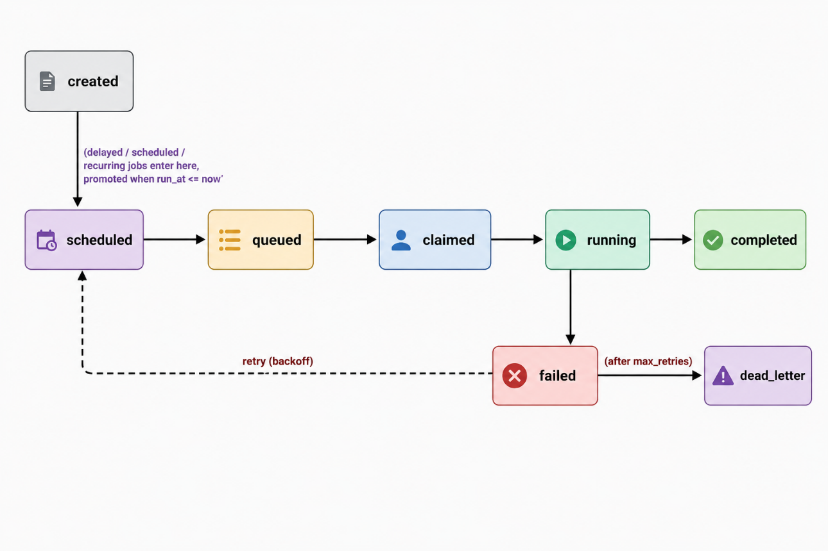

4.2 Atomic claiming
The core correctness guarantee of a distributed scheduler is that two workers can never execute the same job. claimNextJob() performs the eligibility check and the queued → claimed status flip inside one synchronous function call on the API server — since the server is single-threaded, no other request can interleave mid-check. This is functionally equivalent to a SQL:
UPDATE jobs SET status='claimed', claimed_by=$1
WHERE id = (SELECT id FROM jobs WHERE status='queued'
ORDER BY priority DESC, created_at ASC
LIMIT 1 FOR UPDATE SKIP LOCKED) RETURNING *;
This mapping to a real transactional statement is intentional and documented inline in jobService.js, so migrating to Postgres preserves the exact same guarantee under true multi-process concurrency.

4.3 Retry & backoff
- Fixed delay: constant wait between attempts.
- Linear backoff: delay grows linearly with attempt number (base × attempt).
- Exponential backoff (default): delay doubles each attempt, capped at max_delay_ms, with ±10% random jitter to avoid retry storms across many jobs failing at once.
- After max_retries is exhausted, the job is moved to the Dead Letter Queue with a snapshot of its payload and final error, and is never silently dropped.

4.4 Liveness & graceful shutdown
- Workers send a heartbeat (active job count, load, memory) on a fixed interval; a worker is shown as offline in the dashboard if no heartbeat has arrived recently.
- On SIGINT/SIGTERM, a worker signals /drain, stops claiming new jobs, and waits (up to 30s) for in-flight jobs to finish before exiting — no job is abandoned mid-execution on a normal shutdown.
- Per-queue concurrency_limit is enforced at claim time, so a single busy queue cannot starve others sharing the same worker pool.

5. Frontend & UX
- Single dashboard covering every required view: queue health cards, a filterable/paginated job explorer, worker status list, and a Dead Letter Queue table with one-click retry.
- Live activity feed and metric cards update automatically over WebSocket as jobs move through their lifecycle — no manual refresh needed to see a job get claimed, retried, or dead-lettered.
- Queue and job creation are handled through lightweight modal forms (new project, new queue with retry-policy config, new job of any of the 5 types) rather than requiring API calls by hand.
- Status is always shown with consistent color-coded pills (queued/scheduled/running/completed/dead_letter) so system health is readable at a glance.
- The UI is a single dependency-free HTML file — it can be opened directly in a browser with no build step, which keeps the reviewer's setup friction near zero.

6. API Design
- Consistent resource hierarchy: /projects/:id/queues/:id/jobs mirrors the actual ownership model, so URLs are predictable.
- List endpoints return a uniform envelope ({ data, page, limit, total, total_pages } or { data, count }), so the frontend never special-cases a response shape.
- Authentication boundary is explicit: user-facing routes require a JWT; worker routes are identified by worker id since they're called by backend processes, not logged-in humans — documented and enforced by route-mounting order in server.js.
- Job creation is idempotent when an idempotency_key is supplied, so retried client calls (e.g. after a timeout) never create duplicate jobs.
- Mutating actions that change system behavior (pause/resume a queue, retry a DLQ entry) are modeled as explicit POST sub-resources rather than overloading PATCH, keeping intent obvious in the URL.

7. Documentation — 5 marks
- README.md includes an architecture diagram, exact setup/run commands for both the API and worker processes, a full mapping of implemented core requirements, and a dedicated design-decisions & trade-offs section.
- schema.sql is commented inline at the point of each design choice (why a partial index exists, why UUIDs, why cascade behavior is set a certain way) rather than in a separate document, so the reasoning stays next to the code it explains.
- This document exists specifically to walk a reviewer through how each graded criterion is met, without requiring them to reverse-engineer coverage from the code alone.
- A "What I'd do with more time" section in the README is included deliberately — it signals awareness of the gap between this submission and a production system (e.g. wiring RBAC everywhere, workflow dependencies, a real Postgres migration).

8. Testing — 5 marks

8.1 What was manually verified end-to-end
- Full happy path: register → create project → create queue with a retry policy → create a job of each of the 5 types → start a worker → confirm atomic claim, execution, and completion.
- Failure path: a simulated job failure correctly triggers a scheduled retry with a computed backoff delay, and the job is re-claimed and completed on a later attempt.
- Dead Letter Queue path: a job exceeding max_retries is moved to the DLQ with a payload snapshot, visible in the dashboard, and can be manually re-queued from there.
- Queue controls: pause/resume correctly stops/resumes claiming from that queue without affecting others.
- Concurrency limits: a queue's concurrency_limit correctly caps how many jobs from it can be running at once, even under multiple parallel job submissions.

8.2 Automated test plan (documented, next step)
- Unit tests for computeRetryDelayMs() across all three strategies, asserting monotonic growth and the max_delay_ms cap.
- Concurrency test: fire N simultaneous claim requests against a queue with 1 eligible job and assert exactly one caller receives it.
- Integration tests for the full lifecycle transition table (queued → claimed → running → completed, and the failure → retry → dead_letter branch), asserting DB state after each transition.
- API contract tests for validation errors (missing run_at on a delayed job, missing cron_expression on a recurring job, invalid job type).

