IOT Air & Sound Pollution Monitoring System

Air and sound pollution is a growing issue these days. It is necessary to monitor air quality and keep it under control for a better future and healthy living for all. Here we propose an air quality as well as sound pollution monitoring system that allows us to monitor and check live air quality as well as sound pollution in a particular areas through IOT. System uses air sensors to sense presence of harmful gases/compounds in the air and constantly transmit this data to microcontroller. Also system keeps measuring sound level and reports it to the online server over IOT. The sensors interact with microcontroller which processes this data and transmits it over internet. This allows authorities to monitor air pollution in different areas and take action against it. Also authorities can keep a watch on the noise pollution near schools, hospitals and no honking areas, and if system detects air quality and noise issues it alerts authorities so they can take measures to control the issue.

Block Diagram :
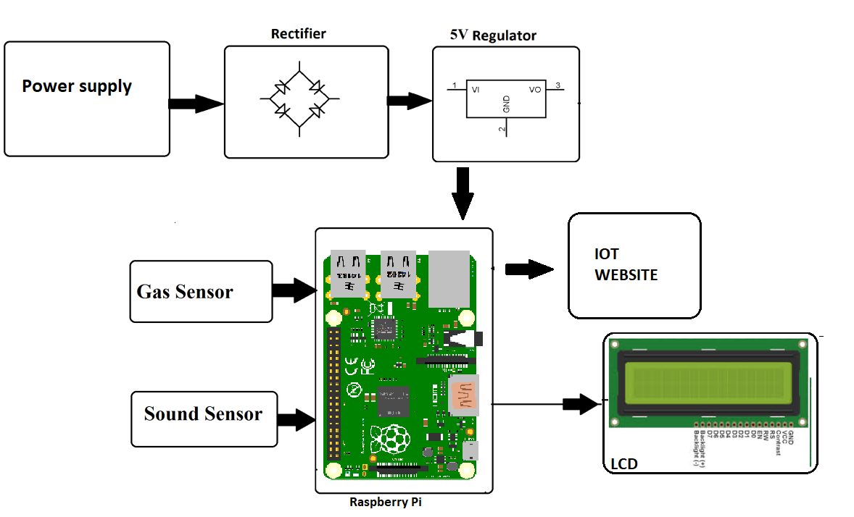

Hardware Specifications :
- Air Pollution Sensors
- Sound Sensors
- Atmega 328 Microcontroller
- Wifi Modem
- LCD Display
- LED’s
- Transformer
- Resistors
- Capacitors
- Diodes
Software Specifications :
- Arduino Compiler
- MC Programming Language: C

Reference
- http://ieeexplore.ieee.org/xpl/articleDetails.jsp?arnumber=7361361&queryText=iot%20pollution&newsearch=true

