LevelSVG Manual

Installing Inkscape
Warning: The SVG parser ONLY supports SVG files generated by Inkscape. You should NOT use any other SVG editor to generate the SVG files.

Download:
- http://www.inkscape.org/download/
Use version 0.47, 0.48 or newer. Older version are not supported.

Preferences:
- Open Inkscape
- Open Inkscape preferences (File → Inkscape Preferences )
- Set the SVG output preferences
- Path data
- Allow relative coordinates MUST be DISABLED
- Force repeat commands SHOULD be ENABLED for debugging purposes
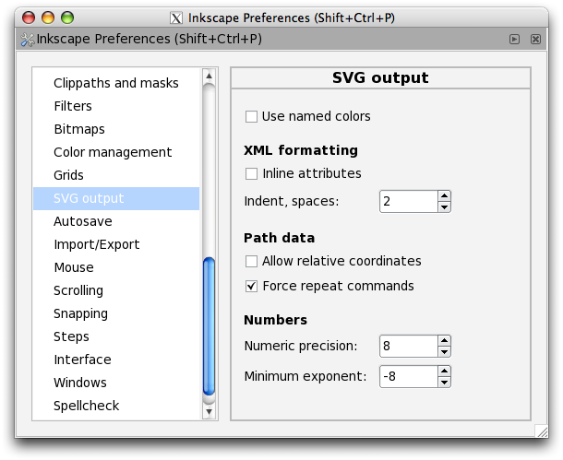

Using Inkscape

Layers
In your SVG file you can have as many layers as you want, but only the layers that begins with the physics: name will be parsed.
Example of layers:
- physics:static (notice that “static” is a helper name)
- physics:dynamic (“dynamic” is also a helper name)
- physics:enemies (“enemies”, another helper name)
- map (this layer won't be parsed)
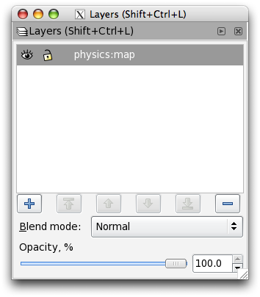

Supported SVG objects

Supported Inkscape objects:
- Rectangles: It will create a solid box2d rectangle (1 fixture). They support: restitution, density, friction and isSensor. Take into account that rounded boxes are not supported.
- 3D Boxes: They are supported, but they are not very useful for 2d games.
- Ellipses: It will create a solid box2d circle (1 fixture). If the X-radius is different from the Y-radius, it will create a circle of radius: (rx+ry)/2. They support: restitution, density, friction and isSensor.
- Stars: It will create a body with multiple edges (multiples fixtures). Since these objects are not “solid” objects, density is not supported.
- Spirals: It will create a body with multiple edges (multiple fixtures). Since these objects are not “solid” objects, density is not supported.
- Pencil: Limited support. Warning: Only useful to create straight lines. If it is used as a 'freehand' pencil, it will create objects that will make box2d crash.
- Pen: It will create a body with multiple edges (multiple fixtures). Since these objects are not “solid” objects, density is not supported.
- Calligraphy: Limited support. Warning: Only works with very simple objects, otherwise it will create objects that will make box2d crash.
- Text: Not supported

Additional features:
- Each of the supported objects can be transformed (translated, rotated and/or scaled)
- Each of the supported objects can be grouped with other supported objects.
- Each of the supported objects can be joined (union) with other supported objects, thus, creating just one box2d object.

Integration with physics
For each SVG object a b2Body will be created. You can't create compound shapes in Inkscape, but you can do it from the “game_data” callback. See: Integration with your game.

Supported physics properties in the created SVG objects:
- restitution: float number. The restitution (elasticity) usually in the range [0,1].
- density: float number. If density is not present or if density is 0, the body will be treated as an static body. Otherwise it will be treated as a dynamic body. Usually in kg/m^2.
- friction: float number. The friction coefficient, usually in the range [0,1].
- isSensor: expects a boolean (0 or 1). Only supported on “solid” objects (circles and rectangles)
- fixedRotation: expects a boolean (0 or 1). If enabled, then the body won't rotate.
- type: an string. It could be “static”, “dynamic” or “kinematic”. By default it will be “static” if density is 0. If density is > 0 then, by default it will be “dynamic”.

To add any of these properties, you need to open the XML editor (Shift + Control + X).

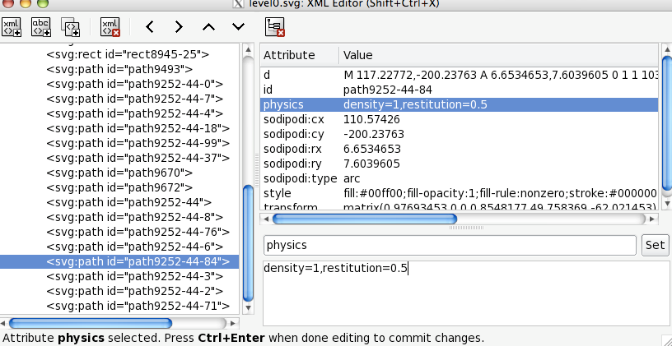
You have to add the physics attribute to the elements that you want to edit.
The value is list of key-values separated with comas. Example of possible values:
density=0.3,friction=0.5,restitution=0.9

The order is not important.

Level configuration
You can also configure some level variables like:
- gravity_x: a float for the horizontal gravity (default is 0)
- gravity_y:a float for the vertical gravity (default is -10)
- controls:
- 2way: Supports only horizontal movement of the hero
- 4way: Supports both horizontal and vertical movement of the hero (default)
- 4waycar: Supports both horizontal and vertical movement with 4 buttons: up, down, left and right. Use this joystick to control the HeroCarTopDown hero.
- buttons: How many buttons the 2way and the 4way joystick will have. The value can be between 0 and 2 (default value is 1)

To do so, you need to edit the 1st SVG element, in particular you need to edit the <svg:svg> element, and you need to add the game_config attribute to it:

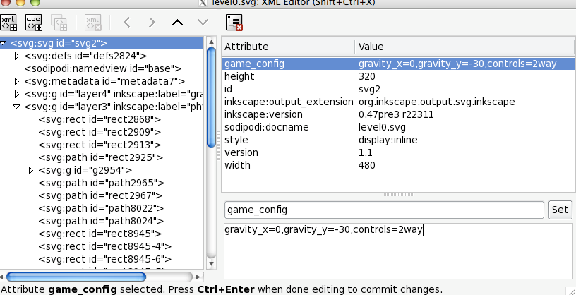

Integration with your game
You can also link elements (box2d bodies) with cocos2d objects using the game_data attribute.
At present, the only supported keys are object and objectParams but you can extend it easily to match your needs.
Example:
game_data="object=portal,objectParams=moveToX:80;moveToY:1730"

Supported objects:

herobox:

- object=herobox
- It is a “Hero”, it means that it will create a main character. It can only be 1 hero per level.
- It is implemented in the HeroBox.mm file, with the class Herobox
- It is a subclass of Hero.
- It is implemented with 1 b2body with 1 boxed shape, with fixed rotation.
- It is a dynamic object.
- It is animated when it walks
- Supported parameters: n/a
- Used in levels: Level 2, Level 4 and Playground0

heroround:

- object=heroround
- It is a “Hero”, it means that it will create a main character. It can only be 1 hero per level.
- It is implemented in the HeroRound.mm file, with the class Heroround.
- It is a subclass of Hero.
- It is implemented with 1 b2body with a circular shape.
- It is a dynamic object.
- Supported parameters: n/a
- Used in levels: Level0, Level1, Level3 and Playground1

herocar:

- object=herocar
- It is a “Hero”, it means that it will create a main character. It can only be 1 hero per level.
- It is implemented in the HeroCar.mm file, with the class Herocar
- It is a subclass of Hero.
- It is implemented with several b2bodies and shapes. It is a complex box2d object.
- It is a dynamic object.
- Supported parameters: n/a
- Used in levels: Level5

herocartopdown:
- object=herocartopdown
- It is a “Hero”, it means that it will create a main character. It can only be 1 hero per level.
- It is implemented in the HeroCarTopDown.mm file, with the class Herocartopdown
- It is a subclass of Hero.
- It is implemented with several b2bodies and shapes. It is a complex box2d object.
- It is a dynamic object.
- Supported parameters: n/a
- Used in levels: Level7

princess:

- object=princess
- The “goal”. The hero needs to touch it in order to complete the level. There can be as many “princess” as you want.
- It is implemented in the file Princess.mm with the class Princess.
- It is a subclass of BodyNode
- It is implemented using 1 b2body and 1 circular fixture.
- It is a dynamic object.
- Supported parameters: n/a
- Used in levels: Level0, Level1, Level2, Level3, Playground0 and Playground1

princessbox:

- object=princessbox
- This is another “goal” object, like Princess.
- It is implemented in the file PrincessBox.mm with the class PrincessBox.
- It is a subclass of Princess
- It is implemented using 1 b2body and 1 box2d fixture.
- It is a dynamic object.
- The sprite is animated with several sprite frames.
- Supported parameters: n/a
- Used in levels: Level4 and Level5

enemy:

- object=enemy
- If the 'hero' touches any of these objects, he lose 1 life.
- It is implemented in Enemy.mm file in the class Enemy.
- It is implemented using 1 b2body with 1 circular fixture.
- It is a dynamic object.
- It is a subclass of BadGuy
- Supported parameters ( objectParams=patrolTime:0;patrolSpeed:2 )
- patrolTime (float): the time it takes to go from left to right. Default: 0 (no movement)
- patrolSpeed (float): the speed of the patrol (the speed is in Box2d units). Default: 2
- This object can by dragged by default.
- Used in levels: Level0, Level3, Level4

enemycar:
- object=enemycar
- Another kind of enemy, this time with the shape of a sort of car
- Supported parameters ( object=enemycar,objectParams=motorRPM:-250 )
- motorRPM (float): The RPM of the “right” wheel. If the value is negative, it will move to the left. If it is positive, it will move to the right.
- Used in levels: level6

hole:
- object=hole
- Another kind of enemy. If the Hero touches any of these objects, it will lose 1 life.
- It is implemented in Hole.mm file in the class Hole.
- It is an static object.
- It is a subclass of BadGuy
- Used in levels: Level1

poison:
- object=poison:
- Similar to hole, but this time it will be an invisible object.
- Useful if you want to draw it using a TMX map.
- It is implemented in Poison.mm file in the class Poison.
- It is an static object.
- It is a subclass of BadGuy
- Used in levels: Level0 and Level4

platform1:
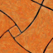
- object=platform1
- A One sided platform, AKA Super Mario platforms.
- It is implemented in the file Platform1.mm with the class Platform1
- It is a subclass of BodyNode
- It is an static object
- Supported parameters:
- visible (string): default: “yes”
- If you want to draw the platform using TMX maps, set objectParams=visible:no
- Used in levels: Level0, level2 and Level4

platform:
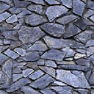
- object=platform
- A solid platform.
- It is implemented in the file Platform.mm with the class Platform
- It is a subclass of BodyNode
- It is an static object
- Used in levels: Level2.

movingplatform:
- object=movingplatform
- A platform that goes from horizontally or vertically.
- It is implemented in the file MovingPlatform.mm with the class MovingPlatform
- It is a subclass of BodyNode
- It is a kinematic object
- Supported parameters : objectParams=direction:horizontal;duration:2;translation:150
- direction (string): Possible values “horizontal” or “vertical”
- duration (float): in seconds.
- translation (float): in pixels
- Used in levels: level2 and level5

ladder:
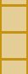
- object=ladder
- A 'ladder' object. When the HeroBox touches it, the hero can climb up or down.
- It is implemented with 1 dynamic.
- This object is a sensor.
- It is implemented in the Ladder.mm file with the class Ladder
- It is a subclass of BodyNode
- Used in levels: Level4 and Level6

spinner:

- object=spinner
- An 'spinner' object. It is recommended that you create a SVG circle element to define the spinner, since the spinner will be as big as the circle.
- It is implemented with 1 dynamic body with 2 shapes, 1 static body and 1 revolute joint.
- This object can be rotated by touching it.
- It is implemented in the Spinner.mm file with the class Spinner
- It is a subclass of BodyNode
- Used in levels: Level3

portal:
- object=portal
- When the Hero touches this object, the hero will be teleported to a certain location
- It is implemented in the Portal.mm file with the class Portal
- It is a subclass of BodyNode
- It is an static object.
- Supported parameters: (objectParams=moveToX:842;moveToY:800)
- moveToX (float): X location in pixels
- moveToY (float): Y location in pixels
- Used in levels: level4 and level5

chain:
- object=chain
- A complex object implemented using 9 b2body objects, 8 fixtures and 8 joints
- 8 b2bodies are dynamic objects, while the “attach” b2body is an static one.
- It is implemented in the Chain.mm file with the class Chain
- It is a subclass of BodyNode
- Used in levels: level5 and playground0

fruit:
- object=fruit
- A bonus node. When touched by the Hero, it will increase the score by 1.
- It is a sensor and static object.
- It is implemented in the Fruit.mm file with the class Fruit
- It is a subclass of BonusNode
- Used in levels: level0, level1, level2, level3, level4, level5 and playground0.
- Supported parameters: (objectParams=respawnTime:3)
- respawnTime (float): If 0, then the it won't be respawned. Otherwise the node will be respwawn N seconds after it has been touched by the hero

star:

- object=star
- A bonus node. When touched by the Hero, it will increase the score by 5.
- It is implemented in the Star.mm file with the class Star
- It is a subclass of BonusNode
- It is a sensor and static object.
- Used in levels: level0, level1, level2, level3, level4, level5 and playground0.
- Supported parameters: (objectParams=respawnTime:3)
- respawnTime (float): If 0, then the it won't be respawned. Otherwise the node will be respwawn N seconds after it has been touched by the hero

life:

- object=life
- A bonus node. When touched by the Hero it will increase the lives by 1.
- It is implemented in the Life.mm file with the class Life
- It is a subclass of BonusNode
- It is a sensor and static object.
- Used in levels: level0, level1, level2, level3, level4, level5 and playground0
- Supported parameters: (objectParams=respawnTime:3)
- respawnTime (float): If 0, then the it won't be respawned. Otherwise the node will be respwawn N seconds after it has been touched by the hero

Creating your own object

Subclassing BodyNode
You can easily add you own custom objects by editing extending the BodyNode class. Just create a subclass of BodyNode with the name that you want, and an instance of your class will be created each time the parser finds an object with it's name.

Example, when object=enemy is detected, an Enemy class will be instantiated.

WARNING: The class names MUST only have the initial character in capital letter.
Example of valid class names:
- Herobox
- Heroround
- Enemy
Example of invalid class names:
- HeroBox
- HeroRound
- enemy

How to create complex physics objects ?:
- Create complex box2d objects in Mekanimo or any other complex box2d editor. Coding complex box2d objects by hand (writing all the code) is also possible.
- In Inkscape create a simple object with more or less the dimensions of the complex object
- Add the game_data attribute to that object
- Create a subclass of BodyNode

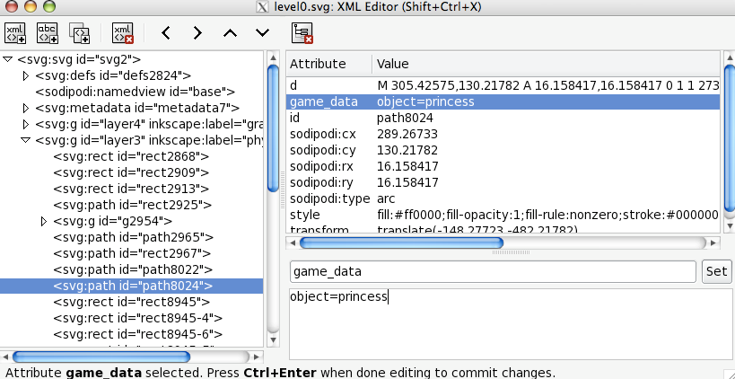

For example, take a look at the 'spinner' object. It is a complex object that was coded by 'hand' but it's size and position are defined within Inkscape. See Spinner.mm file for further information.

BodyNode
The BodyNode class is the class that links Box2d objects with cocos2d objects.
So, in order to create a LevelSVG object you must subclass BodyNode.
BodyNode has the following properties:
- reportContacts (int): (default: BN_CONTACT_NONE)
- BN_CONTACT_NONE
- BN_CONTACT_BEGIN
- BN_CONTACT_END
- BN_CONTACT_PRESOLVE
- BN_CONTACT_POSTSOLVE
- or any combination like: BN_CONTACT_BEGIN | BN_CONTACT_END

- isTouchable (BOOL): (default: NO)
- Is YES, then the object can be dragged by touching it
- properties (int): (default: BN_PROPERTY_SPRITE_UPDATED_BY_PHYSICS)
- BN_PROPERTY_NONE
- BN_PROPERTY_SPRITE_UPDATED_BY_PHYSICS
- If you want to update the object using cocos2d (manually), then set the value BN_PROPERTY_NONE.

For example, lets see the Enemy class:

@implementation Enemy
-(id) initWithBody:(b2Body*)body game:(GameNode*)game
{
if( (self=[super initWithSpriteFrameName:@"sprite_enemy_01.png"] ) ) {

// bodyNode properties
reportContacts_ = BN_CONTACT_NONE; // <---- NO CONTACTS WILL BE REPORTED
body_ = body;
isTouchable_ = YES; // <----- THIS OBJECT CAN BE DRAGGED

…

}
return self;
}

@end

