Folder di codeigniter beserta kegunaannya

app → core aplikasi nya
public → tempat penyimpanan asset aplikasi
contoh asset = image,js,css etc
public.htaccess → file yang membersihkan jenis file yang digunakan pada url aplikasi dengan mod-rewrite
test → pengujian aplikasi
vendor → tempat penyimpanan dependency seperti third party dengan menggunakan composer
writeable → ngga penting

Whenever you create an application, you have to find a way to organize the code to make it simple to locate the proper files and make it simple to maintain. Like most of the web frameworks, CodeIgniter uses the Model, View, Controller (MVC) pattern to organize the files. This keeps the data, the presentation, and flow through the application as separate parts. It should be noted that there are many views on the exact roles of each element, but this document describes our take on it. If you think of it differently, you’re free to modify how you use each piece as you need.
Models manage the data of the application and help to enforce any special business rules the application might need.we can set up our rest Api on this folder.
Views are simple files, with little to no logic, that display the information to the user. We can set up our interface on this folder.
Controllers act as glue code, marshaling data back and forth between the view (or the user that’s seeing it) and the data storage(model folder). This folder uses to manage between user and our application,so usually called in front of layer on our application.

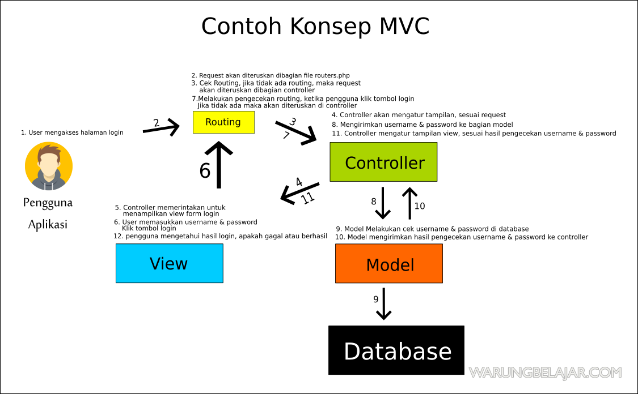

What is a Controller?
A Controller is simply a class file that is named in a way that it can be associated with a URL.
Sebelum masuk url di controller kita harus tau urutan url di codeigniter atau disebut url segment
example.com/class/method/ID

diatas itu merupakan urutan url secara pengetahuan dan index.php dihapus oleh htaccess.
By default URL set up in general:

example.com/index.php/helloworld/ →

index.php pada url itu berasal dari bootstrap jadi seluruh komponen bootstrap dipanggil.kita bisa sebut itu core route dari segala routes yang ada.

Contoh

index.php → file baru di controller terus kita tambahin sebagai contoh di url nama file tersebut helloworld. Kalau bingung kenapa nama file disebut class karena di codeigniter menggunakan konsep oop dalam codenya.

the “index” method is always loaded by default if the second segment of the URI is empty. Jadi disini kita wajib mengisi method index di setiap file controller kita agar dijadikan method default dari class tersebut.

Set up method on routers

Cara pertama

$routes→setDefaultController('Helloworld'); kalau pake cara kedua seperti ini
$routes->get('/', 'Helloworld::index');

cara kedua

$routes->get('/', 'Home::index');kalau pake cara pertama seperti ini
$routes→setDefaultController('Home');

Set up method on method

cara pertama

$routes->setDefaultMethod('index');

cara kedua

$routes->get('/', 'customer::index');

bedanya dimana?

Secara coding di kerjaan pasti setiap controller/api pasti ada bagian disitu aku pakai bagian customer kemudian aku mengatur arah routing nya ke index,namun cara pertama aku set up itu secara global dalam artian di app/controller nya langsung atau core routing.

Nah untuk segment seterusnya atau method selanjutnya kita bisa mengubah method ke parameter atau secara sederhana kita panggil paramater aja biar ngga bingung.

