**What is the difference between SDK, JRE and JDK**

* SDK - Software Development Kit -toolkit intended for coding on specific platform / software / framework
* JDK - Java Development Kit- toolkit intended for coding in Java
* JRE - Java Runtime Environment (programs capable to launch Java applications)

JDK includes JRE

**What is the difference between 3 tools eclipse/junit/intelliJ**

IntelliJ is a Java IDE for pros and students, Eclipse focuses on open-source and has wide range of optimized IDEs. Compared to IntelliJ IDEA, Eclipse comes in many other languages. Also, it is a bigger project than IntelliJ IDEA. IntelliJ IDEA offers the Community Edition as the production-ready variant of its IDE while no commercial IDE is offered by Eclipse. Eclipse is also available as a cloud-based IDE unlike Intellij

**get to know commands for windows**

1. Ping Command

When you ping a device you send that device a short message, which it then sends back (the echo).

Example: ping www.google.com or ping 216.58.208.68

2. ipconfig Command

Another indispensable and frequently used utility that is used for finding network information about your local machine like IP addresses, DNS addresses etc

Basic Use: Finding Your IP Address and Default Gateway

Type the command ipconfig at the prompt.

The following is displayed

router-internet-setup-3

Ip config has a number of switches the most common are:

* ipconfig /all – displays more information about the network setup on your systems including the MAC address.
* ipconfig /release – release the current IP address
* ipconfig /renew – renew IP address
* ipconfig /? -shows help
* ipconfig/flushdns – flush the dns cache

3. Hostname Command

A very simple command that displays the host name of your machine. This is much quicker than going to the control panel>system route.

windows-network-command-hostname

4. getmac Command

Another very simple command that shows the MAC address of your network interfaces

windows-network-command-getmac

5. arp Command

This is used for showing the address resolution cache. This command must be used with a command line switch arp -a is the most common.

windows-network-command-arp

Type arp at the command line to see all available options.

See using arp in the basic networking course

6. NSlookup

Used for checking DNS record entries. See Using NSlookup for more details

7. Nbtstat

Diagnostic tool for troubleshooting netBIOS problems. See This technet article.

8 Net Command

Used for managing users,service,shares etc see here

9. Netstat Command

Used for displaying information about tcp and udp connections and ports. See tcp and udp ports and sockets and how to use the netstat command

10. TaskKill Command

**get shortcut keys of your javaTool**

CTRL + D – delete row

Ctr+ Space – Autocomplete

Ctr + e – all editors

Ctr + N – new wizard

Alt + Up – move the row up or down

Alt + left/ right – last location edited

**what are ascii values**

They are the 7 bit set of characters containing 128 characters. They range for A-Z upper and lower case, special characters, digits, etc

**Can we have an else condition without if condition?**

Else statements do not work unless they are associated with an if statement. Ensure that you have an if statement and that your else statement isn't nested within your if statement.

**Other than boolean can we use anything in if condition?**

the break is necessary to avoid passing through to the code under the next label.

**Why github gives u free of cost to create new repository?**

So that programmers can be much more collaborative and grow together as a community. Everyone will be able to benefit and access these resources

**What is agile?**

Agile software development refers to a group of software development methodologies based on iterative development, where requirements and solutions evolve through collaboration between self-organizing cross-functional teams.

**What are the ticketing tools used in agile?**

**How many version control tools are there?**

There are a lot of version control tools available

Some examples are:--

GitHub,Git,GitLab,Apache Subversion (SVN),CVS,Mercurial,Monotone,Bitbucket Server,Team Foundation Server (TFS),Bazaar

**What is scrum call?**

The Scrum team reviews what happened during the sprint to determine what worked, what didn't work, and how they can improve the process during the next sprint.

**Understand difference between WAR,EAR,JAR file?**

JAR file allows Java Runtime Environment (JRE) to deploy an entire application including the classes and related resources in a single request. WAR file allows testing and deploying web applications easily while EAR file allows deploying different modules onto an application server simultaneously

**Is java 100% Object oriented language?**

It doesn’t support primitive datatype(like int, char, float, bool, etc.). There are seven qualities to be satisfied for a programming language to be pure Object Oriented. They are:

Encapsulation/Data Hiding

Inheritance

Polymorphism

Abstraction

All predefined types are objects

All user defined types are objects

All operations performed on objects must be only through methods exposed at the objects.

**What is Debugging?**

Debugging means to run your code step by step in a debugging tool like Eclipse,

to find the exact point where you made a programming mistake.

You then understand what corrections you need to make in your code, and debugging tools often allow you to make temporary changes so you can continue running the program.

**What are the default packages present in java?**

Java.lang is imported by default

**Understand the naming conventions**

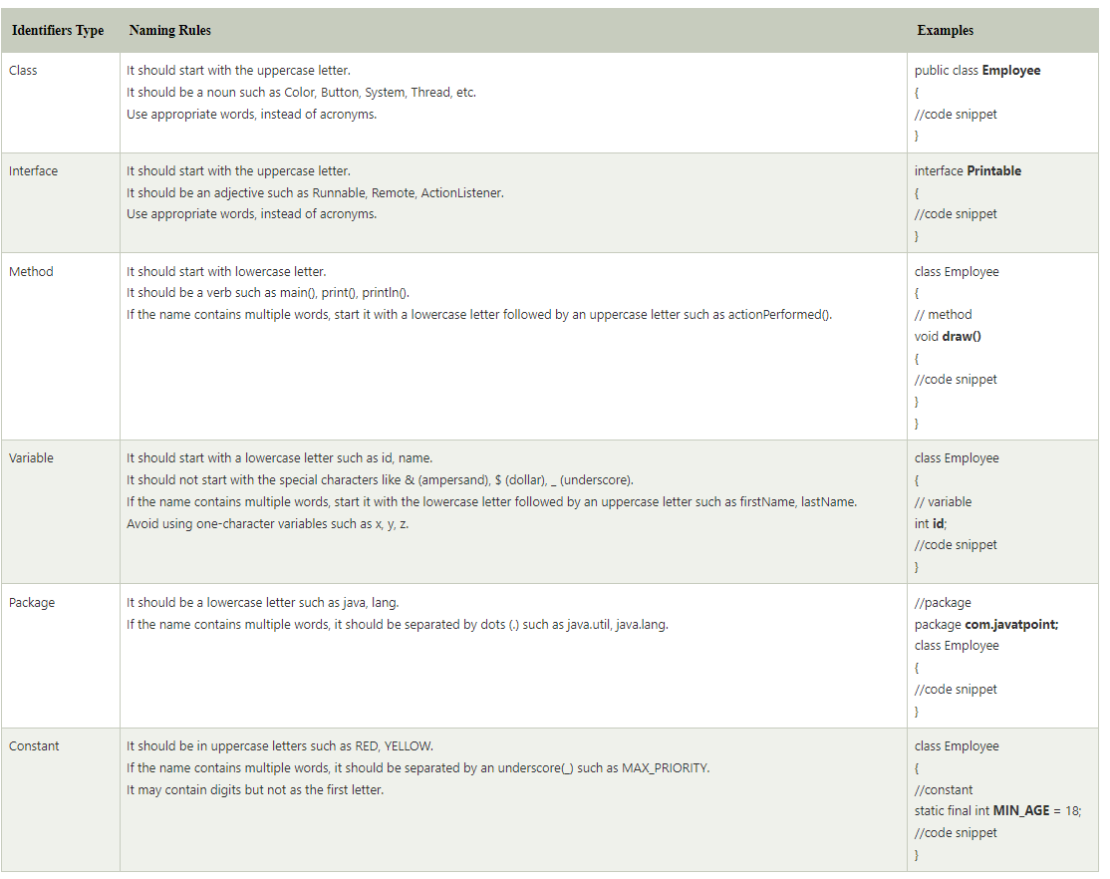

**How can you tell the technology by seeing URL?**

The source code of a website is easily accessible from your browser. In Chrome, look for Developer Tools, in Firefox look for Web Developer in your menu. The source code's file extensions and URLs can tell you what type of platform the website is built on

**what is difference b/w constructor and fucntion in the class**

Constructor is used to initialize an object whereas method is used to exhibits functionality of an object.

Constructors are invoked implicitly whereas methods are invoked explicitly.

Constructor does not return any value where the method may/may not return a value.

In case constructor is not present, a default constructor is provided by java compiler. In the case of a method, no default method is provided.

Constructor should be of the same name as that of class. Method name should not be of the same name as that of class.

**who gives default constructor?**

If no constructors are given the compiler gives a default one

**what are other responsibilities if JVM?**

JVM is specifically responsible for converting bytecode to machine-specific code and is necessary in both JDK and JRE. It is also platform-dependent and performs many functions, including memory management and security.

**Is java call by reference or call by value**

There is only call by value in java, not call by reference. If we call a method passing a value, it is known as call by value. The changes being done in the called method, is not affected in the calling method.

**what happens if a final keyword is applied on class and function?**

On classes: prevents inheritance

On methods prevents overriding

**what happens if final keyword is applied on variable, class and method?**

On variable its value cannot be changed

**why string is passed in main method?**

Because by passing String arrays , we can pass all the necessary parameters like options/arguments related to the program in the form of String easily

**why only jvm gives default constructor?**

In case no constructor is provided then JVM has to provide default constructor.

**who provides extra functions in main method?**

Extra functions are provided by Java APIs and JDK

**predifined functions in collection.**

Executed in eclipse

**underlying ds for linked list,arraylist.**

LinkedList – Double Ended Queue

ArrayList – Array

**advantages and disadvatages of array list**

Arraylist advantages

It is not synchronized so it is fast.

It works fast when we have to fetch or get the elements fron the list.

It maintains insertion order, means any element by default will be added in the end of arraylist.

There can be duplicates in the arraylist.

Disadvantages

Never used Arraylist when you have to do lot of insertion and deletion as this will force arraylist to adjust the elements present in the list instead used linkedlist.

When you want to add elements in the last or first and the arraylist soze is 0, in this case u can use linkedlist to add specifically on top and bottom of list.

You can't maintain uniqueness.

Arraylist dnt work on primitive values.

**code for each collection eg:arraylist- Add,Delete,Print**

Executed in eclipse

**what are list iterator,iterator,enumerator with code.**

Enumeration is an interface. It is used in the collection framework in java to retrieve the elements one by one

An iterator is a universal cursor that can be applied to any collection object. It provides a single direction iteration.

ListIterator is the most powerful cursor among all the three cursors. ListIterator is only applicable for list implemented classes like ArrayList, LinkedList, Stack, etc. ListIterator traverses both in the forward and backward direction.

Code execution done in eclipse.

**What are iterators and cursors.**

In Java, Iterator is an interface available in Collection framework in java. util package. It is a Java Cursor used to iterate a collection of objects. It is used to traverse a collection object elements one by one.

Iterator- Iterator is an object that can be used to loop through collections

methods

hasNext() ,next() , remove()

Cursor- A Java Cursor is an Iterator, which is used to iterate or traverse or

retrieve a Collection or Stream object’s elements one by one.

Type of Cursor –

Iterator, Enumeration, ListIterator

**List down the security breaches than can happen in front end backend.**

10 OWASP-

1. Broken Access Control

2. Cryptographic Failures

3. Injection

4. Insecure Design

5. Security Misconfiguration

6. Vulnerable and Outdated Components

7. Identification and Authentication Failures

8. Software and Data Integrity Failures

9. Security Logging and Monitoring Failures

10. Server-Side Request Forgery

**IndexOutOfBoundsException and ArrayIndexOutOfBoundsException is same?**

IndexOutOfBoundsException: Thrown to indicate that an index of some sort (such as to an array, to a string, or to a vector) is out of range.

ArrayIndexOutOfBoundsException: Thrown to indicate that an array has been accessed with an illegal index. The index is either negative or greater than or equal to the size of the array.

**can catch be written without try?**

No, “Catch” has to written for a “Try”.

**can try be written without catch block?**

Yes, we can have “try” without “catch” block by using “finally” block.

we cannot write only “try” block without “catch” or a “finally” blocks.

**can finally be return without try catch?**

We cannot have a “finally” without a “try”, “Catch” is optional.

**When and why were collections added?**

Collection interface is used to add the element 'element' to this collection

**Difference between Collection and Collections**

The Collection is an interface whereas Collections is a utility class in Java. The Set, List, and Queue are some of the subinterfaces of Collection interface, a Map interface is also part of the Collections Framework, but it doesn't inherit Collection interface. The important methods of Collection interface are add(), remove(), size(), clear() etc and Collections class contains only static methods like sort(), min(), max(), fill(), copy(), reverse() etc.