Pakistan Aaisa Kyon Hai ?



**A Report By:**

**[Students of Namal University Mianwali]**

* Syed Sarib Naveed
* Dilawer Khan
* Muhammad Saqib Khan

**Instructor:**

* Junaid Akhter

**Contents**

**Preface** 4

**Abstract** 6

**Introduction** 6

**Purpose** 7

**Mehodology** 8

**Reading Data:** 8

**Variables and lists:** 9

**Selecting list:** 10

**Main part:** 11

**Function:** 11

**Result** 12

**Comparison with World:** 13

**Comparison with Continents:** 13

**Conclusion** 14

# **Preface**

Love to own country is human’s nature .Everyone wants to work for the prosperity of his country and to serve his beloved nation .Every human has certain factors in his mind that by doing so ,he/she can serve his country and nation as well .For this purpose ,a patriot passes his entire life and even most of them have no successful ending .We have lot of examples in history as well where different patriots have devoted their lives for their beloved country .They were true patriots .Even today are true patriots but they can’t do anything because they don’t know what to do .They lack knowledge in the terms that they don’t have in terms of data of their respected country. Educated patriots always leaves more advantage to their country .These educated patriots may be ministers of country as well .If they don’t know the facts about data of their country ,then that country has far less chances to progress .Another condition is that they know well but they can’t do anything due to laziness or any other factors about which they know .This type of country goes down and down and don’t make any kind of progress as compared to the world.

# **Abstract**

Pakistan from very first day, when it came into being is facing lot of challenges. Pakistan’s rank is very low as compared to other good countries. we find the reason for ‘why Pakistan is standing in that position’. During our project, we find many difficulties but with the lot of completed our project and find these reasons which show that ‘Pakistan Aaisa kyon Hai?

# **Introduction**

Pakistan from the very first day when it came into being is facing lot of challenges , many ups and downs and tough conditions till now .We all know that Pakistan is in tough condition and struggling hard on the way of progress .We just talk about it but we can’t do anything .Even in some conditions we don’t know anything why it is happening but we still behave as if we know everything .We are not well aware of the facts that in certain matters where we are standing and progress of country depends upon these matters .To be aware of these facts we have been assigned a project .This project contains data in excel sheet .Data in excel include all of countries in the world and different years data from 1952 to 2012 with different indicators like agricultural land , imports , exports , income per person and many others . We have to calculate data for each country using python(a worldwide programming language) .

# **Purpose**

The main purpose of this assigned task to calculate the data for Pakistan and to tell why Pakistan is in such state from independence day. Another purpose was to make us aware of the facts and numbers that how much they are responsible for progress of any country.

# **Mehodology**

## **Reading Data:**

After taking a brief look to excel sheet, the first thing that we do is to importing libraries like pandas and matplotlib which are going to use in our project.

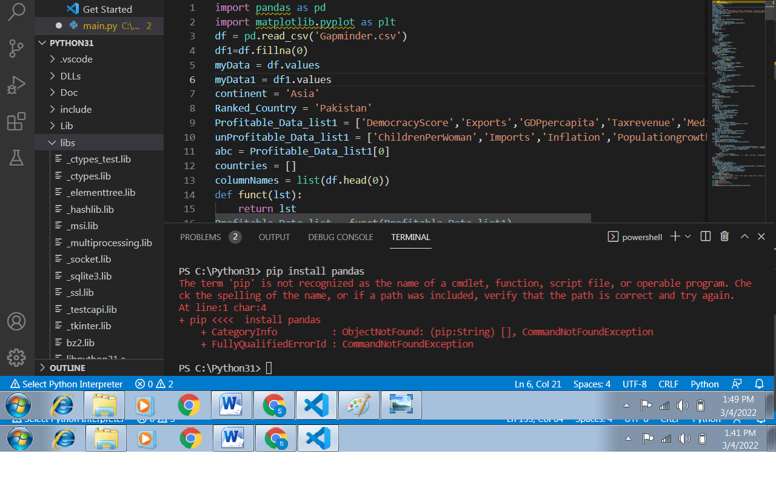

The first one (pandas) is used to read the data from excel or any other file and matplotlib is used to plot graph. These libraries play key role in our project, without these libraries we can’t complete our project.

After importing libraries, next step is to read the data. In this file some empty spaces are also present and it is so difficult to deal such things. Therefore after reading data we made two data frames, one is original and other one is copy in which NAN (empty) values are replaced by zero. This technique helps us a lot because dealing with NAN was difficult but with zero it was easy.



## **Variables and lists:**

Variables and lists are used in almost every project. We made some variables like ‘continent’ in which if you give a name of any continent like ‘Asia’, ‘Africa’, ‘Europe’ or any other with first letter capital, you will get the data of that continent in output. And for the whole world you just need to put ‘World’ in ‘continent’ variable and you will get the rank and graph worldwide. And another variable named ‘Ranked_Country’ in which if you add the name of any country, you will get the rank and output of that data in output specifically. And the two lists are made in which one is for that category whose excess is beneficial for country and other one is that who’s excess is unbeneficial for country. If you want to know the data of only one country then you simply add that category in suitable list(beneficial or unbeneficial) and remove other categories from that list. Variable ‘abc’ is used to identify that either you want to know the data of profitable list or from unprofitable list. Similarly many other variables and lists are made according to their need.



## **Selecting list:**

Now this step is so important step because in this step you have to select whether you want to know the data of profitable data or unprofitable data. For unprofitable data, just put ‘unprofitable_Data_list1’ in ‘funct’ function else put ‘Profitable_Data_list1’.

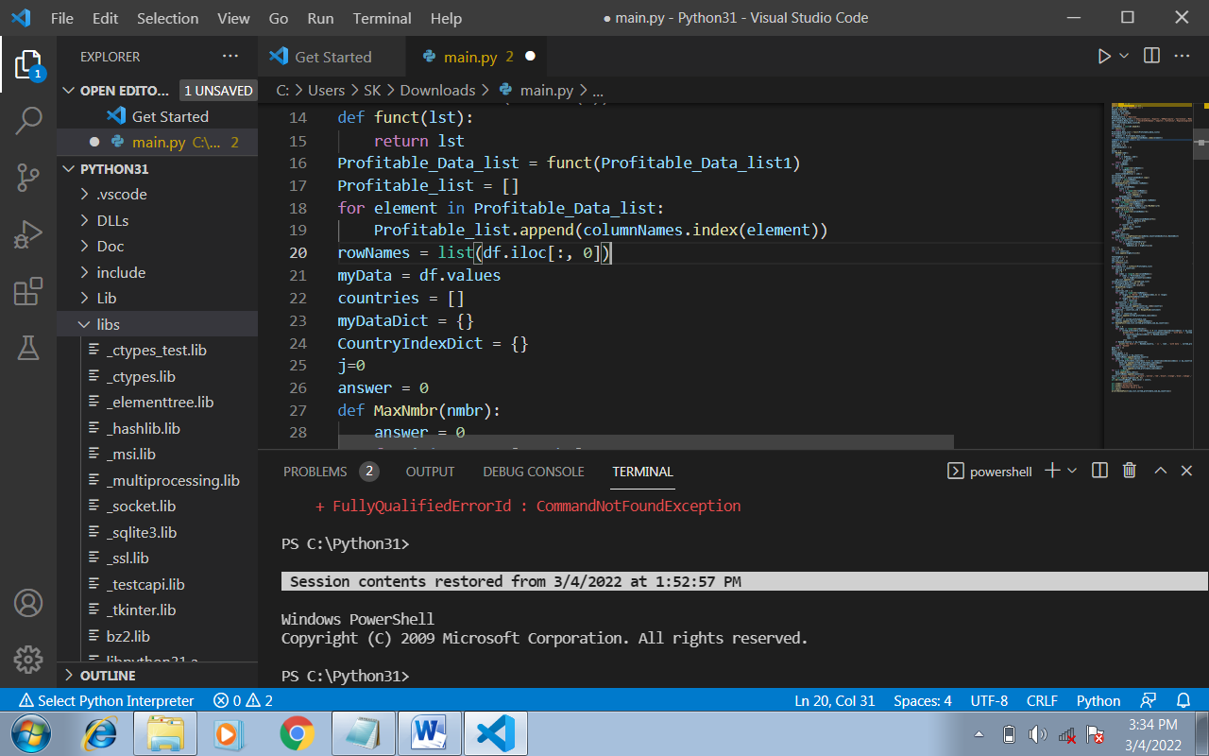

## **Main part:**

This is the main part of our project in which we ranked the countries by given data. Firstly we normalized the data in 0 & 1 form by dividing the maximum value of column so that they can be added easily. And then we calculated the average category wise by ignoring 0(NAN) and then put the avg. value of that category of required country in empty places of that category. And then we ranked the countries with respect to their values.

## **Function:**

In this project we made many little functions like function for minimum, average, for indices and many more.

# **Result**

After completing our project when we run our program then Pakistan ranked in different ranking depending on the indicators selected but the rank of Pakistan was always not good. The rank of Pakistan came to very low in the world as well as in continents.

**Plotting a graph:**

The last thing is plotting. Graph added to the beauty of our project.

## **Comparison with World:**

We plot a graph to compare “Pakistan” with world. 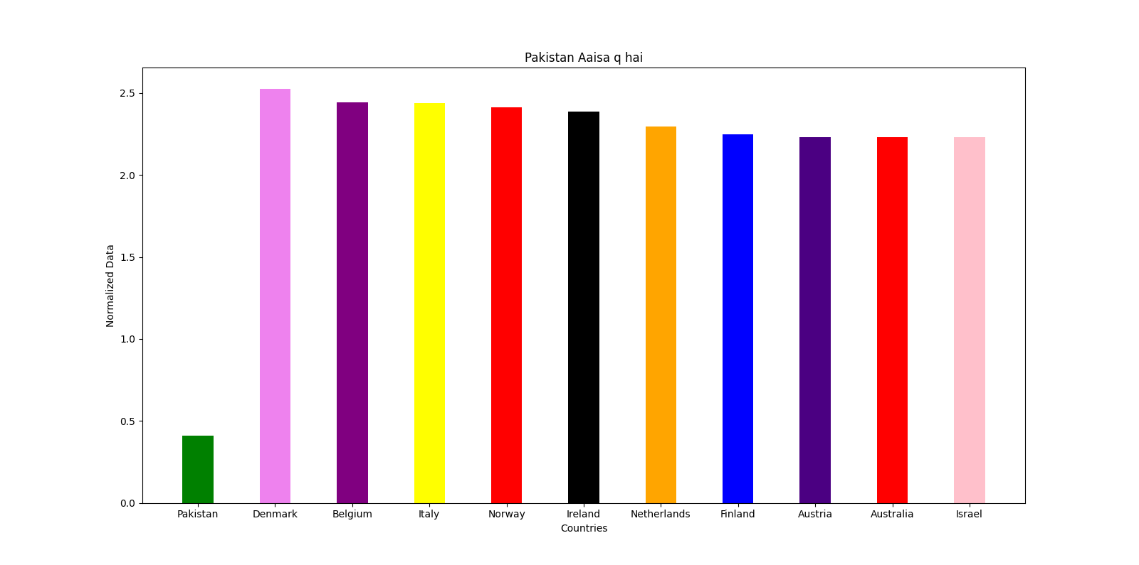

Fig : Showing comparison of Pakistan with top 10 countries(world)

The value of Pakistan is low as shown in the graph as compared to others. This graph completely shows the slow progress of Pakistan as compared to other countries.

# 

## **Comparison with Continents:**

We also plotted a graph of Pakistan using average with countries in continent .The output was as follow:

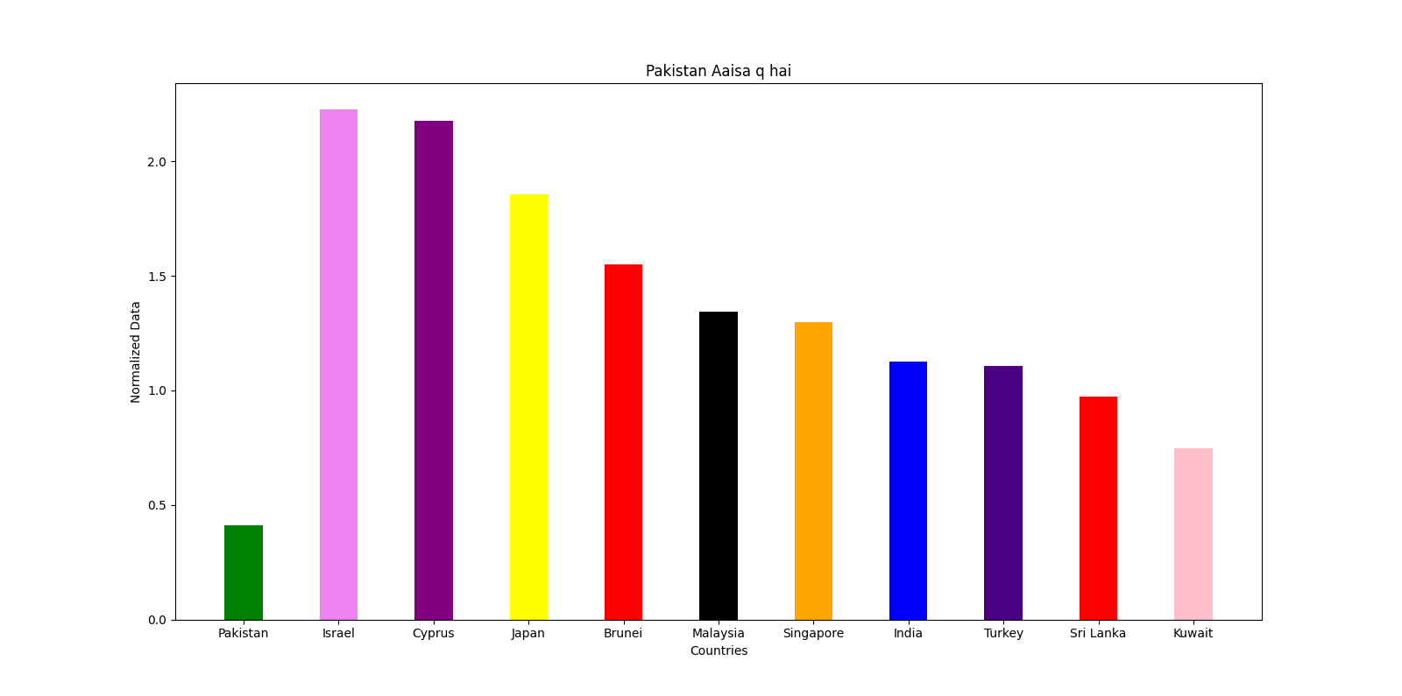

Fig : Showing comparison of Pakistan with top 10 countries(continent)

# **Conclusion**

After a lot of hard work and efforts, we reached at a result of our problem. From data we concluded that Pakistan is far behind than developed countries and it’s ranking is very low in the world as well as in continents. There are certain profitable factors from which prosperity of country increases like exports, income per person , Gdp per capita and tax revenue etc. There are certain unprofitable factors from which prosperity of country decreases like population growth , CO2 emission and children per women etc. This is due to reason that profitable factors are less as compared to other while unprofitable factors are greater than others. From data we concluded that Pakistan is far behind than developed countries and it’s ranking is very low in the world. The reason is that Pakistan do not have resources it needs like population of Pakistan is increasing rapidly but their effective factors like Exports and other good factors are standing on same position. This behavior pulls Pakistan behind in the rank. Poverty in Pakistan is very high as compared to other top countries in the world which impact negative effect on country development. Inshort, Pakistan has to focus on the factors which are necessary and appropriate for the prosperity of any country.

**Email addresses:**

[dilawer2021@namal.edu.pk](mailto:dilawer2021@namal.edu.pk)

[sarib2021@namal.edu.pk](mailto:sarib2021@namal.edu.pk)

[saqib2021@namal.edu.pk](mailto:saqib2021@namal.edu.pk)

**Thank you so much !!!**