EmailJS

1. To Install

npm install --save @emailjs/browser

1. Go to EmailJs.com make an account/login.

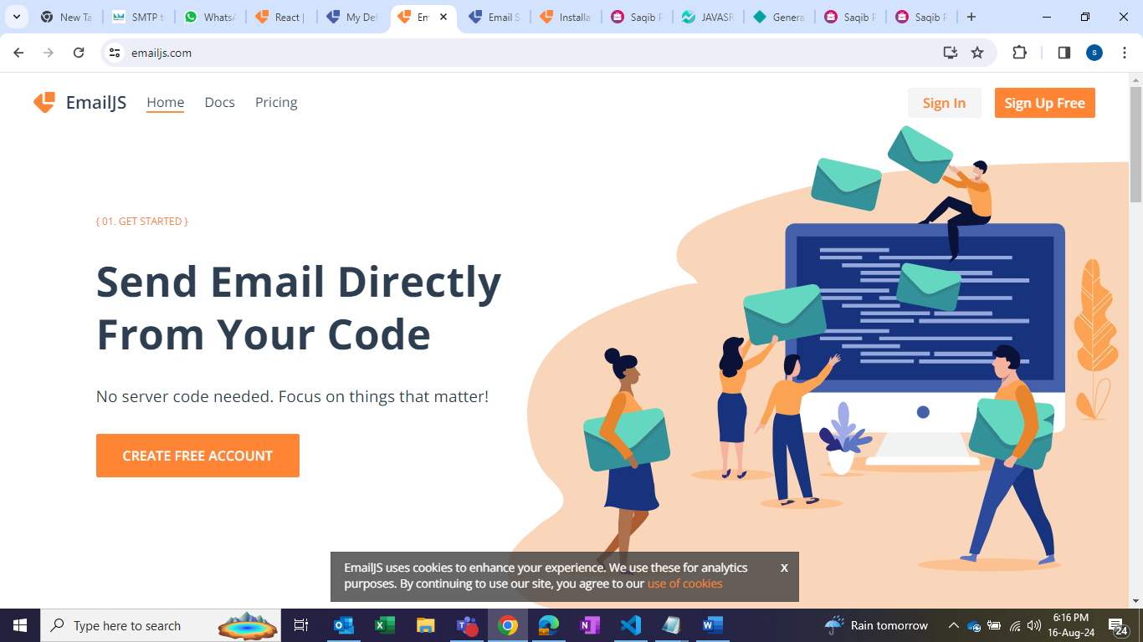

1. Add New Service >>> Connect Account >>> Create Service

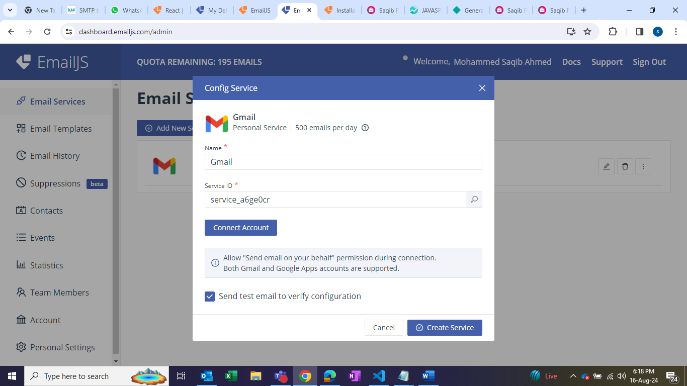

1. Click on Email Templates

Edit as per the names given in VScode

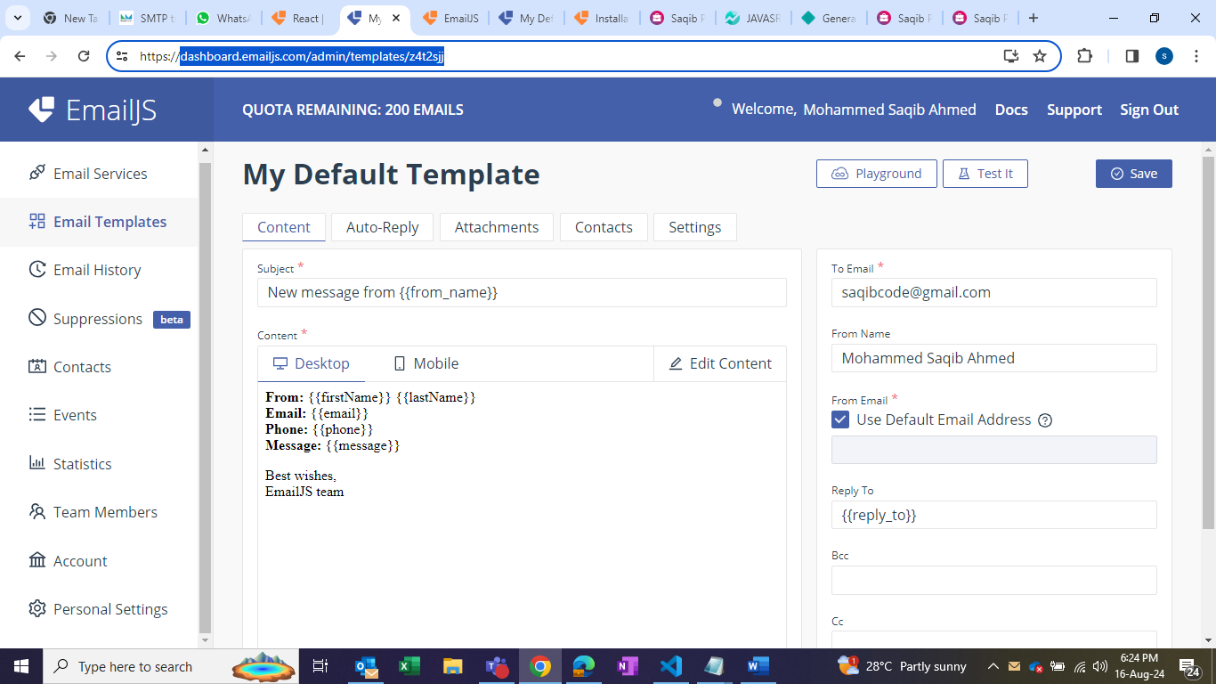

Go to React >>> change --- service Id, your_template id and public key as shown below.

