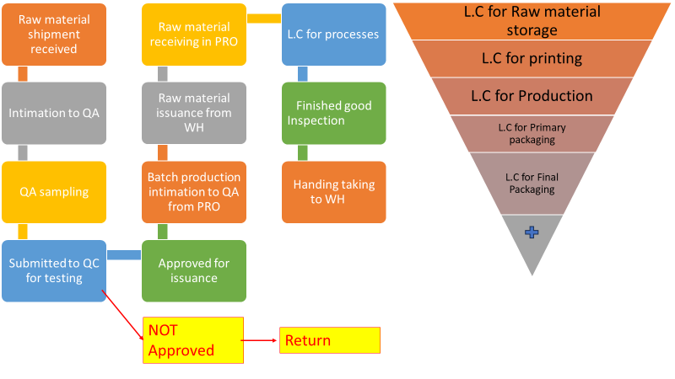**Process Flow of Quality Assurance**