**Project List:**

http://bootcamp2020_saqibamin_01_helloworld.surge.sh

http://bootcamp2020_saqibamin_02_Welcome.surge.sh

**Deploy simple website on Surge**

# Create GitHub Repository [BootCamp2020-2021](https://github.com/saqibamin257/BootCamp2020-2021) and publish on GitHub.

Create project folder Project01-HelloWorld.

Create index.html file and write Hello world message.

Write command *surge token* on terminal and get token like



Go to the settings -----🡪 secrets -------🡪 create new secret

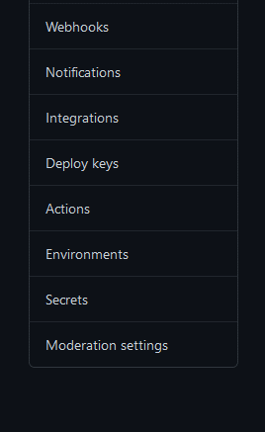

Save your surge token here. With name like Surge_Token.

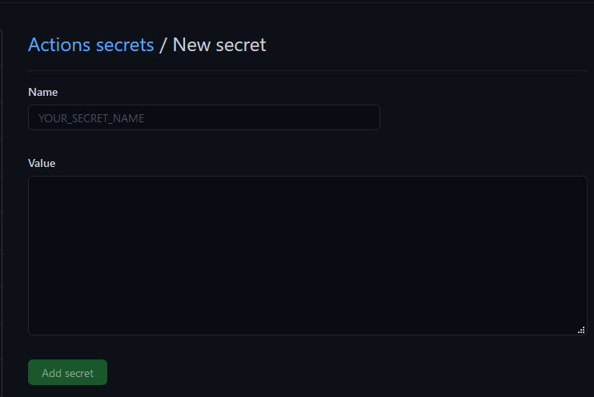

Go to Actions of your repository and create new workflow and name it auto-deploy.yml.

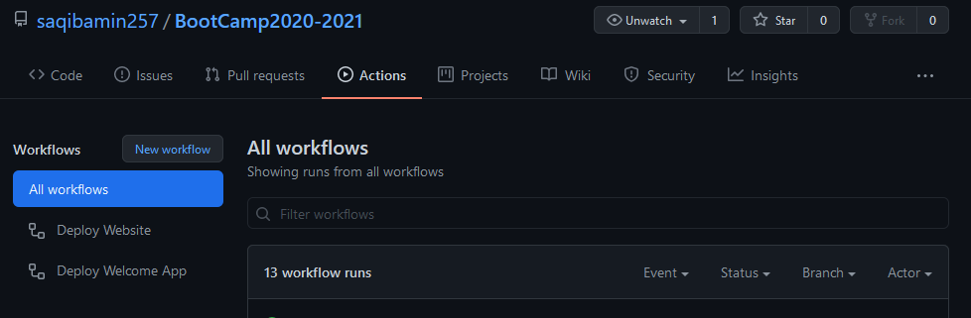

Below is Yml file code .

name: Deploy Hello World

on: [push]

jobs:

  build:

    runs-on: ubuntu-latest

    name: Deploying to surge

    steps:

      - uses: actions/checkout@v2

      - name: Install Node.js

        uses: actions/setup-node@v2-beta

        with:

          node-version: 12

      - name: Install Surge

        run: npm install -g surge

      - name: Run surge

        run: surge ./Project01-HelloWorld http://bootcamp2020_saqibamin_helloworld.surge.sh --token ${{ secrets.SURGE_TOKEN}}

HelloWorld http://bootcamp2020_saqibamin_helloworld.surge.sh --token ${{ secrets.SURGE_TOKEN}}

Here secrets.Surge_Token is your token.

Update your index.html and commit and push to GitHub.

It will start deploying your project on surge and you can see the deployment stages on GitHub by going into Actions----🡪 All workflow.

Browse this url and you will see the result in the browser.

**Deploy project from inside the folder**

**surge ./Project01-HelloWorld http://bootcamp2020_saqibamin_helloworld.surge.sh --token ${{ secrets.SURGE_TOKEN}}**

**Project inside folder**

**./Project01-HelloWorld http://bootcamp2020_saqibamin_helloworld.surge.sh ------**

**means your project is inside this folder.**

**Project on root directory**

**./ http://bootcamp2020_saqibamin_helloworld.surge.sh ------**

