INFORMATION

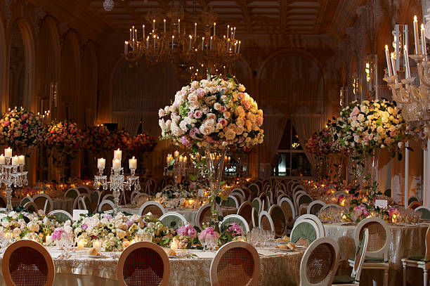

FLORAL DECOR

providing top-quality event management services, including the best flower . We understand that flower decoration is a crucial element of any event, and its success depends on it. Our team of experts worked with some of the best florists in the business to curate a comprehensive list of flower decoration services, ensuring that we provide unmatched quality at affordable prices.