**Excel Steps to follow for data cleaning**

* **Use filters on all the data to check whether categories of data are making sense.**
* **Check whether there are duplicates.**
* **Use ctrl + H to replace values in columns like “Male” at ‘M” place etc, in advance option select “search by columns”**
* **If you got a column of “ age “ to use, but age cant be used because it varies, so you can segmentise age in different segments like “Old”, “Young” etc, eg i have used “=IF(L2 >54, "Old",IF(L2 >=31,"Middle Age",IF(L2 < 31, "Adolescent","Invalid")))”**

**After cleaning your data, start making a “ pivot table” of the questions that you need to get answered.**

* **Eg in our case, the first question was , what was the average income of people who didn’t buy our bikes.**
* 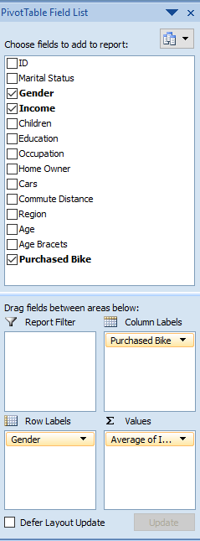 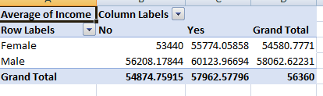

**Add charts too so that your data is visually sound and making sense to your manager and stakeholders.**

**In same way answer and analyse every asked question .**

* **In Dashboards section , copy all graphs to it. Make a god dashboard, use slicing to make your dashboards more dynamic.**