AI Document Analyzer

Research Report I



Supervisor

Dr. M. Milhan Afzal

Submitted by

Muhammad Ahmad
AG #2022-AG-8042

BS Software Engineering
Department of Computer Science
University of Agriculture, Faisalabad.

Table of Contents

INTRODUCTION 4
1.1 Background 4
1.2 Description 4
1.3 Scope 4
1.4 Objectives 4
2. REQUIREMENTS 5
2.1 Functional Requirements 5
FR01: User Authentication and Login 5
FR02: User Account Registration 5
FR03: Document Upload 5
FR04: Text Extraction from Documents 5
FR05: Document Analysis 5
FR06: Document Summarization 6
FR07: Interactive Chatbot 6
FR08: MCQ and Quiz Generation 6
FR09: Question and Answer Generation 6
FR10: User Interaction and Navigation 6
FR11: Logout Functionality 6
2.2 Non- Functional Requirements 7
2.3 Hardware Requirements 8
2.4 Software Requirements 8
3. METHODOLOGY 8
3.2 Significance of the Iterative and Incremental Model 9
3.2 How the Model Fits the Project 9
3.2 Tools & Technologies 10
4. Gantt Chart Timeline 12

List of Figures

Figure 1: Iterative and Incremental Development Model for an AI-Based System 7
Figure 2: Gantt Chart of the project activities 9

INTRODUCTION

1.1 Background
With the rapid growth of digital content, students and professionals are required to process large volumes of documents such as books, research papers, and presentations. Manual reading and analysis of such documents is time-consuming and inefficient. The need for intelligent systems that can automatically understand and transform document content into interactive knowledge has become increasingly important.

Description
The AI-Based Document Reader, Analyzer, and Learning Assistant is an intelligent software system designed to read, analyze, and understand documents such as PDFs, DOCX, and PPTX files. The system extracts text, performs semantic analysis using artificial intelligence and natural language processing techniques, and provides interactive learning features such as summaries, question–answering, and quiz generation.

1.3 Scope
The scope of this project includes document upload, text extraction, semantic understanding, and interactive learning features. The system supports multiple document formats and provides AI-powered chat, summaries, and MCQ generation. It is intended for academic and professional use.

1.4 Objectives
Goals and objectives define what has to be done. A goal is simply a broad statement of what you want to do. The objectives are sub-goals, more detailed, that explain what must be done to achieve the goal. The project has one main goal and several specific objectives.
- Extract and clean textual content from uploaded documents using appropriate document processing techniques.
- Apply artificial intelligence and natural language processing techniques to analyze and understand the document content.
- Develop an interactive chatbot that answers user questions based on the uploaded document.
- Automatically generate summaries, quizzes, MCQs, and question–answer sets from the document content.

REQUIREMENTS

2.1 Functional Requirements
Any requirement which precisely specifies what the system should do is called a functional requirement of the system. A functional requirement describes the behavior or function of the system when certain conditions are met

FR01: User Authentication and Login
FR01-01 | System shall provide a login interface to the user.
FR01-02 | System shall get username and password from the user.
FR01-03 | System shall validate the entered username and password.
FR01-04 | System shall allow the user to log in if credentials are valid.
FR01-05 | System shall display an error message if login credentials are invalid.

FR02: User Account Registration
FR02-01 | System shall allow new users to create an account.
FR02-02 | System shall collect required information such as name, email, and password.
FR02-03 | System shall validate user input during registration.
FR02-04 | System shall store user account information securely.

FR03: Document Upload
FR03-01 | System shall allow users to upload documents.
FR03-02 | System shall support document formats including PDF, DOCX, and PPTX.
FR03-03 | System shall validate document format before upload.
FR03-04 | System shall store uploaded documents for processing.

FR04: Text Extraction from Documents
FR04-01 | System shall extract text from uploaded PDF documents.
FR04-02 | System shall extract text from uploaded DOCX documents.
FR04-03 | System shall extract text from uploaded PPTX documents.
FR04-04 | System shall clean and preprocess extracted text.

FR05: Document Analysis
FR05-01 | System shall analyze extracted text using AI and NLP techniques.
FR05-02 | System shall identify key topics from the document.
FR05-03 | System shall divide document content into logical sections.

FR06: Document Summarization
FR06-01 | System shall generate a summary of the document content.
FR06-02 | System shall present the summary in readable form to the user.

FR07: Interactive Chatbot
FR07-01 | System shall provide a chatbot interface to the user.
FR07-02 | System shall accept user questions related to the uploaded document.
FR07-03 | System shall generate answers based on document content.
FR07-04 | System shall display responses in real time.

FR08: MCQ and Quiz Generation
FR08-01 | System shall provide a user-friendly interface.
FR08-02 | System shall allow users to navigate between document, chatbot, and quiz modules.
FR-03 | System shall display system messages and notifications clearly.

FR09: Question and Answer Generation
FR09-01 | System shall generate short questions from document topics.
FR09-02 | System shall generate answers corresponding to the questions.

FR10: User Interaction and Navigation
FR10-01 | System shall provide a user-friendly interface.
FR10-02 | System shall allow users to navigate between document, chatbot, and quiz modules.
FR10-03 | System shall display system messages and notifications clearly.

FR11: Logout Functionality
FR11-01 | System shall allow users to log out from the system.
FR11-02 | System shall terminate user session after logout.

2.2 Non- Functional Requirements
Any requirement which specifies how the system performs a certain function is called a non-functional requirement. A non-functional requirement describes how a system should behave and what constraints or limits exist on its functionality. These requirements define the system’s quality attributes such as performance, availability, security, usability, reliability, and scalability.

ID | Category | Core Requirement
NFR1 | Availability | The system must remain accessible 24/7 and handle multiple requests without service interruption.
NFR2 | Performance | Queries and document processing must be completed within acceptable time limits without noticeable delay.
NFR3 | Usability | The interface must be intuitive, providing clear tooltips and helpful error/success messages.
NFR4 | Security | Access must be restricted by user roles, with secure authentication and protection of credentials.
NFR5 | Reliability | The system must function consistently and possess the ability to recover gracefully from unexpected errors.
NFR6 | Scalability | The architecture must support an increasing user base and future feature enhancements without losing speed.
NFR7 | Maintainability | The system must use a modular design to allow developers to apply updates and fixes with minimal impact.
NFR8 | Compatibility | Full functionality must be maintained across all major web browsers and different operating systems.
NFR9 | Data Integrity | The system must ensure data accuracy and prevent any loss or corruption during processing.
NFR10 | Interoperability | The system must integrate smoothly with external libraries and AI frameworks.

2.3 Hardware Requirements
Processor: Intel Core i3 CPU or above
Hard Disk: 5GB or more
RAM: 4GB or more

2.4 Software Requirements
Operating System: Windows10, Windows 8.1, Windows 8, Windows 7
Backend Technology: Python(Django or FastAPI)
Frontend Technology:Html,CSS JavaScript
DataBase: MySQL
Libraries and Frameworks:PyMuPDF, python-docx, python-pptx, NLP and AI libraries
Browser: Google Chrome, Firefox, Mozilla etc

METHODOLOGY

(For the development of the AI-Based Document Reader, Analyzer, and Learning Assistant, I have chosen the Iterative and Incremental Development Model. This approach allows the system to be developed through repeated cycles (iterative) and in small, manageable portions (incremental), ensuring that each functional module is refined and perfected before the next is added.

3.2 Significance of the Iterative and Incremental Model
The significance of choosing this model lies in its ability to handle complexity and uncertainty, which are inherent in AI-driven applications. Its key advantages include:
- Risk Management: By breaking the project into smaller increments, technical risks—such as difficulties in text extraction or AI response accuracy—can be identified and addressed early in the development lifecycle.
- Continuous Improvement: Unlike the traditional Waterfall model, this model allows for "loops." If the results from the AI analysis phase (Step 5) are not satisfactory, we can go back and refine the Preprocessing phase (Step 4) without disrupting the entire project.
- Operational Flexibility: It allows us to deliver a functional "core" (the document reader) while still working on the more advanced "enhancements" (the quiz and MCQ generator).
- Enhanced Quality Control: Testing is not a final step but an ongoing process. Each module is validated individually, leading to a more robust and error-free final system.

3.2 How the Model Fits the Project
The Iterative and Incremental model is uniquely suited for an AI Learning Assistant for the following reasons:
- Logical Dependency: The project has a strict hierarchy. The AI cannot analyze text until the Extraction module is perfect. By using an incremental approach, we ensure that the "foundation" (Steps 3 & 4) is stable before building the "intelligent" features (Steps 5, 6, & 7) on top of it.
- Handling AI Variability: AI models often require "prompt tuning" and adjustments. The iterative nature allows us to refine the Chatbot’s responses (Step 6) through multiple cycles of testing and feedback until the accuracy meets the user's needs.
- Feature Integration: This model allows for the progressive addition of features. We can first ensure the user can upload and read a document, then add the summary feature, then the chatbot, and finally the quiz generator. This prevents the development team from being overwhelmed by the complexity of the entire system at once.

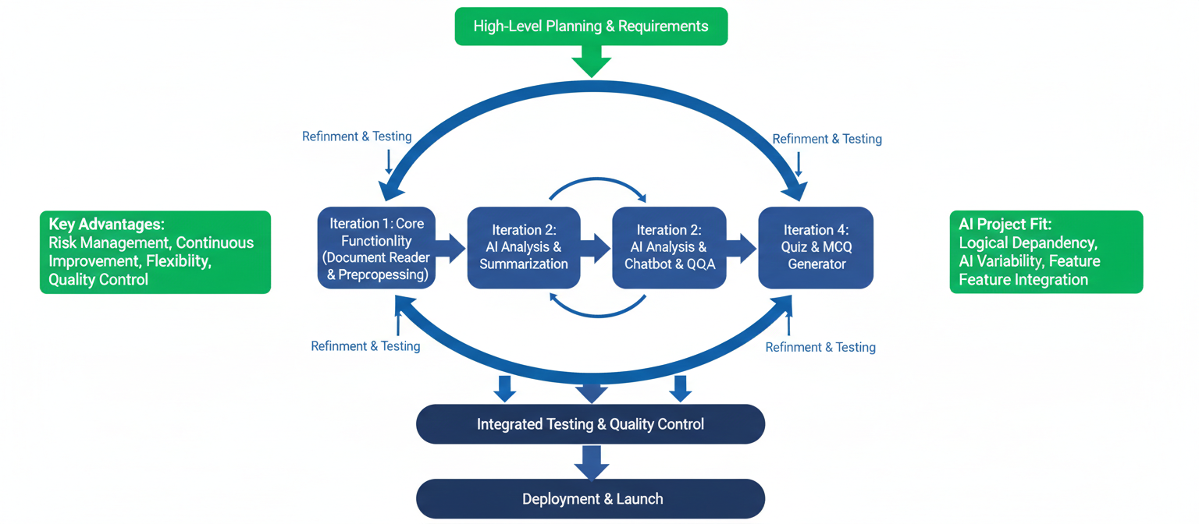

Figure 1: \

Tools & Technologies
The following tools and technologies are used for the development and implementation of the system:
Python
Python is used as the primary programming language due to its simplicity, flexibility, and strong support for AI and NLP libraries.
Django / FastAPI
Django or FastAPI is used as the backend framework to manage server-side logic, API handling, authentication, and system integration.
HTML, CSS, JavaScript
These technologies are used to design and develop the frontend user interface, ensuring an interactive and user-friendly experience.
MySQL
MySQL is used as the database management system to store user information, document metadata, and system records.
PyMuPDF
PyMuPDF is used for extracting text from PDF documents efficiently.
python-docx
This library is used to extract textual content from Microsoft Word documents.
python-pptx
This library is used to extract text from PowerPoint presentation files.
Natural Language Processing (NLP) Libraries
NLP libraries are used to analyze document content, generate summaries, and understand user queries.
AI Models (LLMs)
AI models are used to understand document semantics, generate answers, summaries, and quizzes.
Web Browser
Web browsers such as Google Chrome and Mozilla Firefox are used to access and test the system.

4. Gantt Chart Timeline
A Gantt chart is a timeline view that makes it easy to see how a project is tracking. You can visualize project tasks and see how they relate to each other as projects progress over time. Use this tool to simplify your tasks and details with a visual project timeline by transforming task names, start dates, durations, and end dates into cascading horizontal bar charts.
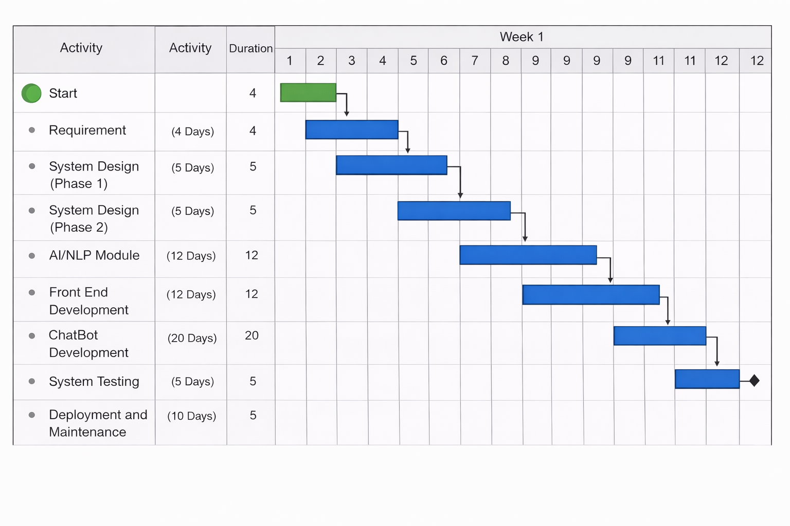

Figure 2: Gantt Chart of the project activities

Usage Scenario 4: Access Guest Workspace
Section | Details
Use Case Title | Access Guest Workspace
Abbreviated Title | Guest Workspace
Use Case Id | UC_GuestWorkspace
Requirement Id | FR03, NFR09
Description | Provides an anonymous visitor immediate access to an isolated, temporary version of the study dashboard without needing account registration.
Pre-Conditions | The visitor must not be currently logged into an active, registered account session.
Task Sequence | 1. User visits the application homepage.  2. User clicks on the "Try as Guest" action button.  3. System initializes a temporary session state using secure, ephemeral browser cookies.  4. System allocates a transient memory buffer area disconnected from permanent user tables.  5. System redirects the user to the restricted, guest-mode version of the split-screen workspace.
Exceptions | * Ex-01 (Active Session Conflict): If the visitor is already logged into a standard account, the system bypasses guest initialization and automatically opens their primary personal library workspace.
Post-Conditions | The guest interface is rendered on screen, permitting temporary document evaluation until the session expires or the browser tab is closed.
Unresolved Issues | None.
Authority | Anonymous Guest
Modification History | Author: Sole Developer  Description: Built cookie-based transient session control.
### Usage Scenario 4: Access Guest Workspace | Section | Details | | :--- | :--- | | **Use Case Title** | Access Guest Workspace | | **Abbreviated Title** | Guest Workspace | | **Use Case Id** | UC_GuestWorkspace | | **Requirement Id** | FR03, NFR09 | | **Description** | Provides an anonymous visitor immediate access to an isolated, temporary version of the study dashboard without needing account registration. | | **Pre Conditions** | The visitor must not be currently logged into an active, registered account session. | | **Task Sequence** | **Exceptions** | | 1. User visits the application homepage.<br>2. User clicks on the "Try as Guest" action button.<br>3. System initializes a temporary session state using secure, ephemeral browser cookies.<br>4. System allocates a transient memory buffer area disconnected from permanent user tables.<br>5. System redirects the user to the restricted, guest-mode version of the split-screen workspace. | *None* | | **Post Conditions** | The guest interface is rendered on screen, permitting temporary document evaluation until the session expires or the browser tab is closed. | | **Unresolved issues** | None. | | **Authority** | Anonymous Guest | | **Modification history** | **Author:** Project Developer<br>**Description:** Built cookie-based transient session control. | ---

Usage Scenario 4: Access Guest Workspace
Use Case Title | Access Guest Workspace
Abbreviated Title | Guest Workspace
Use Case Id | UC_GuestWorkspace
Requirement Id | FR03, NFR09
Description: Provides an anonymous visitor immediate access to an isolated, temporary version of the study dashboard without needing account registration.
Pre Conditions: The visitor must not be currently logged into an active, registered account session.
Task Sequence | Exceptions
1. User visits the application homepage. | None
2. User clicks on the "Try as Guest" action button.
3. System initializes a temporary session state using secure, ephemeral browser cookies.
4. System allocates a transient memory buffer area disconnected from permanent user tables.
5. System redirects the user to the restricted, guest-mode version of the split-screen workspace.
Post Conditions: The guest interface is rendered on screen, permitting temporary document evaluation until the session expires or the browser tab is closed.
Unresolved issues: None.
Authority: Anonymous Guest
Modification history:
Author: Project Developer
Description: Built cookie-based transient session control.
Usage Scenario 5: Register Account
Use Case Title | Register Account
Abbreviated Title | Registration
Use Case Id | UC_Register
Requirement Id | FR02
Description: Allows anonymous visitors to permanently establish a unique profile on the system to save files, highlights, and revision materials.
Pre Conditions: The user must provide a unique email address and a username that does not already exist in the database.
Task Sequence | Exceptions
1. User clicks the "Sign Up" link on the home screen navigation menu.
2. System displays the registration form containing username, email, password, and password confirmation fields.
3. User inputs their details and hits the "Submit" trigger.
4. System verifies that all required data fields are populated.
5. System runs database checks to confirm the username and email are completely unique. | Ex-01 (Duplicate Account Strings): System catches the non-unique field flag, stops registration execution, and highlights the conflicting field with an inline error message.
6. System matches the password and confirmation string inputs to guarantee parity. | Ex-02 (Password Mismatch): System stops data insertion, clears the password inputs, and displays an error message stating that the passwords do not match.
7. System salts and hashes the password string, commits the record, and prompts a success notification.
Post Conditions: A unique, persistent user record is safely committed to the database, and the user is routed to the standard application login panel.
Unresolved issues: None.
Authority: Anonymous Guest
Modification history:
Author: Project Developer
Description: Implemented native registration form logic and database validation hooks.
Usage Scenario 6: Log In / Log Out
Use Case Title | Log In / Log Out
Abbreviated Title | Authentication
Use Case Id | UC_Login
Requirement Id | FR01, FR15, NFR08
Description: Authenticates user credentials against database values to grant secure workspace entry, or securely terminates active sessions.
Pre Conditions: For Login: The user account must exist. For Logout: An active user session token must be currently cached by the server environment.
Task Sequence | Exceptions
1. User opens the authentication screen and fills in their Username and Password.
2. System hashes the incoming password string and compares it with the saved database value. | Ex-01 (Invalid Credentials Provided): If checking the username/hash combo fails, the system blocks entry and returns a general "Invalid username or password" notification panel.
3. If they match, the system creates a persistent session token and loads the library dashboard.
4. To log out, the user clicks the "Sign Out" option in the navigation header bar.
5. System catches the request, completely drops the server session record, and invalidates the browser token.
6. System redirects the view layer directly back to the public root homepage.
Post Conditions: Access states are altered dynamically, securing backend data paths from unauthorized requests.
Unresolved issues: None.
Authority: Registered Client / Learner, System Admin
Modification history:
Author: Project Developer
Description: Tied view routing decorators to standard authentication state handlers.
Usage Scenario 7: Submit YouTube Link (Extract Transcript)
Use Case Title | Submit YouTube Link (Extract Transcript)
Abbreviated Title | Extract YouTube Transcript
Use Case Id | UC_YouTube
Requirement Id | FR06, NFR12
Description: Pulls time-linked caption strings out of a public YouTube address to convert a video lecture into readable study text.
Pre Conditions: The user must provide a fully reachable YouTube URL that contains accessible text caption metadata tracks.
Task Sequence | Exceptions
1. User opens the workspace intake panel and selects the "YouTube URL" tab options.
2. User pastes the target video hyperlink string into the text input bar and hits "Fetch". | Ex-01 (Invalid URL or ID Failure): System fails to match regex components, drops the request, and asks for a properly structured video link.
3. System runs a regular expression parser to isolate the alphanumeric Video ID string from the address.
4. System sends a background network request to the youtube-transcript-api using the parsed ID. | Ex-02 (Captions Missing/Disabled): System catches the API exception error, stops progress, and alerts the user that no transcript tracks are available for that specific video file.
5. External APIs locate the English text caption tracks and return them to the backend server container.
6. System concatenates the text array, structures line spacing, and writes it to a video workspace database row.
Post Conditions: The harvested video transcript lines are successfully stored and loaded directly inside the left workspace pane.
Unresolved issues: Handling translation layers for automated YouTube captions that contain heavy phonetic formatting errors.
Authority: Registered Client / Learner
Modification history:
Author: Project Developer
Description: Integrated translation API catch blocks and regular expression string parsers.
Usage Scenario 8: Interact with Chat & Source Context
Use Case Title | Interact with Chat & Source Context
Abbreviated Title | Contextual AI Chat
Use Case Id | UC_Chat
Requirement Id | FR07, FR08, NFR05
Description: Handles the back-and-forth conversation with the user by keeping queries grounded in the text of the open file.
Pre Conditions: A file text record or video transcript string must be active in the user's current session.
Task Sequence | Exceptions
1. User types a question about the study text into the chat sidebar input box and clicks send.
2. System uses JavaScript to append the message bubble to the local user view without a page reload.
3. System pulls the extracted text content of the active document from the database cache.
4. System packages the text content, current query, and chat history into a structured prompt message block.
5. System posts this prompt block using an asynchronous worker path to the Groq API model engine. | Ex-01 (Context Window Exhausted): If the source text is too large for a single payload request, the system runs an extraction pass to send only the most relevant text matches.
6. The model processes the bounds of the provided context and returns a targeted answer string.
7. System receives the answer payload and pushes the response text directly into the chat container view.
Post Conditions: The AI response is appended to the message feed, and the conversational history updates inside the active database table.
Unresolved issues: Setting up a custom token counter to prevent multi-file libraries from exceeding the context limits of the model.
Authority: Registered Client / Learner
Modification history:
Author: Project Developer
Description: Built the frontend AJAX messenger module and configured the backend Groq message payload constructor.
Usage Scenario 9: Highlight Text & Get Explanations
Use Case Title | Highlight Text & Get Explanations
Abbreviated Title | Text Highlights & Explanations
Use Case Id | UC_Explain
Requirement Id | FR11, FR12
Description: Catches user selection points on the text view to apply colored highlight markings and display instant, AI-generated breakdowns.
Pre Conditions: A document must be open, and the user must physically highlight a text block inside the left viewing pane.
Task Sequence | Exceptions
1. User drags their mouse cursor over a confusing paragraph inside the document viewing pane. | Ex-01 (Empty String Highlights): If the cursor selection catches blank spaces or invalid text rows, the system suppresses menu generation and takes no further action.
2. JavaScript event listeners catch the text highlight coordinates and display an inline context menu widget.
3. User clicks on a specific color option icon to lock in the highlighted segment view style.
4. User clicks the "Explain This" button inside the context menu layout.
5. System isolates the highlighted text string snippet and routes it to the Groq backend interface model.
6. The language model generates a simplified summary explanation block for that exact snippet.
7. System receives the text explanation and presents it inside a clean modal pop-up box over the active screen.
Post Conditions: The text snippet color styling persists in the database, and the corresponding explanatory breakdown renders immediately on screen.
Unresolved issues: None.
Authority: Registered Client / Learner
Modification history:
Author: Project Developer
Description: Programmed client-side window selection tools and tied them to localized prompt queries.
Usage Scenario 10: Trigger Live Search (Web Extraction)
Use Case Title | Trigger Live Search (Web Extraction)
Abbreviated Title | Live Web Search
Use Case Id | UC_Search
Requirement Id | FR09, FR10
Description: Runs real-time internet scraping routines to answer questions about external facts or events not covered by the document text.
Pre Conditions: The system must detect that a user's question asks for information outside the current file text scope.
Task Sequence | Exceptions
1. User submits a general question that cannot be answered using the open document text alone.
2. System backend flags the query as an out-of-scope question using intent-routing logic rules.
3. System calls a web search script, passing search keywords to online retrieval scraping libraries. | Ex-01 (Search Extraction Timed Out): If external connections drop or experience lagging delays, the system falls back to standard model knowledge and adds a note that live search results are unavailable.
4. Scraping tools collect top text snippets from public results pages.
5. System injects these fresh internet search snippets into the background prompt context template payload.
6. System forwards the search-supported prompt to the Groq API engine to compile a factual answer.
7. System returns the update-supported answer directly back to the active user chat panel interface.
Post Conditions: Factual responses backed by live web data are rendered for the user without requiring changes to the underlying document file data.
Unresolved issues: None.
Authority: Registered Client / Learner
Modification history:
Author: Project Developer
Description: Integrated live background search fetching and context-injection prompt routines.
Usage Scenario 11: Manage Personal Study Library
Use Case Title | Manage Personal Study Library
Abbreviated Title | Library Management
Use Case Id | UC_Library
Requirement Id | FR01, FR04, FR06
Description: Gives users complete control over their saved study dashboard, allowing them to browse, reopen, or permanently clear historical text files.
Pre Conditions: The user must be logged into a verified client profile that contains previously uploaded documents or transcripts.
Task Sequence | Exceptions
1. User opens the "My Library" catalog view page. | Ex-01 (Empty Library Collection): If a user hasn't uploaded any documents yet, the library page displays a placeholder message guiding them to upload their first file.
2. System queries database rows, pulling all documents and video summaries tied to the user's account ID.
3. System renders the matching files as a grid of interactive document cards on screen.
4. User can click any document card to immediately open it back up in the split-screen workspace view.
5. User can click the "Delete" icon on any document card to clear it out.
6. If deleted, the system drops the corresponding text entries, flashcards, and highlights from the database.
Post Conditions: The dashboard view refreshes instantly to match the updated state of the user's database records.
Unresolved issues: None.
Authority: Registered Client / Learner
Modification history:
Author: Project Developer
Description: Built the relational database query views and added confirmation alerts to deletion triggers.

