AI-Powered Learning Support System
Updated Final Year Project Report
Supervisor: Dr. M. Milhan Afzal
Submitted by: Muhammad Ahmad
AG #: 2022-AG-8042
BS Software Engineering
Department of Computer Science
University of Agriculture, Faisalabad
May 2026

Table of Contents
Right-click and update field in Word to refresh page numbers.

List of Tables
Table 1: Functional requirements summary ........................................ 3
Table 2: Non-functional requirements summary .................................. 5
Table 3: Hardware requirements ........................................................ 6
Table 4: Software requirements ......................................................... 7
Table 5: Tools and technologies ..................................................... 10
Table 6: Database entity summary .................................................. 15

List of Figures
Figure 1: System Architecture of DocuLearn AI ................................ 13
Figure 2: Iterative and Incremental Process Model .............................. 18
Figure 3: Gantt Chart Timeline ...................................................... 20

Abstract
This report documents the updated AI-Powered Learning Support System, also referred to in the interface as DocuLearn AI. The project is a Django-based web application that allows students and researchers to upload learning material, extract readable content from multiple file formats, ask contextual questions, generate study artifacts, save highlights and learn from YouTube lecture transcripts. The current implementation includes authenticated and guest workflows, a document library, an upload pipeline, Office document viewing, AI-assisted chat, text explanation, flashcards, multiple-choice questions and short-answer question generation. The report consolidates project introduction, requirements, methodology, Gantt chart, software requirements specification, design documentation, technical manual, user manual, testing view and deployment considerations in a clear structure.

1. INTRODUCTION
1.1 Project Background
The amount of digital learning content available to students has increased rapidly. Lecture notes, textbooks, research articles, presentations, spreadsheets and recorded video lectures are now common parts of academic work. Although these resources are useful, they also create a problem: learners must spend considerable time searching, reading and converting raw material into revision-friendly knowledge. Traditional document readers display files but do not explain concepts, answer questions or produce practice material.
The AI-Powered Learning Support System addresses this problem by combining document processing with artificial intelligence. Instead of forcing the learner to manually summarize long files, the system extracts content and makes it available through an interactive assistant. It supports local document uploads and YouTube transcript processing, which makes it suitable for both written and video-based study resources.
1.2 Project Description
The project is a web-based learning platform developed with Django. Users can upload PDF, DOC, DOCX, PPTX, XLSX and TXT files or submit a YouTube URL. The system validates input, stores the uploaded material, extracts text, displays the content and provides AI-powered learning functions. The assistant uses Groq with the llama-3.3-70b-versatile model to answer questions, explain selected text and generate flashcards, MCQs and short-answer questions.
The application contains a document library where each user can see their own uploaded documents. Anonymous users are also supported through a guest mode with a limit of three free uploads. Registered users receive persistent access to their documents and generated study material.
1.3 Project Scope
The project scope covers the development of an intelligent study assistant for academic documents and YouTube lecture content. It includes user registration, login, upload management, text extraction, document viewing, interactive AI chat, selected-text explanation, saved highlights and generated learning exercises. The scope also includes deployment preparation using Render-oriented settings, static-file handling through WhiteNoise and media storage for uploaded files.
The system does not attempt to replace a full learning management system. It focuses on document-centered study support rather than course enrollment, grading workflows or institutional administration. It also depends on available captions for YouTube videos and on external AI service availability for generated answers.
1.4 Objectives
- To provide a simple web interface for uploading and organizing learning materials.
- To extract readable text from common academic file formats and YouTube transcripts.
- To allow users to ask natural-language questions about their own documents.
- To generate flashcards, MCQs and short-answer questions from selected or complete content.
- To support highlights and persistent chat history for document-centered revision.
- To maintain clear separation between user data, guest data and document processing logic.

2. PROJECT REQUIREMENTS
2.1 Functional Requirements
Table 1: Functional requirements summary
ID | Requirement | Description
FR-01 | User registration | A new user can create an account with username, password and required email address.
FR-02 | Login by username or email | The authentication backend accepts either username or email with a valid password.
FR-03 | Guest upload access | Anonymous users can upload up to three documents using session-based ownership.
FR-04 | Document upload | Users can upload PDF, DOC, DOCX, PPTX, XLSX and TXT files up to 10 MB.
FR-05 | YouTube processing | Users can submit supported YouTube URLs and fetch timestamped transcripts.
FR-06 | Text extraction | The system extracts text from PDFs, Word files, PowerPoint files, Excel files and plain text.
FR-07 | Document viewing | PDF files are served inline and Office files can be shown through generated HTML views.
FR-08 | AI chat | Users can ask questions and receive contextual answers based on document text.
FR-09 | Selection explanation | Users can select text and request a clear explanation from the assistant.
FR-10 | Study artifact generation | The system creates flashcards, MCQs and short-answer questions.
FR-11 | Highlight saving | Users can save highlighted text with page number and color.
FR-12 | Document deletion | Users can remove documents they own from the library.
2.2 Non- Functional Requirements
Table 2: Non-functional requirements summary
Quality Attribute | Requirement
Usability | The interface should be clear enough for students to upload, open and study documents without training.
Performance | Document processing should complete within reasonable time for files under the configured 10 MB limit.
Security | A user should only access owned documents; guest access must be limited to IDs stored in the session.
Reliability | The system should show clear messages when text extraction, YouTube captions or AI generation fail.
Maintainability | Processing, AI interaction, routing, forms and data models should remain separated into focused modules.
Portability | The project should run locally with Django and be deployable to a platform such as Render.
Scalability | The architecture should allow future migration from SQLite/media files to cloud storage and a stronger database.
2.3 Hardware Requirements
Table 3: Hardware requirements
Component | Minimum | Recommended
Processor | Dual-core CPU | Quad-core CPU or better
RAM | 4 GB | 8 GB or more
Storage | 2 GB free space | 10 GB or more for media uploads
Network | Internet connection for AI and YouTube features | Stable broadband connection
Client device | Modern laptop or desktop browser | Chrome/Edge/Firefox on laptop or desktop
2.4 Software Requirements
Table 4: Software requirements
Software | Purpose
Python 3.10 or later | Runtime environment for Django and processing libraries.
Django 6.0.4 | Backend web framework used for routing, models, templates and authentication.
SQLite | Development database used by the current project.
PyMuPDF | PDF text extraction with page markers.
python-docx, python-pptx, openpyxl | Office document text extraction.
Mammoth | DOCX to HTML conversion for browser viewing.
LibreOffice headless | DOC/DOCX/PPTX/XLSX conversion support where needed.
Groq API | AI chat and content generation service.
youtube-transcript-api | Fetching captions/transcripts for YouTube videos.
WhiteNoise | Serving compressed static files in deployment.

3. METHODOLOGY
3.1 Process Model
The project follows an iterative and incremental process model. This model is suitable because the system combines several uncertain components: document extraction, AI response quality, user interface behavior, guest access and external YouTube transcript support. Instead of attempting to complete every module at once, the system can be delivered through increments such as authentication, document upload, extraction, chat, study tools and deployment refinement.
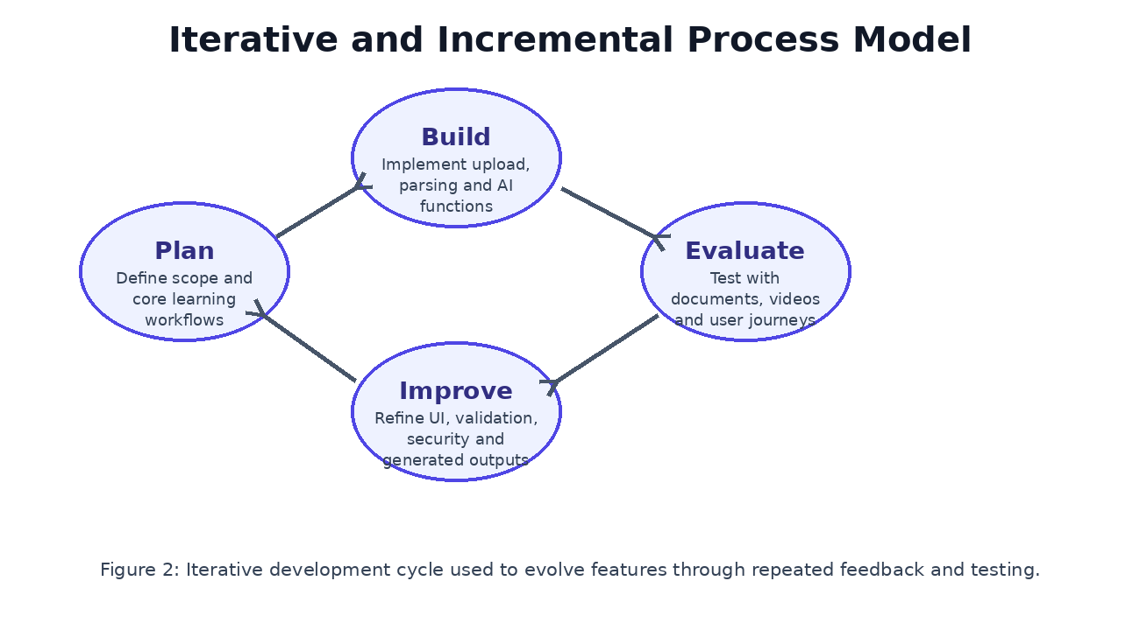
Figure 2: Iterative and Incremental Process Model
3.2 Tools & Technologies
Table 5: Tools and technologies
Layer | Technology | Role
Frontend | Django templates, HTML, CSS, JavaScript | Library, upload form, document viewer, chat panel and study tabs.
Backend | Django | Request handling, model persistence, validation and authentication.
AI | Groq llama-3.3-70b-versatile | Contextual Q&A, explanations and generation of study material.
Document Processing | PyMuPDF, python-docx, python-pptx, openpyxl, Mammoth | Extracting and rendering uploaded learning materials.
Video Processing | youtube-transcript-api | Retrieving timestamped YouTube transcripts.
Database | SQLite | Stores users, documents, messages, highlights and generated questions.
Deployment Support | Gunicorn, WhiteNoise, Render build script | Production server execution and static-file serving.

4. GANTT CHART
The Gantt chart represents the planned execution of the project from requirement analysis to final documentation. The activities are arranged as overlapping increments because some tasks, such as testing and UI refinement, continue while new features are implemented.
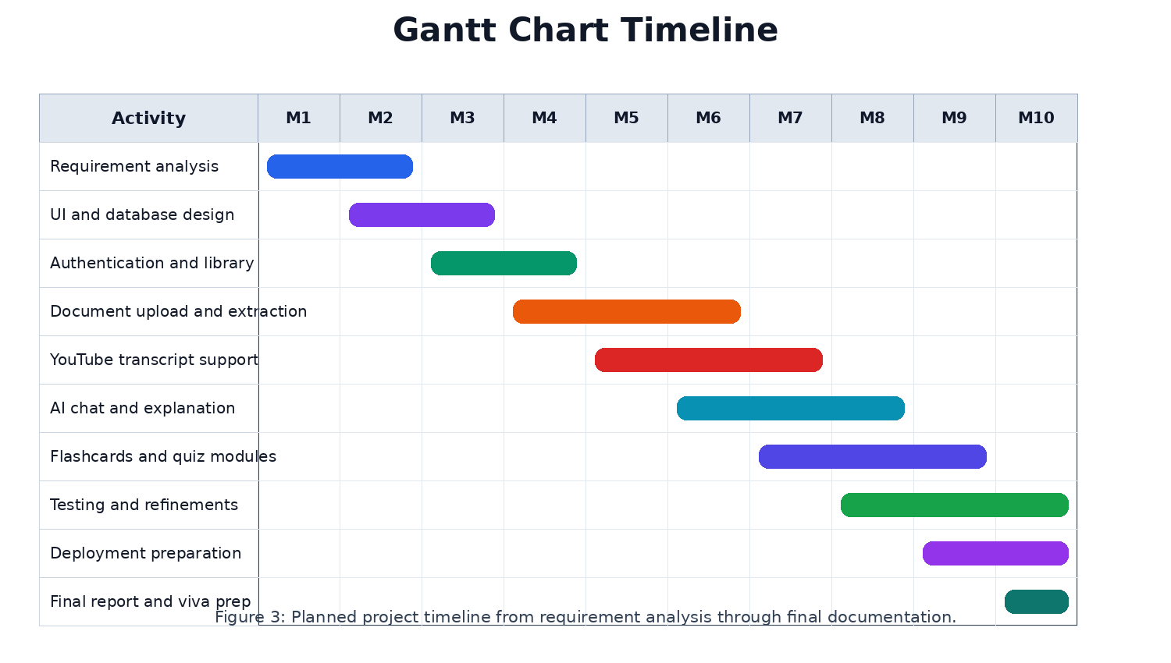
Figure 3: Gantt Chart Timeline

5. SOFTWARE REQUIREMENTS SPECIFICATION (SRS)
5.1 System Users
The system has three main user categories: anonymous guests, registered learners and administrators. Guests can test the platform with limited uploads. Registered learners can manage their personal document library and generated learning artifacts. Administrators can manage data using Django admin facilities.
5.2 Use Case Overview
- Upload a document and create a searchable learning record.
- Submit a YouTube URL and create a transcript-based learning record.
- Open a document and interact with chat, flashcards, MCQs, short questions and highlights.
- Ask a question and receive an answer grounded in extracted content.
- Delete a document that belongs to the current user.
5.3 Input Validation Rules
The upload view validates that a file exists, checks the file extension against pdf, doc, docx, pptx, xlsx and txt, and rejects files larger than 10 MB. The YouTube workflow validates the presence of a URL and extracts an eleven-character video ID from standard youtube.com, youtu.be, embed and shorts URL formats. Chat and explanation endpoints reject empty input.
5.4 Data Requirements
Table 6: Database entity summary
Entity | Main Fields | Purpose
Document | user, title, file, file_type, source_url, uploaded_at, text_content, total_pages | Represents uploaded files or YouTube transcripts.
ChatMessage | document, user_message, bot_response, page_reference, timestamp | Stores document-specific conversations.
Highlight | document, text, page_number, color, created_at | Stores selected important passages.
Flashcard | document, front, back, source_text, page_number, created_at | Stores generated revision cards.
ShortQuestion | document, question, answer, source_text, page_number, created_at | Stores generated short questions.
MCQQuestion | document, question, options, correct_answer, explanation, source_text, page_number | Stores generated multiple-choice questions.

6. DESIGN DOCUMENTATION
6.1 Architectural Design
The design follows a layered structure. The presentation layer is built with Django templates and JavaScript interactions. The application layer is implemented in views.py and coordinates request validation, ownership checks, document processing and AI calls. The domain/data layer is represented by Django models. Utility classes in utils.py and youtube.py isolate file extraction, Office rendering, context selection, AI prompts and YouTube transcript handling.
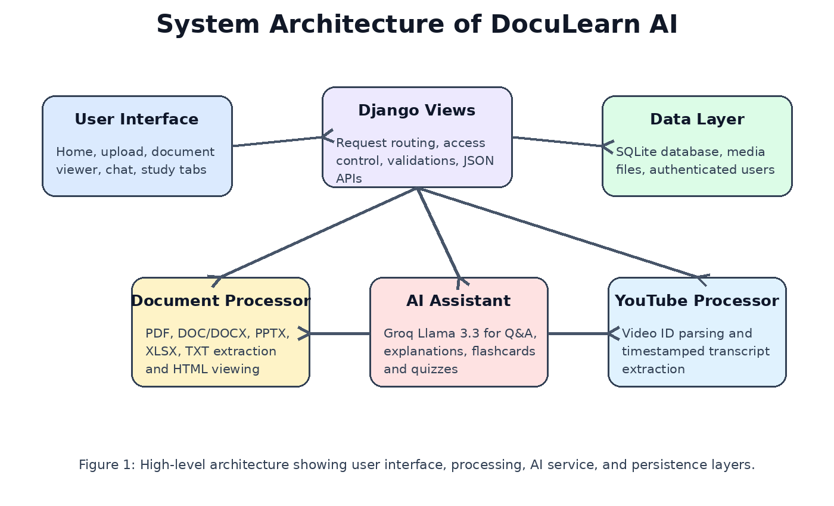
Figure 1: System Architecture of DocuLearn AI
6.2 Module Design
- models.py defines persistent entities and ownership relationships.
- views.py contains page views and AJAX endpoints for chat, explanation and study generation.
- utils.py contains DocumentProcessor, YouTubeProcessor and AIAssistant classes.
- youtube.py contains reusable YouTube video ID parsing logic.
- forms.py defines the custom registration form with required email.
- backends.py enables login by exact username or exact email.
6.3 Database Design
The Document model is the central entity. Chat messages, highlights, flashcards, short questions and MCQs are linked to a document through foreign keys with related names. User ownership is optional so the same model can support both registered users and guest session uploads. The cascade delete behavior ensures that deleting a document removes dependent study artifacts.

7. TECHNICAL MANUAL
7.1 Installation
To install the project, create a Python virtual environment, install packages from requirements.txt, configure environment variables and run Django migrations. LibreOffice must be available for Office conversion support, and GROQ_API_KEY must be set for AI features. The current settings load environment variables using python-dotenv.
7.2 Configuration
- SECRET_KEY should be provided through the environment in production.
- DEBUG is disabled when the RENDER environment variable is present.
- ALLOWED_HOSTS includes the Render external hostname when configured, otherwise localhost and 127.0.0.1.
- MEDIA_ROOT points to the project media directory for uploaded documents.
- FILE_UPLOAD_MAX_MEMORY_SIZE and DATA_UPLOAD_MAX_MEMORY_SIZE are set to 10 MB.
7.3 Important Commands
Command | Purpose
python manage.py makemigrations | Create database migrations after model changes.
python manage.py migrate | Apply database migrations.
python manage.py createsuperuser | Create an admin user.
python manage.py runserver | Run the local development server.
python manage.py collectstatic | Collect static files for deployment.
7.4 Processing Flow
When a file is uploaded, the view creates a Document record and calls DocumentProcessor according to the file extension. PDF files are parsed with page markers. Word, PowerPoint and Excel files are parsed with format-specific libraries. Text is cleaned by collapsing whitespace and then saved in text_content. For YouTube URLs, the transcript is converted into timestamped lines and saved as a document with file_type set to youtube.

8. USER MANUAL
8.1 Registration and Login
A new user opens the registration page, enters username, email and password details, and submits the form. After successful registration the user is logged in automatically. Existing users can log in using either username or email.
8.2 Uploading a Document
- Open the upload page from the navigation bar.
- Select the document upload tab.
- Choose or drag a supported file into the upload area.
- Optionally enter a title, otherwise the file name is used.
- Submit the form and wait for processing to complete.
8.3 Processing a YouTube Lecture
- Open the upload page and select the YouTube tab.
- Paste a valid YouTube URL from youtube.com, youtu.be, embed or shorts format.
- Submit the form so the system can retrieve available captions.
- Open the created transcript document and use chat or quiz generation as with uploaded files.
8.4 Studying a Document
The document detail page provides a split interface. The left side contains tabs for chat, flashcards, MCQs, short questions and highlights. The right side displays the document or generated HTML representation. Users can ask questions, generate study material and save selected text for later review.

9. TESTING AND VALIDATION
Testing focuses on upload validation, ownership control, processing accuracy and AI endpoint behavior. A practical validation set should include one file for each supported format, at least one unsupported extension, one oversized file, valid and invalid YouTube URLs, authenticated and guest sessions, and deletion of documents with related artifacts.
9.1 Suggested Test Cases
Test Case | Expected Result
Upload supported PDF under 10 MB | Document is saved, text is extracted and detail page opens.
Upload unsupported file type | User receives unsupported file type message.
Guest uploads fourth document | User is redirected to registration prompt.
Ask empty chat question | JSON error is returned with bad request status.
Open another user document | Access is denied or document is not found.
Generate MCQs without API key | No questions are created and the UI should handle the empty response.
9.2 Known Constraints
- YouTube processing depends on captions being available for the video.
- AI functions depend on a valid Groq API key and external service availability.
- SQLite is suitable for development but a production deployment should use a managed database.
- Large or complex Office files may require LibreOffice and may process more slowly.

10. CONCLUSION
The AI-Powered Learning Support System successfully combines document management, text extraction and AI-assisted study workflows in one Django application. It improves the learning process by converting static files and lecture transcripts into interactive resources. The updated implementation demonstrates practical support for multiple document formats, guest and registered access, persistent study artifacts and an extensible architecture that can support future improvements such as semantic search, cloud storage, stronger analytics and collaborative study spaces.
10.1 Future Enhancements
- Add vector embeddings for more accurate retrieval on long documents.
- Move media files to cloud object storage for production reliability.
- Add export options for generated flashcards and quizzes.
- Add dashboard analytics showing study progress by document.
- Improve automated tests around processing and permission boundaries.

APPENDIX A: PROJECT STRUCTURE
The repository is organized around the Django project folder doc_learning_system. The documents app contains the core models, views, URLs, forms, authentication backend, utilities and templates. Static images support the visual interface, while media/documents stores uploaded and converted files during local development.
Path | Description
doc_learning_system/settings.py | Project configuration, database, static files, media files and authentication settings.
documents/models.py | Database models for documents, chat, highlights, flashcards and questions.
documents/views.py | Main request handlers for library, upload, YouTube processing, chat and generation.
documents/utils.py | Document processing and AI assistant classes.
documents/youtube.py | YouTube video ID extraction helpers.
templates/documents | Home, upload, document detail and Office viewer pages.

APPENDIX B: DOCUMENTATION COMPLETENESS CHECKLIST
Required Area | Status in This Report
Introduction, scope and objectives | Covered in Section 1.
Functional and non-functional requirements | Covered in Section 2 and SRS Section 5.
Hardware and software requirements | Covered in Sections 2.3 and 2.4.
Methodology and tools | Covered in Section 3.
Gantt chart | Covered in Section 4 with a centered chart.
SRS design documentation | Covered in Sections 5 and 6.
Technical manual | Covered in Section 7.
User manual | Covered in Section 8.
Structure clarity and completeness | Supported through table of contents, figures, tables and appendices.

APPENDIX C: SRS TRACEABILITY MATRIX
The traceability matrix connects requirements with implemented project modules. It helps reviewers confirm that major stated requirements are visible in the codebase and that the documentation is complete enough to support evaluation and maintenance.
Table 7: SRS traceability matrix
Requirement | Implemented In | Verification Method
Registration and login | forms.py, backends.py, views.register, Django auth URLs | Create account, login with username, login with email.
Guest upload limit | views.py session helpers and GUEST_UPLOAD_LIMIT | Upload three files as guest and attempt a fourth.
File upload validation | views.upload_document | Try supported, unsupported and oversized files.
YouTube transcript processing | views.process_youtube, utils.YouTubeProcessor, youtube.py | Submit supported and unsupported URLs.
AI chat | views.chat, utils.AIAssistant.answer_question | Ask document-specific questions and inspect stored ChatMessage.
Flashcards, MCQs and short questions | views.create_flashcards, create_mcqs_from_text, create_short_questions_from_text | Generate each artifact and confirm database records.
Highlights | views.save_highlight, Highlight model | Select text and save page/color metadata.

APPENDIX D: API AND ROUTE REFERENCE
The application exposes browser pages and POST endpoints through the documents URL configuration. The route naming is important because templates refer to named routes such as documents:home, documents:upload and documents:document_detail.
Table 8: Route reference
Route | Method | Purpose
/ | GET | Display user library or guest documents.
/upload/ | GET/POST | Show upload page and process supported files.
/youtube/ | POST | Process a YouTube URL into a transcript document.
/document/<id>/ | GET | Show document detail page with study panels.
/document/<id>/file/ | GET | Serve uploaded file inline.
/document/<id>/view/ | GET | Render Office documents as HTML.
/chat/<id>/ | POST | Return AI answer as JSON and save chat history.
/explain/<id>/ | POST | Explain selected text using the assistant.
/flashcards/<id>/ | POST | Generate and store flashcards.
/mcqs/<id>/ | POST | Generate and store MCQs.
/short-questions/<id>/ | POST | Generate and store short-answer questions.
/highlight/<id>/ | POST | Save selected highlight data.

APPENDIX E: SECURITY AND PRIVACY CONSIDERATIONS
Security is handled mainly through Django authentication, document ownership checks and input validation. The helper _get_doc_for_request prevents authenticated users from opening documents that belong to another user. For anonymous users, only IDs stored in the session are accepted. This design reduces accidental exposure of uploaded materials.
E.1 Recommended Improvements
- Store SECRET_KEY and GROQ_API_KEY only in environment variables or a protected secrets manager.
- Use a production database with backups instead of SQLite when deploying publicly.
- Scan uploaded files for malware before processing in a shared deployment.
- Add rate limits to AI endpoints to control cost and prevent abuse.
- Avoid logging private document content or complete AI prompts in production logs.
- Use HTTPS and secure cookie settings on the deployed site.

APPENDIX F: DEPLOYMENT MANUAL
The project includes deployment-oriented settings for static files, allowed hosts and Render support. WhiteNoise serves compressed static assets, and the render-build.sh file can be used to collect static files during deployment. The application should be deployed with Gunicorn behind a managed platform or reverse proxy.
Table 9: Deployment checklist
Step | Action
1 | Create production environment variables for SECRET_KEY, GROQ_API_KEY and RENDER_EXTERNAL_HOSTNAME.
2 | Install requirements in a clean virtual environment or platform build container.
3 | Run migrations against the production database.
4 | Run collectstatic so WhiteNoise can serve static assets.
5 | Configure media file persistence or cloud storage for uploaded documents.
6 | Start the app with Gunicorn using the Django WSGI application.
7 | Test login, upload, document viewing, YouTube transcript retrieval and AI endpoints.

APPENDIX G: MAINTENANCE MANUAL
Maintenance work should focus on dependency updates, prompt quality, document conversion reliability and storage management. Since the project depends on several external packages, changes in library APIs can affect transcript fetching, Office rendering or AI response parsing. The code is modular enough to update individual processors without rewriting the whole application.
G.1 Maintenance Tasks
- Review requirements.txt regularly and test upgrades in a separate branch.
- Keep a small sample set of PDF, DOCX, PPTX, XLSX, TXT and YouTube inputs for regression testing.
- Monitor media storage and remove unused converted files when safe.
- Validate generated JSON parsing for flashcards and quiz items after model or prompt changes.
- Back up database records before migrations in production.
- Document any new routes or models in the technical manual.

APPENDIX H: PROMPT AND AI DESIGN
The AI assistant uses role-specific prompts for different learning tasks. Question answering uses relevant context selected from the document and instructs the model to cite pages or timestamps when identifiable. Flashcards, MCQs and short questions request JSON-only responses so the application can parse and store generated content.
Table 10: AI prompt design summary
Function | Prompt Goal | Output Handling
answer_question | Answer from document context and cite pages or timestamps. | Text response is stored with optional page reference.
explain_text | Explain selected text clearly with examples where helpful. | Text explanation is returned to the page.
generate_flashcards | Create front/back educational cards as valid JSON. | Parsed into Flashcard records.
generate_mcqs | Create MCQs with options, correct answer and explanation as JSON. | Parsed into MCQQuestion records.
generate_short_questions | Create short-answer questions and answers as JSON. | Parsed into ShortQuestion records.

APPENDIX I: RISK MANAGEMENT
The project has technical, operational and educational risks. Managing these risks improves the reliability of the learning experience and makes the system more suitable for real student use.
Table 11: Risk management plan
Risk | Impact | Mitigation
AI service unavailable | Chat and generation features stop working. | Show clear error messages and keep document viewing available.
Poor text extraction | Generated answers become incomplete. | Use multiple extraction libraries and display warnings when extraction fails.
Unsupported YouTube captions | Video cannot be processed. | Explain that only videos with manual or auto captions are supported.
Large files slow processing | Poor user experience. | Keep 10 MB upload limit and consider background jobs later.
Private data exposure | Loss of trust and compliance concerns. | Enforce ownership checks and secure deployment settings.

APPENDIX J: DETAILED TEST PLAN
The following test plan expands the validation section with practical scenarios that can be executed manually or automated using Django tests. These cases cover positive workflows, negative workflows and boundary conditions.
Table 12: Detailed test plan
Area | Scenario | Expected Result
Authentication | Register with valid email and password | User account is created and session starts.
Authentication | Login with registered email | User reaches document library.
Upload | Upload DOCX under 10 MB | Document text is extracted and saved.
Upload | Upload file with .exe extension | Error message appears and no Document is created.
YouTube | Paste youtu.be short URL | Video ID is parsed and transcript processing starts.
Chat | Ask question after upload | ChatMessage record is saved with answer.
Study tools | Generate five flashcards | Up to five Flashcard records are stored.
Permissions | Guess another document ID | Access is denied.
Deletion | Delete document with generated artifacts | Document and related records are removed.

APPENDIX K: REVIEWER CHECKLIST
This checklist is intended for project evaluation. It maps the report structure and implementation evidence to the expected final-year-project documentation areas.
Table 13: Reviewer checklist
Item | Evidence
Project background and problem statement | Section 1.1 and Section 1.2.
Clear scope and objectives | Section 1.3 and Section 1.4.
Functional/non-functional requirements | Section 2 and Appendix C.
Process model and tools | Section 3.
Gantt chart | Section 4 and Figure 3.
SRS and design | Sections 5 and 6.
Technical manual | Section 7 and Appendices F, G and H.
User manual | Section 8.
Testing and risk coverage | Section 9 and Appendices I and J.
Formatting | Times New Roman styles, centered captions, table captions above tables and 1 inch margins.

APPENDIX L: FINAL SUMMARY OF COMPLETENESS
The updated document is structured to satisfy the requested report components: introduction, requirements, methodology, Gantt chart, SRS, design documentation, technical manual, user manual, testing, deployment, maintenance, risk management and appendices. It is based on the actual Django project files rather than only the previous report. The predecessor file remains unchanged, and the new updated report is saved as a separate DOCX file.
The report also includes tables, figures, captions and front matter. Word can update the table of contents field when the document is opened, and the page numbering is configured with Roman numerals for front matter and decimal numbering from the introduction onward.
APPENDIX M: IMPLEMENTATION NOTES
The implementation uses Django views as orchestration points rather than placing business logic directly in templates. This makes the interface easier to adjust while keeping validation and persistence inside server-side code.
The DocumentProcessor class is responsible for format-specific extraction. This keeps PDF, Word, PowerPoint, Excel and plain-text handling in one location and prevents duplication across upload and viewing workflows.
The AIAssistant class wraps the Groq client lazily. If the API key is missing, AI features return controlled responses or empty generated lists rather than crashing the complete application.
The current design is intentionally simple enough for a final-year-project deployment while remaining extensible for background jobs, vector search and cloud storage later.
Table: Key points for APPENDIX M
Focus | Summary
Purpose | The implementation uses Django views as orchestration points rather than placing business logic directly in templates. This makes the interface easier to adjust
Project relevance | The DocumentProcessor class is responsible for format-specific extraction. This keeps PDF, Word, PowerPoint, Excel and plain-text handling in one location and p
Evaluation value | The AIAssistant class wraps the Groq client lazily. If the API key is missing, AI features return controlled responses or empty generated lists rather than cras
APPENDIX N: DATA DICTIONARY
The data dictionary explains the meaning of important fields used by the application. The Document table stores the extracted text that powers the AI assistant, while related tables store learning activity around that document.
The user field in Document is nullable to support guest mode. A registered document has a user owner, while a guest document is protected by a session list of allowed document IDs.
The source_url field is mainly used for YouTube documents. For normal uploaded files, the file field points to media/documents and the file_type field identifies the processor to use.
The source_text fields in generated artifacts preserve the input snippet used for generation, which supports review and future traceability.
Table: Key points for APPENDIX N
Focus | Summary
Purpose | The data dictionary explains the meaning of important fields used by the application. The Document table stores the extracted text that powers the AI assistant,
Project relevance | The user field in Document is nullable to support guest mode. A registered document has a user owner, while a guest document is protected by a session list of a
Evaluation value | The source_url field is mainly used for YouTube documents. For normal uploaded files, the file field points to media/documents and the file_type field identifie
APPENDIX O: USER INTERFACE WORKFLOW DETAILS
The home page works as the learner library. Authenticated users see their own documents; guests see only documents recorded in the active session. This gives both quick trial access and persistent registered access.
The upload page separates document upload and YouTube URL processing through tabs. This lowers confusion because each source has different input fields, validation rules and expected processing outcomes.
The document detail page is the main study workspace. It places the document viewer beside panels for chat, flashcards, MCQs, short questions and highlights, allowing the user to study without switching pages repeatedly.
The interface returns asynchronous JSON responses for chat and generation features. This makes the experience feel interactive because the page can update study panels without a complete reload.
Table: Key points for APPENDIX O
Focus | Summary
Purpose | The home page works as the learner library. Authenticated users see their own documents; guests see only documents recorded in the active session. This gives bo
Project relevance | The upload page separates document upload and YouTube URL processing through tabs. This lowers confusion because each source has different input fields, validat
Evaluation value | The document detail page is the main study workspace. It places the document viewer beside panels for chat, flashcards, MCQs, short questions and highlights, al
APPENDIX P: QUALITY ATTRIBUTE DETAIL
Usability is supported through direct upload controls, clear messages and a single document workspace. The system avoids forcing users to learn a complex menu structure before they can study.
Reliability is supported by validation, exception handling around extraction and graceful behavior when AI output cannot be parsed. More automated tests would further strengthen this attribute.
Maintainability is supported by the separation of models, routes, views, forms, authentication backend and utility processors. Each module has a clear purpose and can be reviewed independently.
Performance is acceptable for the configured upload size. For larger production usage, document extraction and AI generation should move to background jobs so web requests remain responsive.
Table: Key points for APPENDIX P
Focus | Summary
Purpose | Usability is supported through direct upload controls, clear messages and a single document workspace. The system avoids forcing users to learn a complex menu s
Project relevance | Reliability is supported by validation, exception handling around extraction and graceful behavior when AI output cannot be parsed. More automated tests would f
Evaluation value | Maintainability is supported by the separation of models, routes, views, forms, authentication backend and utility processors. Each module has a clear purpose a
APPENDIX Q: LIMITATIONS
The application depends on external services for AI completion and YouTube transcripts. If those services are unavailable, the document library and viewer remain useful, but generated study support becomes limited.
The current relevant-context selection uses word overlap and page markers. This is simple and transparent, but semantic retrieval using embeddings would improve answer quality on long and complex documents.
Media files are stored locally in the development structure. A production system should use persistent storage because local disk storage can be temporary on some hosting providers.
The report reflects the current codebase and does not claim that every future feature is implemented. Recommendations are listed separately so implemented behavior and future work remain clear.
Table: Key points for APPENDIX Q
Focus | Summary
Purpose | The application depends on external services for AI completion and YouTube transcripts. If those services are unavailable, the document library and viewer remai
Project relevance | The current relevant-context selection uses word overlap and page markers. This is simple and transparent, but semantic retrieval using embeddings would improve
Evaluation value | Media files are stored locally in the development structure. A production system should use persistent storage because local disk storage can be temporary on so
APPENDIX R: FUTURE WORK ROADMAP
Phase one should add automated tests for upload validation, guest limits, ownership checks and route responses. These tests would protect the project from regressions during maintenance.
Phase two should add semantic search with embeddings. This would let the assistant retrieve the best passages even when the user question does not share exact words with the document text.
Phase three should improve deployment architecture with PostgreSQL, cloud media storage, background processing and rate limiting for expensive AI operations.
Phase four should introduce export features such as downloading flashcards, quizzes or a study summary as PDF or DOCX, which would make the platform more useful for exam preparation.
Table: Key points for APPENDIX R
Focus | Summary
Purpose | Phase one should add automated tests for upload validation, guest limits, ownership checks and route responses. These tests would protect the project from regre
Project relevance | Phase two should add semantic search with embeddings. This would let the assistant retrieve the best passages even when the user question does not share exact w
Evaluation value | Phase three should improve deployment architecture with PostgreSQL, cloud media storage, background processing and rate limiting for expensive AI operations.
APPENDIX S: BIBLIOGRAPHY AND REFERENCES
Django documentation was the primary reference for project structure, models, authentication, views, templates, static files and deployment behavior.
PyMuPDF, python-docx, python-pptx and openpyxl documentation informed the file extraction approach used by the document processing layer.
Groq API documentation informed the chat completion integration and model configuration used by the AI assistant class.
YouTube Transcript API documentation informed the transcript fetching workflow and the need to handle unavailable captions gracefully.
Table: Key points for APPENDIX S
Focus | Summary
Purpose | Django documentation was the primary reference for project structure, models, authentication, views, templates, static files and deployment behavior.
Project relevance | PyMuPDF, python-docx, python-pptx and openpyxl documentation informed the file extraction approach used by the document processing layer.
Evaluation value | Groq API documentation informed the chat completion integration and model configuration used by the AI assistant class.
APPENDIX T: VIVA PREPARATION NOTES
The central problem statement is that students have many learning documents and videos but limited time to convert them into useful revision material. The project solves this by turning documents into interactive AI-supported study workspaces.
The strongest implemented features are multi-format upload, YouTube transcript support, contextual AI chat, selected-text explanation, flashcard generation, quiz generation, highlights and ownership-aware document access.
The main technical challenge is integrating varied document formats and external AI output into one reliable flow. The design handles this by isolating processors and validating inputs before saving generated records.
The most important future improvement is semantic retrieval, because it would make AI answers more accurate when documents become long and complex.
Table: Key points for APPENDIX T
Focus | Summary
Purpose | The central problem statement is that students have many learning documents and videos but limited time to convert them into useful revision material. The proje
Project relevance | The strongest implemented features are multi-format upload, YouTube transcript support, contextual AI chat, selected-text explanation, flashcard generation, qui
Evaluation value | The main technical challenge is integrating varied document formats and external AI output into one reliable flow. The design handles this by isolating processo
APPENDIX U: LATEST CHATBOT AND LIVE WEB UPDATE
After the initial report was created, the chatbot workflow was improved so that the system behaves more like a conversational AI assistant instead of always producing transcript-style summaries. The updated system now classifies the user message by intent, responds naturally to greetings, uses document or video context when the question is about the uploaded source, passes YouTube metadata to the model, and can use live web-search snippets when the answer may require current information.
U.1 Updated Chatbot Behaviour
- Casual messages such as hi, hello, yo, thanks and short unclear prompts are handled with friendly natural replies before document Q&A is invoked.
- The Llama prompt now tells the model to answer the exact question first, keep replies concise by default and avoid dumping a full script-style outline unless the user asks for a summary.
- The assistant can answer from uploaded document or video context when the question is source-related.
- When the uploaded source does not contain the answer, the assistant can answer from general knowledge or from live web-search results when available.
- For current or internet-dependent questions, the Django backend can collect live search snippets and pass them to Llama as context.
Table 14: Updated chatbot response modes
Mode | Trigger | System Response
Casual chat | Greetings, thanks, short unclear text | Return a friendly conversational response without forcing document explanation.
Source Q&A | Question about uploaded document/video | Use title, metadata and extracted document/transcript context.
General knowledge | Question not answered by uploaded source | Answer from model knowledge and clarify when the answer is not from the uploaded file.
Live web assisted | Latest/current/web-style question | Fetch search snippets, pass them to Llama and include relevant source URLs.
U.2 YouTube Metadata Support
The YouTube processor now uses YouTube oEmbed metadata where possible. This provides the public video title, channel or creator name, channel URL and canonical video URL without requiring a paid YouTube Data API key. The metadata is used during upload to improve the saved document title and during chat to answer natural questions such as “whose video is this?”, “who made this video?” and “what channel is this?”.
Table 15: YouTube metadata used by the assistant
Metadata Field | Purpose
Video title | Used as the document title and to answer identity questions about the video.
Channel/creator name | Allows the chatbot to identify who published or created the video.
Channel URL | Provides a source link when the assistant mentions the channel.
Video URL | Preserves the source reference for the uploaded learning item.
U.3 Live Web Search Workflow
A lightweight WebSearch helper was added to the technical design. It sends a query to DuckDuckGo HTML search, extracts result titles, URLs and snippets using BeautifulSoup, formats the results, and passes them into the Llama prompt. This gives the assistant a live information path for questions that are current, broad or not answered by the uploaded document. The model is instructed to mention when it uses live web results and to include relevant source URLs.
Table 16: Live web search implementation flow
Step | Description
1. Detect need | The chat view checks for latest/current/web/general question patterns.
2. Search web | WebSearch queries DuckDuckGo HTML and extracts result snippets.
3. Prompt Llama | Search snippets are added beside document context and source metadata.
4. Generate answer | Llama chooses whether to use source context, web snippets or general knowledge.
5. Return response | The answer is saved in chat history and shown to the user.
U.4 Updated Technical Components
The main files affected by the latest update are documents/utils.py and documents/views.py. The utilities module now contains YouTube metadata retrieval, the WebSearch helper and a broader prompt policy for the AI assistant. The views module now prepares source metadata and optional live web results before calling the assistant.
Table 17: Files changed in latest update
File | Latest Responsibility
documents/utils.py | YouTube oEmbed metadata, WebSearch helper and updated Llama prompt policy.
documents/views.py | Casual chat handling, source metadata preparation and conditional live-search context.
templates/documents/document_detail.html | Earlier UI fix: hidden transcript panel and improved chat scroll position.
U.5 Deployment Notes for Live Search
- The server must allow outbound HTTPS requests for YouTube oEmbed and DuckDuckGo HTML search.
- The project already includes requests and beautifulsoup4 in requirements.txt, so no extra package is required for this update.
- After uploading the changed Python files to the server, the Django or Gunicorn process must be restarted so the new prompt and search code are loaded.
- If a hosting provider blocks search-engine requests, the WebSearch helper can later be replaced with a formal search API such as Serper, Tavily, Bing Search or Google Custom Search.
- The assistant should never claim a live result if no web results were successfully provided to the prompt.
APPENDIX V: UPDATED AI PROMPT POLICY
The assistant prompt was revised from a document-only answering style to a router-style policy. The new policy asks the model to identify the user intent first and then select the proper response mode. This is important because a learning assistant must be able to greet the user, answer source-specific questions, answer general questions and use live web results when needed.
Table 18: Prompt policy before and after update
Area | Previous Behaviour | Updated Behaviour
Greeting | Could be interpreted as a document question. | Handled as friendly chat.
Video identity | Often summarized transcript content. | Uses title/channel metadata plus transcript if useful.
General question | Forced into uploaded context. | Can answer generally or use live web results.
Current question | No live path available. | Can receive live search snippets from Django backend.
Answer style | Detailed script-like summaries. | Direct conversational answer first, detail only when requested.

