Sandwich Ontology Report - Assignment Part 1

Overview of Ontology
This sandwich ontology provides a comprehensive conceptual framework for modelling various types of sandwiches and their constituent components or parts. The ontology encompasses 37 classes organised hierarchically to capture essential characteristics and relationships within the sandwich domain. More than 10 were used to try and encapsulate the bread of sandwich types mentioned in the Wikipedia link on sandwiches.
The ontology is constructed around two primary branches: sandwich types and ingredient categories. The classification system distinguishes between fundamental structural differences (open versus closed sandwiches) whilst accommodating cultural variations (Panini, Smorrebrod, Club sandwiches). The ingredient hierarchy systematically organises components from general categories (Bread, Filling, Condiment) to specific instances (Ham, Ciabatta, Cucumber).
Five object properties (containsBread, hasFilling, hasIngredient, isCompatibleWith, isLayeredAbove) establish the relational framework for expressing complex sandwich structures and ingredient interactions.

Justification of Hierarchical Relations
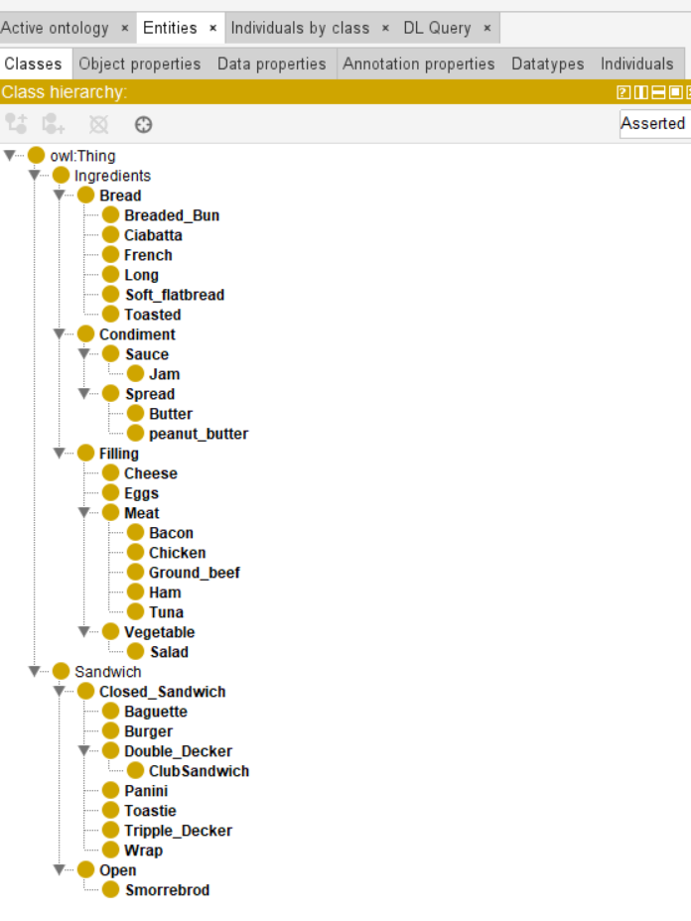

Primary Hierarchical Structure
The Sandwich → Closed_Sandwich/Open hierarchy reflects the structural difference in sandwich classification. Closed sandwiches (multiple bread pieces enclosing fillings) have different structural requirements than open sandwiches (single bread base with toppings), and hence requiring different logical constraints and preparation methods.

Ingredient Categorisation
The Ingredients → Bread/Filling/Condiment hierarchy organises components by functional role rather than material. Bread classes are distinguished by preparation method and cultural origin, whilst Filling subclasses (Meat, Vegetable, Cheese) are grouped by nutritional function and standard dietary requirements. Condiment division into Sauce and Spread reflects application methods.

Specialised Sandwich Types
Complex sandwiches such as ClubSandwich inherit from Double_Decker, which is a Closed_Sandwich because they maintain fundamental closed structure whilst adding specific layer requirements. Tripple_Decker, also a Closed_Sandwich represents further multi-layer construction and therefore a separate classification.

Property Classification
The following properties were used:
containsBread: needed to classify sandwich types
hasFilling: needed to define recipes
hasIngredients: capture other items which are not bread or filling
isCompatibleWith: required for culinary intelligence / cooking knowledge
isLayeredAbove: know what’s inside but not how to build

Property | Functional | Inverse Functional | Transitive | Symmetric | Asymmetric | Reflexive | Irreflexive
containsBread |  |  |  |  | Y |  | Y
hasFilling |  |  |  |  | Y |  | Y
hasIngredient |  |  |  |  | Y |  | Y
isCompatibleWith |  |  |  |  |  | Y
isLayeredAbove |  |  | Y |  | Y |  | Y

Examples of terminology
Symmetric: If bacon is compatible with lettuce, then lettuce is compatible with bacon
Asymmetric: If sandwich contains bread, then bread cannot contain sandwiches
Transitive: If lettuce is above tomato, and tomato is above bread, then lettuce us above bread
Reflexive: Every ingredient is compatible with itself
Irreflective: A Sandwich cannot contain itself as a sandwich

Explanation of the Axiom

Primary Axiom: Double Decker Definition
Double_Decker ≡ Closed_Sandwich ⊓ (= 3 containsBread.Bread) ⊓ (= 2 hasFilling.Filling)
Plain Language: A Double Decker sandwich contains exactly three bread pieces and 2 filling layers.

Advanced Axiom: ClubSandwich Specification
ClubSandwich ≡ Double_Decker ⊓ (= 1 hasFilling.Bacon) ⊓ (= 1 hasFilling.Chicken) ⊓ (= 1 hasFilling.Salad)
Plain Language: A Club sandwich is a double-decker containing exactly one each of bacon, chicken, and salad fillings.

Logical Justification
These axioms capture structural mathematics of multi-layer construction following the formula: filling layers = bread pieces - 1. For triple-deckers, four bread pieces create three filling spaces, while for double-deckers, three bread pieces create three filling spaces. Exact cardinality constraints prevent classification ambiguity whilst allowing precise automatic recognition.
The ClubSandwich axiom demonstrates constraint modelling by inheriting structural requirements from Double_Decker whilst specifying exact ingredient composition, supporting menu classification and dietary analysis applications.

Supporting Axioms
Double Decker: = 3 containsBread.Bread ⊓ ≥ 2 hasFilling.Filling
Open Sandwich: ≥ 1 containsBread.Bread
These establish consistent classification frameworks enabling automatic reasoning about sandwich types based on structural and compositional requirements.

Advantages and Disadvantages of This Starting Point

Advantages
1. Comprehensive Coverage Successfully captures sandwich types from simple (Open) to complex (Tripple_Decker), accommodating both Western varieties and international forms such as Smorrebrod, enabling cross-cultural reasoning.
2. Structural Precision Exact cardinality restrictions provide mathematical precision in definition, eliminating classification ambiguity and supporting clear automated reasoning.
3. Scalable Framework Hierarchical organisation allows straightforward extension for new sandwich types without disrupting existing structure; hence structures such as bread, condiment, filling (meat/veg) and open/closed sandwiches.
4. Recipe-Level Specificity Qualified number restrictions, exemplified by ClubSandwich definition, enable automatic recognition based on exact ingredient composition, supporting commercial applications.

Disadvantages
1. Over-Specification Risk Detailed categorisation may prove excessive for practical applications, potentially creating unnecessary complexity for simple identification tasks.
2. Cultural Bias Primarily reflects Western sandwich concepts, potentially inadequately representing non-Western bread-based foods or continuous bread forms common in other cultures. e.g. Pakistani roti, chapati, naan, paratha, tortillas etc
3. Preparation Method Limitations Focus on ingredients and structure largely ignores preparation methods (grilled, toasted, cold) which significantly affect sandwich classification.
4. Limited Dynamic Properties Lacks temporal properties for construction sequences, freshness constraints, or serving temperatures, limiting utility for food service applications.
5. Ingredient Interaction Gaps There are insufficient axioms to capture flavour profiles, dietary restrictions, or nutritional interactions influencing sandwich design decisions.

