PROECT REPORT

Program: Implementation of A* Search Algorithm with Threads

Submitted to: Miss Naz Memon

Submitted by: Saqib Shaikh & Taha Siddiqui

Roll no: K21-3874 & k21-3845

Introduction

A* search algorithm is a widely used algorithm in artificial intelligence and robotics for finding the shortest path between two points in a graph. It is a heuristic search algorithm that is based on the best-first search technique. The algorithm takes into account both the cost of moving from the starting point to a particular node and the estimated cost of moving from that node to the destination point.

The algorithm uses a heuristic function to estimate the cost of moving from a particular node to the destination point. The heuristic function is admissible if it never overestimates the actual cost. A* algorithm guarantees to find the optimal path if the heuristic function is admissible.

To improve the performance of the A* algorithm, we can use threads. In multi-threading, a process is divided into multiple threads that can run concurrently. Each thread can execute a part of the process, and the results can be combined at the end to get the final result.

We can divide the A* algorithm into two threads: the main thread and the search thread. The main thread is responsible for creating the search thread and managing the overall search process. The search thread is responsible for exploring the search space and finding the shortest path.

The main thread initializes the search by creating the search thread and passing the starting node to it. The search thread explores the search space by examining the neighboring nodes of the current node and adding them to the priority queue based on their estimated cost. The search thread then selects the node with the lowest estimated cost from the priority queue and repeats the process until it reaches the destination node.

To improve the performance further, we can use multiple search threads. Each search thread can explore a different part of the search space, and the results can be combined at the end. This approach can significantly reduce the search time, especially for large search spaces.

In summary, using threads in the A* algorithm can significantly improve the performance of the algorithm, especially for large search spaces. The main thread manages the overall search process, while the search thread explores the search space and finds the shortest path. Multiple search threads can be used to further improve the performance of the algorithm.

Features

The main features of A* Search Algorithm with threads include:

1. Parallelism: By using multiple threads, the algorithm can explore multiple parts of the graph simultaneously, potentially reducing the overall search time.
2. Load Balancing: In a multi-threaded implementation, the algorithm can distribute the workload evenly among the threads, reducing the time taken to search the graph.
3. Scalability: With threads, the algorithm can be scaled to handle larger graphs, as each thread can explore a different part of the graph independently.
4. Efficient use of resources: A multi-threaded implementation can make efficient use of the available CPU resources, as idle cores can be utilized to speed up the search process.
5. Thread safety: The implementation must ensure thread safety to avoid race conditions and ensure correct results.
6. Coordination and synchronization: Proper coordination and synchronization mechanisms must be used to ensure that each thread explores the graph correctly, without overlapping with other threads.
7. Early termination: When a thread finds the goal node, it can notify the other threads to stop searching, potentially reducing the overall search time.

Overall, using threads can improve the performance and scalability of A* Search Algorithm, making it a viable solution for searching large graphs. However, the implementation must take into account thread safety, load balancing, and proper coordination and synchronization mechanisms to ensure correct and efficient execution.

Technology Used

A* Search Algorithm with Threads can be implemented using a variety of programming languages and technologies. Here are some of the common technologies used for implementing this algorithm:

* Programming languages: The implementation is done using C programming language that supports multi-threading and synchronization mechanisms.
* Multi-threading libraries: Pthread library is used to provide an API to create and manage threads. This library provide thread-safe synchronization mechanisms such as mutexes, semaphores, and condition variables.
* Linux terminal: A terminal is a command-line interface used to interact with a Linux-based operating system. It allows users to execute commands and run programs.
* GCC compiler: GCC (GNU Compiler Collection) is a popular compiler for the C programming language. It is used to compile C code into machine-readable binary files.
* Makefile: A Makefile is a text file used to automate the build process of a program. It contains a set of rules and dependencies that define how the program should be built.
* GNU Debugger (GDB): GDB is a debugging tool that allows developers to debug their C programs by stepping through the code and examining memory and variables at runtime.

Code Snippets

#include <stdlib.h>

#include <stdio.h>

#include <string.h>

#include <float.h>

#include <pthread.h>

#include <iso646.h>

#include <math.h>

#include <graphics.h>

#define map_size_rows 10

#define map_size_cols 10

char map[map_size_rows][map_size_cols] = {

{1, 1, 1, 1, 1, 1, 1, 1, 1, 1},

{1, 0, 0, 0, 0, 0, 0, 0, 0, 1},

{1, 0, 0, 0, 0, 0, 0, 0, 0, 1},

{1, 0, 0, 0, 0, 1, 1, 1, 0, 1},

{1, 0, 0, 1, 0, 0, 0, 1, 0, 1},

{1, 0, 0, 1, 0, 0, 0, 1, 0, 1},

{1, 0, 0, 1, 1, 1, 1, 1, 0, 1},

{1, 0, 0, 0, 0, 0, 0, 0, 0, 1},

{1, 0, 0, 0, 0, 0, 0, 0, 0, 1},

{1, 1, 1, 1, 1, 1, 1, 1, 1, 1}

};

/* description of graph node */

struct stop {

double col, row;

/* array of indexes of routes from this stop to neighbours in array of all routes */

int * n;

int n_len;

double f, g, h;

int from;

};

int ind[map_size_rows][map_size_cols] = {

{-1, -1, -1, -1, -1, -1, -1, -1, -1, -1},

{-1, -1, -1, -1, -1, -1, -1, -1, -1, -1},

{-1, -1, -1, -1, -1, -1, -1, -1, -1, -1},

{-1, -1, -1, -1, -1, -1, -1, -1, -1, -1},

{-1, -1, -1, -1, -1, -1, -1, -1, -1, -1},

{-1, -1, -1, -1, -1, -1, -1, -1, -1, -1},

{-1, -1, -1, -1, -1, -1, -1, -1, -1, -1},

{-1, -1, -1, -1, -1, -1, -1, -1, -1, -1},

{-1, -1, -1, -1, -1, -1, -1, -1, -1, -1},

{-1, -1, -1, -1, -1, -1, -1, -1, -1, -1}

};

struct route {

int x;

int y;

double d;

};

void *search(void *threadid)

{

int i, j, k, l, b, found;

int p_len = 0;

int * path = NULL;

int c_len = 0;

int * closed = NULL;

int o_len = 1;

int * open = (int*)calloc(o_len, sizeof(int));

double min, tempg;

int e;

int current;

int s_len = 0;

struct stop * stops = NULL;

int r_len = 0;

struct route * routes = NULL;

long s;

s = (long)threadid;

for (i = 1; i < map_size_rows - 1; i++) {

for (j = 1; j < map_size_cols - 1; j++) {

if (!map[i][j]) {

++s_len;

stops = (struct stop *)realloc(stops, s_len * sizeof(struct stop));

int t = s_len - 1;

stops[t].col = j;

stops[t].row = i;

stops[t].from = -1;

stops[t].g = DBL_MAX;

stops[t].n_len = 0;

stops[t].n = NULL;

ind[i][j] = t;

}

}

}

e = s_len - 1;

for (i = 0; i < s_len; i++) {

stops[i].h = sqrt(pow(stops[e].row - stops[i].row, 2) + pow(stops[e].col - stops[i].col, 2));

}

for (i = 1; i < map_size_rows - 1; i++) {

for (j = 1; j < map_size_cols - 1; j++) {

if (ind[i][j] >= 0) {

for (k = i - 1; k <= i + 1; k++) {

for (l = j - 1; l <= j + 1; l++) {

if ((k == i) and (l == j)) {

continue;

}

if (ind[k][l] >= 0) {

++r_len;

routes = (struct route *)realloc(routes, r_len * sizeof(struct route));

int t = r_len - 1;

routes[t].x = ind[i][j];

routes[t].y = ind[k][l];

routes[t].d = sqrt(pow(stops[routes[t].y].row - stops[routes[t].x].row, 2) + pow(stops[routes[t].y].col - stops[routes[t].x].col, 2));

++stops[routes[t].x].n_len;

stops[routes[t].x].n = (int*)realloc(stops[routes[t].x].n, stops[routes[t].x].n_len * sizeof(int));

stops[routes[t].x].n[stops[routes[t].x].n_len - 1] = t;

}

}

}

}

}

}

open[0] = s;

stops[s].g = 0;

stops[s].f = stops[s].g + stops[s].h;

found = 0;

while (o_len and not found) {

min = DBL_MAX;

for (i = 0; i < o_len; i++) {

if (stops[open[i]].f < min) {

current = open[i];

min = stops[open[i]].f;

}

}

if (current == e) {

found = 1;

++p_len;

path = (int*)realloc(path, p_len * sizeof(int));

path[p_len - 1] = current;

while (stops[current].from >= 0) {

current = stops[current].from;

++p_len;

path = (int*)realloc(path, p_len * sizeof(int));

path[p_len - 1] = current;

}

}

for (i = 0; i < o_len; i++) {

if (open[i] == current) {

if (i not_eq (o_len - 1)) {

for (j = i; j < (o_len - 1); j++) {

open[j] = open[j + 1];

}

}

--o_len;

open = (int*)realloc(open, o_len * sizeof(int));

break;

}

}

++c_len;

closed = (int*)realloc(closed, c_len * sizeof(int));

closed[c_len - 1] = current;

for (i = 0; i < stops[current].n_len; i++) {

b = 0;

for (j = 0; j < c_len; j++) {

if (routes[stops[current].n[i]].y == closed[j]) {

b = 1;

}

}

if (b) {

continue;

}

tempg = stops[current].g + routes[stops[current].n[i]].d;

b = 1;

if (o_len > 0) {

for (j = 0; j < o_len; j++) {

if (routes[stops[current].n[i]].y == open[j]) {

b = 0;

}

}

}

if (b or (tempg < stops[routes[stops[current].n[i]].y].g)) {

stops[routes[stops[current].n[i]].y].from = current;

stops[routes[stops[current].n[i]].y].g = tempg;

stops[routes[stops[current].n[i]].y].f = stops[routes[stops[current].n[i]].y].g + stops[routes[stops[current].n[i]].y].h;

if (b) {

++o_len;

open = (int*)realloc(open, o_len * sizeof(int));

open[o_len - 1] = routes[stops[current].n[i]].y;

}

}

}

}

for (i = 0; i < map_size_rows; i++) {

for (j = 0; j < map_size_cols; j++) {

if (map[i][j]) {

putchar(0xdb);

} else {

b = 0;

for (k = 0; k < p_len; k++) {

if (ind[i][j] == path[k]) {

++b;

}

}

if (b) {

putchar('x');

} else {

putchar('.');

}

}

}

putchar('\n');

}

if (not found) {

puts("IMPOSSIBLE");

} else {

printf("path cost is %d:\n", p_len);

for (i = p_len - 1; i >= 0; i--) {

printf("(%1.0f, %1.0f)\n", stops[path[i]].col, stops[path[i]].row);

}

}

for (i = 0; i < s_len; ++i) {

free(stops[i].n);

}

free(stops);

free(routes);

free(path);

free(open);

free(closed);

}

int main() {

pthread_t threads[5];

int rc;

long int i;

for(i = 0; i < 5; i++)

{

rc = pthread_create(&threads[i],NULL,search,(void *)i);

if(rc)

{

printf("Error while creating thread\n");

exit(-1);

}

}

pthread_exit(NULL);

return 0;

}

REFRENCES

* "Parallel A* Algorithm with Load Balancing on Multi-core CPUs and GPUs" by Nhat-Duc Hoang, et al. (2017) This paper presents a parallel A* algorithm that utilizes both multi-core CPUs and GPUs to improve the search efficiency. The algorithm uses a dynamic load balancing technique to distribute the workload among threads.
* "Parallel A* Search on Shared-Memory Systems" by M. Salman Niazi and Faisal N. Abu-Khzam (2014) This paper proposes a parallel A* algorithm that uses shared-memory parallelism to speed up the search process. The authors use OpenMP to implement the parallelism and show improved performance on large graphs.
* "Parallelization of the A* Algorithm for Real-Time Pathfinding on Multicore Processors" by Daniel Ibanez, et al. (2010) This paper describes a parallel A* algorithm that uses multiple threads to search for the optimal path in real-time applications. The authors use C threads and show improved performance on large grids.

EXAMPLE WORKING GRAPHS

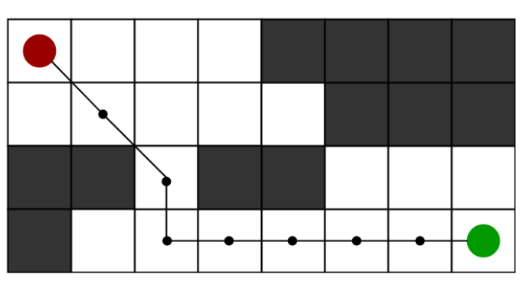

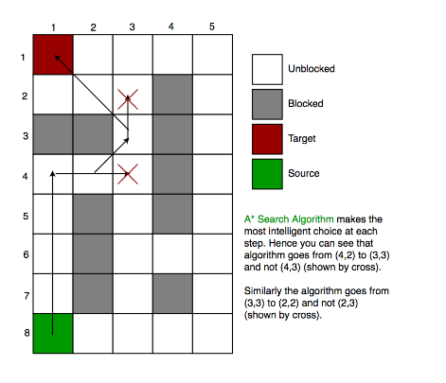

CONCLUSION & LIMITATION

In conclusion, A* Search Algorithm with Threads is a powerful technique that can significantly improve the efficiency of the A* algorithm. By parallelizing the search process across multiple threads, we can divide the search space into smaller subgraphs and search them in parallel, potentially reducing the overall search time.

However, there are some limitations to the use of threads in the A* algorithm. One limitation is that the algorithm's performance may be limited by the number of available cores on the system. If there are more threads than available cores, there may be contention for resources, leading to reduced performance. Another limitation is that thread synchronization can introduce overhead, potentially reducing the overall performance gain from parallelization.

Additionally, A* Search Algorithm with Threads may not always be the best approach for pathfinding problems. In some cases, other algorithms such as Dijkstra's algorithm or Breadth-First Search may be more suitable, depending on the characteristics of the search space and the specific requirements of the application.

In summary, A* Search Algorithm with Threads is a powerful technique that can be used to improve the performance of the A* algorithm. However, careful consideration must be given to the number of threads used, the synchronization mechanisms employed, and the specific characteristics of the problem being solved to ensure that the algorithm's performance is optimized.