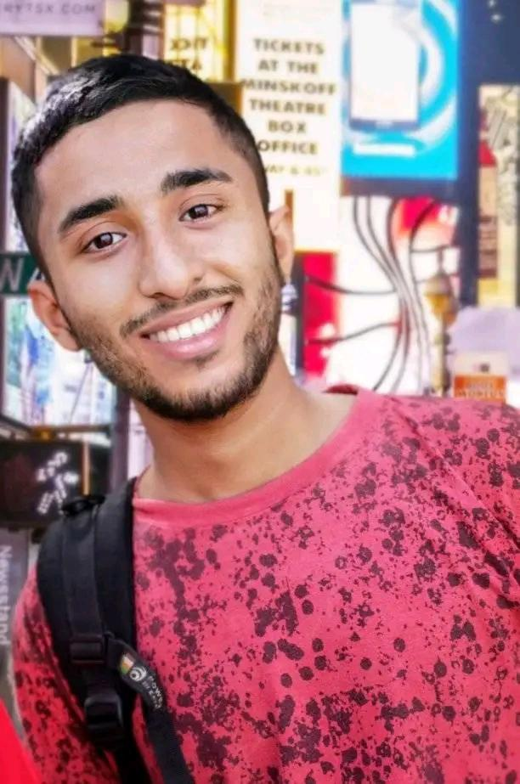 |  |  |  | Muhammad  Saqlain

Objective Statement
Energetic and Passionate professional with analytical, problem solving and decision making skills. I plan to seek career advancement and a challenging work environment that offers stimulating learning for developing my web development and data analyzing skills so that I would see myself amongst the top rated web developers and data analyst.

Projects
Creative Agency – Landing Page
HTML5, CSS3, Bootstrap 5
https://saqlain017.github.io/Creative_Agency-Landing-Page/

Computer Center – Single Page
HTML5, CSS3, Bootstrap 5
https://saqlain017.github.io/IT-Centre-Front-End/

Education
UBIT, University of Karachi
Jan, 2022 - since
3rd Semester Student of Bachelors of Science in Computer Science.

NCR College of Emerging Technologies, Karachi
2019 - 2021
Intermediate in Pre-Engineering from BIE, K with 95%.

Ghulaman-e-Abbas School, Karachi
2017-2019
Matriculation in Computer Science from AKUEB with 85%.

Certifications
Crash Course on Python
By Google
https://www.coursera.org/account/accomplishments/certificate/DMYUTUPZN2RZ

Introduction to Front-End Development
By Meta
https://www.coursera.org/account/accomplishments/certificate/QABLEAPLXZHP

Getting Started with Git and GitHub
By IBM
https://www.coursera.org/account/accomplishments/certificate/A9K55M92HCR2

Soft Skills
Communication
English Basic
Leadership
Creative thinking
Decision Making

Technical Skills
HTML5 – Intermediate
CSS3 – Intermediate
Boot Strap 5 – Basics
Java Script - Basics

Gilgit Colony, Korangi
Karachi 74900
 |  | +923498725789
 |  | Mohammadsaqlain253@gmail.com
 |  | https://saqlain017.github.io/portfolio/

