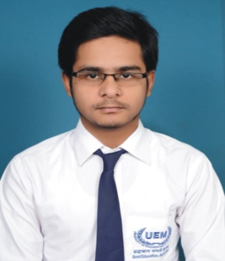

**Curriculum Vitae**

[Photo]

# Name : MD SAQLAN NASIM

**Address : 24/3, DASU BABU BAGAN, KAMARHATI, KOL-58**

**Mobile No : 7980000693/8100550523**

# E-mail : mdsaqlan1998@gmail.com

|  |  |  |  |  |  |
| --- | --- | --- | --- | --- | --- |
| **Degree / Certificate** | Degree | Institute | Board /University | **Year of Passing** | **Aggregate % / CGPA** |
| Graduation | B-TECH  (CSE) | UEM | UEM | 2020 | 8.19 |
| 12th | H.S | TITAGARH A.G.M HIGH SCHOOL | W.B.C.H.S.E | 2016 | 79% |
| 10th | MADHYAMIK | KAMARHATI HIGH SCHOOL | W.B.B.S.E | 2014 | 62% |

**Academic Qualifications:**

**Trainings / Projects Undertaken:**

|  |  |  |
| --- | --- | --- |
| **Name of Institute / Organization** | **Trainings/Project Title** | **Duration** |
| YouTube | HTML, CSS, BOOTSTRAP | 1 MONTH |
| NETWIZARD | MEAN STACK DEVELOPMENT (TRAINING) | 2 MONTH |
| MY SELF | Online Shopping using Express JS, Node JS and MongoDB (Mini Project) | ----- |
| MY SELF | E-Commerce Website using PHP and My SQL | 1 MONTH |
| MY SELF | **Niamhbeauty.com** using PHP and SQL | 15 Days |
| YouTube | ReactJS | 15 Days |

**Additional Qualification / Achievements / Certifications:**

* CERTIFICATE IN SOME COMPUTER COURSE(DTP, MS OFFICE)

**Subjects of Interest:**

* DATA BASE MANAGEMENT SYSTEM
* OOPS (JAVA)

**Computer Languages:**

* C language
* JAVA
* HTML, CSS, ReactJS

**Hobbies:**

* PLAYING CRICKET

**Family Details:**

|  |  |  |
| --- | --- | --- |
| **Details** | **Name** | **Occupation** |
| **Father** | MD NASIM AKHTAR | BUSSINESS |
| **Mother** | RESHMA KHATOON | HOUSE WIFE |
| **Siblings** | SHAMA NIGAR  MD SADAIN NASIM | M.SC(pursuing)  XII(pursuing) |

**Personal Details:**

**Date of Birth :** **21/11/1998**

**Gender** **:** **MALE**

**Languages Known : ENGLISH, URDU, BENGALI and HINDI**

**GitHub :** [**https://github.com/saqlain05**](https://github.com/saqlain05)

**Date : 29-08-2020**