UNIVERSITY OF AZAD KASHMIR
Department of Software Engineering
GRAPHIC Design
Quiz 1
Student Name: | Saqlain Mushtaq
Roll Number: | 2024-CET-27
Class / Semester: | 4th Semester
Course: | Graphic Design
Topic: | Introduction to UI/UX | Wireframes | Mockups
Date: | 15-05-2026

Question: Low-Fidelity Wireframe – Mobile App Login Screen
Below is a simple low-fidelity wireframe drawn using boxes and labels.
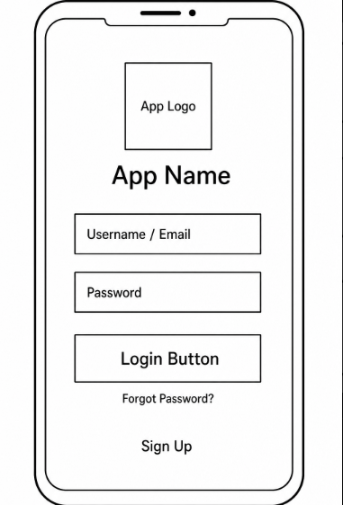

UX Explanation (How This Design Improves User Experience)
1. Simple and Clean Layout
The login screen is kept simple with only the necessary elements. The user is not confused by too many options. Everything is placed in a top-to-bottom order which feels natural.
2. Clear Labels and Fields
Each field like Email and Password is clearly labeled so the user knows what to type. This reduces mistakes and makes the form easy to fill.
3. Easy Navigation Options
The 'Forgot Password' and 'Sign Up' links are placed below the login button so users can find them easily without searching. This saves time for new users and users who forgot their password.
4. Visible App Identity
The app logo and title is placed at the top so the user knows which app they are logging into. This builds trust and makes the screen look familiar.

