Total Marks: | 04
Obtained Marks:

Android Development
Assignment # 04

Submitted To: Sir Muhammad Azhar
_____________________________________________________________________________________________________________________________________________________________________________________________________________________________________
Student Name: Saqlain Mushtaq
______________________________________________________________________________________________________________________________________________________________________________________________________________________________________
Reg. Number: 2212352 ______________________________________________________________________________________________________________________________________________________________________________________________________________________________________

INTRODUCTION:
The objective of this project is to develop a robust Android application that integrates modern mobile computing concepts. The application provides a seamless user experience by combining cloud data (REST API) with local persistence (SQLite). Key highlights include a dynamic UI theme engine, secure session management via SharedPreferences, and interactive web content display through WebViews.
SOFTWARE DEVELOPMENT:
To build this application, the following technologies and libraries were utilized:
- Language: Java (JDK 11)
- IDE: Android Studio Ladybug/Hedgehog
- Networking: Retrofit 2.9.0 with GSON Converter
- Database: SQLite OpenHelper
- UI Components: Material Design 3, RecyclerView, CardView
- Minimum SDK: API 21 (Android 5.0)

The app is designed to handle the complex Android Activity Lifecycle. By using onSaveInstanceState, the app preserves the state of the UI even when the system kills the activity during configuration changes.

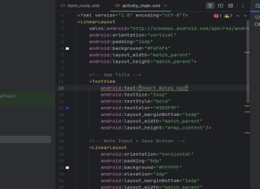

We utilized the JSONPlaceholder API. Retrofit was configured with an interface ApiService to handle the GET requests. The response is parsed into a Post model class using Google’s GSON library.
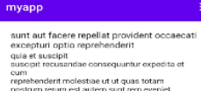

A dedicated DatabaseHelper class manages the SQLite operations. Whenever the API call is successful, the local database is updated. This ensures that the user always sees the most recent data, even without an active internet connection.

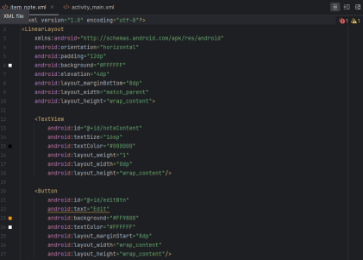

For detailed content, we integrated a WebViewClient. This allows the app to render HTML/Web content directly within the application, ensuring that the user stays engaged within the app's ecosystem.


Post.java:

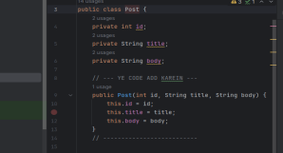

MENU IMPLEMENTATION AND NAVIGATION:
Options Menu Implementation:
The application implements an Options Menu to provide global actions accessible from the app bar. The Options Menu allows the user to change the application theme and log out from the application.The menu is created by overriding the onCreateOptionsMenu() method, where menu items such as Change Theme and Logout are inflated using a menu resource file. When a user selects a theme option, the selected theme is saved using SharedPreferences, and the activity is restarted to apply the new theme immediately.The Logout option clears the authentication flag (isLoggedIn) from SharedPreferences and redirects the user to the login screen using Intent-based navigation, ensuring proper session handling.
Context Menu Implementation:
A Context Menu is implemented to provide item-specific actions on long press of list items displayed using RecyclerView. This menu allows users to perform actions such as Edit and Delete on stored data items.The Context Menu is registered with the RecyclerView items using registerForContextMenu(). When an item is long-pressed, the menu appears with relevant options. The Delete option removes the selected record from the SQLite database, while the Edit option allows modification of existing data. These actions demonstrate effective use of CRUD operations integrated with UI interactions.
Popup Menu Implementation:
The application also includes a Popup Menu for quick actions within individual list items. A menu icon is placed inside each RecyclerView item layout, and clicking this icon displays a Popup Menu.The Popup Menu provides lightweight and quick access to actions such as View Details, Edit, or Delete without interrupting the user flow. The Popup Menu is implemented using the PopupMenu class and is dynamically linked to each item via the RecyclerView adapter. This enhances usability and demonstrates efficient adapter-based event handling.
Navigation Using Intents:
Navigation between activities such as Login Activity, Main Activity, and WebView Activity is handled using Explicit Intents. Menu selections trigger appropriate intent calls, ensuring smooth and structured navigation throughout the application.
CONCLUSION:
The project demonstrates a comprehensive understanding of the Android platform. By balancing cloud-based data with local storage and providing a customizable UI.

