|  |  |  |
| --- | --- | --- |
| **CLO #** | **Course Learning Outcome** | **Taxonomy Level** |
| CLO 4 | Demonstrate proficient individual and team work skills in a collaborative environment, to complete a project as per given specification. | A3 |

* **Submission Date and Time**:  **23rd Nov 2023 in Office @4-5pm. D building .**
* **Project Name: WanderWise**
* **Section: S4**
* **List of Authors:**

|  |  |  |
| --- | --- | --- |
|  | Group Participant’s Reg Number | Group Participant’s Name |
| 1 | **L1F20BSSE0472** | **Ameer Hamza** |
| 2 | **L1F20BSSE0452** | **Sikandar Ali** |
| 3 | **L1F20BSSE0473** | **Furqan Amjad cheema** |

**Question no 1: Form Project Charter of your project in the given template.**

**Question no 2: Explain the vision and scope for your project in a complete document.**

**Question no 3: Create WBS of your project.**

**Sample of both are attached for reference:**

**Project Charter**

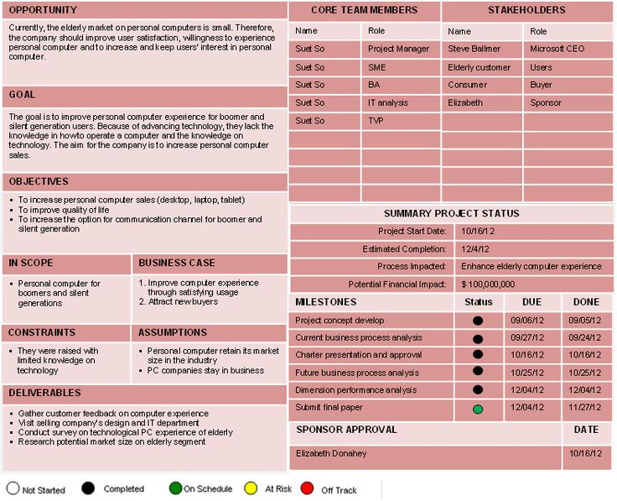

**Q1 Project Charter**

**Opportunity:**

WanderWise endeavors to redefine travel exploration by addressing complexities in trip planning while prioritizing user safety. The opportunity lies in offering a cutting-edge, user-centric travel planning application using machine learning algorithms to provide personalized itineraries, real-time safety advisories, weather forecasts, and an intuitive user interface.

**Goal:**

The primary goal is to revolutionize the travel planning experience by creating a platform that is user-centric, secure, and efficient. Leveraging machine learning, safety advisories, and weather forecasts aims to enhance user satisfaction, simplify trip planning, and prioritize safety.

**Objectives:**

1. Develop a user-centric travel planning platform.
2. Implement machine learning algorithms for personalized itineraries.
3. Integrate real-time safety advisories.
4. Provide accurate and timely weather forecasts.
5. Ensure a responsive and intuitive user interface.

**IN Scope:**

Personalized travel planning platform (web-based) offering machine learning-driven itineraries, safety advisories, and weather forecasts.

1. Development of WanderWise platform with user registration/login functionality.
2. Implementation of machine learning algorithms for itinerary generation.
3. Integration of real-time safety advisories and weather forecast APIs.
4. User search functionality for itineraries.
5. Ensuring a responsive and user-friendly interface.

**Business Case:**

WanderWise aims to address the complexities of travel planning, enhance user experience, and prioritize safety. It is projected to significantly increase user engagement and satisfaction, potentially leading to increased revenue through user subscriptions and partnerships.

1. Enhance the overall travel planning user experience by optimizing the process and ensuring convenience and satisfaction.
2. Prioritize user safety by delivering timely and accurate safety advisories during travel experiences.

**Constraints:**

1. Limited availability of comprehensive user data for initial machine learning model training.
2. Technical complexities in integrating real-time safety advisories from multiple sources.
3. Budget constraints for development and maintenance.
4. Time constraints for meeting project deadlines.
5. Compliance with data privacy and security regulations.

**Assumptions:**

1. Continuous demand for convenient and safe travel planning tools in the market.
2. Availability of relevant APIs and data sources for weather forecasts and safety advisories.
3. Availability of reliable APIs for real-time safety advisories and weather forecasts.
4. Adequate user adoption and engagement.
5. Team expertise and collaboration for successful development.

**Deliverables:**

1. Functional WanderWise platform with user registration/login.
2. Machine learning-based personalized itineraries.
3. Integration of real-time safety advisories and weather forecasts.
4. User-friendly search functionality for itineraries.

**Team Members and Stakeholders**

|  |  |  |  |
| --- | --- | --- | --- |
| **Team Members** | | **Stakeholders** | |
| **Name** | **Role** | **Name** | **Role** |
| Ameer Hamza | Project Manager, Machine learning Engineer | CEO/Founder | Project Sponsor |
| Saqlain Shahbaz | Lead Developer | End Users | Customers |
| Sehar Arooj | UI/UX Designer |  |  |

|  |  |
| --- | --- |
| **Summary Project Status** | |
| Project start date | 10/23/2023 |
| Estimated Completion | 8/1/2024 |
| Process Impacted | Travel Planning Experience |
| Potential Financial Impact | Improved user experience, increased safety measures, and enhanced travel planning valued at [$XXXXX] |

**Milestones**

|  |  |  |  |
| --- | --- | --- | --- |
| **Milestone** | **Status** | **Due** | **Done** |
| SRS document | In Progress | 12/5/2023 |  |
| SDS document | In Queue |  |  |
| Platform Development | In Queue |  |  |
| Machine Learning Integration | In Queue |  |  |
| Safety Advisories Integration | In Queue |  |  |
| Weather Forecast Integration | In Queue |  |  |
| UI/UX | In Queue |  |  |
| Testing | In Queue |  |  |
| Deployment | In Queue |  |  |

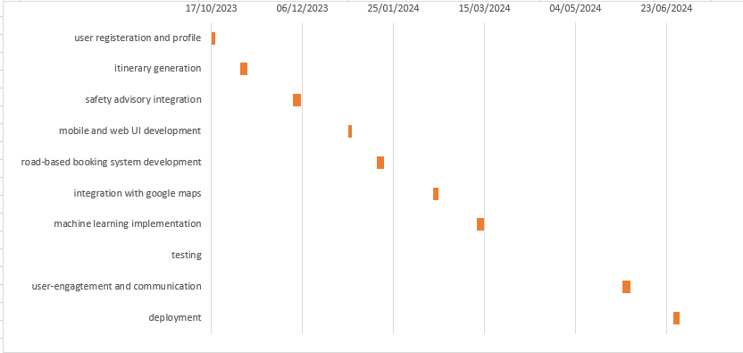

**Sponsor Approvals**

|  |  |
| --- | --- |
| **Name** | **Date** |
|  |  |

**Q2 Vision and Scope Document**

1. **Business requirements**
2. **Business Opportunity**

* **Description of Market Opportunity:** WanderWise addresses the complexity and time-consuming nature of travel planning. It improves user safety and experience by providing personalized itineraries, real-time safety advisories, and weather forecasts, setting itself apart in the travel planning market.
* **Competing Market:** Various travel planning applications exist but lack comprehensive safety features and personalized itineraries.
* **Business Problem Being Improved:** Simplifying trip planning while ensuring safety and personalized experiences.
* **Advantage of Proposed Solution:** Uniting personalized itineraries, real-time safety advisories, and weather forecasts in one platform.

1. **Business Objective and Success Criteria**

* **Important Business Benefits:** Improved user satisfaction, increased market share, positive cash flow within 6 months.
* **Quantitative Success Measures:** Capture 80% market share, be recognized as the most secure product via trade journal reviews and surveys.
* **Factors Impacting Success:** User adoption rate, positive reviews, and sustained positive cash flow.

1. **Customer or Market Needs**

Complexity and time-consuming nature of travel planning, lack of comprehensive safety guidance in existing solutions.

1. **Business Risks**

* Market competition
* User acceptance
* Timing of release
* Technical implementation challenges.

1. **Vision of the solution** 
   1. **Vision statement** (Refer Slide # 25 and 26 of Lecture 7 for Vision Statement Template)

"**For** modern explorers, **who** crave personalized and secure adventures, **WanderWise** is a groundbreaking travel planner. Seamlessly integrating personalized itineraries, real-time safety advisories, and weather forecasts, our platform uses advanced AI for accurate, efficient planning. Revolutionizing travel, we empower users to craft unique and safe journeys effortlessly."

* 1. **Major features**

1. **Personalized Itinerary Generation:** Tailored trip planning based on user preferences, interests, and constraints.
2. **Real-time Safety Advisories Integration:** Continuous monitoring and provision of real-time safety alerts and advisories during the travel period.
3. **Weather Forecast Functionality:** Access to accurate and up-to-date weather forecasts for planned destinations.
4. **User-friendly Interface:** Intuitive and responsive platform design for ease of use across various devices.
   1. **Assumptions**
5. **User Adoption of Safety-Centric Travel Planning:** Assumes users prioritize safety in travel planning and are willing to adopt a platform that integrates safety advisories with trip planning.
6. **Reliable Availability of External APIs:** Assumes the availability and reliability of external APIs providing real-time safety advisories and accurate weather forecasts for various destinations.
7. **Preference for Personalized Travel Experiences:** Assumes a growing trend among travelers to seek personalized and unique travel experiences tailored to their preferences.
8. **Continued Technological Advancements:** Assumes continued advancements in machine learning and AI technologies, enabling accurate and efficient itinerary generation and safety advisories.
9. **User Engagement and Feedback:** Assumes active user engagement and feedback to refine and enhance WanderWise features for ongoing improvements.
   1. **Major dependencies to external factors outside of the project’s control**
10. **Reliable API Providers:** Dependence on third-party providers for access to accurate and reliable data sources for real-time safety advisories and weather forecasts.
11. **Compliance with Travel Regulations:** Adherence to varying international travel regulations and safety standards governing different regions and countries.
12. **Industry Standards and Technological Advancements:** Reliance on evolving industry standards and technological advancements to improve machine learning algorithms for itinerary generation and safety advisories.
13. **Cooperation from Development Partners:** Collaboration and support from development partners for seamless integration of APIs, ensuring consistent access to safety and weather-related data.
14. **Market Acceptance and User Behavior:** Dependence on market acceptance and user behavior towards safety-centric travel planning, as the success of the platform relies on users embracing safety-oriented travel approaches.
15. **Government Policies and Travel Restrictions:** Adapting to and navigating through government policies, travel restrictions, and changes in geopolitical situations that might impact travel safety advisories and itineraries.
16. **Business context:**
    1. **Project Priorities**

**User Safety and Satisfaction:** The primary priority is to ensure user safety by providing accurate and real-time safety advisories. Simultaneously, ensuring high user satisfaction through personalized and seamless travel planning experiences.

* 1. **Operating Environment**

**Web-Based Accessibility:** WanderWise will operate as a web-based platform accessible across various devices (desktops, tablets, and mobile phones), allowing users to plan their trips from anywhere with internet access.

1. **Scope and limitation** (for initial releases)
   1. **Concept and range of proposed solution:** WanderWise is a comprehensive travel planning platform that integrates personalized itineraries, real-time safety advisories, and weather forecasts to ensure secure and tailored travel experiences for users.
   2. **Limitations:** Advanced booking features (e.g., direct hotel or flight reservations) are not within the initial scope of WanderWise.
   3. **Scope of initial release**

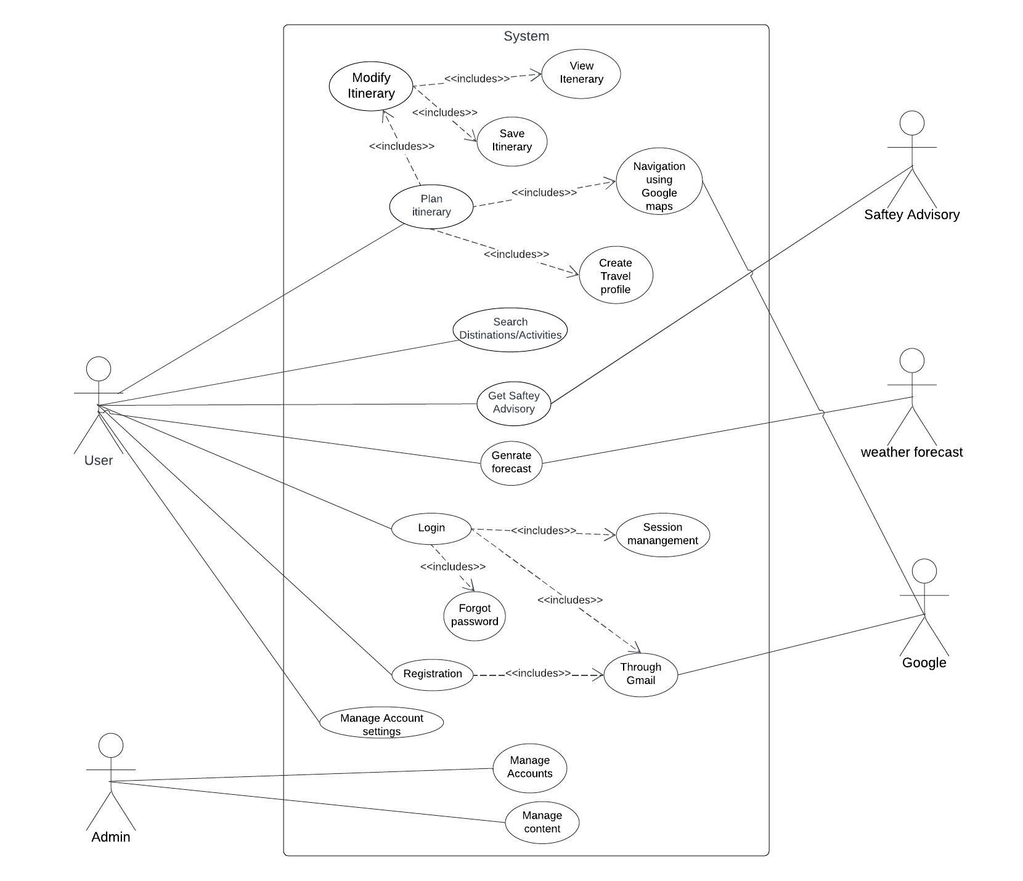

**Q3 WBS**

