**Web programming**

**Task#1:**

**Screenshot of Git commands and upload cp and Assignment#1 and create branch and commit it**

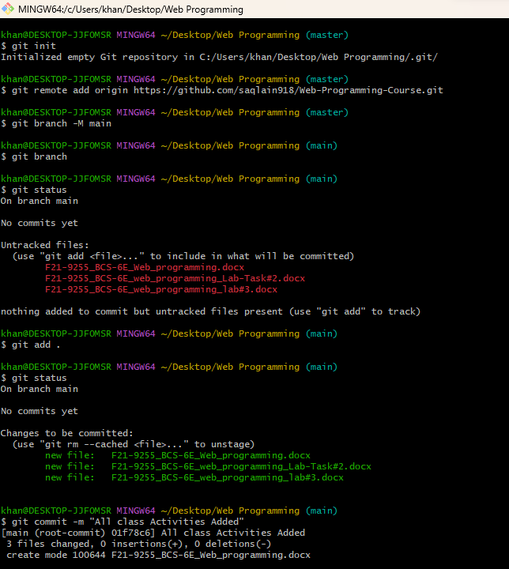

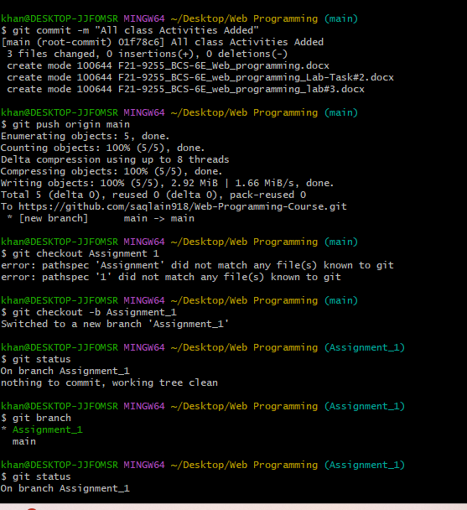

**This is all for task1 and upload all data on github**