**Web Assignment#3**

**GITHUB REPO LINK:**

**https://github.com/saqlain918/F21-9255-Web-Programming-Course.git**

**TASK#1:**

**Code is uploaded already in files**

**OUTPUT:**



**TASK#2**

**Code is uploaded already in files**

**OUTPUT:**

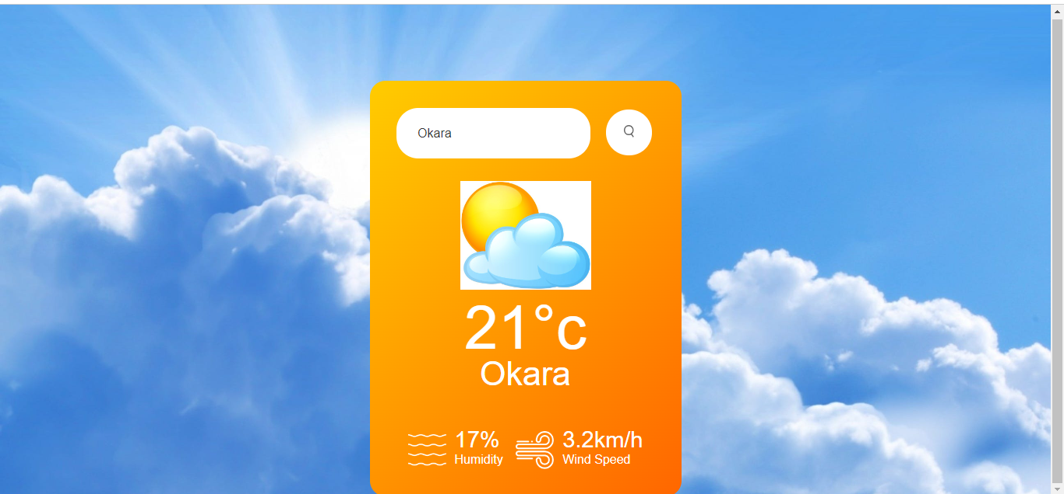

**TASK#3:**

**Code is uploaded already in files**

**OUTPUT:**

**TASK#4:**

**Code is uploaded already in files**

**Approaches:**

* Use event listeners in JavaScript to capture user input when they select rock, paper, or scissors. Validate the input to ensure it's one of the valid choices.
* Keep track of the score for each player and update it after each round. Display the current score prominently on the screen.
* Create a user-friendly interface where players can make their choices and see the results.
* Update the UI to display the results of each round, including the choices made by the players and who won.

**Challenges:**

* Implementing the scoring mechanism accurately, ensuring that the correct player is awarded points based on the outcome of each round according to the game rules.
* Updating the interface to display the current score for each player after each round. Ensuring that the score is clear and easily visible to the players.
* Implementing logic to handle ties when both players make the same choice.
* Providing immediate feedback to the players after they make their selection, indicating whether their choice was valid and if the submission was successful.

**OUTPUT:**



