**Web Activity # 5**

**Task#1:**

**HTML:**

In HTML, we can use the **<!-- and -->** tags to enclose your comments.

**EXAMPLE:**

<!DOCTYPE html>

<html>

<head>

<title>TASK#1</title>

</head>

<body>

<!-- comment in HTML -->

<h1>F21-9255</h1>

<p>I am CS student</p>

</body>

</html>

**CSS:**

In CSS, comments are enclosed between **/* and */.**

**EXAMPLE:**

/* comment in CSS */

p {

margin-left:20px;

}

**Javascript:**

* In JavaScript, we can use **//** for single-line comments.
* We can use **/* */** for multi-line comments.

**EXAMPLE:**

// single-line comment in JavaScript

/*

multi-line comment

in JavaScript.

*/

var a = 15;

var b = 25;

var Add_sum= a + b;

console.log('The sum of a and b is: ' + Add_sum);

**Task#2:**

**jQuery download:**

<!DOCTYPE html>

<html lang="en">

  <head>

    <meta charset="UTF-8" />

    <meta name="viewport" content="width=device-width, initial-scale=1.0" />

    <title>Welcome to jQuery</title>

    <script src="node_modules/jquery/dist/jquery.min.js"></script>

  </head>

  <body>

    <script>

      $(document).ready(function () {

        alert("Welcome to jQuery");

      });

    </script>

  </body>

</html>

{

  "dependencies": {

    "jquery": "^3.7.1"

  }

}

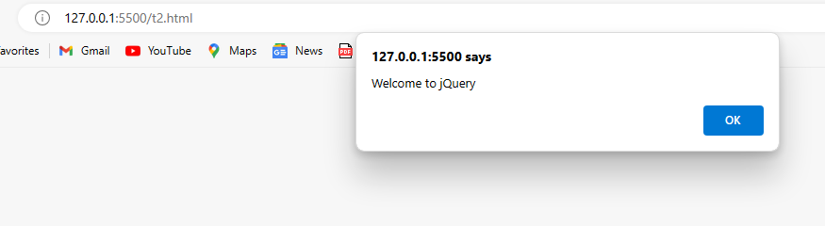

**CDN:**

<!DOCTYPE html>

<html lang="en">

  <head>

    <meta charset="UTF-8" />

    <meta name="viewport" content="width=device-width, initial-scale=1.0" />

    <title>Welcome to jQuery</title>

    <script src="https://code.jquery.com/jquery-3.6.4.min.js"></script>

  </head>

  <body>

    <script>

      $(document).ready(function () {

        alert("Welcome to jQuery");

      });

    </script>

  </body>

</html>

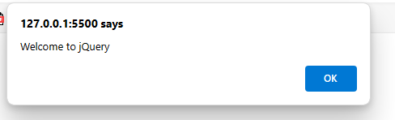

**Task#3:**

<!DOCTYPE html>

<html lang="en">

  <head>

    <meta charset="UTF-8" />

    <meta name="viewport" content="width=device-width, initial-scale=1.0" />

    <title>Hide and show</title>

    <script src="https://code.jquery.com/jquery-3.6.4.min.js"></script>

    <link rel="stylesheet" href="t3.CSS" />

  </head>

  <body>

    <button class="btn" id="Button">Show Image</button>

    <img

      id="Image"

      src="panda.ipg.webp"

      alt="Image"

      width="300px"

      height="300px"

    />

    <script src="t3.js"></script>

  </body>

</html>

#Image {

  display: none;

}

.btn {

  background-color: lightcoral;

  color: black;

  font-size: larger;

}

$(document).ready(function () {

  $("#Button").click(function () {

    $("#Image").toggle();

    var buttonText =

      $(this).text() === "Show Image" ? "Hide Image" : "Show Image";

    $(this).text(buttonText);

  });

});

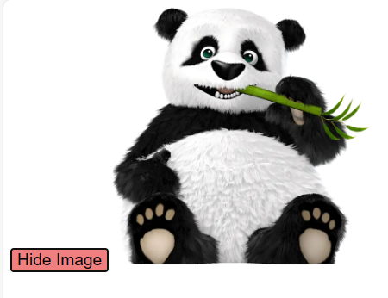

**Task#4:**

<!DOCTYPE html>

<html lang="en">

  <head>

    <meta charset="UTF-8" />

    <meta name="viewport" content="width=device-width, initial-scale=1.0" />

    <title>Remove Row</title>

    <script src="https://code.jquery.com/jquery-3.6.4.min.js"></script>

    <link rel="stylesheet" href="t4.css" />

  </head>

  <body>

    <table id="Table">

      <thead>

        <tr>

          <th>Name</th>

          <th>Roll no</th>

          <th>Remove row</th>

        </tr>

      </thead>

      <tbody>

        <tr>

          <td>Rai Saqlain</td>

          <td>1</td>

          <td><button class="remove-row">Remove</button></td>

        </tr>

        <tr>

          <td>Yasir</td>

          <td>2</td>

          <td><button class="remove-row">Remove</button></td>

        </tr>

        <tr>

          <td>Nadeem</td>

          <td>3</td>

          <td><button class="remove-row">Remove</button></td>

        </tr>

        <tr>

          <td>Sohail</td>

          <td>4</td>

          <td><button class="remove-row">Remove</button></td>

        </tr>

      </tbody>

    </table>

    <script src="t4.js"></script>

  </body>

</html>

table {

  width: 50%;

  border-collapse: collapse;

  margin-top: 20px;

}

th,

td {

  border: 1px solid black;

  padding: 8px;

  text-align: center;

}

th {

  background-color: #f2f2f2;

}

.remove-row {

  background-color: sandybrown;

  color: white;

  border: none;

  padding: 5px 10px;

  cursor: pointer;

}

.remove-row:hover {

  background-color: firebrick;

}

$(document).ready(function () {

  $(".remove-row").on("click", function () {

    $(this).closest("tr").remove();

  });

});

**BEFORE REMOVE ROW:  
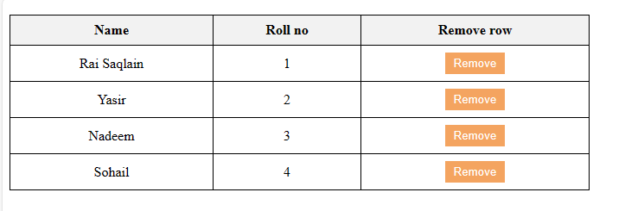**

**AFTER REMOVE ONE ROW:  
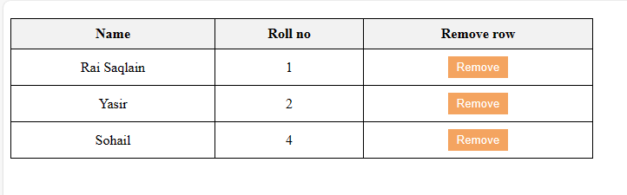**

**Task#5:**

<!DOCTYPE html>

<html lang="en">

  <head>

    <meta charset="UTF-8" />

    <meta name="viewport" content="width=device-width, initial-scale=1.0" />

    <title>Task5</title>

  </head>

  <body>

    <div class="Myclass" id="myid">Hi Rai</div>

  </body>

  <script src="https://ajax.googleapis.com/ajax/libs/jquery/3.7.1/jquery.min.js"></script>

  <script src="t5.js"></script>

</html>

$(document).ready(() => {

  $("div").click(function () {

    alert(`Class name : ${$(this).attr("class")} ID : ${$(this).attr("id")}`);

  });

});

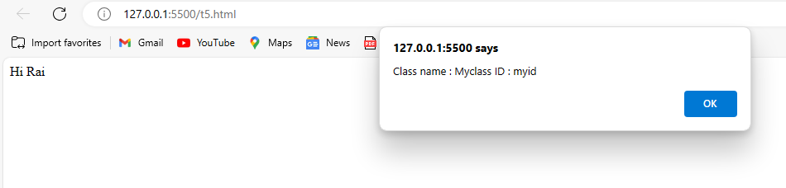

**Task#6:**

<!DOCTYPE html>

<html lang="en">

  <head>

    <meta charset="UTF-8" />

    <meta name="viewport" content="width=device-width, initial-scale=1.0" />

    <title>

      Find total width of an element (including width, padding and border) in

      jQuery.

    </title>

    <link rel="stylesheet" href="t6.css" />

  </head>

  <body>

    <p id="myText">jQuery Exercises, Practice, Solution</p>

    <div></div>

  </body>

  <script src="https://ajax.googleapis.com/ajax/libs/jquery/3.7.1/jquery.min.js"></script>

  <script src="t6.js"></script>

</html>

p {

  padding-top: 50px;

  padding-right: 30px;

  padding-bottom: 50px;

  padding-left: 80px;

}

$(document).ready(() => {

    console.log("Width + padding + borders : " + $("#myText").outerWidth());

  });

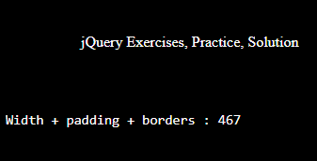

**Task#7:**

<!DOCTYPE html>

<html lang="en">

  <head>

    <meta charset="UTF-8" />

    <meta name="viewport" content="width=device-width, initial-scale=1.0" />

    <title>Count child elements using jQuery.</title>

  </head>

  <body>

    <div id="selected">

      <p>Red</p>

      <p>White</p>

      <p>Green</p>

      <p>Black</p>

      <p>Blue</p>

      <p>Orange</p>

    </div>

  </body>

  <script src="https://ajax.googleapis.com/ajax/libs/jquery/3.7.1/jquery.min.js"></script>

  <script src="t7.js"></script>

</html>

$(document).ready(() => {

  alert($("p").length);

});

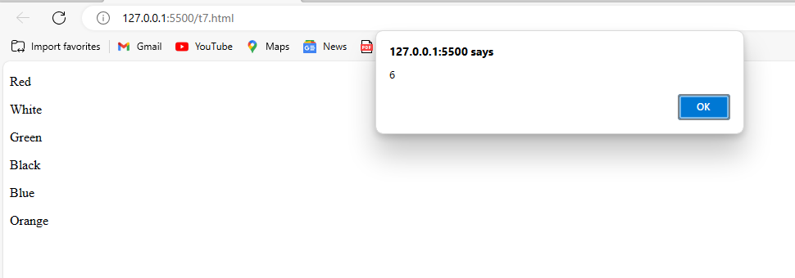

**Task#8:**

<!DOCTYPE html>

<html lang="en">

  <head>

    <meta charset="UTF-8" />

    <meta name="viewport" content="width=device-width, initial-scale=1.0" />

    <title>TASK8</title>

    <link rel="stylesheet" href="t8.css" />

  </head>

  <body>

    <div id="Myid1">Rai</div>

  </body>

  <script src="https://ajax.googleapis.com/ajax/libs/jquery/3.7.1/jquery.min.js"></script>

  <script src="t8.js"></script>

</html>

#Myid1 {

  background-color: magenta;

  padding-top: 35px;

  text-align: center;

  width: 100px;

  height: 50px;

  position: relative;

}

$(document).ready(() => {

  $("#Myid1").animate({ left: "80%" }, 8000);

});



