**Web**

**Task1:**

<! <!DOCTYPE html>

<html lang="en">

  <head>

    <meta charset="UTF-8" />

    <meta name="viewport" content="width=device-width, initial-scale=1.0" />

    <title>Firstwebpage</title>

  </head>

  <style>

    h1 {

      text-align: center;

      color: #00008b;

    }

    h2 {

      color: #00008b;

    }

  </style>

  <body>

    <h1>MY TNTRO</h1>

    <h3>Name:Rai muhammad Saqlain</h3>

    <h3>Roll no:21F-9255</h3>

    <h2>My detail</h2>

    <p>

      I am from lahore.I am student of BSCS.I study in Fast university.I like to

      play bedminton.

    </p>

  </body>

</html>

**OUTPUT:**

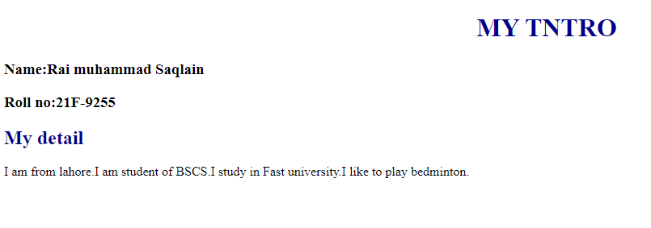

**Task2:**

<!DOCTYPE html>

<br lang="en">

  <head>

    <meta charset="UTF-8" />

    <meta name="viewport" content="width=device-width, initial-scale=1.0" />

    <title>Firstwebpage</title>

  </head>

    <b>This text is bold</b><br><br>

    <strong>This text is strong</strong><br><br>

    <bi>This text is big</bi><br><br>

    <i>This text is italic</i><br><br>

    <em>This text is Emphasized</em><br><br>

<samp>This is computer output</samp><br><br>

   This is<sub>Subscript</sub> and <sub>Subscript</sub><br><br>

  </body>

</html>

OUTPUT:

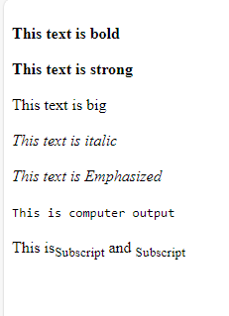

**Task3:**

<!DOCTYPE html>

<br lang="en">

  <head>

    <meta charset="UTF-8" />

    <meta name="viewport" content="width=device-width, initial-scale=1.0" />

    <title>Firstwebpage</title>

  </head>

  <img  src="images.png"width="500px"height="500px" />

  </body>

</html>

OUTPUT:



**Task4:**

<!DOCTYPE html>

<br lang="en">

  <head>

    <meta charset="UTF-8" />

    <meta name="viewport" content="width=device-width, initial-scale=1.0" />

    <title>Firstwebpage</title>

  </head>

  <a href="https://cfd.nu.edu.pk/" target="https://cfd.nu.edu.pk/">

    <img src="images.png" alt="Fast" width="500px"height="500px"></a>

  </body>

</html>

OUTPUT:



**Task5:**

<!DOCTYPE html>

<br lang="en">

  <head>

    <meta charset="UTF-8" />

    <meta name="viewport" content="width=device-width, initial-scale=1.0" />

    <title>Firstwebpage</title>

  </head>

  <h1>HTML Lists</h1>

  <h2>Unordered List</h2>

  <p>We have books on a variety of languages </p>

  <ul type="default">

    <li>Oracle </li>

    <li> java</li>

    <li> HTML</li>

    <li> CSS</li>

    </ul>

    <h2>Ordered List</h2>

    <ol type="1">

    <li>Download the software</li>

    <li>Extract to a folder</li>

    <li>Double click the executable to run</li>

    </ol>

  </body>

</html>

OUTPUT:

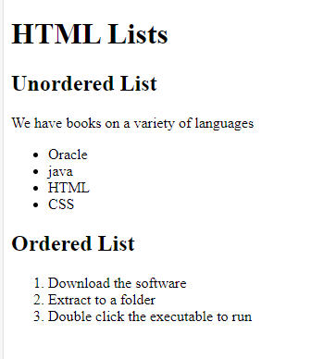

**Task6:**

<!DOCTYPE html>

<html lang="en">

  <head>

    <meta charset="UTF-8" />

    <meta name="viewport" content="width=device-width, initial-scale=1.0" />

    <title>Firstwebpagetable</title>

    <style>

      table,

      tr,

      th,

      td {

        border: 2px solid black;

        border-collapse: collapse;

        width: 400px;

      }

      td {

        width: 50px;

        height: 25px;

        text-align: center;

      }

    </style>

  </head>

  <body>

    <table>

      <tr>

        <td rowspan="3">

          <strong><b>APRIL</b></strong>

        </td>

        <td></td>

        <td></td>

      </tr>

      <tr>

        <td></td>

        <td></td>

      </tr>

      <tr>

        <td></td>

        <td></td>

      </tr>

      <tr>

        <td></td>

        <td></td>

      </tr>

      <tr>

        <td></td>

        <td></td>

      </tr>

    </table>

  </body>

</html>

OUTPUT:

**Task7:**

<!DOCTYPE html>

<br lang="en">

  <head>

    <meta charset="UTF-8" />

    <meta name="viewport" content="width=device-width, initial-scale=1.0" />

    <title>Firstwebpagetable</title>

    <style>

      table,

      tr,

      th,

      td {

        border: 2px solid black;

        border-collapse: collapse;

        width: 400px;

      }

      td{

        width: 50px;

        height: 25px;

        text-align: center;

      }

</style>

  </head>

    <table>

      <tr>

        <th colspan="3">2022</th>

      </tr>

      <tr>

        <td></td>

        <td></td>

        <td></td>

      </tr>

      <tr>

        <td colspan="2" rowspan="2">FIESTA</td>

        <td></td>

      </tr>

      <tr>

        <td></td>

      </tr>

      <tr>

        <td></td>

        <td></td>

      </tr>

    </table>

  </body>

</html>

OUTPUT:

**Task8:**

<!DOCTYPE html>

<html lang="en">

  <head>

    <meta charset="UTF-8" />

    <meta name="viewport" content="width=device-width, initial-scale=1.0" />

    <title>Sign-Up Form</title>

  </head>

  <body>

    <h2>Sign-Up Form</h2>

    <form>

      username:

      <br /><input type="text" /><br />

      Email:

      <br /><input type="email" /> <br />

      Password:

      <br /><input type="password" /><br />

      Confirm Password:

      <br /><input type="password" /><br />

      <button type="submit">Submit</button>

      <button type="reset">Reset</button>

    </form>

  </body>

</html>

OUTPUT:

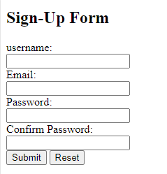

**Task9:**

<!DOCTYPE html>

<html lang="en">

  <head>

    <meta charset="UTF-8" />

    <meta name="viewport" content="width=device-width, initial-scale=1.0" />

    <title>pizza</title>

    <style>

      h1,

      h2 {

        text-align: center;

      }

      div {

        text-align: center;

      }

      h3{

        text-align: center;

      }

    </style>

  </head>

  <body>

    <h1>Pete's Pizza Delivery</h1>

    <h2>Online Order Form</h2>

    <div>

    <form name="petes_pizza_delivery_online_order_form" type="text/html">

      *Name:

      <input type="text" id="name" name="name" required /><br /><br />

      *Tel:

      <input type="tel" id="tel" name="tel" required /><br /><br />

      *Address:

      <input type="text" id="address" name="address" required /><br /><br />

      *Town/city:

      <input type="text" id="towncity" name="towncity" required /><br /><br />

      *Postcode:

      <input type="text" id="postcode" name="postcode" required /><br /><br />

      *Email:

      <input type="email" id="email" name="email" required /><br /><br />

    </div>

      <h3><strong>Required fields</strong></h3>

      <h2>Topping:</h2>

      <br />

      <div>

        <input type="radio" id="margherita" name="topping" value="margherita" />

        <label for="margherita">Margherita</label><br />

        <input type="radio" id="meat_feast" name="topping" value="meat_feast" />

        <label for="meat_feast">Meat Feast</label><br />

        <input

          type="radio"

          id="four_seasons"

          name="topping"

          value="four_seasons"

        />

        <label for="four_seasons">Four Seasons</label><br /><br />

      </div>

      <h2>Size:</h2>

      <br />

      <div>

        <input type="radio" id="small" name="size" value="small" />

        <label for="small">Small</label><br />

        <input type="radio" id="medium" name="size" value="medium" />

        <label for="medium">Medium</label><br />

        <input type="radio" id="large" name="size" value="large" />

        <label for="large">Large</label><br /><br />

      </div>

      <h2>Extras:</h2>

      <br />

      <div>

        <input type="checkbox" id="mushrooms" name="extras" value="mushrooms" />

        <label for="mushrooms">Mushrooms</label><br />

        <input

          type="checkbox"

          id="green_peppers"

          name="extras"

          value="green_peppers"

        />

        <label for="green_peppers">Green peppers</label><br />

        <input type="checkbox" id="anchovies" name="extras" value="anchovies" />

        <label for="anchovies">Anchovies</label><br />

        <input

          type="checkbox"

          id="extra_cheese"

          name="extras"

          value="extra_cheese"

        />

        <label for="extra_cheese">Extra cheese</label><br /><br />

      </div>

      <div>

      <label for="preferred_delivery_time">Preferred delivery time:</label>

      <input

        type="time"

        id="preferred_delivery_time"

        name="preferred_delivery_time"

      /><br /><br />

    </div>

      <div>

      <label for="delivery_instructions">Delivery instructions:</label><br />

      <textarea

        id="delivery_instructions"

        name="delivery_instructions"

        rows="4"

        cols="50"

      ></textarea

    </div>

      ><br /><br />

      <input type="submit" value="Submit order" />

    </form>

  </body>

</html>

OUTPUT:

There is an issue in the format. Due to this I cannot fulfil the requirements of this task because this is done by CSS.



