**Web Class Task**

**TASK#1:**

**Code :**

<!DOCTYPE html>

<html lang="en">

  <head>

    <meta charset="UTF-8" />

    <meta name="viewport" content="width=device-width, initial-scale=1.0" />

    <title>Lab Task1</title>

  </head>

  <style>

    body {

      background-color: black;

    }

    h2 {

      color: white;

      font-size: x-large;

      font-weight: lighter;

      font-family: "Times New Roman", Times, serif;

    }

    h3 {

      color: white;

      font-size: medium;

      font-weight: lighter;

      margin-bottom: 20px;

    }

    button {

      color: white;

      background-color: MediumSeaGreen;

      border: none;

      padding: 15px 15px;

      border-radius: 5px;

    }

    button span {

      font-size: 22px;

    }

    button:hover {

      background-color: brown;

    }

  </style>

  <body>

    <h2>Start CSS Exercises</h2>

    <h3>Good Luck!</h3>

    <button type="button">Start CSS Exercises <span>&#x203A;</span></button>

  </body>

</html>

**Output :**

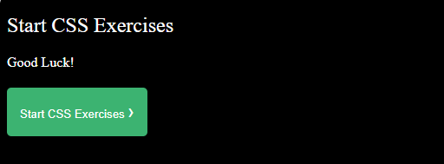

**TASK#2:**

**Code :**

<!DOCTYPE html>

<html lang="en">

  <head>

    <meta charset="UTF-8" />

    <meta name="viewport" content="width=device-width, initial-scale=1.0" />

    <title>Lab Task2</title>

    <style>

      body {

        background-color: DodgerBlue;

      }

      form {

        background-color: DodgerBlue;

        padding: 20px;

        border-radius: 8px;

      }

      input {

        width: 300px;

        margin-left: 140px;

        margin-top: 13px;

        height: 30px;

      }

      button {

        background-color: Tomato;

        color: #fff;

        cursor: pointer;

        width: 308px;

        margin-left: 140px;

        margin-top: 13px;

        height: 30px;

      }

      button:hover {

        background-color: Violet;

      }

    </style>

  </head>

  <body>

    <form>

      <input type="text" id="Name" placeholder="Name*" required /><br />

      <input type="text" id="username" placeholder="Username*" required /><br />

      <input

        type="password"

        id="password"

        placeholder="Password*"

        required

      /><br />

      <input type="tel" id="number" placeholder="Number*" required /><br />

      <input type="email" id="email" placeholder="Email*" required /><br />

      <button type="submit">Register</button><br />

    </form>

  </body>

</html>

**Output :**

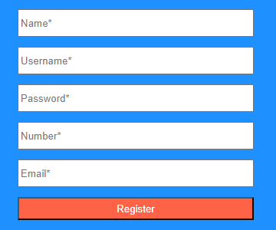

**TASK#3:**

**Code :**

<!DOCTYPE html>

<html lang="en">

  <head>

    <meta charset="UTF-8" />

    <meta name="viewport" content="width=device-width, initial-scale=1.0" />

    <title>Lab Task3</title>

    <style>

      div {

        width: 400px;

        height: 430px;

        box-shadow: 2px 2px 20px 2px;

        text-align: center;

        margin-top: 50px;

        font-weight: bold;

        font-size: 20px;

        color: black;

        margin-left: 20px;

      }

      h4 {

        margin-top: 15px;

      }

      img {

        object-fit: fill;

        width: 400px;

        height: 350px;

      }

    </style>

  </head>

  <body>

    <div>

      <img src="card.webp" />

      <h4>Cinque Terre</h4>

    </div>

  </body>

</html>

**Output :**

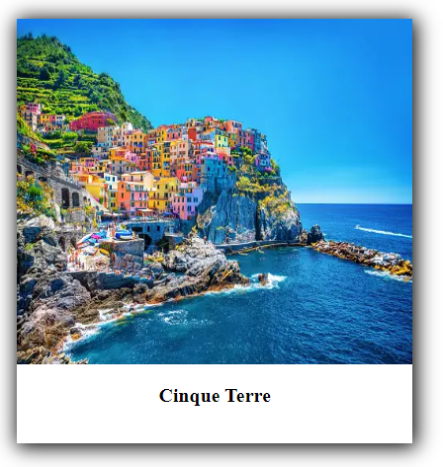

**TASK#4:**

**Code :**

<!DOCTYPE html>

<html lang="en">

  <head>

    <meta charset="UTF-8" />

    <meta name="viewport" content="width=device-width, initial-scale=1.0" />

    <title>Lab Task4</title>

    <style>

      div {

        width: 400px;

        height: 430px;

        box-shadow: 2px 2px 20px 2px;

        text-align: center;

        margin-top: 50px;

        font-weight: bold;

        font-size: 20px;

        color: black;

        margin-left: 20px;

        position: relative;

        animation-name: Rai;

        animation-duration: 5s;

      }

      h4 {

        margin-top: 15px;

      }

      img {

        object-fit: fill;

        width: 400px;

        height: 350px;

      }

      @keyframes *Rai* {

        0% {

          left: 99px;

        }

        100% {

          left: 799px;

        }

      }

    </style>

  </head>

  <body>

    <div>

      <img src="card.webp" />

      <h4>Cinque Terre</h4>

    </div>

  </body>

</html>

**Output :**

**Because video is not paste on word so I paste screen shots of**

**Different position of Card while working.**

**Initial position of Card:**

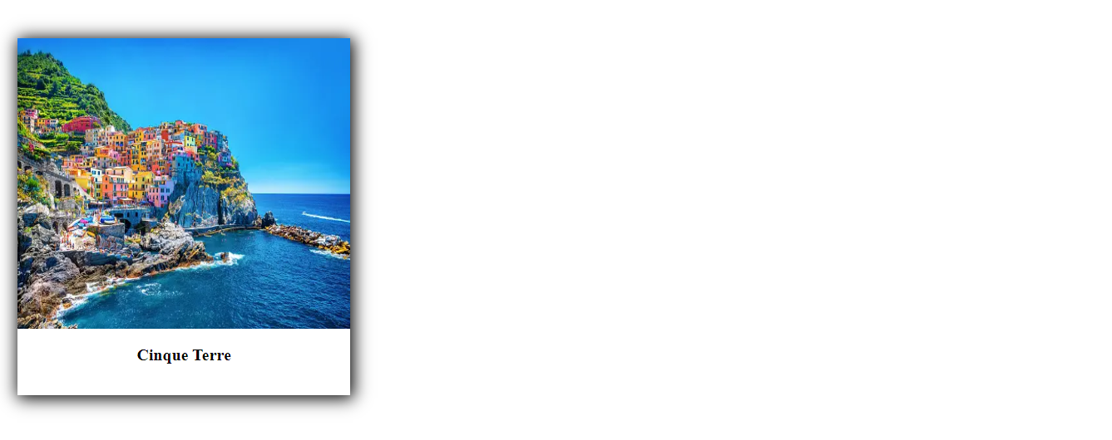

**After 5 second Animation start:**

**After Animation Completed:**

