**Web Class Task**

**TASK#1:**

**Code :**

<!DOCTYPE html>

<html lang="en">

  <head>

    <meta charset="utf-8" />

    <meta name="viewport" content="width=device-width, initial-scale=1" />

    <title>Bootstrap Task1</title>

    <link rel="stylesheet" href="t1.css" />

    <link

      href="https://cdn.jsdelivr.net/npm/bootstrap@5.3.2/dist/css/bootstrap.min.css"

      rel="stylesheet"

      integrity="sha384-T3c6CoIi6uLrA9TneNEoa7RxnatzjcDSCmG1MXxSR1GAsXEV/Dwwykc2MPK8M2HN"

      crossorigin="anonymous"

    />

  </head>

  <style>

    a {

      text-decoration: none;

    }

  </style>

  <body>

    <div class="container-fluid">

      <a  href="https://www.w3schools.com/bootstrap/bootstrap_ver.asp">

      <div class="link_decoration bg-success text-success bg-opacity-50 s box">

        Feel good about bootstrap

        <span class="close-btn" onclick="hideBox(this)">×</span>

      </a>

      </div>

      <a href="https://www.w3schools.com/bootstrap/bootstrap_ver.asp">

      <div class="link_decoration text-success bg-primary bg-opacity-25 s box">

        Feel Informed about bootstrap

        <span class="close-btn" onclick="hideBox(this)">×</span>

      </a>

      </div>

<a href="https://www.w3schools.com/bootstrap/bootstrap_ver.asp">

      <div class="link_decoration text-warning bg-warning bg-opacity-25 s box">

        Feel warned about Bootstrap

        <span class="close-btn" onclick="hideBox(this)">×</span>

      </a>

      </div>

<a href="https://www.w3schools.com/bootstrap/bootstrap_ver.asp">

      <div class="link_decoration text-warning bg-warning bg-opacity-25 s box">

        Maybe I should read the docs...

        <span class="close-btn" onclick="hideBox(this)">×</span>

      </a>

      </div>

<a href="https://www.w3schools.com/bootstrap/bootstrap_ver.asp">

      <div class="link_decoration bg-danger text-danger bg-opacity-25 s box">

        Danger zone

        <span class="close-btn" onclick="hideBox(this)">×</span>

      </a>

      </div>

<a href="https://www.w3schools.com/bootstrap/bootstrap_ver.asp">

      <div class="link_decoration bg-danger text-danger bg-opacity-25 s box">

        I really should read the docs...

        <span class="close-btn" onclick="hideBox(this)">×</span>

      </div>

    </a>

    </div>

    <script

      src="https://cdn.jsdelivr.net/npm/bootstrap@5.3.2/dist/js/bootstrap.bundle.min.js"

      integrity="sha384-C6RzsynM9kWDrMNeT87bh95OGNyZPhcTNXj1NW7RuBCsyN/o0jlpcV8Qyq46cDfL"

      crossorigin="anonymous"

    ></script>

    <script>

      function hideBox(*element*) {

        var box = element.closest(".box");

        box.style.display = "none";

      }

    </script>

  </body>

</html>

CSS Code:

.container-fluid {

  background-color: white;

}

.link_decoration {

  text-decoration: none;

}

.box {

  position: relative;

  padding-right: 30px;

}

.close-btn {

  position: absolute;

  top: 50%;

  transform: translateY(-50%);

  right: 0;

  padding: 5px;

  cursor: pointer;

}

**Output :**

**After click on link link is open:**

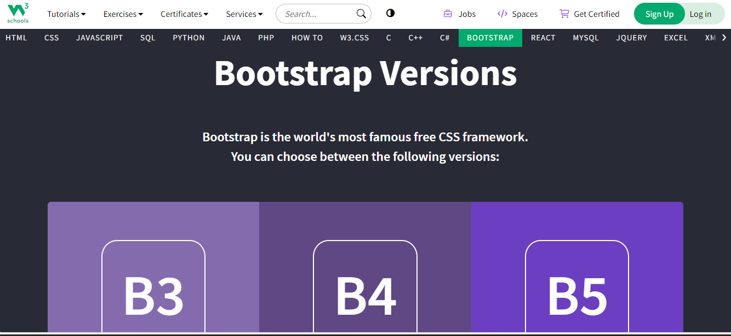

**TASK#2:**

**Code :**

<!DOCTYPE html>

<html lang="en">

  <head>

    <meta charset="utf-8" />

    <meta name="viewport" content="width=device-width, initial-scale=1" />

    <title>Bootstrap task2</title>

    <link rel="stylesheet" href="t1.css" />

    <link

      href="https://cdn.jsdelivr.net/npm/bootstrap@5.3.2/dist/css/bootstrap.min.css"

      rel="stylesheet"

      integrity="sha384-T3c6CoIi6uLrA9TneNEoa7RxnatzjcDSCmG1MXxSR1GAsXEV/Dwwykc2MPK8M2HN"

      crossorigin="anonymous"

    />

  </head>

  <body>

    <div class="container-fluid">

      <button type="button" class="btn">Basic</button>

      <button type="button" class="btn btn-primary">Primary</button>

      <button type="button" class="btn btn-secondary">Secondary</button>

      <button type="button" class="btn btn-success">Success</button>

      <button type="button" class="btn btn-info">Info</button>

      <button type="button" class="btn btn-warning">Warning</button>

      <button type="button" class="btn btn-danger">Danger</button>

      <button type="button" class="btn btn-dark">Dark</button>

      <button type="button" class="btn btn-light">Light</button>

      <button type="button" class="btn btn-link">Link</button>

    </div>

    <script>

      let buttons = document.getElementsByClassName("btn");

      for (let i = 0; i < buttons.length; i++) {

        buttons[i].addEventListener("click", function () {

          alert("My name is Rai");

        });

      }

    </script>

    <script

      src="https://cdn.jsdelivr.net/npm/bootstrap@5.3.2/dist/js/bootstrap.bundle.min.js"

      integrity="sha384-C6RzsynM9kWDrMNeT87bh95OGNyZPhcTNXj1NW7RuBCsyN/o0jlpcV8Qyq46cDfL"

      crossorigin="anonymous"

    ></script>

  </body>

</html>

**CSS code:**

.container-fluid {

  background-color: white;

}

**Output :**



**TASK#3:**

**Code :**

<!DOCTYPE html>

<html lang="en">

  <head>

    <meta charset="utf-8" />

    <meta name="viewport" content="width=device-width, initial-scale=1" />

    <title>js Task3</title>

    <link rel="stylesheet" href="t1.css" />

    <link

      href="https://cdn.jsdelivr.net/npm/bootstrap@5.3.2/dist/css/bootstrap.min.css"

      rel="stylesheet"

      integrity="sha384-T3c6CoIi6uLrA9TneNEoa7RxnatzjcDSCmG1MXxSR1GAsXEV/Dwwykc2MPK8M2HN"

      crossorigin="anonymous"

    />

  </head>

  <body>

    <div>

      <input id="v1" placeholder="Enter the 1st number" />

      <input id="v2" placeholder="Enter the 2nd number" />

      <input id="res" placeholder="Result" />

    </div>

    <br />

    <button class="b1" id="v3" onclick="Addition()">Add</button>

    <button class="b1" id="v4" onclick="subtract()">Sub</button>

    <button class="b1" id="v5" onclick="multiply()">Mul</button>

    <button class="b1" id="v6" onclick="Divide()">Div</button>

    <script src="t1.js"></script>

    <script

      src="https://cdn.jsdelivr.net/npm/bootstrap@5.3.2/dist/js/bootstrap.bundle.min.js"

      integrity="sha384-C6RzsynM9kWDrMNeT87bh95OGNyZPhcTNXj1NW7RuBCsyN/o0jlpcV8Qyq46cDfL"

      crossorigin="anonymous"

    ></script>

  </body>

</html>

**CSS Code:**

.b1 {

  color: white;

  background-color: teal;

}

**JS Code:**

let buttons = document.getElementById("v3");

let Addition = () => {

  let i1 = Number(document.getElementById("v1").value);

  let i2 = Number(document.getElementById("v2").value);

  console.log(i1 + i2);

  document.getElementById("res").value = i1 + i2;

};

let subtract = () => {

  let i1 = Number(document.getElementById("v1").value);

  let i2 = Number(document.getElementById("v2").value);

  console.log(i1 - i2);

  document.getElementById("res").value = i1 - i2;

};

let multiply = () => {

  let i1 = Number(document.getElementById("v1").value);

  let i2 = Number(document.getElementById("v2").value);

  console.log(i1 * i2);

  document.getElementById("res").value = i1 * i2;

};

let Divide = () => {

  let i1 = Number(document.getElementById("v1").value);

  let i2 = Number(document.getElementById("v2").value);

  console.log(i1 / i2);

  document.getElementById("res").value = i1 / i2;

};

**Output :**

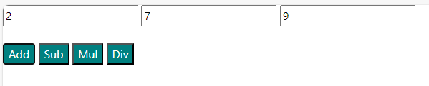

**TASK#4:**

**Code :**

<!DOCTYPE html>

<html lang="en">

  <head>

    <meta charset="utf-8" />

    <meta name="viewport" content="width=device-width, initial-scale=1" />

    <title>js Task4</title>

    <link rel="stylesheet" href="t1.css" />

    <link

      href="https://cdn.jsdelivr.net/npm/bootstrap@5.3.2/dist/css/bootstrap.min.css"

      rel="stylesheet"

      integrity="sha384-T3c6CoIi6uLrA9TneNEoa7RxnatzjcDSCmG1MXxSR1GAsXEV/Dwwykc2MPK8M2HN"

      crossorigin="anonymous"

    />

  </head>

  <body>

    <input id="v1" type="text" placeholder="Please Enter month name " />

    <h1 id="days"></h1>

    <button class="b1" id="v6" onclick="Display()">Submit</button>

    <script src="t1.js"></script>

    <script

      src="https://cdn.jsdelivr.net/npm/bootstrap@5.3.2/dist/js/bootstrap.bundle.min.js"

      integrity="sha384-C6RzsynM9kWDrMNeT87bh95OGNyZPhcTNXj1NW7RuBCsyN/o0jlpcV8Qyq46cDfL"

      crossorigin="anonymous"

    ></script>

  </body>

</html>

**CSS Code:**

.container-fluid {

  background-color: white;

}

#days {

  color: red;

  margin-left: 50px;

}

.b1 {

  color: white;

  background-color: MediumSeaGreen;

  margin-left: 40px;

}

**JS code:**

let Display = () => {

  let day = 0;

  let i1 = document.getElementById("v1").value;

  if (

    i1 == "Jan" ||

    i1 == "Mar" ||

    i1 == "May" ||

    i1 == "Jul" ||

    i1 == "Aug" ||

    i1 == "Oct" ||

    i1 == "Dec"

  ) {

    day = 31;

  } else if (i1 == "Apr" || i1 == "Jun" || i1 == "Sep" || i1 == "Nov") {

    day = 30;

  } else if (i1 == "Feb") {

    day = 28;

  }

  document.getElementById("days").innerHTML = `${day}`;

};

**Output :**

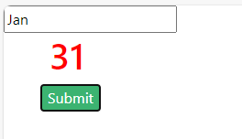

**TASK#5:**

**Code :**

<!DOCTYPE html>

<html lang="en">

  <head>

    <meta charset="utf-8" />

    <meta name="viewport" content="width=device-width, initial-scale=1" />

    <title>js task5</title>

    <link rel="stylesheet" href="t1.css" />

    <link

      href="https://cdn.jsdelivr.net/npm/bootstrap@5.3.2/dist/css/bootstrap.min.css"

      rel="stylesheet"

      integrity="sha384-T3c6CoIi6uLrA9TneNEoa7RxnatzjcDSCmG1MXxSR1GAsXEV/Dwwykc2MPK8M2HN"

      crossorigin="anonymous"

    />

  </head>

  <body>

    <input id="v1" type="Number" placeholder="Enter Number for Table" />

    <h1 id="Num"></h1>

    <button class="b1" id="v6" onclick="Table()">Submit</button>

    <script src="t1.js"></script>

    <script

      src="https://cdn.jsdelivr.net/npm/bootstrap@5.3.2/dist/js/bootstrap.bundle.min.js"

      integrity="sha384-C6RzsynM9kWDrMNeT87bh95OGNyZPhcTNXj1NW7RuBCsyN/o0jlpcV8Qyq46cDfL"

      crossorigin="anonymous"

    ></script>

  </body>

</html>

**CSS Code:**

.b1 {

  color: white;

  background-color: MediumSeaGreen;

  margin-left: 30px;

}

**JS code:**

let Table = () => {

  let i1 = Number(document.getElementById("v1").value);

  let r = document.createElement("div");

  r.classList.add("Num");

  for (let i = 1; i <= 10; i++) {

    let v1 = document.createElement("h3");

    let v3 = i1 * i;

    v1.innerHTML = `${i1} * ${i} = ${v3}`;

    v1.style.color = "red";

    r.appendChild(v1);

  }

  document.getElementById("Num").appendChild(r);

};

**Output :**

