A Tour of Qwiklabs and the Google Cloud Platform (free)

* <https://google.qwiklabs.com/focuses/2794?locale=en&parent=catalog>

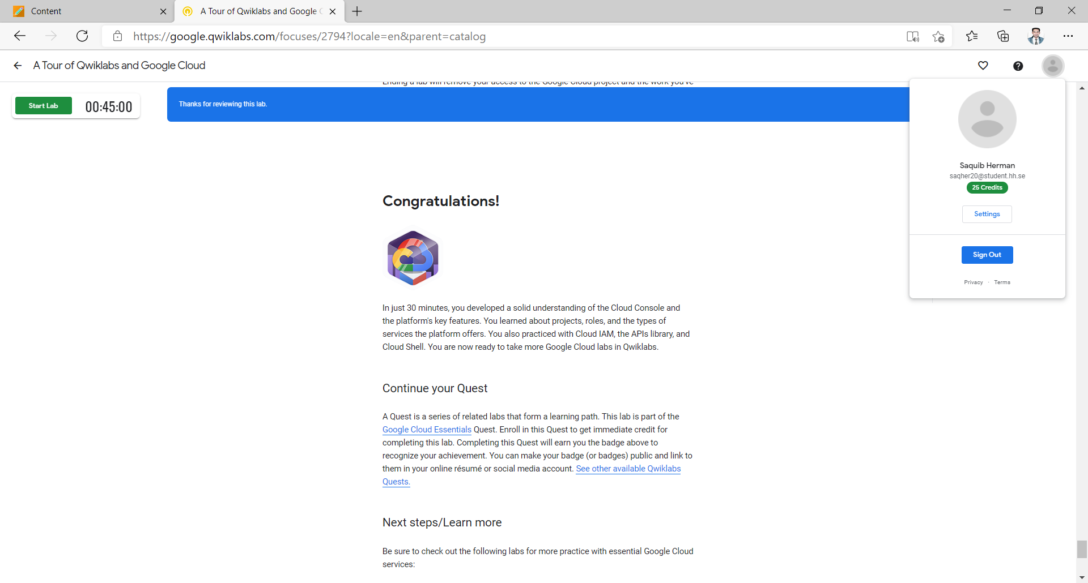

Google Cloud Pub/Sub: Qwik Start - Console (free)

* <https://www.qwiklabs.com/focuses/3719?parent=catalog>

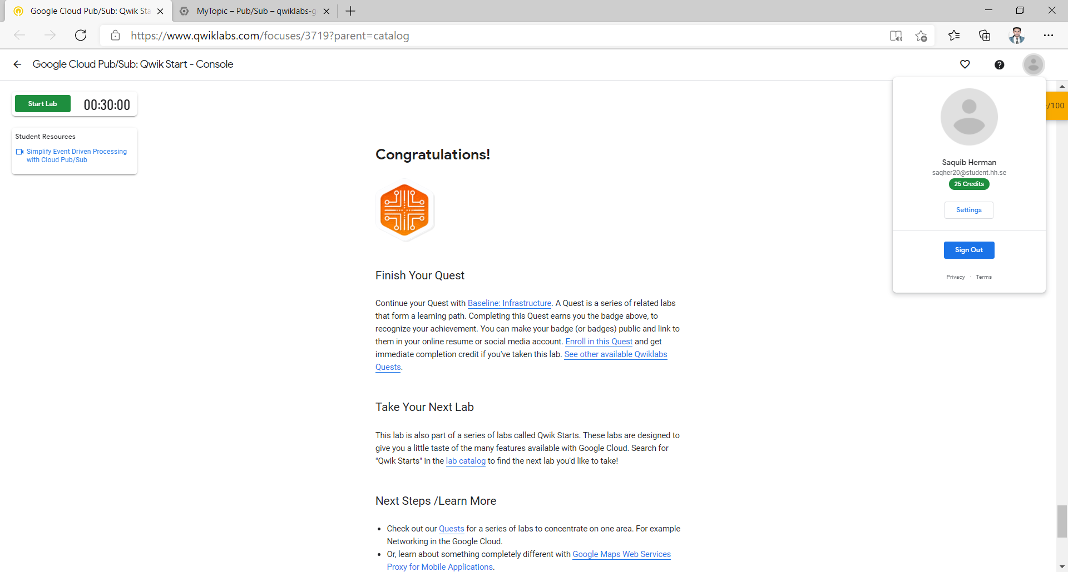

Internet of Things: Qwik Start (1 credit)

* <https://www.qwiklabs.com/focuses/1771?parent=catalog>

