Problem statement
Idea for AI PM - UX using AI hands-on

- Product - CricBuzz
- What do I want to improve - Insites and prediction for live cricket matches
- Who is the user - 25 y male, who is a cricket follower

Story Telling
Idea for AI PM - UX using AI hands-on

- Product - CricBuzz
- What do you want to improve - Insites and prediction for live cricket matches
- Who is the user - 25 y male, who is a cricket follower

Tool used - https://gemini.google/overview/storybook/

Output - https://gemini.google.com/share/091bf6f19535

Prompt -

Storybook Master Prompt - Persona Hero Narrative (High-Emotion)

You are a story creator crafting a cinematic, empathetic persona story.

Ask me only these 3 inputs in one message:

1. What is the product/feature to highlight?

2. What is the target persona's name?

3. Which region/city is this story set in?

After I answer, do not ask anything else. Produce the story.

Story requirements (apply automatically):

Length 250-400 words, 6-8 short paragraphs: title 1-line logline on top.

Arc: Before (daily struggle with sensory detail & stakes) - Inciting friction - Rising tension (time pressure, context, constraints) Product feature enters as the "hero" (name the feature, show how it works concretely) - Transformation (specific outcomes, relief, control) - After (new routine, confidence, meaningful gain) - Close with a hopeful image soft call-to-action.

Tone: empathetic, vivid, human; plain language, no jargon; culturally respectful to the given region (use natural names, moments, and cues).

Show 1 short line of natural dialogue and 1-2 italicized inner thoughts from the persona to deepen connection (keep tasteful and brief).

Make the feature tangible: include 3 concrete mechanisms woven into sentences (e.g., "auto-sorts receipts." "predicts peak traffic," "schedules recurring orders"). Avoid bullet lists.

Avoid hype or unrealistic claims; no medical/financial promises; keep privacy-safe and brand-safe.

Focus on emotion relief: frustration, overwhelm, or anxiety transitions to calm, time saved, or confidence gained.

End with a subtle CTA that fits the story (e.g., "Tonight, she taps "Start").

Output format (strict):

Title

Logline (one sentence)

Story (paragraphs only; no bullets, no meta commentary)

Generation steps (internal, do not display): build a brief outline; map the persona's day; select 2-3 region-authentic details; integrate the feature's mechanisms where they naturally solve pain; convert to prose; polish for rhythm and clarity.

Begin by asking only:

"Product/feature - Cricbuzz/Insites and prediction for live cricket matches

"Persona name - 25 y male, who is a cricket follower

"Region/city - Delhi,Mumbai, Kolkata, Bangalore

Then generate the story per the above.

User Journey Diagram
User journey Diagram - CricBuzz

Tool used - https://www.eraser.io/diagramgpt or https://whimsical.com/ or https://claude.ai/
Here's a crisp, interview-ready prompt you can paste directly into Eraser DiagramGPT or Whimsical AI — written from a PM's perspective with the five pain points embedded as distinct journey stages and emotional states:

Prompt to copy-paste:
Create a user journey diagram for CricBuzz, a cricket score and match information platform, specifically for the feature: Match Insights & Predictions.
User persona: Rahul, 24, a passionate cricket fan from Raipur who checks CricBuzz 4–5 times per day during live matches. He uses the app to follow scores, read match analysis, and stay connected with cricket culture.
Map the journey across these 5 phases, each with a touchpoint, action, emotion, and pain point:
Phase 1 – Discover Match Insights Touchpoint: Match detail page | Action: Rahul scrolls through live commentary and insights | Emotion: Curious but overwhelmed | Pain point: Too much textual information — insights and live commentary are visually identical, making it hard to differentiate key insights from ball-by-ball commentary.
Phase 2 – Engage with Insights Touchpoint: Insights card/section | Action: Rahul reads an insight about a bowler's performance trend | Emotion: Interested but passive | Pain point: Rahul cannot contribute his own insight, prediction, or opinion — he can only consume what the app shows.
Phase 3 – Share & Discuss Touchpoint: Individual insight card | Action: Rahul wants to share a key stat or insight with friends | Emotion: Excited but frustrated | Pain point: No social features — Rahul cannot share, comment, or discuss insights with fellow cricket fans within the app.
Phase 4 – Follow Favourite Team Touchpoint: Home screen / Notification settings | Action: Rahul wants tailored updates for his favourite team (e.g. CSK or India) | Emotion: Loyal but neglected | Pain point: No option to select a favourite team or receive team-specific push notifications for match insights.
Phase 5 – Follow Favourite Player Touchpoint: Player profile page | Action: Rahul visits Virat Kohli's profile and wants alerts when Kohli does something notable | Emotion: Eager but disappointed | Pain point: No option to follow a player and receive player-specific push notifications for performance insights.
For each phase, include: phase name, touchpoint, user action, emotional state (use an emotion scale or emoji), and pain point. Add an Opportunity row beneath each pain point showing the proposed solution.
Style: horizontal swimlane diagram. Use color coding — red/orange for pain points, green for opportunities, neutral for actions.

A few things I've built into this prompt intentionally as a PM:
The persona is named and grounded (Rahul, Raipur) rather than generic — tools like Eraser tend to produce richer diagrams when the persona has a face. The pain points are written as user-felt frustrations, not technical issues, which keeps the journey diagram human-centred rather than system-centred. And the Opportunity row ensures the diagram doubles as a problem-solution artifact — useful for portfolio reviews where you want to show end-to-end PM thinking in a single visual.
If Eraser gives you a text-heavy output, add this line at the end: "Keep text inside each cell to under 10 words. Prioritize visual hierarchy over completeness."

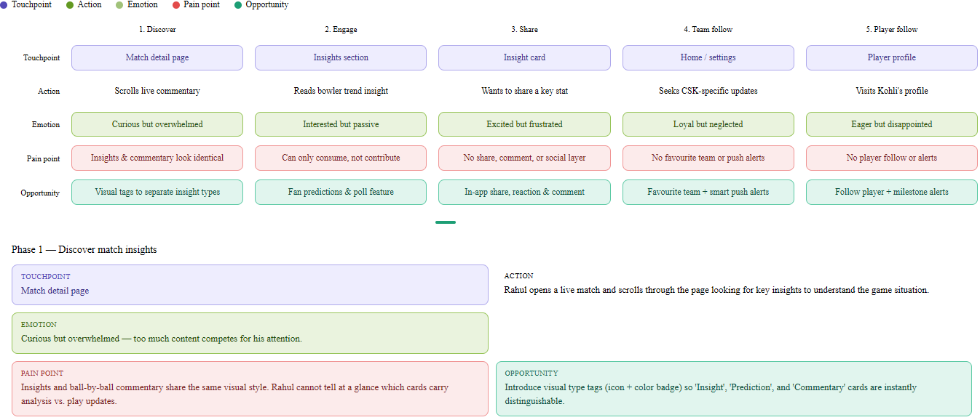

Workflow Diagram

Workflow Diagram - CricBuzz

Tool Used - https://www.eraser.io/diagramgpt

Prompt Used -

Create a workflow and data flow diagram for a new CricBuzz feature called Match Insights & Predictions.
Feature overview: The feature allows users to read AI-generated match insights, submit their own match predictions, follow favourite teams and players, and share insights socially within the app.
Map the complete workflow across these 5 functional flows, showing actors, data inputs, processing steps, and outputs for each:
Flow 1 – Insight generation pipeline Actor: System (backend + AI engine) Input: Live match data feed (ball-by-ball scores, player stats, historical data) Process: AI model analyses live data → generates insight cards → tags each card by type (Insight / Prediction / Commentary) → pushes to match detail page Output: Visually tagged insight cards displayed to user in real time
Flow 2 – Fan prediction submission Actor: Logged-in user (Rahul) Input: User selects match outcome prediction (e.g. "CSK wins by 20+ runs") Process: Prediction stored → displayed on community feed → upvoted by other users → resolved against actual match result at end of match Output: Prediction card with vote count + post-match result badge (Correct / Incorrect)
Flow 3 – Social sharing and discussion Actor: User Input: User taps Share or Comment on an insight card Process: Share → generates deep-link card → opens native share sheet / WhatsApp; Comment → opens threaded comment UI → comment stored → displayed in thread; Reaction → emoji stored → aggregated count updated Output: Shared card with CricBuzz branding OR live comment thread under insight
Flow 4 – Favourite team push notification Actor: User + notification service Input: User selects favourite team during onboarding or from settings Process: Preference saved to user profile → notification service listens for that team's match events → filters events by type (toss, wicket, milestone, result) → sends push notification Output: Personalised push notification delivered to user's device for their team only
Flow 5 – Favourite player push notification Actor: User + notification service Input: User taps "Follow" on a player profile page Process: Player ID saved to user follow list → event listener tracks player performance milestones (50, 100, wicket, dismissal, MOTM) → triggers alert when milestone hit Output: Push notification with player name, event type, and deep link back to match page
Diagram style instructions:
- Use a swimlane layout with four lanes: User, App (frontend), Backend / AI, and Notification Service
- Show decision nodes where the system branches (e.g. "Is user logged in?", "Did prediction match result?")
- Use colour coding: blue for user actions, purple for AI/backend processes, green for successful outputs, red/orange for error or null states (e.g. "not followed", "prediction incorrect")
- Label all arrows with the data being passed (e.g. "match event payload", "user preference ID", "push token")
- Keep each flow visually separated with a horizontal divider and a flow label

This prompt gives the tool enough structure to generate clean swimlanes with decision branches and labeled data flows — the kind of diagram that shows you've thought about the system end-to-end, not just the user surface.
Here's the PM-framed prompt for the Workflow / Data Flow Diagram — ready to paste into Eraser DiagramGPT or Whimsical AI:

Create a workflow and data flow diagram for a new CricBuzz feature called Match Insights & Predictions.
Feature overview: The feature allows users to read AI-generated match insights, submit their own match predictions, follow favourite teams and players, and share insights socially within the app.
Map the complete workflow across these 5 functional flows, showing actors, data inputs, processing steps, and outputs for each:
Flow 1 – Insight generation pipeline Actor: System (backend + AI engine) Input: Live match data feed (ball-by-ball scores, player stats, historical data) Process: AI model analyses live data → generates insight cards → tags each card by type (Insight / Prediction / Commentary) → pushes to match detail page Output: Visually tagged insight cards displayed to user in real time
Flow 2 – Fan prediction submission Actor: Logged-in user (Rahul) Input: User selects match outcome prediction (e.g. "CSK wins by 20+ runs") Process: Prediction stored → displayed on community feed → upvoted by other users → resolved against actual match result at end of match Output: Prediction card with vote count + post-match result badge (Correct / Incorrect)
Flow 3 – Social sharing and discussion Actor: User Input: User taps Share or Comment on an insight card Process: Share → generates deep-link card → opens native share sheet / WhatsApp; Comment → opens threaded comment UI → comment stored → displayed in thread; Reaction → emoji stored → aggregated count updated Output: Shared card with CricBuzz branding OR live comment thread under insight
Flow 4 – Favourite team push notification Actor: User + notification service Input: User selects favourite team during onboarding or from settings Process: Preference saved to user profile → notification service listens for that team's match events → filters events by type (toss, wicket, milestone, result) → sends push notification Output: Personalised push notification delivered to user's device for their team only
Flow 5 – Favourite player push notification Actor: User + notification service Input: User taps "Follow" on a player profile page Process: Player ID saved to user follow list → event listener tracks player performance milestones (50, 100, wicket, dismissal, MOTM) → triggers alert when milestone hit Output: Push notification with player name, event type, and deep link back to match page
Diagram style instructions:
- Use a swimlane layout with four lanes: User, App (frontend), Backend / AI, and Notification Service
- Show decision nodes where the system branches (e.g. "Is user logged in?", "Did prediction match result?")
- Use colour coding: blue for user actions, purple for AI/backend processes, green for successful outputs, red/orange for error or null states (e.g. "not followed", "prediction incorrect")
- Label all arrows with the data being passed (e.g. "match event payload", "user preference ID", "push token")
- Keep each flow visually separated with a horizontal divider and a flow label

This prompt gives the tool enough structure to generate clean swimlanes with decision branches and labeled data flows — the kind of diagram that shows you've thought about the system end-to-end, not just the user surface.

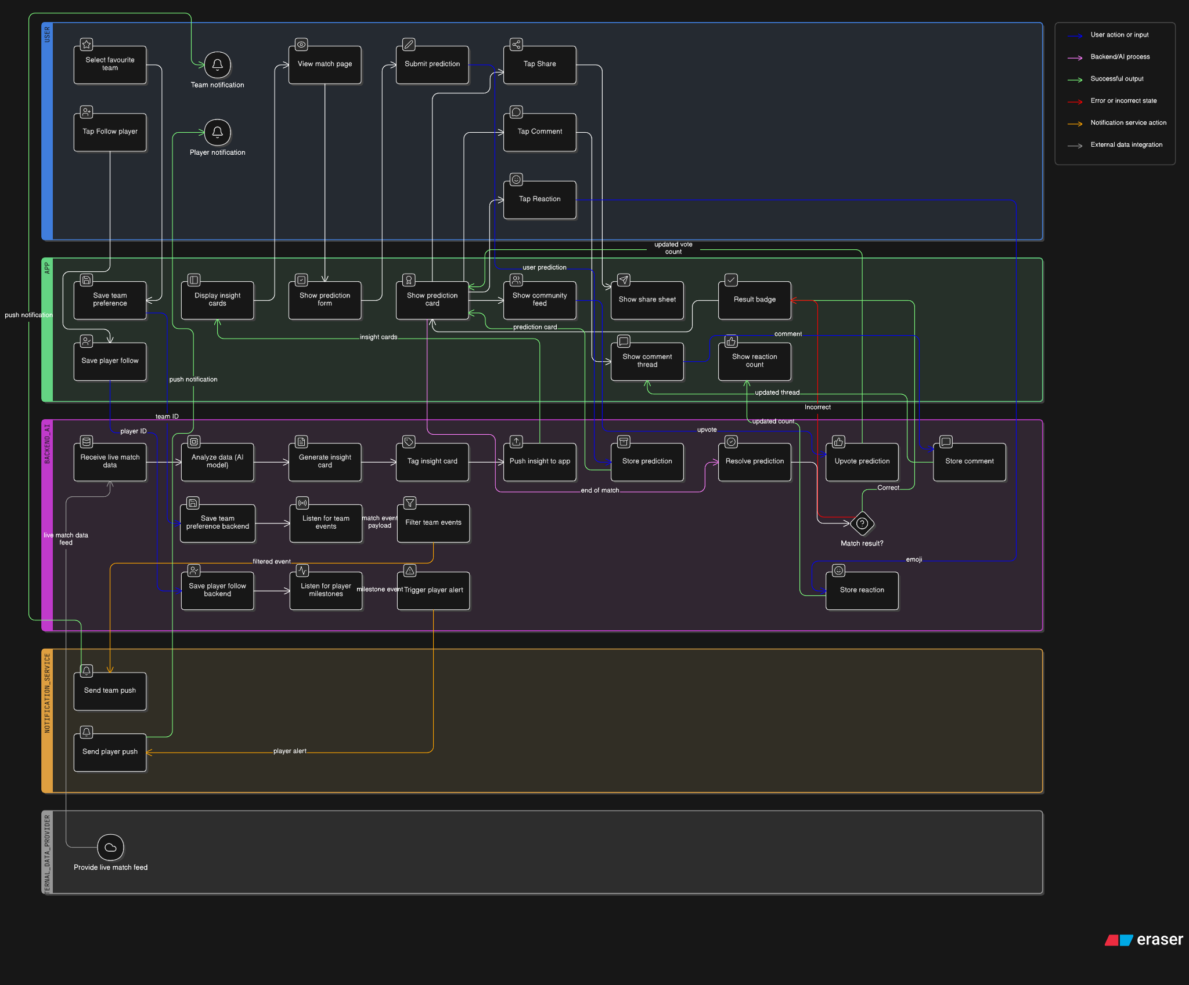

Data Flow Diagram
Dataflow Diagram - CricBuzz

Tool Used - https://whimsical.com/

Prompt -
Create a Data Flow Diagram (DFD) for the CricBuzz Match Insights & Predictions feature.
Use Level 1 DFD conventions: show external entities, processes, data stores, and data flows with labeled arrows.
External entities (actors outside the system):
- User (cricket fan)
- Cricket data provider (live match feed, e.g. Sportradar or BCCI API)
- Push notification service (e.g. Firebase FCM)
- Social/share platform (WhatsApp, native share sheet)
Core processes (numbered):
- Ingest live match data
- Generate and tag insight cards (AI engine)
- Display insights to user
- Accept and store fan prediction
- Resolve prediction against match result
- Handle social action (share / comment / react)
- Manage user preferences (favourite team + player)
- Trigger and deliver push notification
Data stores:
- DS1: Match data store (live scores, ball-by-ball, player stats)
- DS2: Insights store (generated insight cards with type tags)
- DS3: Predictions store (user predictions, vote counts, resolution status)
- DS4: Social store (comments, reactions, share logs)
- DS5: User profile store (favourite team, followed players, push token, preferences)
Key data flows to show (label every arrow):
- Cricket data provider → Process 1: "live match event payload"
- Process 1 → DS1: "structured match data"
- DS1 → Process 2: "match stats + historical data"
- Process 2 → DS2: "tagged insight card"
- DS2 → Process 3: "insight card list"
- Process 3 → User: "rendered insight feed"
- User → Process 4: "prediction input"
- Process 4 → DS3: "stored prediction"
- DS3 → Process 5: "prediction record"
- DS1 → Process 5: "final match result"
- Process 5 → DS3: "resolution status (correct / incorrect)"
- Process 5 → User: "prediction result badge"
- User → Process 6: "share / comment / reaction action"
- Process 6 → DS4: "social interaction record"
- Process 6 → Social/share platform: "deep link card"
- User → Process 7: "favourite team ID / player ID"
- Process 7 → DS5: "updated user preferences"
- DS5 → Process 8: "user push token + preference filters"
- DS1 → Process 8: "match event trigger (wicket, milestone, result)"
- Process 8 → Push notification service: "notification payload"
- Push notification service → User: "push notification"
Style instructions:
- Use standard DFD shapes: rectangles for external entities, rounded rectangles or circles for processes, open-ended rectangles for data stores
- Colour code: grey for external entities, blue for processes, yellow/amber for data stores
- Label every arrow with the exact data being passed
- Group the 8 processes in the centre of the diagram with data stores nearby and external entities on the outer edges
- Keep the layout left-to-right: data provider on far left, user on far right, notification service on bottom right, social platform on bottom left

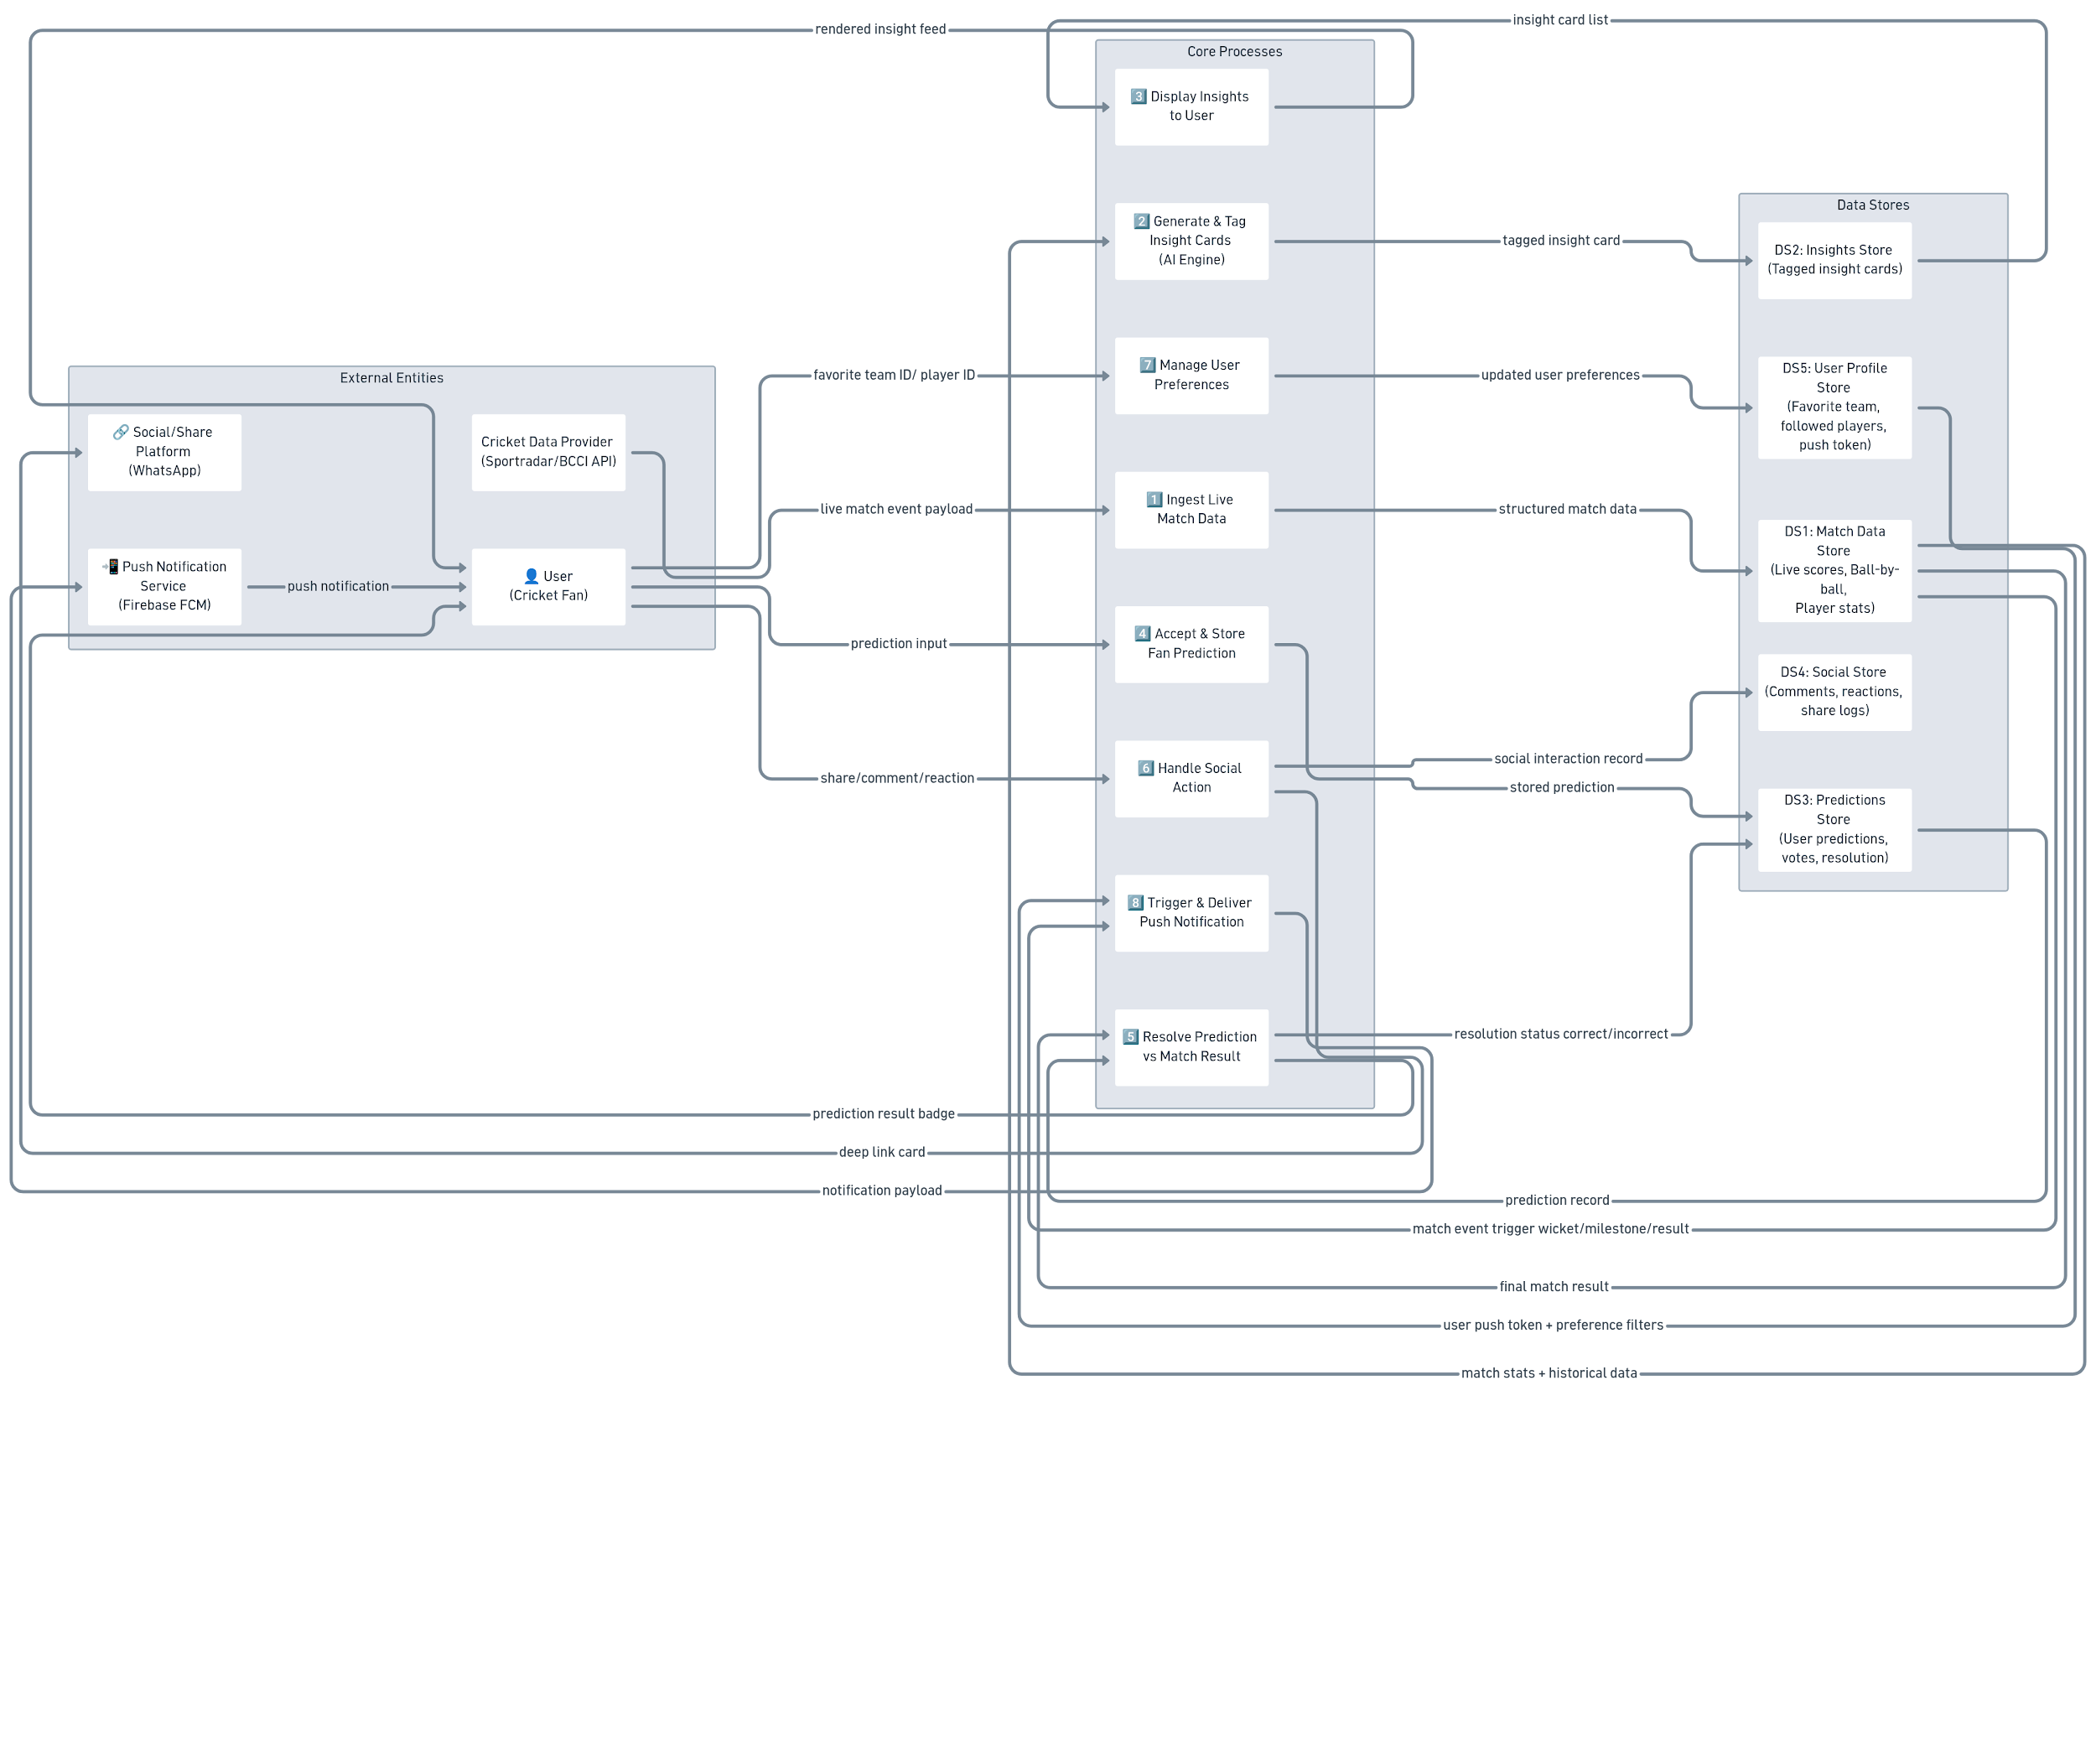

Interaction Diagram
Interaction Diagram - CricBuzz

Tool Used - https://whimsical.com/

Prompt Used -
Create a sequence diagram for a CricBuzz feature called Match Insights & Predictions.
Participants: User, Mobile App, API Gateway, Insight Service, Prediction Service, Notification Service, User Profile DB, Firebase FCM
Show these 5 flows as separate labeled sections:
1. Load insights User → App → API Gateway → Insight Service → DB → Insight Service → App → User
2. Submit prediction User → App → API Gateway → Prediction Service → DB → App → User
3. Share insight User → App → Notification Service → App → User (native share sheet)
4. Follow favourite team + get alert User → App → API Gateway → User Profile DB → App → User DB → Notification Service → Firebase FCM → User
5. Follow player + get milestone alert User → App → API Gateway → User Profile DB → App → User DB → Notification Service → Firebase FCM → User
Keep it clean. Use standard sequence diagram arrows. Label each arrow with one short action phrase.

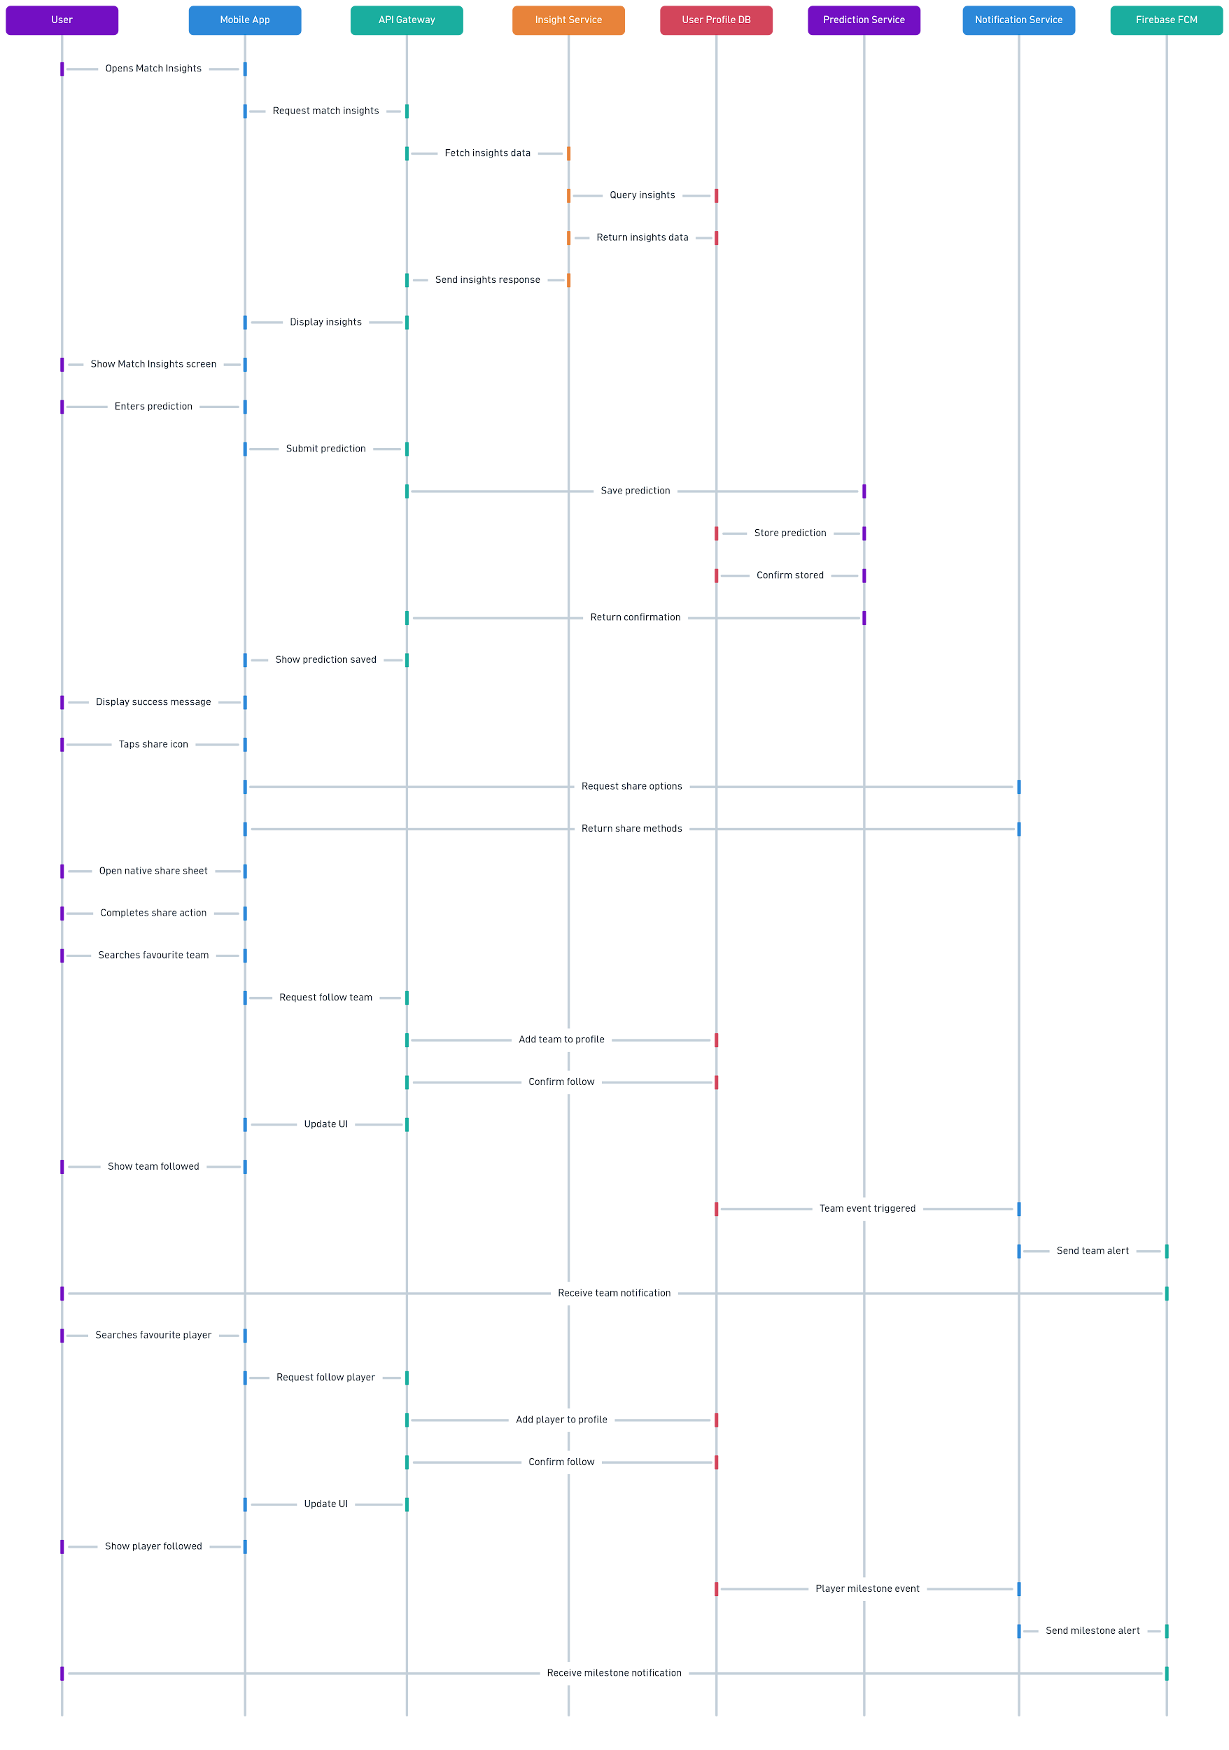

Low-fidelity mock-up
Low-fidelity mockup diagram - CricBuzz

Link to the Tool - https://app.visily.ai/

Prompt -

Create a low fidelity wireframe for the CricBuzz mobile app for a feature called Match Insights & Predictions.
Use simple grey boxes, placeholder lines, and basic shapes only. No color, no icons, no real text — just layout structure.
Screen 1 — Match Detail Page (Insights Feed)
- Top: match scorecard bar (team names, score, overs)
- Below scorecard: horizontal filter tab bar with 3 tabs — "All", "Insights", "Predictions"
- Main content: vertical scroll feed of cards
- Each card has: a small tag label top left (Insight / Prediction / Commentary), a title line, two body text lines, and a row of 3 action icons at the bottom (react, comment, share)
- Show 3 cards in the feed
Screen 2 — Fan Prediction Submission
- Top: back arrow + screen title "Submit Prediction"
- Match context bar (team names + match status)
- Question prompt text line
- 3 prediction option buttons stacked vertically (radio button style)
- Large CTA button at bottom "Submit Prediction"
Screen 3 — Favourite Team & Player Setup
- Top: progress bar (step 2 of 3)
- Heading text line
- Grid of 8 team logo placeholders (2 columns x 4 rows) each with a team name line below
- Below grid: section heading "Favourite Players"
- Horizontal scroll row of 4 circular player photo placeholders each with a name line
- Bottom: CTA button "Save Preferences"
Screen 4 — Push Notification Preview
- Show a mobile lock screen layout
- App icon placeholder + "CricBuzz" label top left
- Notification title line (bold)
- Notification body line (regular)
- Timestamp top right
- Below: a second notification card stacked underneath
Layout instructions:
- Show all 4 screens in a single row left to right
- Use mobile frame (portrait, rounded corners) around each screen
- Grey boxes for all images and icons
- Horizontal lines for all text
- No real content — placeholders only
- Label each screen with a screen title above the mobile frame

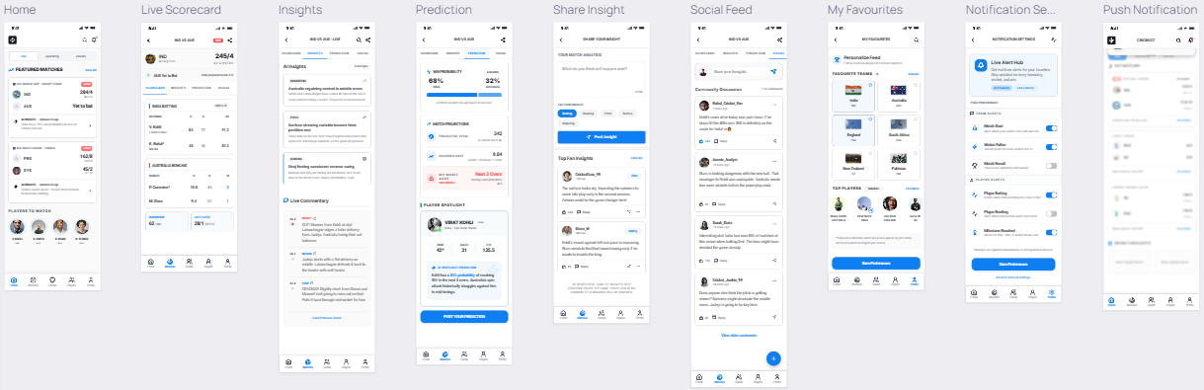

High-Fidelity Mock-up
High-fidelity mockup diagram - CricBuzz

Link to the Tool - https://stitch.withgoogle.com/

Prompt -H

Design a high fidelity mobile UI mockup for a CricBuzz feature called Match Insights & Predictions.
Visual style:
- Follow CricBuzz's existing design language
- Dark navy background: #0D1117
- Primary accent: CricBuzz red #E03A3A
- Card background: #1A2332
- Secondary text: #8B9BB4
- Primary text: #FFFFFF
- Font: Inter or Roboto
- Material Design 3 components
- Mobile screen size: 390 x 844px (iPhone 14 standard)

Screen 1 — Match Insights Feed
- Status bar at top (dark)
- Sticky header: CricBuzz logo left, notification bell + profile icon right
- Live match scorecard card: dark navy card, team names + flags, live score, overs, match status badge in red ("LIVE")
- Below scorecard: horizontal segmented pill tab bar — "All" "Insights" "Predictions" "Commentary" — active tab filled red, inactive grey
- Insight cards in vertical scroll feed: — Each card: dark navy (#1A2332) background, rounded corners 12px, red left border accent — Top left: colored tag pill — red for "Insight", blue for "Prediction", grey for "Commentary" — Card title in white 16px bold — 2 lines of body text in secondary grey — Bottom row: thumbs up icon + count, comment icon + count, share icon — all in secondary grey
- Show 3 insight cards in the feed
- Bottom navigation bar: Home, Live, Search, My Teams, Profile

Screen 2 — Fan Prediction Submission
- Dark navy background
- Top bar: back arrow left, "Submit Prediction" title center
- Match context pill: team names + "Live" badge
- Question card: white bold text "Who will win today's match?"
- 3 prediction option cards stacked: — Unselected: dark card with grey border, team name + odds percentage right aligned — Selected state: red border + light red background tint on one card
- Confidence slider below options (red thumb, grey track)
- Community stats bar: "68% fans predict CSK win" with red progress fill
- Large red CTA button at bottom: "Submit Prediction" white bold text

Screen 3 — Favourite Team & Player Setup
- Dark navy background
- Top: step progress indicator (3 steps, step 2 active in red)
- Heading: "Choose your favourite teams" white bold
- Team grid: 2 columns x 4 rows — Each team card: dark card, circular team logo placeholder, team name below, checkmark overlay on selected cards in red
- Section divider: "Favourite Players" heading
- Horizontal scroll row of player cards: — Circular player photo, name below, red "Following" pill on followed players
- Sticky bottom bar: "Save & Continue" red CTA button

Screen 4 — Push Notification (Lock Screen)
- Dark blurred phone lock screen background
- Time and date at top center in white
- Two stacked notification cards (frosted glass style, dark): — Notification 1: CricBuzz app icon left, "CricBuzz" + timestamp top, bold title "🏏 Virat Kohli just hit a century!", body text "India vs Australia — 3rd ODI, Live" — Notification 2: CricBuzz app icon left, "Your prediction is winning!" body text "CSK are on track — 68% match complete"
- Swipe hint text at bottom center

Output instructions:
- Show all 4 screens side by side in one artboard
- Add a subtle drop shadow under each phone frame
- Use real UI component hierarchy — not flat illustrations
- Apply consistent 16px horizontal padding inside all screens
- All screens must feel like they belong to the same app and design system

